HSP90B1 Exacerbates Myocardial Infarction Injury by Promoting Cardiomyocyte Pyroptosis and Is Associated with M1-like Macrophage Polarization
Yemin Wang ¹, Jiaqian Ge¹, Ying Zhang¹, Keke Shi¹, Jianrong Bao ¹, Mingxiu Dai¹, Xiaopeng Zhang¹, Xuexue Liu¹, Jiaqian Lin¹, Zilong Tang¹, Lei Sun^{1, 2, 3*}, Xiao Yu ^{1, 2*}

¹ Department of Pathology and Forensic Medicine, College of Basic Medical Sciences, Dalian Medical University, Dalian, Liaoning Province, China.
² Key Laboratory of Intervention in Tumor Metastasis, Dalian, Liaoning Province, China.
³ Key Laboratory of Cancer Stem Cell Research, Dalian, Liaoning Province, China.

* Corresponding authors:
Xiao Yu, M.D.
Department of Pathology and Forensic Medicine, College of Basic Medical Sciences, Dalian Medical University, 9th, Lvshun South Road, Dalian, Liaoning Province, 116044, China.
Key Laboratory of Intervention in Tumor Metastasis, Dalian, Liaoning Province, China.
E-mail: xiaoyu@dmu.edu.cn

Lei Sun, M.D.
Department of Pathology and Forensic Medicine, College of Basic Medical Sciences, Dalian Medical University, 9th, Lvshun South Road, Dalian, Liaoning Province, 116044, China.
Key Laboratory of Intervention in Tumor Metastasis, Dalian, Liaoning Province, China.
Key Laboratory of Cancer Stem Cell Research, Dalian, Liaoning Province, China.
E-mail: leisun@dmu.edu.cn

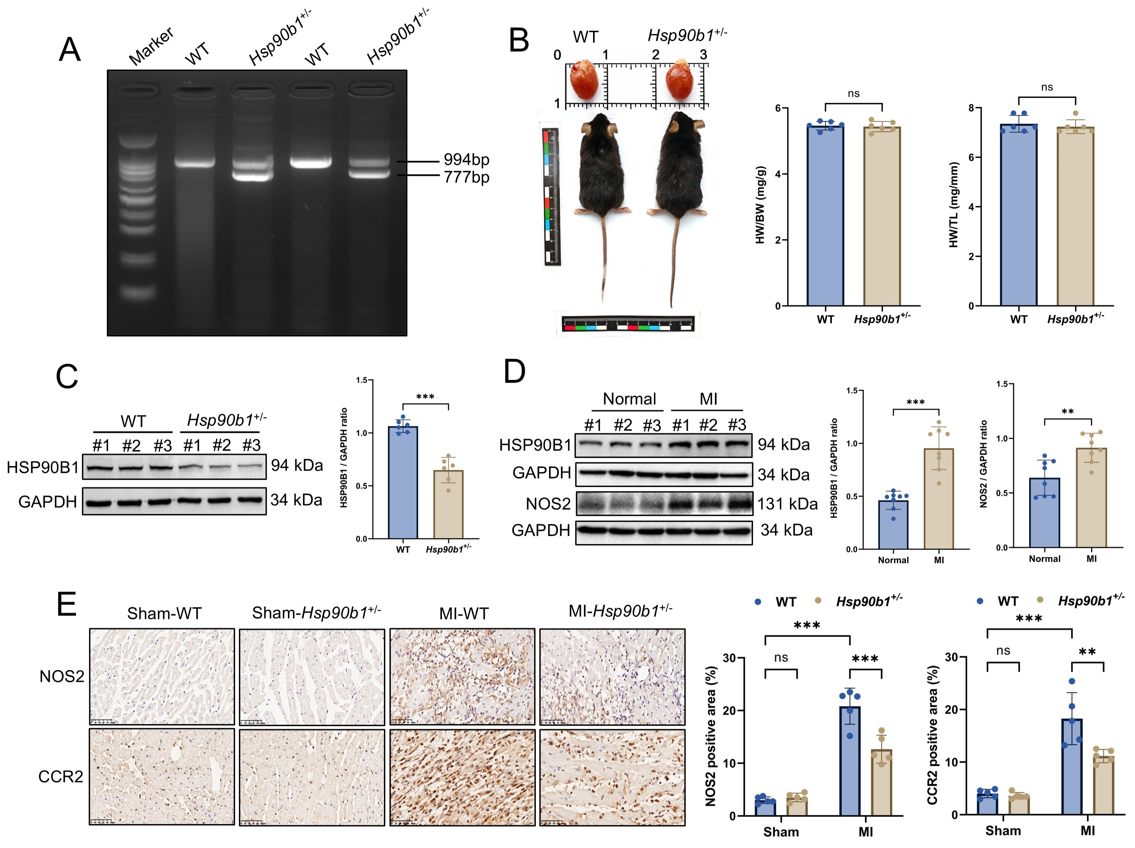
Figure S1. Validation of Hsp90b1 heterozygous deficiency and characterization of cardiac and inflammatory phenotypes.
(A) PCR-based genotyping of WT and Hsp90b1⁺/⁻ mice. (B) Representative images of gross cardiac morphology and whole-body appearance of WT and Hsp90b1⁺/⁻ mice at baseline, with quantitative analysis of the heart weight-to-body weight ratio (HW/BW) and heart weight-to-tibia length ratio (HW/TL), n = 6 per group. (C) Western blot analysis and quantification of HSP90B1 protein expression in heart tissues from WT and Hsp90b1⁺/⁻ mice at baseline, n = 6 per group. (D) Western blot analysis and quantification of HSP90B1 and NOS2 protein expression in human cardiac tissues from normal controls and MI patients, n = 8 per group. (E) Representative IHC images and quantitative analysis of NOS2 and CCR2 expression in myocardial sections from WT and Hsp90b1⁺/⁻ mice after sham or MI surgery. Scale bar, 50 μm, n = 5 per group. Data are presented as mean ± SD. P < 0.05, P < 0.01, P < 0.001; ns, not significant.
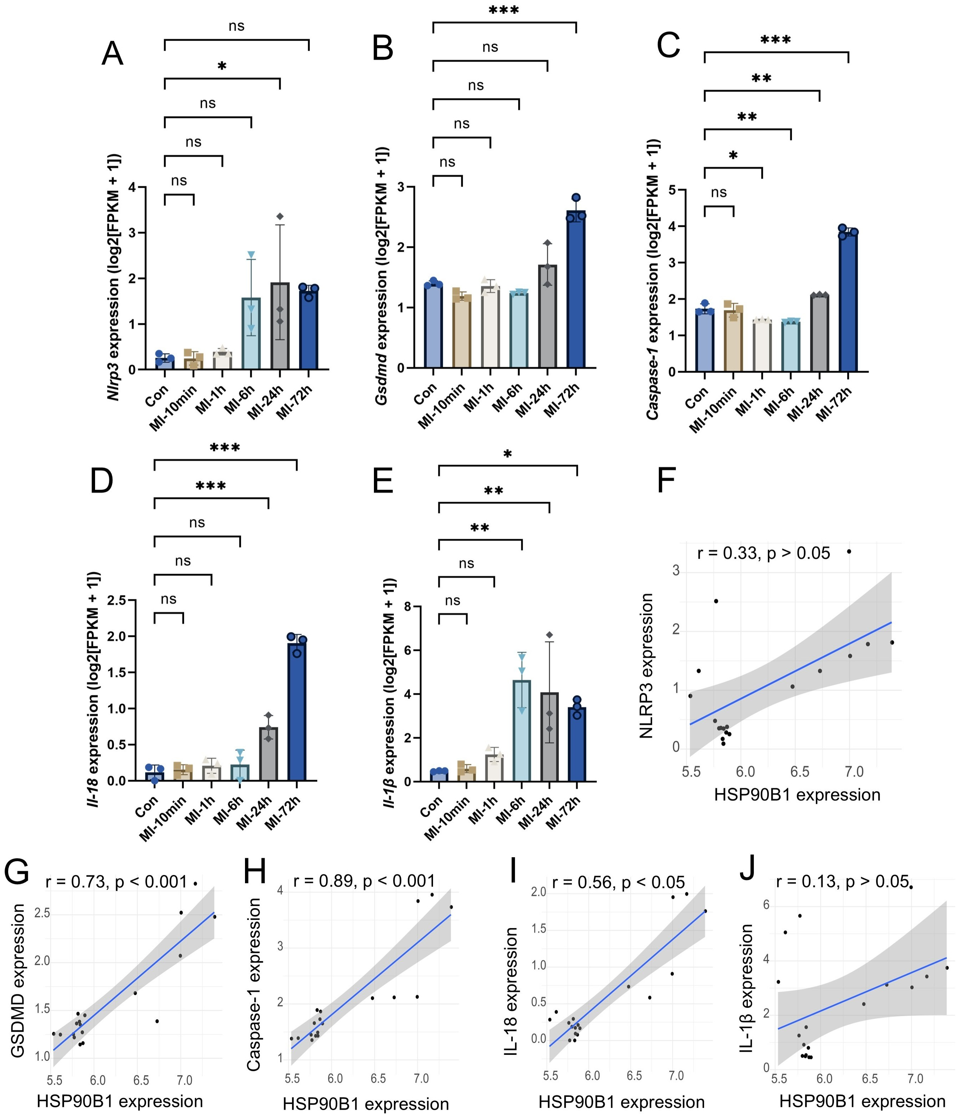
Figure S2. Temporal expression patterns of pyroptosis-related genes and their correlations with Hsp90b1 based on the GSE153494 dataset.
(A–E) Expression levels of Nlrp3, Gsdmd, Caspase 1, Il-18, and Il-1β in the control (Con) group and MI groups at 10 min, 1 h, 6 h, 24 h, and 72 h after MI. Expression values are shown as log2(FPKM + 1). (F–J) Spearman correlation analyses between HSP90B1 expression and NLRP3, GSDMD, Caspase 1, IL-18, and IL-1β expression. Spearman correlation coefficients (r) and corresponding P values are shown in each scatter plot. Blue lines represent linear regression fits, and shaded areas indicate the corresponding 95% confidence intervals. Data are presented as mean ± SD. P < 0.05, P < 0.01, P < 0.001; ns, not significant.
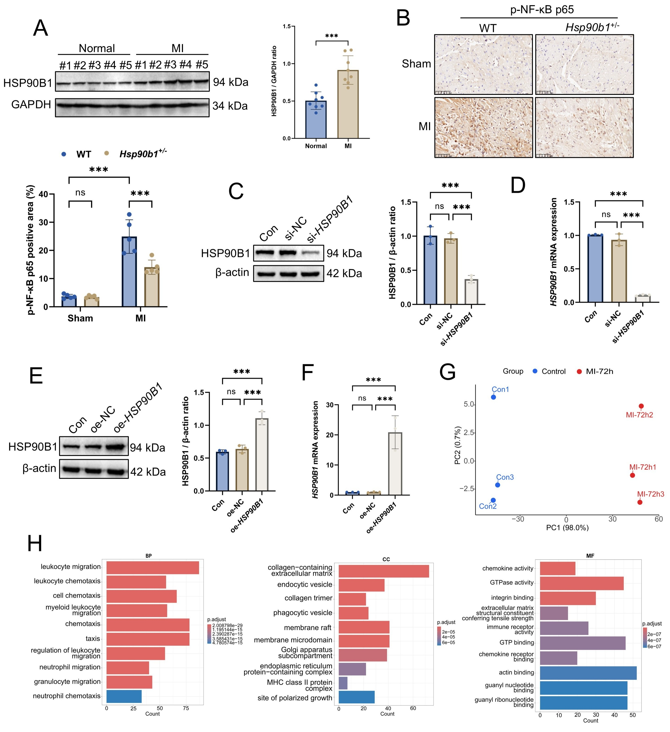
Figure S3. Additional validation of HSP90B1 expression and NF-κB activation and transcriptomic characterization.
(A) Western blot analysis of HSP90B1 protein expression in human cardiac tissues from normal controls and MI patients, n = 8 per group. The five samples from each group not included in the representative blots shown in Figure 1A are presented here. (B) Representative IHC images and quantitative analysis of p-NF-κB p65 staining in myocardial sections from WT and Hsp90b1⁺/⁻ mice after sham or MI surgery. Scale bar, 50 μm, n = 5 per group. (C) Western blot analysis and quantitative analysis of HSP90B1 protein expression in AC16 cardiomyocytes transfected with si-NC or si-HSP90B1, with untreated Con cells included as a reference. (D) RT-qPCR analysis of HSP90B1 mRNA expression in AC16 cardiomyocytes transfected with si-NC or si-HSP90B1, with untreated Con cells included as a reference. (E) Western blot analysis and quantitative analysis of HSP90B1 protein expression in AC16 cardiomyocytes transfected with oe-NC or oe-HSP90B1, with untreated Con cells included as a reference. (F) RT-qPCR analysis of HSP90B1 mRNA expression in AC16 cardiomyocytes transfected with oe-NC or oe-HSP90B1, with untreated Con cells included as a reference. (G) Principal component analysis (PCA) of transcriptomic profiles from Con and MI-72 h mouse myocardial tissues in the GSE153494 dataset. (H) Gene Ontology (GO) enrichment analysis of upregulated differentially expressed genes, shown for biological process (BP), cellular component (CC), and molecular function (MF) categories. Data are presented as mean ± SD. P < 0.05, P < 0.01, P < 0.001; ns, not significant.

Table S1. The primer sequences.
Name | Forward Primer | Reverse Primer
Il-6 (mouse) | 5’-CTGCAAGAGACTTCCATCCAG-3’ | 5’-AGTGGTATAGACAGGTCTGTTGG-3’
Tnf-α (mouse) | 5’-CTGAACTTCGGGGTGATCGG-3’ | 5’-GGCTTGTCACTCGAATTTTGAGA-3’
Il-1β (mouse) | 5’-GAAATGCCACCTTTTGACAGTG-3’ | 5’-TGGATGCTCTCATCAGGACAG-3’
Il-18 (mouse) | 5’-GACTCTTGCGTCAACTTCAAGG-3’ | 5’-CAGGCTGTCTTTTGTCAACGA-3’
Hsp90b1 (mouse) | 5'-AGGCTCAAGGACAGATGATGA-3' | 5'-ATCAGTTCTCTCAGGAAAATCTCTT-3'
Nos2 (mouse) | 5’-GTTCTCAGCCCAACAATACAAGA-3’ | 5’-GTGGACGGGTCGATGTCAC-3’
ACTB (mouse) | 5’-ACATGTCTTCCCCTTTGGGC-3’ | 5’-TGTGTACGCTTGCACAGTGA-3’
IL-6 (human) | 5’-ACTCACCTCTTCAGAACGAATTG-3’ | 5’-CCATCTTTGGAAGGTTCAGGTTG-3’
IL-1β (human) | 5’-ATGATGGCTTATTACAGTGGCAA-3’ | 5’-GTCGGAGATTCGTAGCTGGA-3’
TNF-α (human) | 5’-CCTCTCTCTAATCAGCCCTCTG-3’ | 5’-GAGGACCTGGGAGTAGATGAG-3’
NOS2 (human) | 5’-AGGGACAAGCCTACCCCTC-3’ | 5’-CTCATCTCCCGTCAGTTGGT-3’
ACTB (human) | 5'-CTCGCCTTTGCCGATCC-3' | 5'-GAATCCTTCTGACCCATGCC-3'
HSP90B1 (human) | 5'-GCTGACGATGAAGTTGATGTGG-3' | 5'-CATCCGTCCTTGATCCTTCTCTA-3'
Table S2. Primers used for genotyping of Hsp90b1 heterozygous mice.
Name | Primer | Reverse Primer (5′–3′)
Hsp90b1 | Forward | ACATGTCTTCCCCTTTGGGC
Hsp90b1 | Reverse | TGTGTACGCTTGCACAGTGA

Table S3. Quantitative validation of HSP90B1 knockdown and overexpression in AC16 cardiomyocytes
Manipulation | Assay | Group | Replicate 1 | Replicate 2 | Replicate 3 | Mean ± SD | Effect
Knockdown | RT-qPCR | si-NC | 0.848 | 1.023 | 0.932 | 0.934 ± 0.088 | —
 |  | si-HSP90B1 | 0.117 | 0.110 | 0.095 | 0.107 ± 0.011 | 88.4% reduction
Knockdown | Western blot | si-NC | 0.946 | 1.048 | 0.911 | 0.968 ± 0.071 | —
 |  | si-HSP90B1 | 0.372 | 0.423 | 0.315 | 0.370 ± 0.054 | 61.9% reduction
Overexpression | RT-qPCR | OE-NC | 0.874 | 1.136 | 1.004 | 1.005 ± 0.131 | —
 |  | OE-HSP90B1 | 14.875 | 25.656 | 22.104 | 20.878 ± 5.494 | 20.5-fold increase
Overexpression | Western blot | OE-NC | 0.576 | 0.691 | 0.654 | 0.640 ± 0.059 | —
 |  | OE-HSP90B1 | 1.218 | 1.076 | 1.027 | 1.107 ± 0.099 | 1.75-fold increase

