Additional file 2: Specific examples of exercises included in home exercise program
Exercise Aim | Dosage | Exercise Options
Deep hip rotator strengthening | 2 - 3 sets | 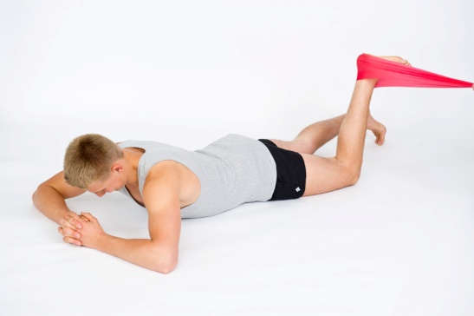 | 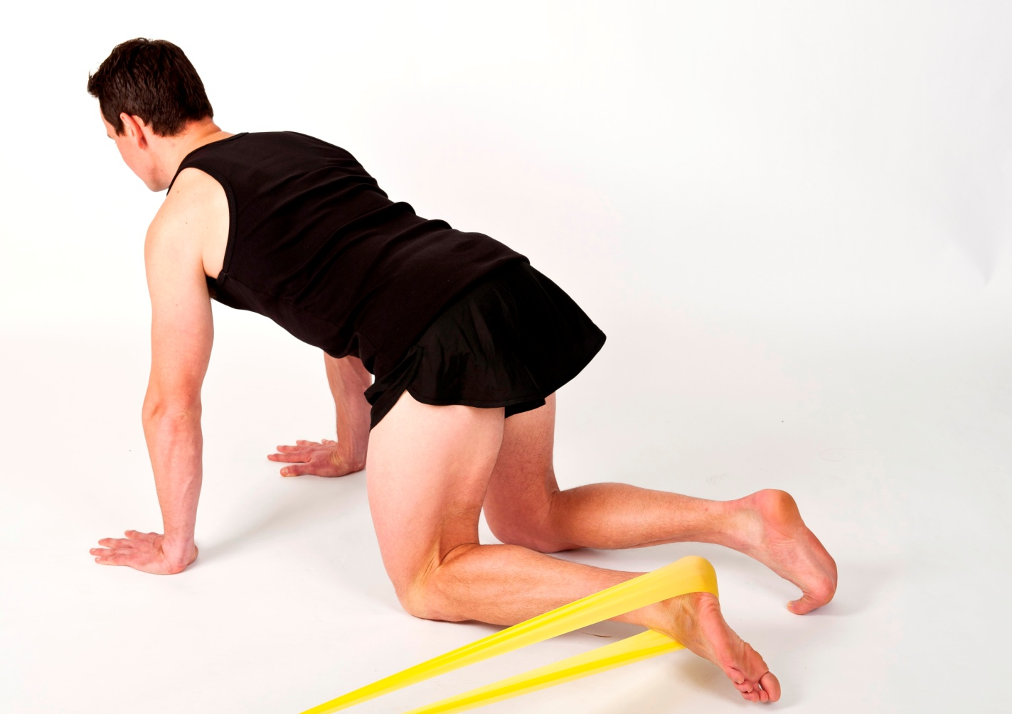
Deep hip rotator strengthening | 20 - 40 reps | Prone Hip ER | Four Point Kneel Hip ER
Deep hip rotator strengthening | 1 - 3 times per day | Start: isometric 5-second hold against band | Start: isometric 5-second hold against band
Deep hip rotator strengthening | 1 - 3 times per day | Progress: concentric-eccentric through range hip ER | Progress: concentric-eccentric through range hip ER
Hip extensor muscle strengthening | Motor control: | 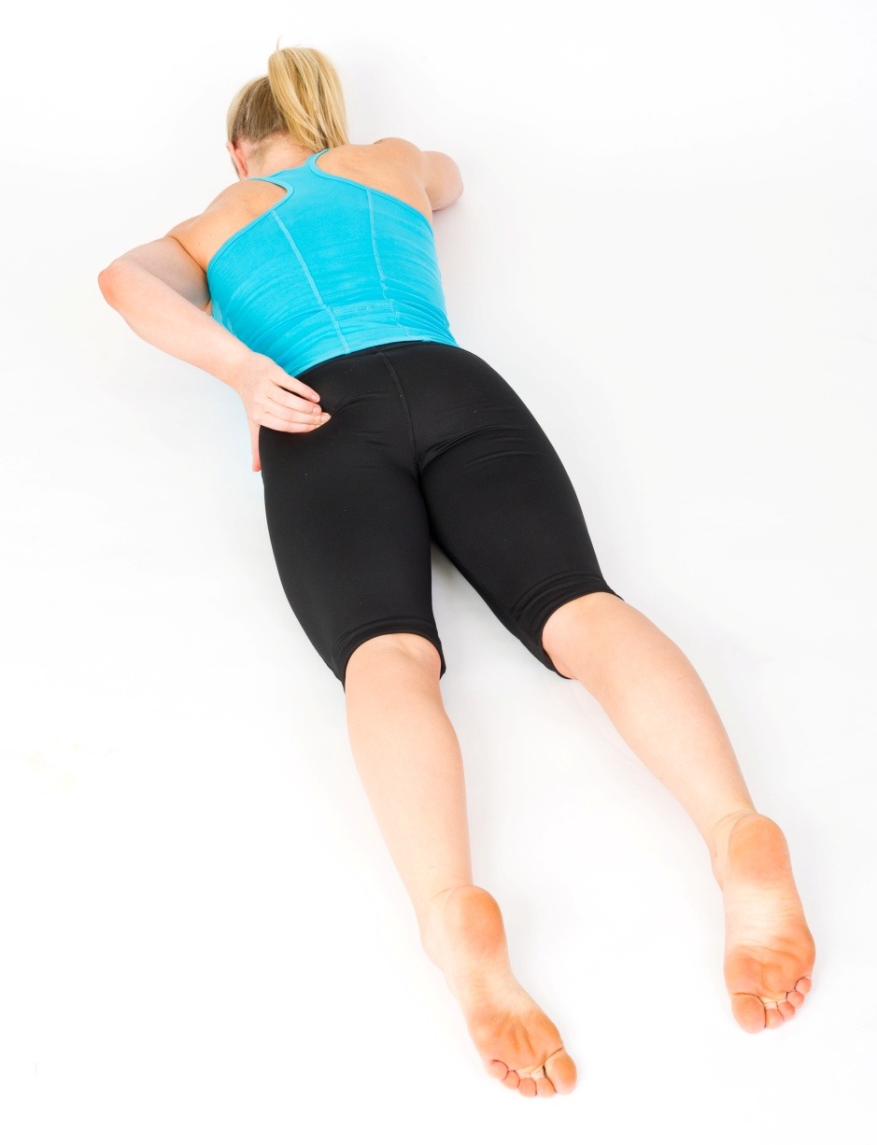 | 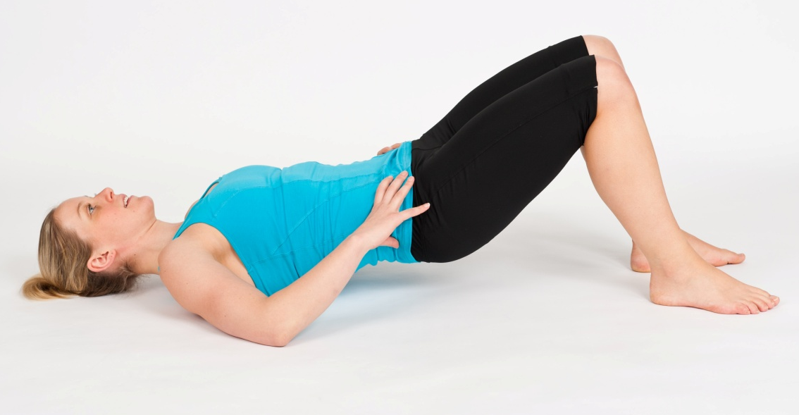 | 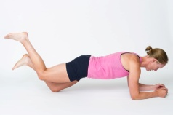 | 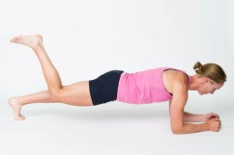
Hip extensor muscle strengthening | 2 - 3 sets | Prone Hip Extension | Bridging | Prone Hold Hip Extension - knees | Prone Hold Hip Extension - toes
Hip extensor muscle strengthening | 20 - 40 reps | Gluteal squeeze and leg extension 3 - 5-second hold and lower | Gluteal squeeze and lift up into bridge position 3 - 5-second hold and lower | From knees move affected leg into hip extension 3 - 5-second hold and lower leg | From toes move affected leg into hip extension 1 - 5-second hold and lower leg
Hip extensor muscle strengthening | 1 - 3 times per day
Hip extensor muscle strengthening | Strength:
Hip extensor muscle strengthening | 1 - 3 sets
Hip extensor muscle strengthening | 6 - 12 reps
Hip extensor muscle strengthening | Once daily
Hip abductor muscle strengthening | Motor control:
Hip abductor muscle strengthening | 2 - 3 sets | 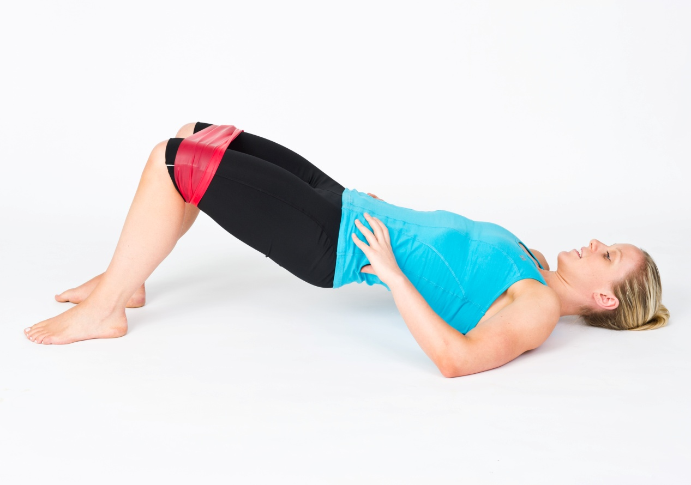 | 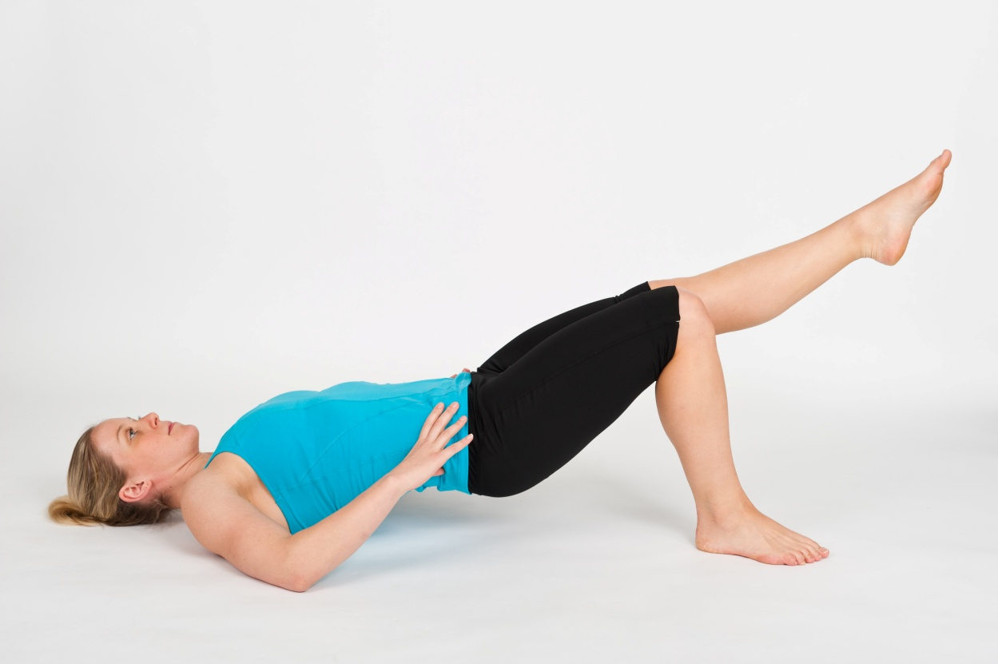 | 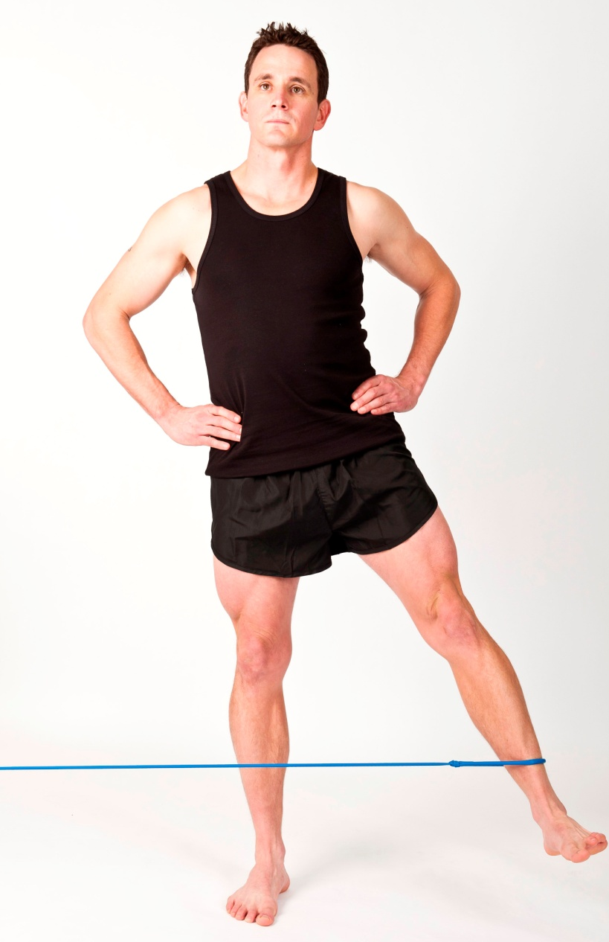 | 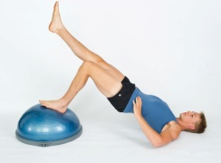
Hip abductor muscle strengthening | 20 - 40 reps | Bridging with Band | Bridge with Leg Extension | Standing Hip Abduction | Bridge with Foot on Unstable Surface
Hip abductor muscle strengthening | 1 - 3 times per day | Bridge with band around knees, gently abduct against band. | Start: lift up with two feet on ground, extend one leg then the other then lower with both legs on ground. | Single leg stance and abduct leg out to side. Keep trunk straight, do not laterally flex. | Keep pelvis level, activate gluteals and lift up
Hip abductor muscle strengthening | Strength:
Hip abductor muscle strengthening | 1 - 3 sets | 3 - 5-second hold and lower | Progression: extend unaffected knee, lift up using affected side, 2 - 5-second hold and lower | Perform both standing and then with band on affected side | Keep pelvis level, activate gluteals and lift up
Hip abductor muscle strengthening | 6 - 12 reps
Hip abductor muscle strengthening | Once daily
Functional strengthening | 2 - 3 sets | 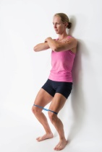 | 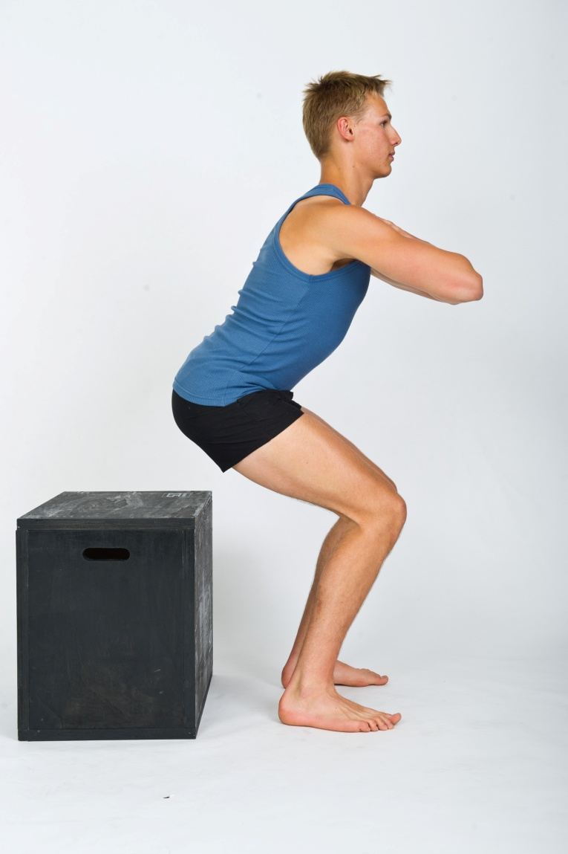 | 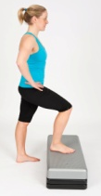 | 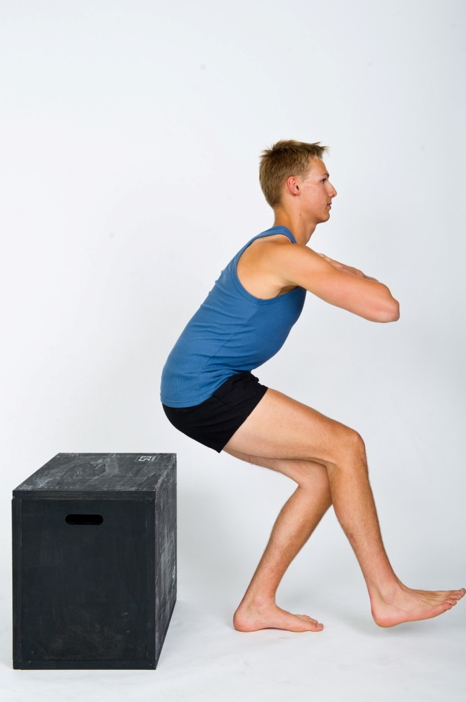
Functional strengthening | 15 - 20 reps
Functional strengthening | Once daily | Wall Slides with Gluteal Activation | Squats | Step Ups | Single Leg Squats
Functional strengthening | Once daily | Band around distal thighs. Slide down wall, activate gluteal muscles at 60 - 90° knee flexion, 5 - 30-second hold then push back up into standing | Flex at hips and squat to comfortable depth, tighten gluteal muscles to return to standing | Affected side on top of step, tighten gluteal muscles to step unaffected side up onto step | Stand on affected side, squat down to comfortable level ensuring adequate hip, knee and ankle alignment. Tighten gluteals to return to standing
Balance exercises | 1 - 3 minutes | 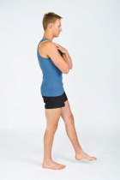 | 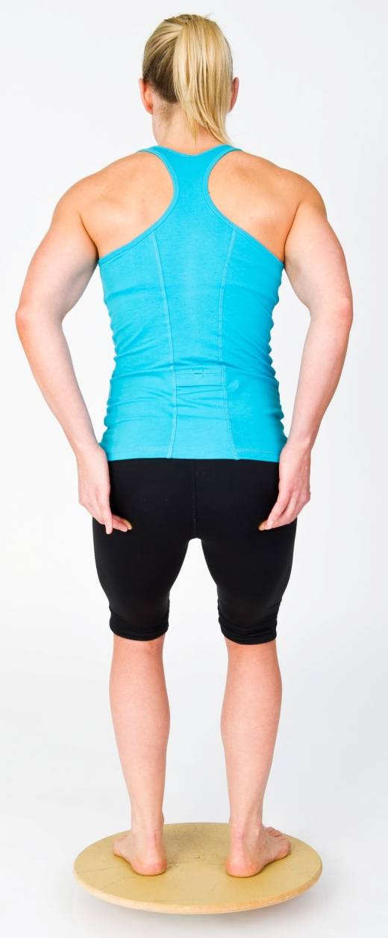 | 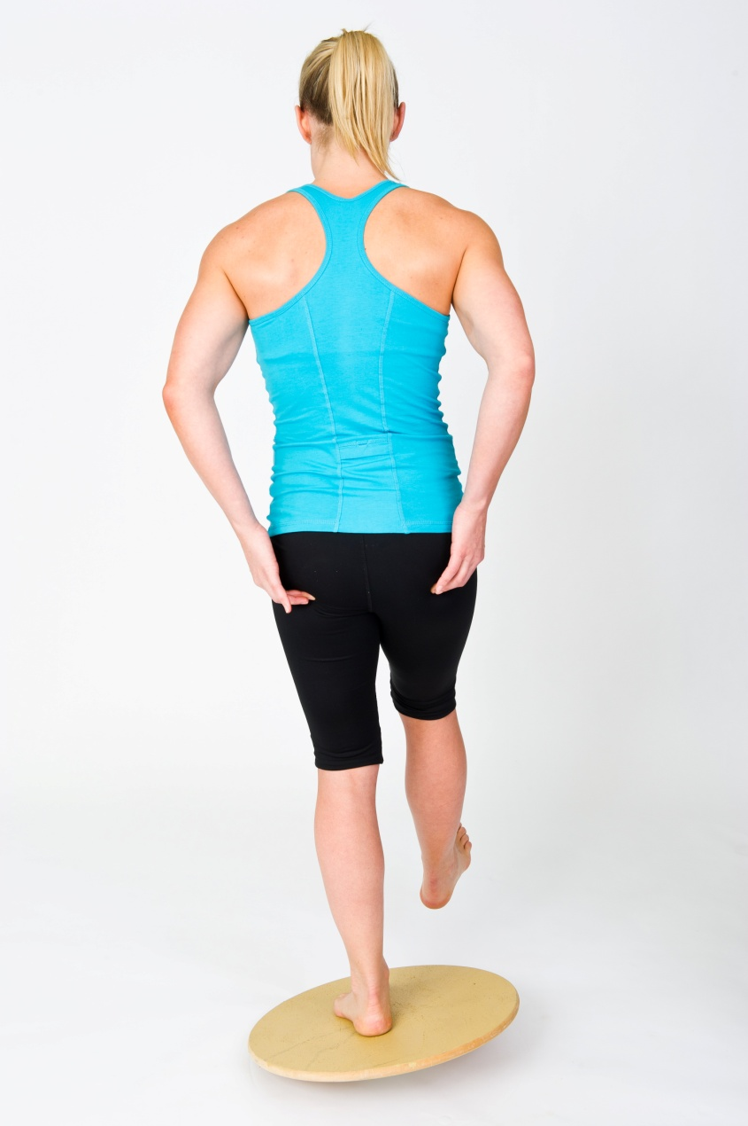 | 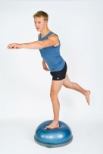
Balance exercises | daily | Single Leg Balancing | Wobble Board with Gluteal Activation | Wobble Board with Gluteal Activation - Single leg | Gluteal Activation with Functional Movements
Balance exercises | daily | Stand on affected leg, ensuring no Trendelenburg sign | Balance on wobble board maintaining gluteal activation | Single leg balance on wobble board, maintaining gluteal activation | Maintain gluteal activation on unstable surface, lean trunk forward and reach with contralateral upper limb
Anterior hip stretch | 1 - 2 minutes | 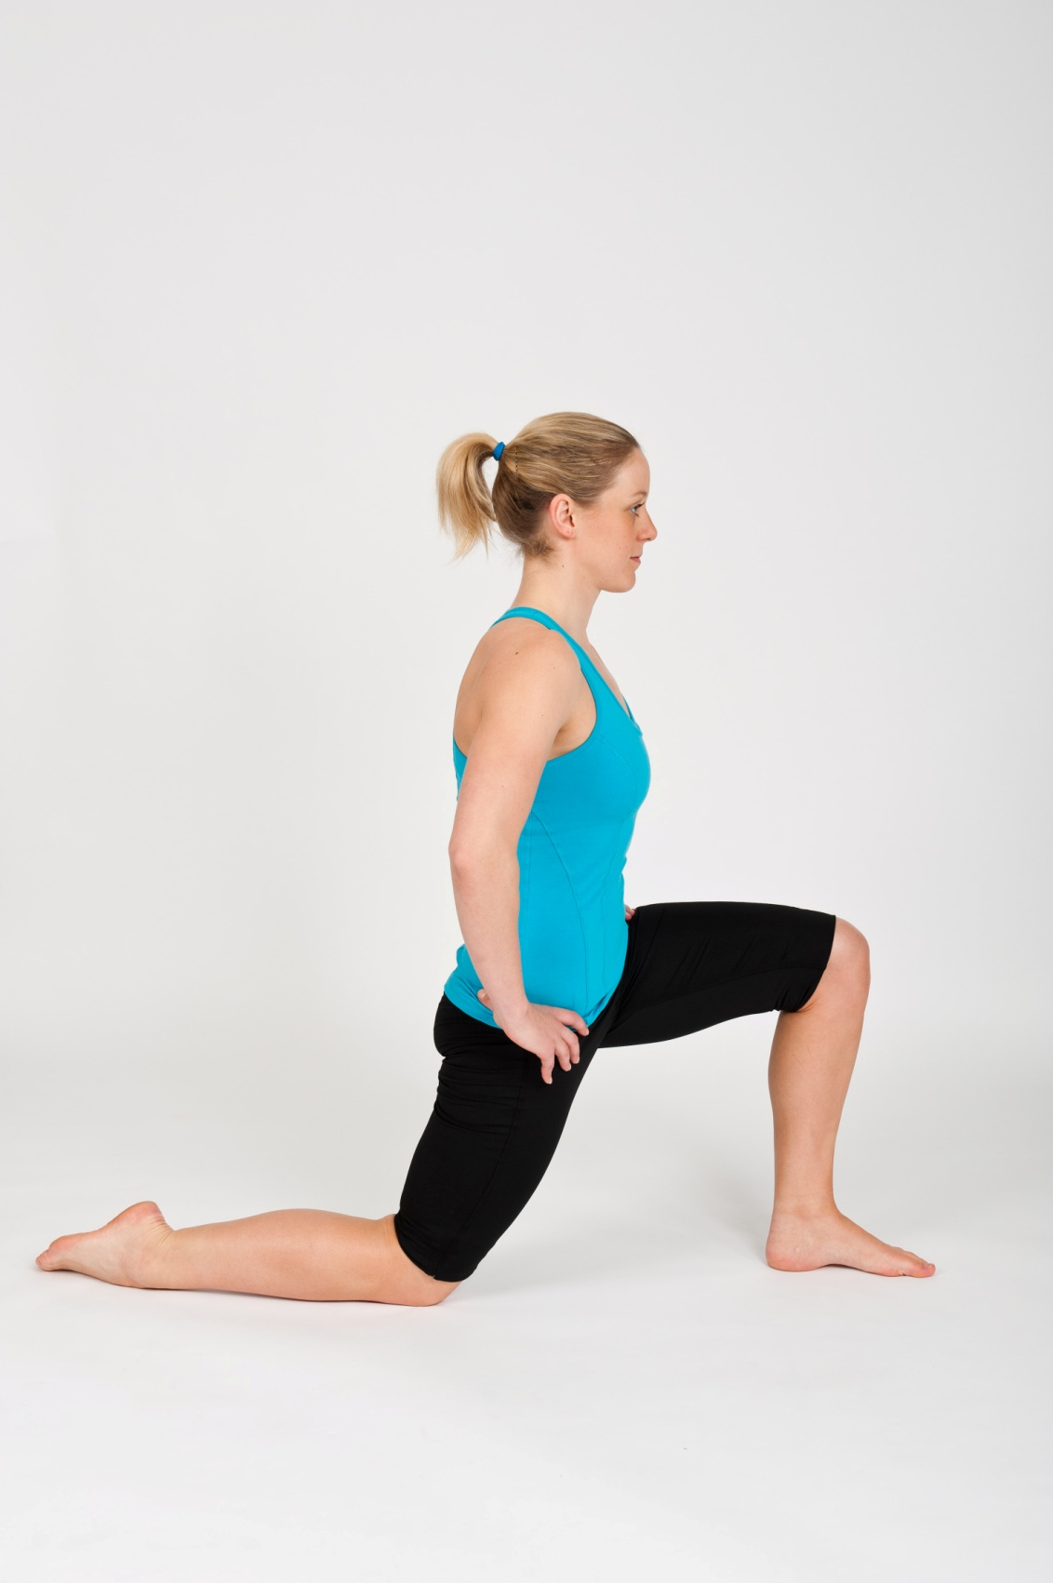
Anterior hip stretch | 1 - 3 times daily | Anterior Hip Stretch
Anterior hip stretch | 1 - 3 times daily | Ensure pelvis is posteriorly tilted, trunk upright and gluteals activated on back leg
Legend: ER = external rotation; IR = internal rotation

