Error estimations of TER-measurement using a Two-compartment model
The trans-capillary escape and re-circulation of the albumin tracer molecule between the plasma and the interstitial compartment was simulated using a 2-compartment model. The time-dependent changes in plasma concentration (C_{p}) and interstitial concentration (C_{i}) were given by
$\frac{dC_{p}}{dt}= -TER∙C_{p}+TRR∙C_{i}-FCR∙C_{p}$ (1)
$\frac{dC_{i}}{dt}= +TER∙C_{p}-TRR∙C_{i}-FCR∙C_{i}$ (2)
where TER (h⁻¹) is the trans-capillary escape rate, TRR (h⁻¹) the ‘re-circulation rate’ of tracer from the interstitial compartment (Ci) and FCR (h⁻¹) is the fractional catabolic rate representing the systemic catabolism (~4%/day) of albumin [2]. The above system of differential equations was solved using a computer algebra system (MAXIMA version 5.26.0) which yielded a bi-exponential expression for the plasma concentration
$C_{p}\left(t\right)= C_{0}\frac{TERe^{-(TER+TRR+FCR)∙t}+TRRe^{-FCR∙t}}{TER+TRR}$ (3)
Here C₀ is the initial plasma concentration (dose/plasma volume). Bolus doses were simulated using a simple step function
$H\left(t\right)=\frac{1}{1+e^{-8t}}$ (4)
The protocol was simulated as three repated bolus doses given at -15 min, +25 and +180 min relative to the start of the albumin infusion (t=0 min) using the equation
$C_{net}\left(t\right)=C_{p}\left(t+15\right)H\left(t+15\right)+C_{p}\left(t-25\right)H\left(t-25\right)+C_{p}\left(t-180\right)H\left(t-180\right)$ (5)
We here assume a “worst case” scenario where the clearances of tracer to and from the extravascular compartment are equal, which, from a mass balance perspective, should represent the maximal TRR possible (meaning that any albumin that is not catabolized will eventually re-enter the circulation). The ratio between plasma and interstitial distribution volumes was assumed to be 1:4, giving a TRR of 3.75% if TER is assumed to be 15%.
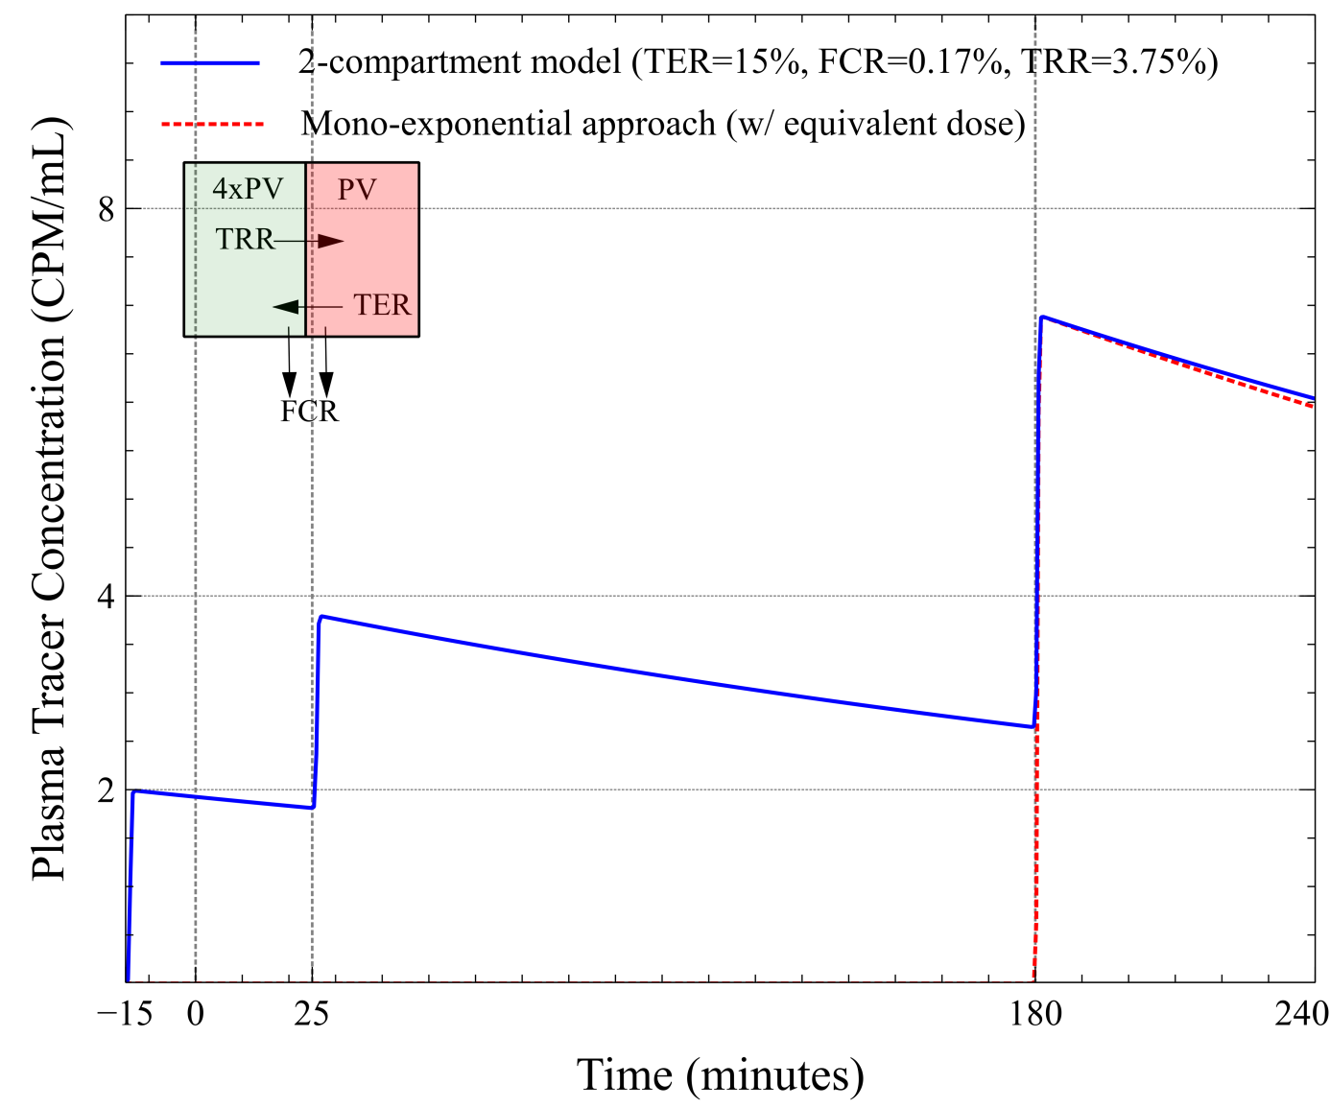
As can be seen in the figure, the mono-exponential approach without re-circulation (red dotted line) gives a small difference (corresponding to a difference in TER <1.0%/h) compared to the model (blue line) even when a large, over-estimated, re-circulation is assumed along with a markedly elevated TER of 15% [1]. Simulations were also performed for TER values of 5% and 10% with negligible differences (< 0.1%/h due to a lower TRR). For example, if the difference between a control group (TER 5%/h) and an intervention group is 200% (TER 15%/h) the difference between the two groups may at most be underestimated by 10% due to re-circulation alone. For differences in TER lower than 100% between the groups, re-circulation will have a negligible effect on the difference between the groups.

References

1. Fleck A, Raines G, Hawker F, Trotter J, Wallace PI, Ledingham IM, and Calman KC. Increased vascular permeability: a major cause of hypoalbuminaemia in disease and injury. Lancet 1: 781-784, 1985.
2. Peters Jr T. All about albumin: biochemistry, genetics, and medical applications. Academic press, 1995.

