Sample size
The sample size was calculated based on our previous data showing that there was no BPAR in MSC treatment group at 6 months after transplantion,compared with 16.7% of acute rejection in the control group[Peng Y, Ke M, Xu L, Liu L, Chen X, Xia W, et al. Donor-derived mesenchymal stem cells combined with low-dose tacrolimus prevent acute rejection after renal transplantation: a clinical pilot study. Transplantation.2013;95(1):161-8]. Based on this preliminary study, we calculated that 44 patients per arm would be required to achieve a power of 90% with a two-sided significance level of p < 0.05. To account for possible dropouts (10%), the target number of patients was, therefore, set at 50 per arm (100 in total)

The calculated formula was as following:
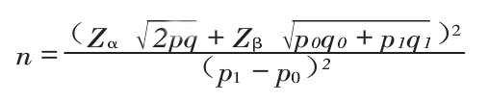

Here, ‘n’ is the number of patients in each arm;
‘Z_{α}’ represents the value of α error；
‘Z_{β}’ represents the value of βerror；
p₀ represents the incidence of acute rejection in control group;
p₁ represents the incidence of acute rejection in treatment group;
q₀ ₌ 1-p₀, q₁₌1-p₁
p= (p₀+p₁)/2, q=1-p

Z_{α}=.1.96, Z_{β}=1.282

To account for possible dropouts (10%), the target number of patients was therefore set at 30 per arm (60 in total).

