Additional File 5: Schedule of Assessments
Study Phase | Transplant and Early Post-operative Phase |  |  |  |  | Follow-up Phase
Study Visit | Baseline | Post-Op | Day 1 | Day 2 | Day 7 | Day 28 | Week 12 | Week 26 | Week 52
Visit Number | 1 | 2 | 3 | 4 | 5 | 6 | 7 | 8 | 9
Timing of visit | On Admission | Arrival at recovery room | 5-9am day after Post-op | 24 hours after  Day 1 | 7 days after Post-Op | 28 days after Post-Op | 84 days after Post-Op | 182 days after Post-Op | 364 days after Post-Op
Timing of visit |  |  |  | (± 120 min) | (± 1 day) | (± 7 days) | (± 7 days) | (± 14 days) | (± 14 days)
Screening | X
Consent | X
Randomization | X
Participant / donor details | X
Use of Immunosuppressant drugs | X |  |  |  | X
Requirement for inotropic support |  |  |  | X
Urine output (last 24 hours) |  |  | X | X | X**
Study Intervention
Intervention fluid volume |  | X | X | X | X**
Non-trial fluids type and volume |  | X | X | X | X**
Outcomes
Dialysis requirement |  |  |  |  | X | X | X
Serum Creatinine |  | X | X | X | X | X | X | X | X
Treatment for hyperkalemia | X | X | X | X | X**
Biopsy requirement |  |  |  |  | X | X
Acute rejection episodes |  |  |  |  | X | X | X | X | X
Quality of life: EQ-5D-5L & EQ-5D-Y | X |  |  |  | X | X | X | X | X
Mortality and graft survival |  | X | X | X | X | X | X | X | X
Serious Adverse Events | X | X | X | X | X
Lab assessments
Haemoglobin, Urea, Electrolytes, Blood pH, Potassium |  | X | X | X
** Only recorded until 48 hours post-op

Timing of visits between Baseline and Day 2
Baseline (visit 1) will occur at the time of randomization. Post-op (visit 2) will occur at the time of arrival to the recovery room after transplant surgery.
For the purposes of subsequent follow-up study assessments, the day that transplant surgery takes place will be designated as day zero. Day 1 post-transplant will commence at 12.00 am (00:00:00 hours; midnight) on the next consecutive day after arrival to the recovery room (i.e. Post-op, visit 2). Assessments for Day 1 (visit 3 in the Table) will be conducted between 5 and 9 am on Day 1, as per local practice for routine collection of laboratory samples. Day 2 post-transplant (visit 4) will commence at 12.00 am the day after Day 1. Assessments for Day 2 (visit 4) will be conducted 24 hours +/- 120 minutes after the assessments on Day 1. Study visits from Day 7 (visit 5) onwards will occur as outlined in Table 5.1.
Two examples of the timing of the study visits on Day 1 and 2 in relation to the timing of transplant surgery and the duration of the intervention are shown in Figure A2.

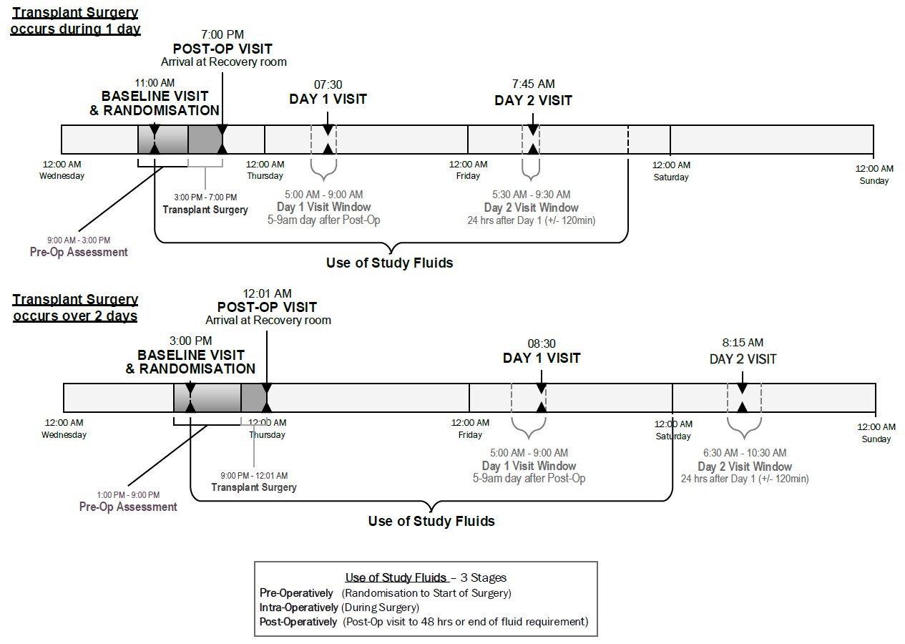

Figure A2. Examples of the timing of Day 1 and Day 2 visits in relation to transplant surgery and the blinded fluid intervention.

