Supplementary file

A) Consent form
B) Food recall
Days | Meals | Time | Food items | Serving | Amount (gr)
Day 1 (working day)
Day 2 (working day)
Day 3 (weekend)

C) Physical activity record
Days | Activity description | Time | Duration | Intensity  (light, moderate, vigorous)
Day 1 (working day)
Day 2 (weekend)

D) 9-point partial Mayo score
Stool Frequency
0 = Normal
1 = 1–2 stools/day more than normal
2 = 3–4 stools/day more than normal
3 = >4 stools/day more than normal
Rectal bleeding*
0 = None
1 = Visible blood with stool less than half the time
2 = Visible blood with stool half of the time or more
3 = Passing blood alone
Physician rating of disease activity
0 = Normal
1 = Mild
2 = Moderate
3 = Severe
*A score of 3 for bleeding required patients to have at least 50% of bowel motions accompanied by visible blood and at least one bowel motion with blood alone
The 9-point partial Mayo score was designed by Sutherland et al. (29)

E) Inflammatory bowel disease questionnaire-9 (IBDQ-9) for quality-of-life assessment
Items | Scores
Items | 1 | 2 | 3 | 4 | 5 | 6 | 7
How frequent have your bowel movements been during the last 2 wk? | Bowel movements as or more frequent than they have ever been | Extremely frequent | Very frequent | Moderate increase in frequency of bowel movements | Some increase in frequency of bowel movements | Slight increase in frequency of bowel movements | Normal, no increase in frequency of bowel movements
How often has the feeling of fatigue or of being tired and worn out been a problem for you during the last 2 wk? | All of the time | Most of the time | A good bit of the time | Some of the time | A little bit of the time | Hardly any of the time | None of the time
How much energy have you had during the last 2 wk? | Most energy felt in years | Much more than usual | Slight increase | About the same | Slight decrease | Much less than usual | Wiped out
How often during the last 2 wk have you had to delay or cancel a social engagement because of your bowel problem? | All of the time | Most of the time | A good bit of the time | Some of the time | A little bit of the time | Hardly any of the time | None of the time
How often during the last 2 wk have you been troubled by cramps in your abdomen? | All of the time | A few times a day | Once a day | Every other day | Once/week | Twice/week | Never
How often during the last 2 wk have you felt generally unwell? | All of the time | Most of the time | A good bit of the time | Some of the time | A little bit of the time | Hardly any of the time | None of the time
Overall, in the last 2 wk, how much of a problem have you had with passing a large amount of gas? | A major problem | A big problem | A significant problem | Some trouble | A little trouble | Hardly any trouble | No trouble
How much of the time during the last 2 wk have you been troubled by feeling nauseated or sick to your stomach? | All of the time | Most of the time | A good bit of the time | Some of the time | A little bit of the time | Hardly any of the time | None of the time
How satisfied, happy, or pleased have you been with your personal life during the last 2 wk? | Very dissatisfied, unhappy mostly | Generally dissatisfied, unhappy | Somewhat dissatisfied, unhappy | Generally satisfied, pleased | Satisfied most of the time, happy | Very satisfied most of the time, happy | Extremely satisfied, could not have been more happy or pleased

F) Inflammatory bowel disease disability index (IBD-DI)

G) Hospital Anxiety and Depression Scale (HADS)
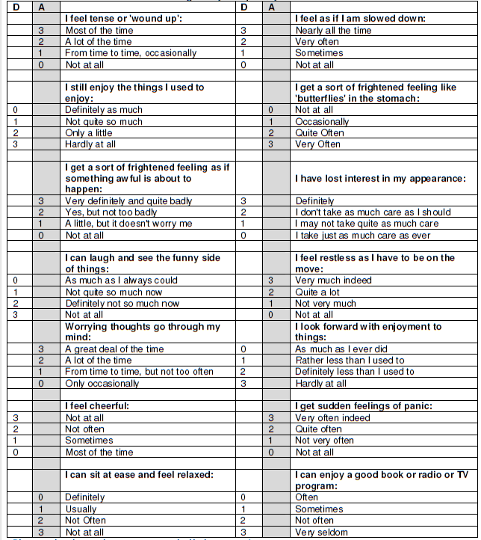

H) General Health Questionnaire (GHQ 12)

Have you recently?
Questions | Answer options
Been able to concentrate on what you’re doing? | Better than usual | Same as usual | Less than usual | Much less than usual
Lost much sleep over worry? | Not at all | No more than usual | Rather more than usual | Much more than usual
Felt you were playing a useful part in things? | More so than usual | Same as usual | Less useful than usual | Much less useful
Felt capable of making decisions about things? | More so than usual | Same as usual | Less so than usual | Much less capable
Felt constantly under strain? | Not at all | No more than usual | Rather more than usual | Much more than usual
Felt you couldn’t overcome your difficulties? | Not at all | No more than usual | Rather more than usual | Much more than usual
Been able to enjoy your normal day-to-day activities? | More so than usual | Same as usual | Less so than usual | Much less than usual
Been able to face up to your problems? | More so than usual | Same as usual | Less so than usual | Much less able
Been feeling unhappy and depressed? | Not at all | No more than usual | Rather more than usual | Much more than usual
Been losing confidence in yourself? | Not at all | No more than usual | Rather more than usual | Much more than usual
Been thinking of yourself as a worthless person? | Not at all | No more than usual | Rather more than usual | Much more than usual
Been feeling reasonably happy, all things considered | More so than usual | About same as usual | Less so than usual | Much less than usual;

