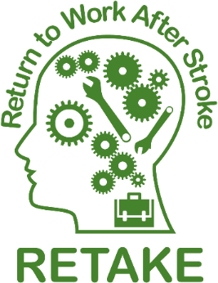

Participant ID (Site no. / trial no.): | Participant Initials:
Participant Date of Birth: | Participant NHS/Hospital Number:
Principal Investigator:

RETAKE – RETurn to work After stroKE

CONSENT FORM

The following statements are MANDATORY
You need to agree to all of them to take part in the study
 |  |  |  |  |  | Please [X] each box 
1 |  |   I have read the information about the research  (Participant Information Sheet dated 18/02/2020  (version 2.0)) |  |  |  | 
2 |  |   I have had the chance to ask questions about the research.  I have had the opportunity to consider the information, ask questions and have had these answered satisfactorily.
3 |  |   I am happy with the answers to my questions.
4 |  |   I understand that I can stop being in the research at any time.
5 |  |   If I stop, I do not have to give a reason and I will still get my normal care.
6 |  |   If I stop being in the research, information already collected about me will still be used.
7 |  |   I understand that the research teams and other people may see information collected about me for this research to check that the research is being completed properly  I am happy for this to happen
8 |  |   I understand that my information may be shared with other people (e.g. the Department for Work and Pensions) to ask whether or not I am working.
9 |  |  |  | I understand that the research team may share  my results with other  researchers, but not use my name
10 |  | 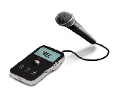 |  | I understand that a  researcher may ask to  watch some of the care I get  and  ask me some questions about the treatment and services I have had.
11 |  |  |  | I understand that my  contact information will be  sent to the Research Office in Leeds so I can be sent the  questionnaire booklets
12 |  |  |  | I understand that  a copy of this consent form  (including my name and date of birth)  will be stored by the Research Office in Leeds  for study purposes
13 |  |  |  | I understand that my doctor  will be told that  I am taking part in  research
14 |  |  |  | I agree to take part in the above study.
The following statement is important but OPTIONAL
Even if you agree to take part in this study, you do not have to agree to this section
15 |  |  | If I get the return to work help I am happy for the therapist to talk to my employer if I agree.

Participant
Signature:

Name (block capitals):

Date:
Day / Month / Year
………. / ….….... / ………..…

Witness (if required)
Signature:
Name (block capitals):
Day / Month / Year
………. / ….….... / ………..…
Date:

Person taking consent
I have explained the study to the above named participant and he/she has indicated his/her willingness to participate.
Signature:
Name (block capitals):
Day / Month / Year
………. / ….….... / ………..…
Date:

(1 copy for patient; 1 for the CTRU; 1 held in patient notes, original stored in Investigator Site File)



