Additional Table 2 | STOMA diet levels.
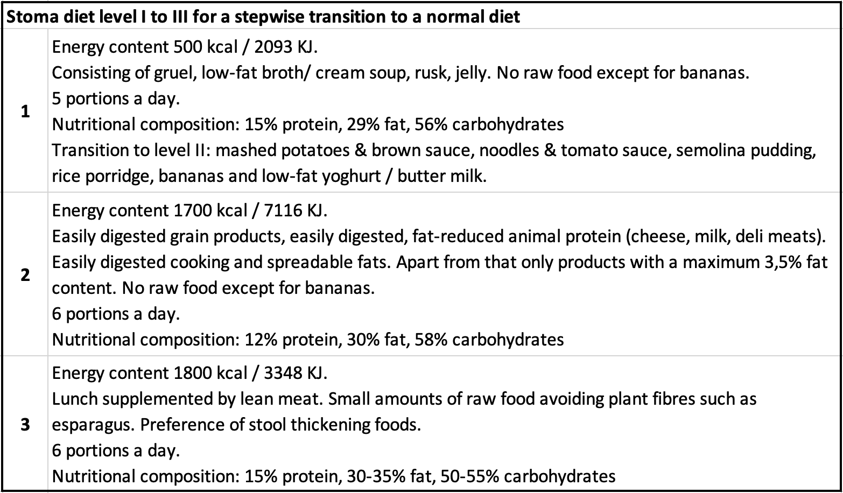
A scheme of a stepwise transition to a normal diet after visceral surgery according to in-house-standards of the University Hospital of Heidelberg.

