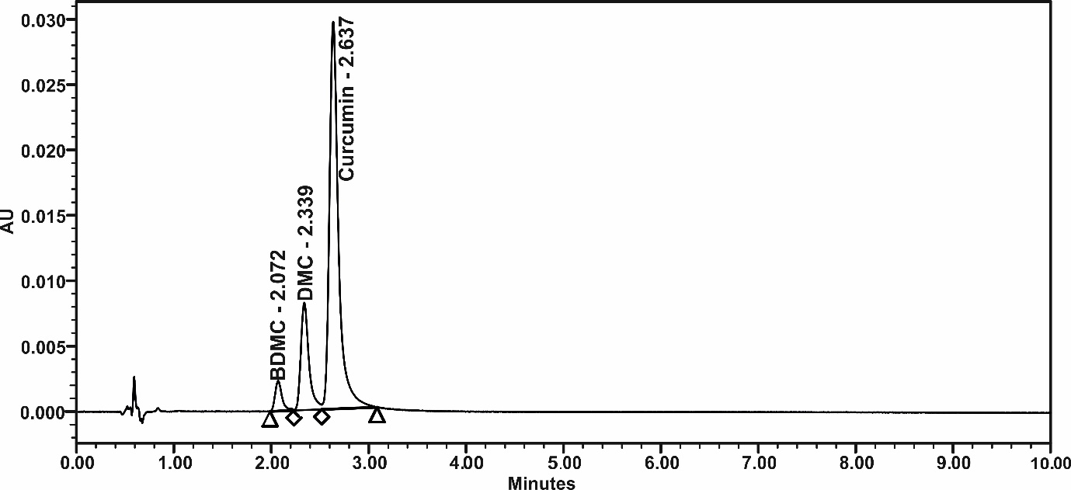
UPLC chromatogram of bioavailable turmeric extract (BCM-95®)
(curcumin eluted at 2.637 min, demethoxycurcumin (DMC) eluted at 2.339 min and bisdemethoxycurcumin (BDMC) eluted at 2.072 min)

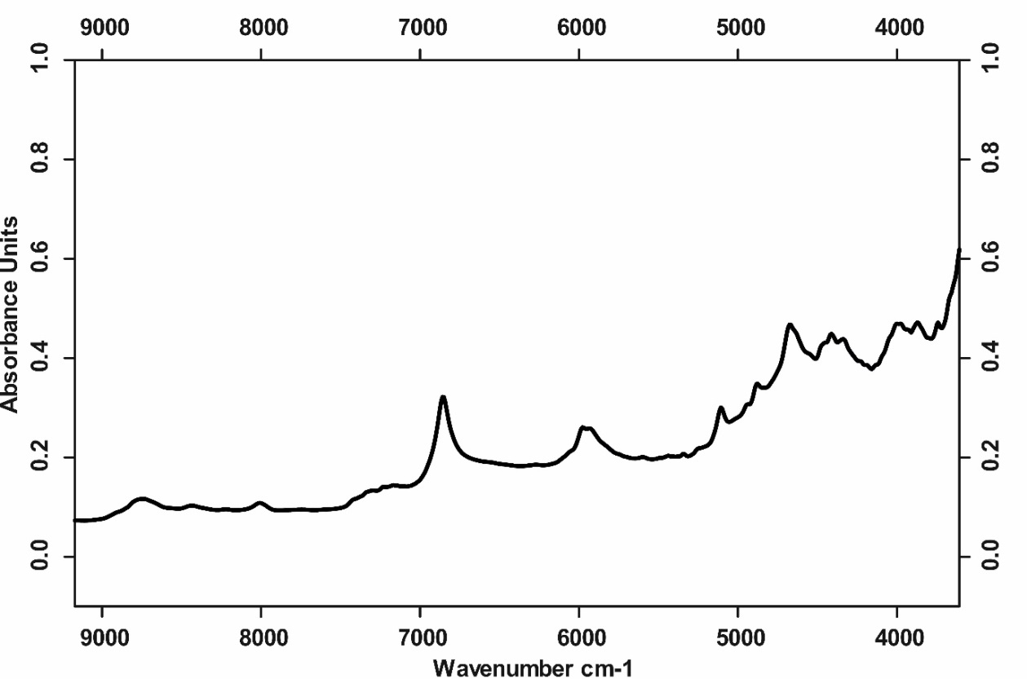
FT-NIR graph of bioavailable turmeric extract (BCM-95®)

