SAGAT participant query form scenario 1

Level 1 (perception)

- Please indicate on the figure below and next to each pictured individual, the letter corresponding to the role played by that team member:

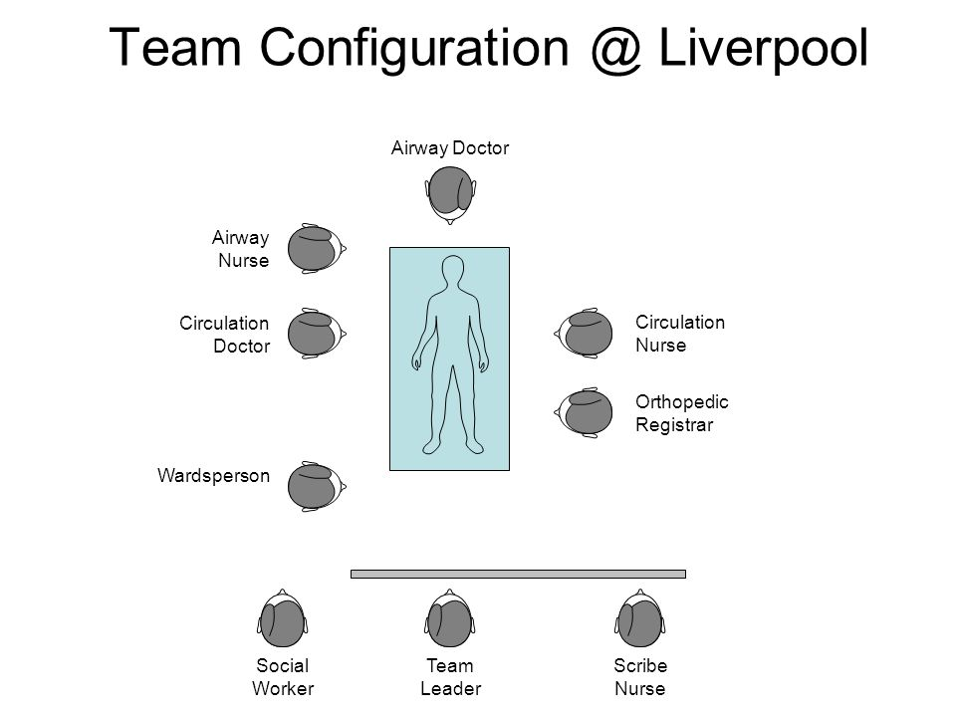
- Physician 1 - assessment

- Physician 2 – team leader

- Airway specialist / Anesthetist

- Nurse 1 – monitoring and procedures

- Nurse 2 – circulation and drug preparation

- Nurse 3 - scribe

- Please state your assessment of the patient’s airway patency:
- Opened
- Threatened
- Obstructed
- I don’t know

- Please state your assessment of the patient’s work of breathing:
- Normal work of breathing
- Increased work of breathing
- Respiratory failure
- I don’t know

- Please state your assessment of the last displayed oxygen saturation:
- >94%
- 90-94%
- <90 %
- Not available
- I don’t know

- Please state your assessment of the patient’s circulation:
- Normal circulation
- Decreased circulation, without circulatory failure
- Circulatory failure
- I don’t know

- Please indicate the last displayed heart rate of the patient:
- 0/min
- <60/min
- 60-100/min
- >100/min
- I don’t know

- Please indicate the systolic blood pressure of the patient:
- 0 mmHg
- > 0 but < 70 mmHg
- > 70 mmHg
- I don’t know

- Please state your assessment of the patient’s consciousness
- Alert
- Responsive to verbal stimuli
- Responsive to pain
- Unresponsive
- I don’t know

- Please state your assessment of the patient’s pupils:
- Constricted
- Normal, responsive to light
- Unilaterally dilated
- I don’t know

- What was the last manual defibrillator setting?
- Defibrillation mode, energy dose 6-12 Joules
- Defibrillation mode, energy dose 24 Joules
- Defibrillation mode, energy dose 48 Joules
- Synchronized cardioversion mode, energy dose 6-12 Joules
- Transcutaneous pacing mode, pacing rate 100/min

- What is the patient’s heart rhythm?
- Sinusal
- Asystole
- Pulseless electrical activity (PEA)
- Pulseless ventricular tachycardia (pVT)
- Ventricular fibrillation (FV)
- I don’t know

- How many times has the patient been defibrillated so far?
- 0
- 1
- 2
- 3
- 4
- I don’t know

- How many times has the patient received epinephrine so far?
- 0
- 1
- 2
- 3
- 4
- I don’t know

- Which drug has been delivered to the patient so far?
- epinephrine
- amiodarone
- epinephrine and amiodarone
- adenosine
- none of the above
- I don’t know

- How many Joules have been delivered to the patient for the last defibrillation?
- 6
- 12 J
- 24 J
- 48 J
- > 48 J
- I don’t know

- Has help from a specialist been discussed and requested?
- yes
- no
- I don’t know

- What is the medical equipment already in place on the patient?
- Monitoring
- Monitoring + IV/IO access
- Monitoring + IV/IO access + defibrillator patches
- Monitoring + IV/IO access + defibrillator patches + ECG leads
- Monitoring + IV/IO access + defibrillator patches + ECG leads + C-spine protection
- I don’t know

- What is the patient’s last measured temperature?
- < 36°C
- 36 - 36.5°C
- 36.5 - 37.0°C
- 37.0 - 37.5°C
- > 37.5°C
- I don’t know

19. Which part of the primary survey was the last one to be evaluated?
- Airways (A)
- Breathing (B)
- Circulation (C)
- Disability (D)
- Exposure (E)
- I don’t know

20. Which PALS algorithm is currently used by your team?
- Bradycardia
- Tachycardia with a pulse and adequate perfusion
- Tachycardia with a pulse and poor perfusion
- Cardiac arrest
- I don’t know

21. Which cardiac arrest algorithm is currently used by your team?
- Asystole
- Pulseless electrical activity (PEA)
- Pulseless ventricular tachycardia (pVT)
- Ventricular fibrillation (FV)
- I don’t know

22. How long has it been since CPR was initiated?
- < 5 min
- 5 – 10 min
- 11 – 15 min
- > 15 min
- I don’t know

23. Is there any CPR algorithm projected on the screen?
- Yes
- No

Level 2 (comprehension)

1. What is the primary problem of the patient?
- Airway
- Breathing
- Circulation
- Disability
- Rhythm disturbances
- A combination of 2 or more of the above-mentioned
- I don’t know

2. Please state your diagnosis (most urgent problem to treat for this patient)?
- Asystole
- Sepsis
- Hypovolemic shock due to a hemorrhage
- pVT
- Major brain injury with delayed loss of consciousness
- VF
- SVT with poor perfusion
- Intoxication
- Suspected parental neglect
- I don’t know

3. Is the patient adequately oxygenated?
- Yes
- No
- I don’t know

- What is the cause of the respiratory failure?
- Upper airway obstruction
- Lower airway obstruction
- Lung parenchymal disease
- Disordered control of breathing
- I don’t know

5. What is the hemodynamic status of the patient?
- Normal hemodynamic parameters
- Compensated shock
- Hypotensive shock
- I don’t know

6. What is the respiratory status of the patient?
- Normal
- Respiratory distress
- Respiratory failure
- Apneic
- I don’t know

- What kind of shock does the patient suffer from?
- The patient is not in shock
- Hypovolemic shock
- Distributive shock
- Cardiogenic shock
- Obstructive shock
- I don’t know

8. What is the current trajectory of the patient?
- No change
- Improving
- Getting worse
- I don’t know

Level 3 (projection)

1. Who is the team leader at this point?

2. Which action needs to be prioritized at this point?
- To deliver a shock
- To administer a drug
- To ensure post-resuscitation (ROSC) care
- To call the cardiologist
- I don’t know

3. Which drugs are required to treat the patient’s current most urgent issue?
- Adenosine 0.1 mg/kg rapid IV bolus and amiodarone 5 mg/kg
- Epinephrine 0.1 mL/kg (0.1 mg/ml concentration) and amiodarone 5 mg/kg
- Epinephrine 0.1 mL/kg (0.1 mg/ml concentration) and atropine 0.02 mg/kg
- Adenosine 0.1 mg/kg rapid IV bolus and atropine 0.02 mg/kg
- I don’t know

4. Is the team complete at this point or do any other health care professionals still need to be notified? If so, which professional needs to be included in the team?
- Pneumologist
- Anesthetist
- Pediatric intensive care unit physician
- None
- I don’t know

5. If the patient’s condition does not improve, what is susceptible to happen to the heart rhythm?
- To progress toward asystole
- To progress toward PEA
- To progress toward pVT
- To progress toward SVT with poor perfusion
- To progress toward VF
- To progress toward sinus rhythm
- I don’t know

6. If the condition does not improve, what is susceptible to happen to the blood pressure?
- No change
- To increase continuously
- To decrease continuously
- To fluctuate
- I don’t know

7. What medication may still be required at the next step?
- Epinephrine
- Amiodarone
- Succinylcholine
- Atropine
- Ketamine
- I don’t know

8. Please state your assessment of overall team function (1 [very poor] to 10 [excellent teamwork]

1 - 2 - 3 - 4 - 5 - 6 - 7 - 8 - 9 - 10

SAGAT participant query form scenario 2

Level 1 (perception)

- Please indicate on the figure below and next to each pictured individual, the letter corresponding to the role played by that team member:

- Physician 1 - assessment

- Physician 2 – team leader

- Airway specialist / Anesthetist

- Nurse 1 – monitoring and procedures

- Nurse 2 – circulation and drug preparation

- Nurse 3 - scribe

- Please state your assessment of the patient’s airway patency:
- Opened
- Threatened
- Obstructed
- I don’t know

- Please state your assessment of the patient’s spine immobilization:
- C-spine secured by a cervical collar
- C-spine NOT neither secured by a cervical collar nor manually
- C-spine manually secured by maintaining the head aligned
- I don’t know

- Please state your assessment of the last displayed oxygen saturation:
- >94%
- 90-94%
- <90
- Not available
- I don’t know

- Please state your assessment of the patient’s circulation:
- Normal circulation
- Decreased circulation, without circulatory failure
- Circulatory failure
- I don’t know

- Please indicate the last displayed heart rate of the patient:
- 0/min
- <60/min
- 60-100/min
- >100/min
- I don’t know

- Please indicate the systolic blood pressure of the patient:
- 0 mmHg
- > 0 but < 70 mmHg
- > 70 mmHg
- I don’t know

- Please state your assessment of this patient’s consciousness:
- Alert
- Responsive to verbal stimuli
- Responsive to pain
- Unresponsive
- I don’t know

- Please state your assessment of the patient’s pupils:
- Constricted
- Normal, responsive to light
- Unilaterally dilated
- I don’t know

- Please state your assessment of the patient’s Glasgow coma scale:
- 15/15
- 9 to14/15
- 4 to 8/15
- 3/15
- I don’t know

- What is the current pulse rate range of the patient?
- Normal range
- Bradycardia
- Tachycardia
- No pulse
- I do not know

- How much intravenous crystalloids (in millilitres) has already been administered to the patient?
- 10 ml/kg
- 20 ml/kg
- 40 ml/kg
- 60 ml/kg
- I don’t know

- Has the patient received any blood transfusions?
- yes
- no
- I don’t know

- Has help from a specialist been discussed and requested?
- yes
- no
- I don’t know

- What is the medical equipment already in place on the patient?
- Monitoring
- Monitoring + IV/IO access
- Monitoring + IV/IO access + C-spine protection
- Monitoring + IV/IO access + C-spine protection+ pelvic binder
- I don’t know

- What is the patient’s last measured temperature?
- < 36°C
- 36 - 36.5°C
- 36.5 - 37.0°C
- 37.0 – 37.5°C
- > 37.5°C
- I don’t know

17. Which part of the primary survey was the last one to be evaluated?
- Airways (A)
- Breathing (B)
- Circulation (C)
- Disability (D)
- Exposure (E)
- I don’t know

18. What exam has already been ordered (multiple answer question)?
- Blood typing and cross-match
- Chest X-ray
- Pelvic and femur X-rays
- FAST
- CT-scan
- I don’t know

19. Which part of the body has been injured (multiple answer question)?
- Head
- Thorax
- Abdomen
- Limbs
- Polytrauma (≥ 2 major systems)
- I don’t know

20. How long has it been since CPR was initiated?
- < 5 min
- 5 – 10 min
- 11 – 15 min
- > 15 min
- I don’t know

21. Has any bone fracture(s) already been noticed?
- Yes: single, closed
- Yes: single, open
- Yes: multiple, open
- Yes: multiple, closed
- None seen or suspected
- I don’t know

22. Is there any CPR algorithm projected on the wall?
- Yes
- No

Level 2 (comprehension)

1. What is the primary problem of the patient?
- Airway
- Breathing
- Circulation
- Disability
- Rhythm disturbances
- Some of the above combined
- I don’t know

2. Please state your diagnosis (most urgent problem to treat for this patient)?
- Asystole
- Sepsis
- Hypovolemic shock due to a hemorrhage
- pVT
- Major brain injury with delayed loss of consciousness
- VF
- SVT with poor perfusion
- Intoxication
- Suspected parental neglect
- I don’t know

3. What is the current life-threatening issue in the patient?
- Hemothorax
- Tension pneumothorax
- Abdominal/pelvic hemorrhage
- Limb fracture with massive blood loss
- Closed head injury
- I don’t know

4. Is the patient adequately oxygenated?
- Yes
- No
- I don’t know

5. Is fluid resuscitation sufficient?
- Yes
- No
- I don’t know

6. What is the hemodynamic state of the patient?
- Normal hemodynamic parameters
- Compensated shock
- Hypotensive shock
- I don’t know

7. What kind of shock does the patient suffer from?
- Not in shock
- Hypovolemic shock
- Distributive shock
- Cardiogenic shock
- Obstructive shock
- I don’t know

8. What is the current trajectory of the patient?
- No change
- Improving
- Getting worse
- I don’t know

Level 3 (projection)

1. Who is the team leader at this point?

2. Which action needs to be prioritized at this point?
- Mask/bag ventilation
- Fluid resuscitation
- CT-scan
- Surgery
- I don’t know

3. Is the team complete at this point or do any other health care professionals still need to be notified? If so, which specialist should be included in the resuscitation team in priority?
- Trauma surgeon
- Neurosurgeon
- Pneumologist
- Pediatric intensive care unit physician
- None
- I don’t know

4. If the condition does not improve, what will happen to the heart rate?
- Increase
- No change
- Decrease
- I don’t know

5. If the condition does not improve, what will happen to the blood pressure?
- Increase
- No change
- Decrease
- I don’t know

6. What investigations may be required?
- Chest X-ray, facial X-ray and kidneys ultrasonography
- Chest CT-scan and legs X-ray
- Diagnostic peritoneal lavage
- Abdominal ultrasonography, total body CT-scan
- Hemoglobin measurement
- I don’t know

7. What intervention may be required?
- Hemothorax drainage
- Crystalloids volume expansions, blood transfusion, surgery
- 30-min electroencephalography recordings
- Immediate transfer to the surgical unit for monitoring
- Albumin infusion
- I don’t know

8. Please state your assessment of overall team function (1 [very poor] to 10 [excellent teamwork])

1 - 2 - 3 - 4 - 5 - 6 - 7 - 8 - 9 - 10

Adapted from M.S. Crozier et al [1] and 2018 ATLS 10th ed Student Course Manual [2].

References:

1. Crozier MS, Ting HY, Boone DC, O'Regan NB, Bandrauk N, Furey A, et al. Use of human patient simulation and validation of the Team Situation Awareness Global Assessment Technique (TSAGAT): a multidisciplinary team assessment tool in trauma education. J Surg Educ. 2015;72(1):156-63. doi: 10.1016/j.jsurg.2014.07.009.
2. Henry S, Brasel K, Stewart RM. Student Course Manual Advanced Trauma Life Support ATLS. 10th ed: ACS American College of Surgeons; 2018.

