Supplementary file 1- The process of designing and producing the BPMAP application and interface of app

The study was arranged in five steps (fig 1). 1-Defining the conceptual framework, bearing in mind the system’s properties and development of appropriate content, 2-Approving the conceptual framework and system of delivery, 3-Arrangement and adjustment of the conceptual framework and content (tailoring), bearing in mind the users’ characteristics, 4-Performance assessment, and, 5-Data collection and analysis. During the first to 4th step, the software has been developed and debugged. In the 5th step, a clinical trial was conducted through the controlled randomized clinical trial.
The interface of the application and some of the pages (Persian)
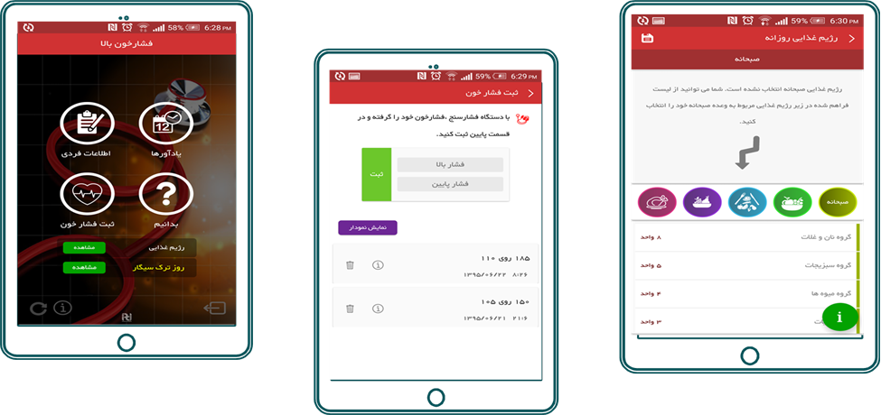
a b c

Smartphone application: a- the home screen of BPMAP, b- The record of BP measurement c- Writing a dash diet page

