Supplementary material

Table of Contents
Appendix I 2
Appendix II: Intervention type and primary purpose of study 4
Appendix III 5
Appendix IV 6

Appendix I
Table 1: Summary of completed studies with results for all the countries
Country | ISRCTN |  | CT.Gov |  | PACTR
Country | Completed  studies | Results  available | Completed  studies | Results  available | Completed  studies | Results  available
Angola | 3 | 0 | - | - | - | -
Benin | 5 | 3 | 12 | 2 | - | -
Botswana | - | - | 15 | 5 | - | -
Burkina Faso | 10 | 6 | 47 | 12 | 6
Burundi | 1 | 0 | 9 | 0 | - | -
Cameroon | 7 | 5 | 21 | 2 | 7
Central African Republic | - | - | 2 | 0 | - | -
Chad | - | - | 3 | 0 | - | -
Congo | - | - | 18 | 3 | - | -
Cote d'Ivoire | 12 | 9 | 14 | 0 | 1
DR Congo | 6 | 3 | 20 | 1 | 3
Equatorial Guinea | - | - | 3 | 0 | - | -
Eritrea | - | - | 1 | 0 | - | -
Eswatini | - | - | 8 | 0 | - | -
Ethiopia | 14 | 7 | 52 | 4 | 18 | 6
Gabon | - | - | 10 | 1 | - | -
Gambia | 11 | 7 | 23 | 5 | 4
Ghana | 17 | 8 | 46 | 7 | 8 | 2
Guinea | 3 | 2 | 6 | 2 | 2 | 0
Guinea Bissau | 2 | 0 | 2 | 1 | - | -
Kenya | 40 | 19 | 193 | 31 | 73 | 10
Lesotho | 1 | 0 | 5 | 0 | - | -
Liberia | - | - | 6 | 1 | - | -
Madagascar | 2 | 1 | 4 | 0
Malawi | 36 | 25 | 71 | 22 | 14 | 2
Mali | 6 | 2 | 36 | 3 | 5 | 0
Mauritius | 1 | 1 | 14 | 3 | - | -
Mozambique | 3 | 2 | 21 | 3 | - | -
Namibia | - | - | 1 | 0 | - | -
Niger | 3 | 1 | 6 | 0 | 1
Nigeria | 31 | 17 | 61 | 9 | 155 | 10
Rwanda | 3 | 0 | 41 | 5 | 4 | 0
Senegal | 2 | 2 | 28 | 6 | 10 | 0
Sierra Leone | 4 | 1 | 17 | 3 | 1 | 0
Somalia | 2 | 1 | 1 | 0 | - | -
South Africa | 50 | 27 | 279 | 64 | 125 | 9
South Sudan | 1 | 1 | - | - | - | -
Sudan | 7 | 1 | 9 | 0 | 3 | 0
Tanzania | 30 | 21 | 100 | 12 | 18 | 0
Togo | 2 | 1 | 2 | 1 | - | -
Tunisia | - | - | - | - | 12 | 0
Uganda | 46 | 34 | 154 | 20 | 49 | 1
Zambia | 18 | 12 | 72 | 6 | 6 | 0
Zimbabwe | 7 | 5 | 35 | 9 | 14 | 0

Appendix II: Intervention type and the primary purpose of study
Table 2: Intervention Type (CT.GOV ONLY)
Intervention type | Frequency | Percent
Drug | 836 | 31.88
Behavioral | 524 | 19.98
Other | 471 | 17.96
Biological | 290 | 11.06
Device | 175 | 6.67
Dietary Supplement | 149 | 5.68
Procedure | 89 | 3.39
Diagnostic Test | 57 | 2.17
Combination Product | 28 | 1.07
Radiation | 3 | 0.11

Table 3: Primary purpose of study (CT.GOV ONLY)
Primary purpose of study | Frequency | Percent
Treatment | 1002 | 0.392
Prevention | 852 | 0.333
Health Services Research | 242 | 0.094
Diagnostic | 141 | 0.055
Other | 127 | 0.05
Supportive Care | 108 | 0.042
Basic Science | 51 | 0.02
Screening | 28 | 0.011
Device Feasibility | 6 | 0.002

Appendix III
Figure 1: Disease type targeted by trials
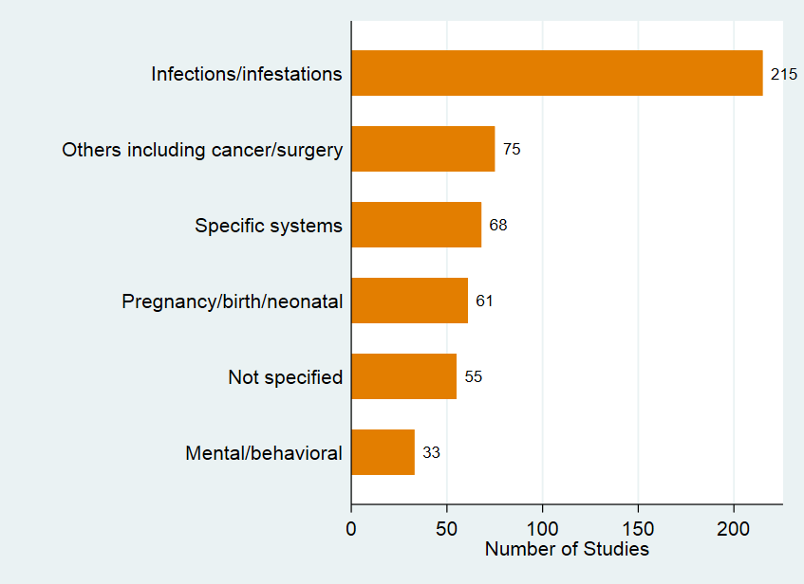

Appendix IV
Figure 2: Type of Study Participants
