TIMP-NR RESEARCH PROTOCOL

1. Greet participant, caregiver

2. WARM UP EXERCISES

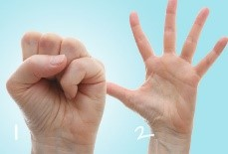
a. WHOLE HAND MOVEMENTS:
- Open and close hands; both hands moving together – 10 repetitions. Look for large opening of the hands.
- No Cueing, participant counts repetitions on their own.

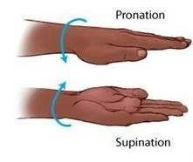

- Pronation/supination; both hands moving together – 10 repetitions. Look for complete turns of the hands.
- No Cueing, participant counts repetitions on their own.

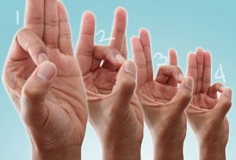
b. FINGER-THUMB OPPOSITION MOVEMENTS (TOUCHING THUMB SEQUENTIALLY WITH OTHER 4 FINGERS)

- Verbally cue movements; both hands move together 3x without pause
- Remind participant to do FULL EXTENSION OF FINGERS

c. HAND TO OBJECT MANIPULATIONS: REACHING, GRASPING, HOLDING, LIFTING OBJECTS

- Have participant sit in front of small table with 3 different objects; a cup, a spoon, and a coin. Items will be picked up, transferred, and set down (Reach, Grasp, Lift, Transfer, Let Go and bring arm back). Verbally cue directions prior to start (no verbal cueing during task).
- Sessions 1-5: Midline transfer to matching side.

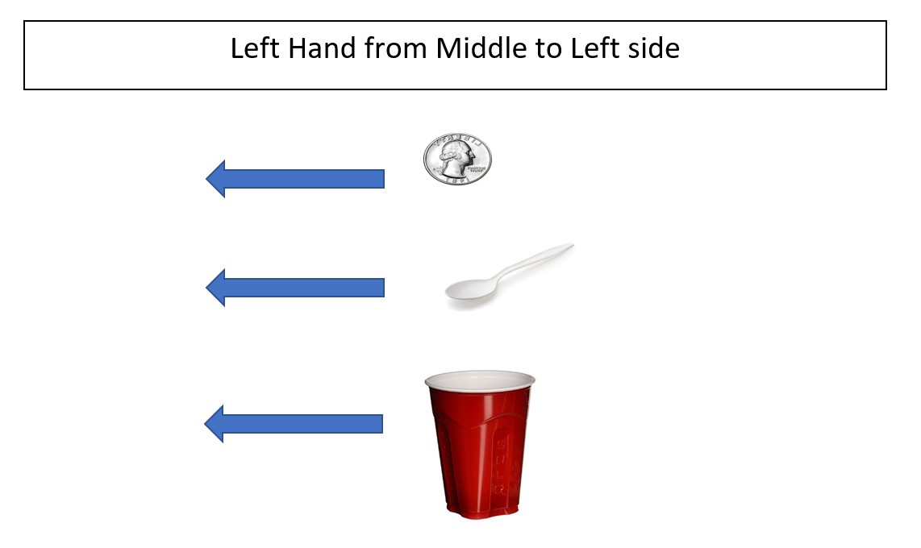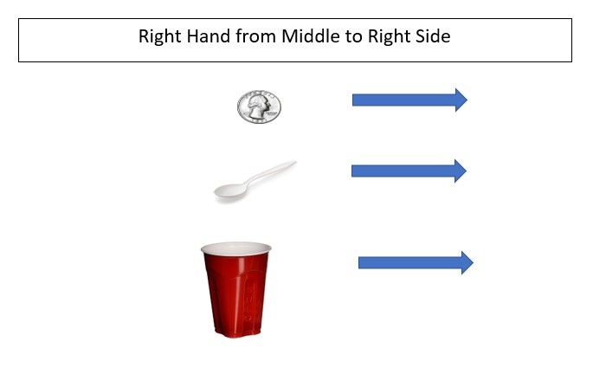

iii. Sessions 6-10: Midline transfer to opposing side
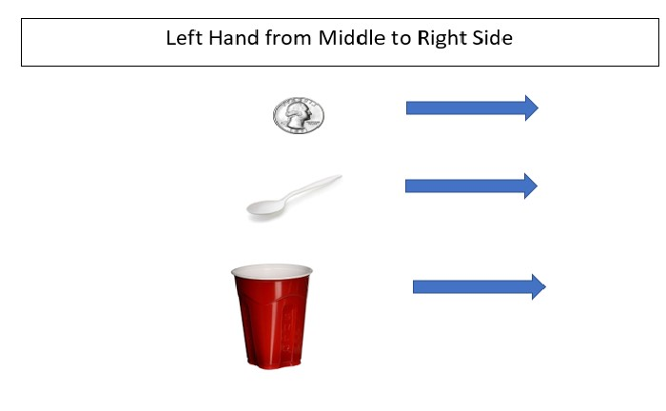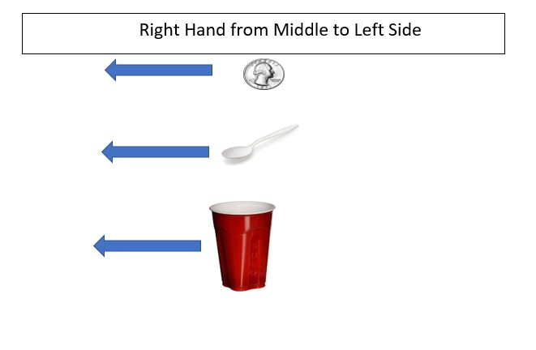

iv. Sessions 11-15: Opposing side transfer across to matching hand side
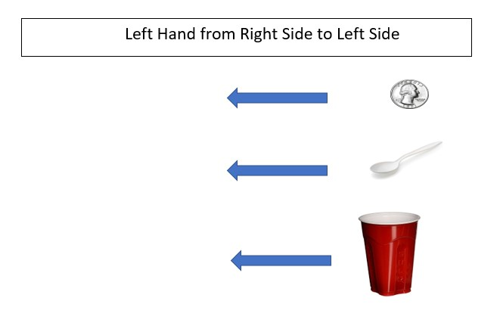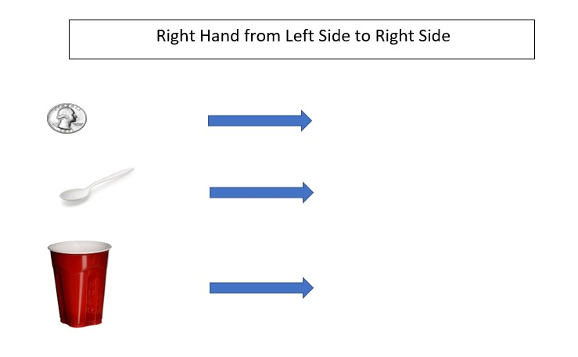

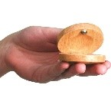

3. CASTANET PLAYING EXERCISES WITH MUSIC THERAPIST SINGING ALONG

- Give participant castanets, one in each hand.
- Have participant show you how fast they are going to play the castanets. Match the participant’s tempo.
- Therapist sings preferred song or set of songs that total 3-4 minutes (offer opportunity for participant to also sing along).
- Participant starts with both hands playing castanets simultaneously.
- Halfway through therapist gives directions to switch to alternating hands

4. DEXTERITY EXERCISES ON KEYBOARD
! Do not give external cues (no foot tapping/no snapping).
a. FINGER ADJACENT SCALES IN DIFFERENT FINGER COMBINATIONS:

- Have participant play scales. Repeat each exercise x1 100% success rate each hand (or more if extra time). Do not give external cues (no foot tapping/no snapping). Starting Pitch- Middle C (C4) on RH and C below middle C (C3) on LH

RH 1-2-3-4-5, 5-4-3-2-1 | LH 5-4-3-2-1, 1-2-3-4-5

Right hand
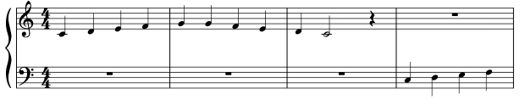
Left hand
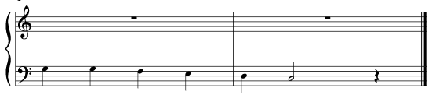

- Have participant play arpeggios. Repeat each exercise x 1 100% success rate each hand (or more if extra time).
Starting Pitch- Middle C (C4) on RH and C below middle C (C3) on LH

RH 1-3-5, 5-3-1 | LH 5-3-1, 1-3-5

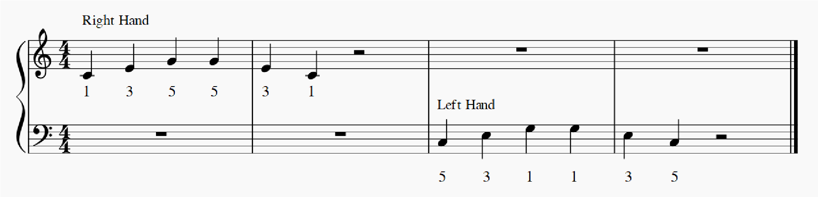

- Have participant play alternating pattern. Repeat each exercise x 1 100% success rate each hand (or more if extra time). Starting Pitch- Middle C (C4) on RH and C below middle C (C3) on LH

RH 1-5-2-5-3-5-4-5, 5-4-5-3-5-2-5-1 | LH 5-1-4-1-3-1-2-1, 1-2-1-3-1-4-1-5

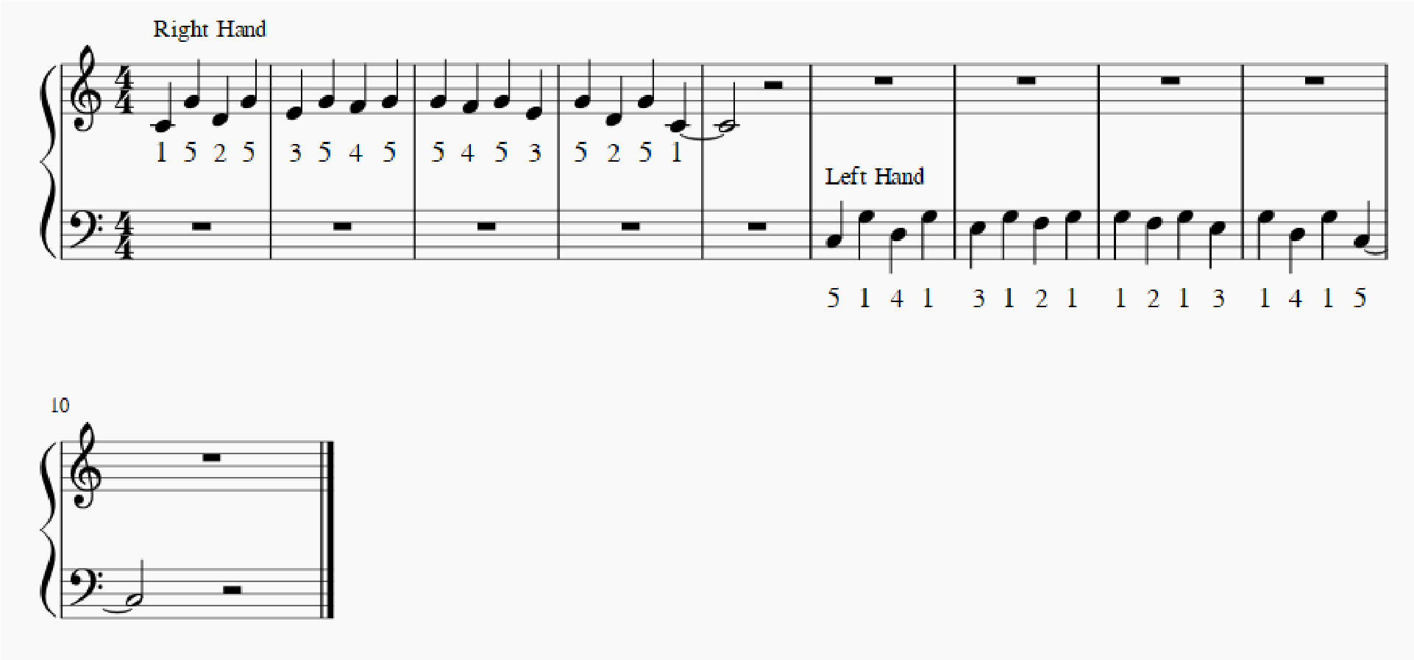

b. SCALES PLAYING IN DIFFERENT OCTAVE REGIONS TO TRAIN FOR FLEXIBILITY AND DISTAL MUSCLE INVOLVEMENT

- Starting Pitch RH- C6, One scale per octave, move down keyboard for 4 octaves. Starting Pitch LH- C2, One scale per octave, move up keyboard for 4 octaves.
- Each exercise x 1 100% success rate per hand (or more if extra time).

RH 1-2-3-4-5, 5-4-3-2-1 | LH 5-4-3-2-1, 1-2-3-4-5

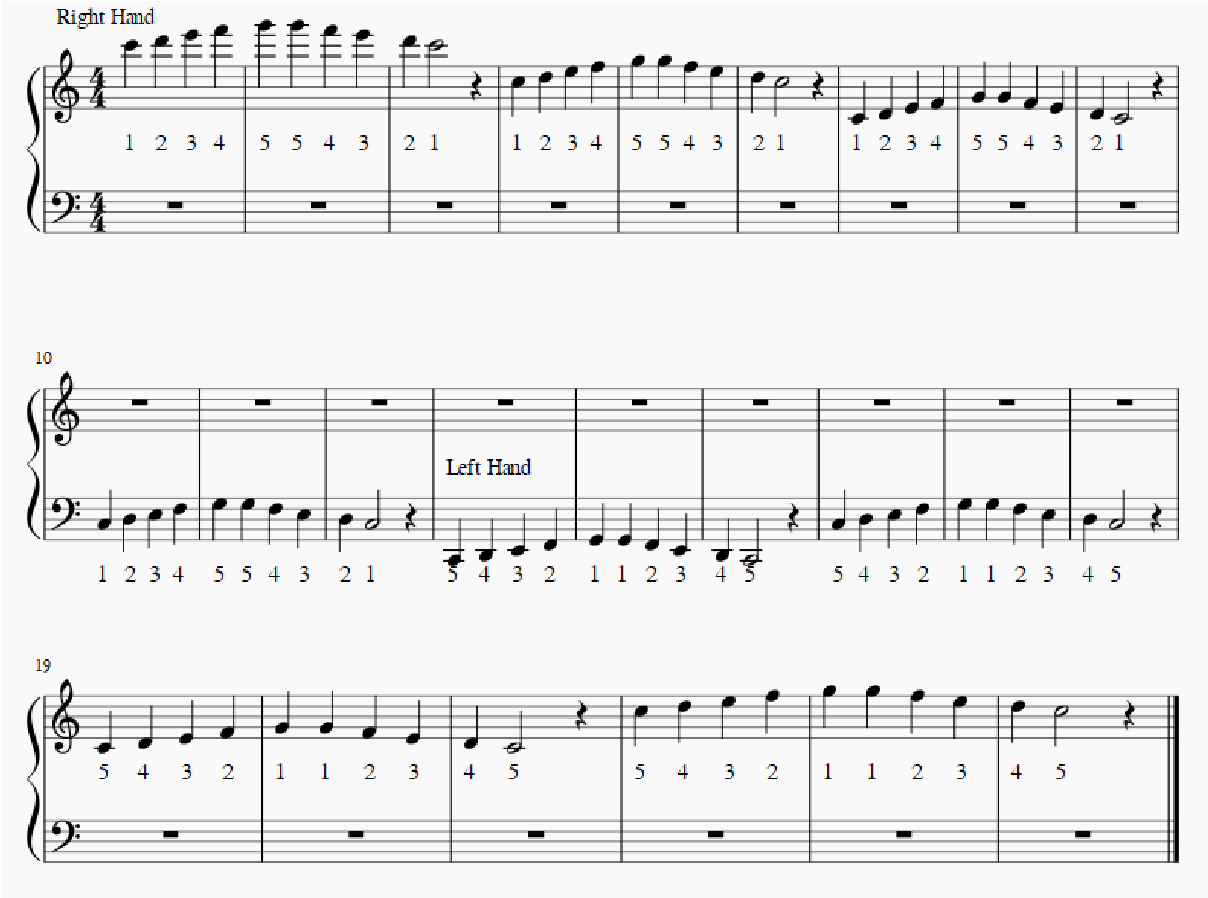

- Each exercise x1 100% success rate per hand (or more if extra time).
Starting Pitch RH- C6, One scale per octave, move down keyboard for 4 octaves.
Starting Pitch LH- C2, One scale per octave, move up keyboard for 4 octaves.

RH 1-3-5, 5-3-1 | LH 5-3-1, 1-3-5

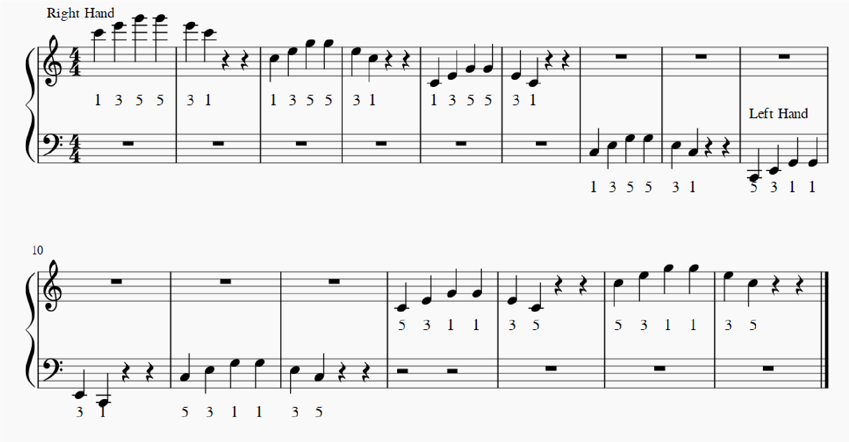

- Each exercise x1 100% success rate per hand (or more if extra time).
Starting Pitch RH- C6, One scale per octave, move down keyboard for 4 octaves.
Starting Pitch LH- C2, One scale per octave, move up keyboard for 4 octaves.

RH 1-5-2-5-3-5-4-5, 5-4-5-3-5-2-5-1 | LH 5-1-4-1-3-1-2-1, 1-2-1-3-1-4-1-5

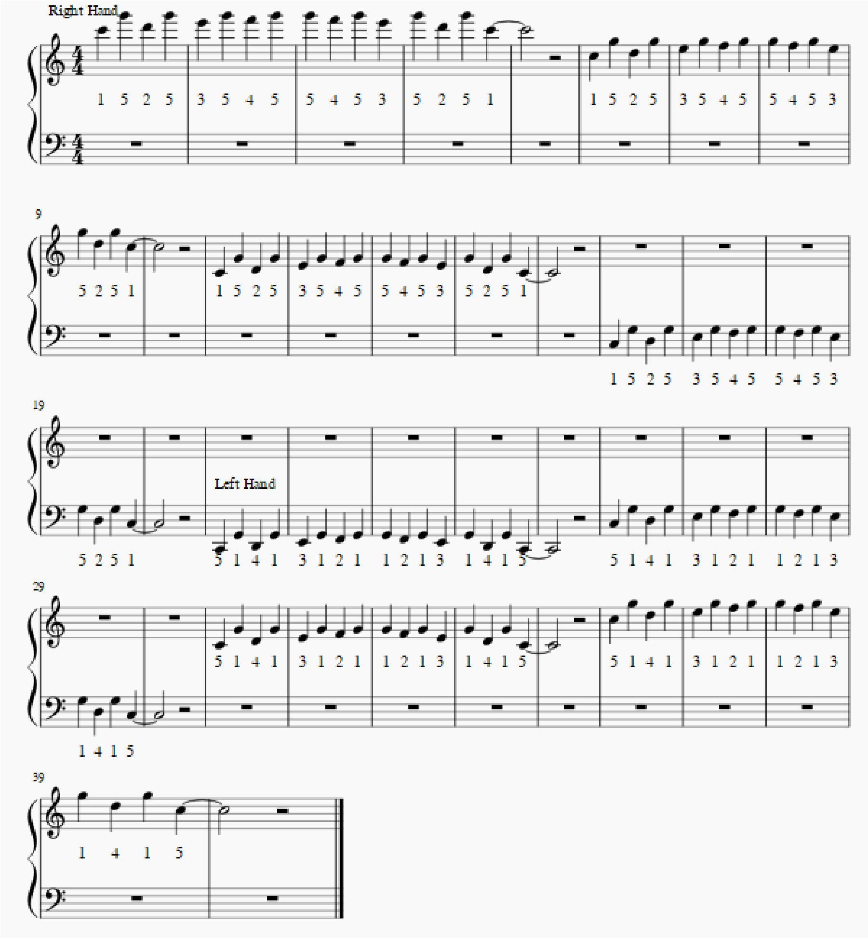

c. SCALES PLAYING IN 3 HAND COMBINATIONS: ALTERNATING, SEQUENTIAL, AND SIMULTANEOUS:

- Each exercise x1 100% success rate per hand (or more if extra time).
Alternating Starting Pitch- RH C5; Starting Pitch- LH C3

RH 1-2-3-4-5, 5-4-3-2-1 | LH 5-4-3-2-1, 1-2-3-4-5
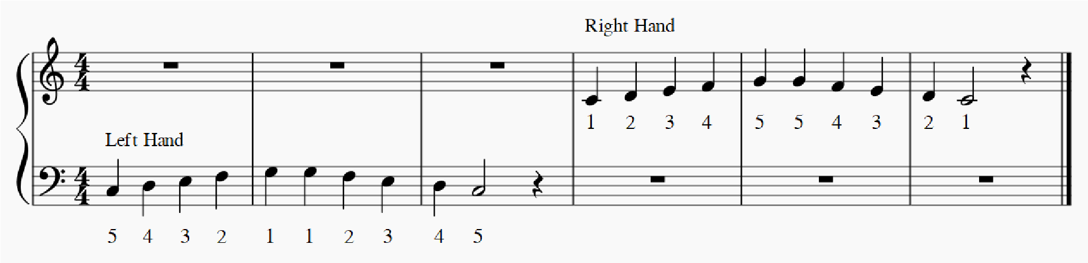

- Each exercise x1 100% success rate per hand (or more if extra time).
Simultaneous Starting Pitch- RH C5; Starting Pitch- LH C3

RH 1-2-3-4-5, 5-4-3-2-1 | LH 5-4-3-2-1, 1-2-3-4-5
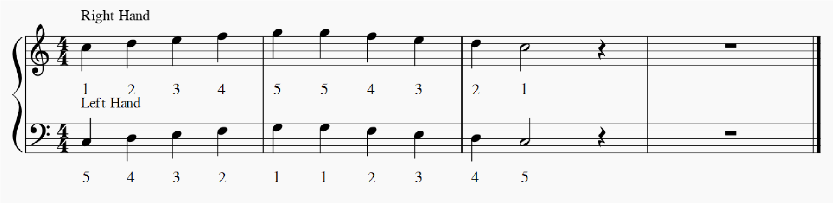

- Each exercise x1 100% success rate per hand (or more if extra time).
Sequential Starting Pitch- LH C2, RH C3; Ending pitch- RH C7, LH C6

RH 5-4-3-2-1, 1-2-3-4-5 | LH 1-2-3-4-5, 5-4-3-2-1

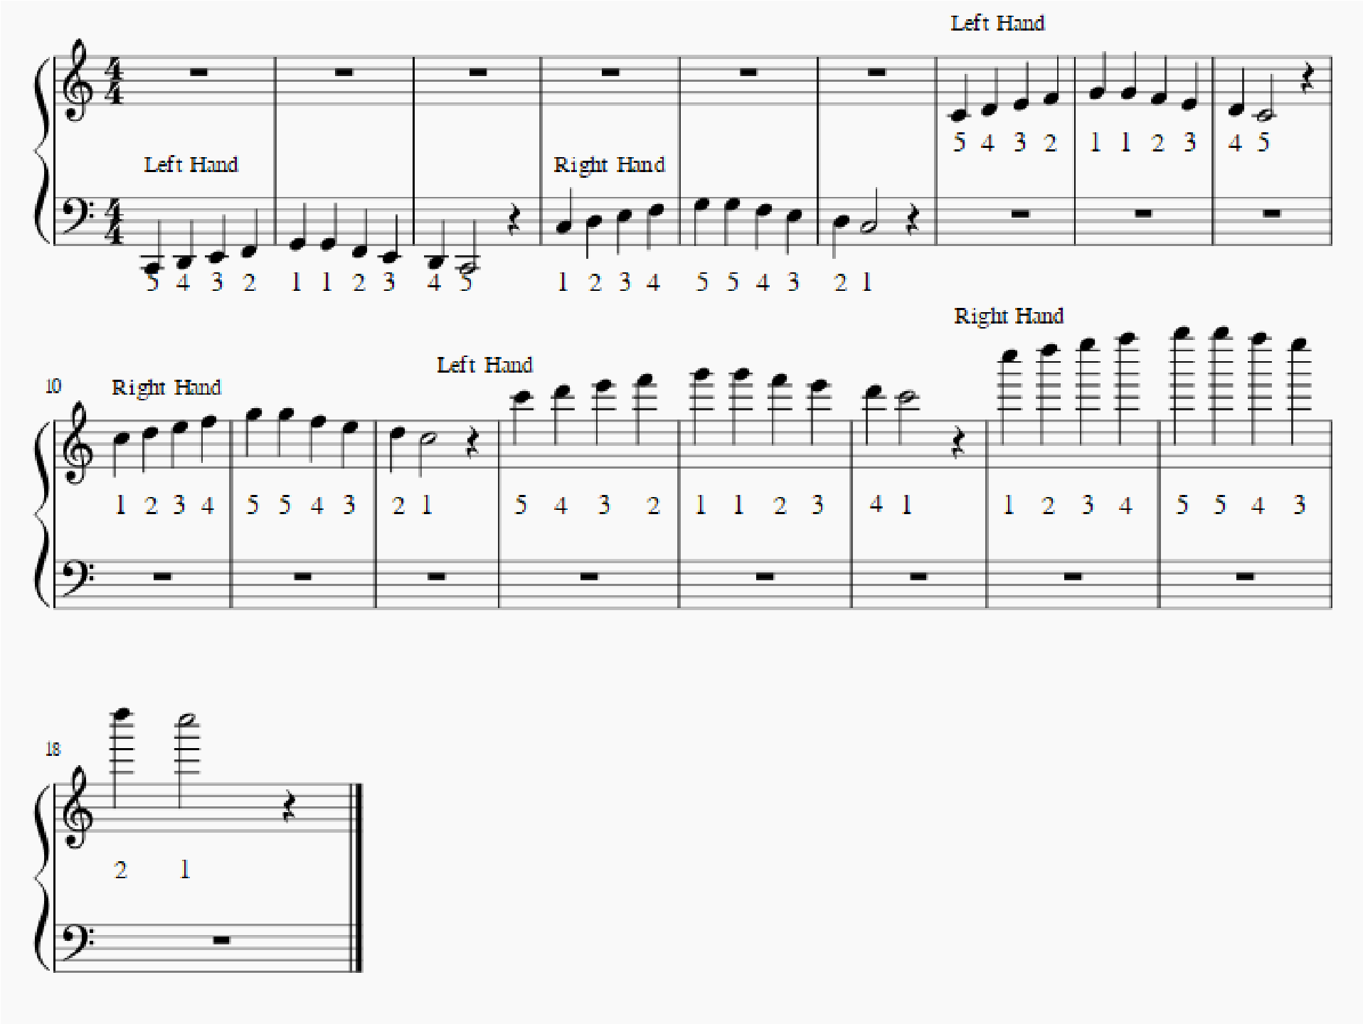

5. FREE MELODIC IMPROVISATION in octave space using heptatonic scales (eg. Dorian) for exploration of free and spontaneous hand/finger movements
- Participant is given visual parameters of a few octaves, only white keys with starting and ending points being identified with stickers. Ionian, Dorian, Mixolydian, and Aeolean
- Therapist sets timer for approximately 2 minutes
- Therapist can give participant suggestions for improvisation.

6. HOME –BASED EXERCISES
Show participant how to do all the exercises under #2 and 3 at home. Encourage participant to sing along during exercise 3.
Provide participant with castanets for home exercises.

