Appendices

Parental/ Caregiver Consent Form
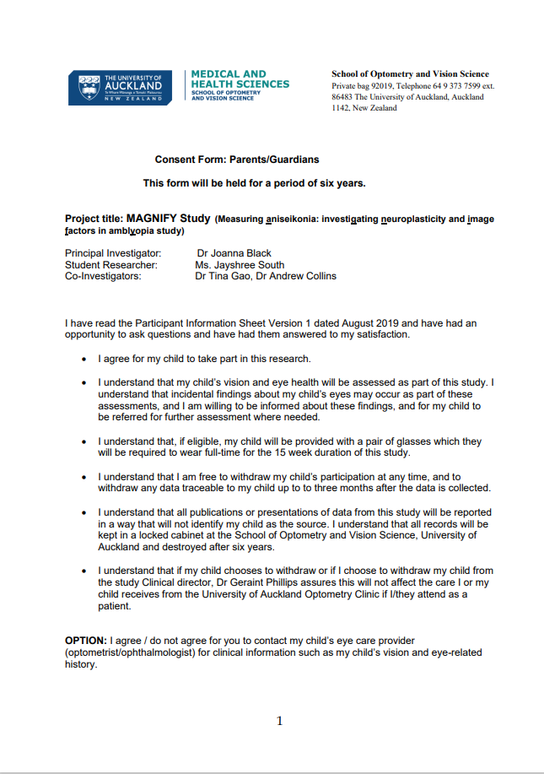
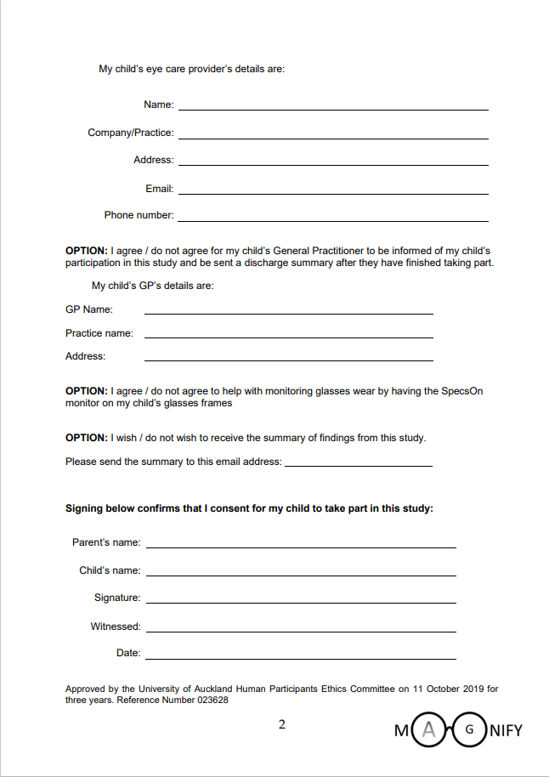

Parent/Caregiver Participant Information Sheet
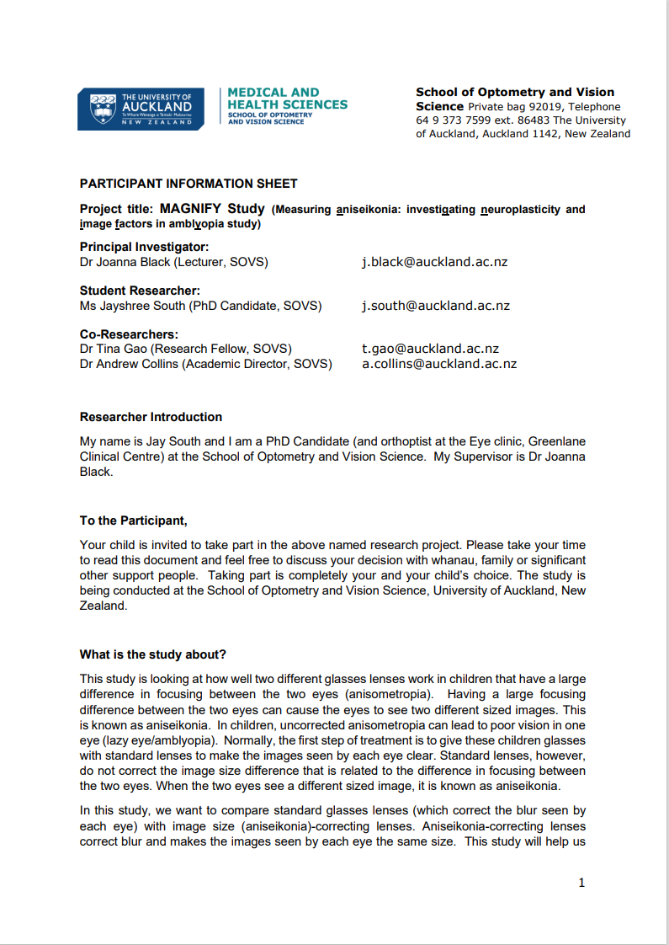

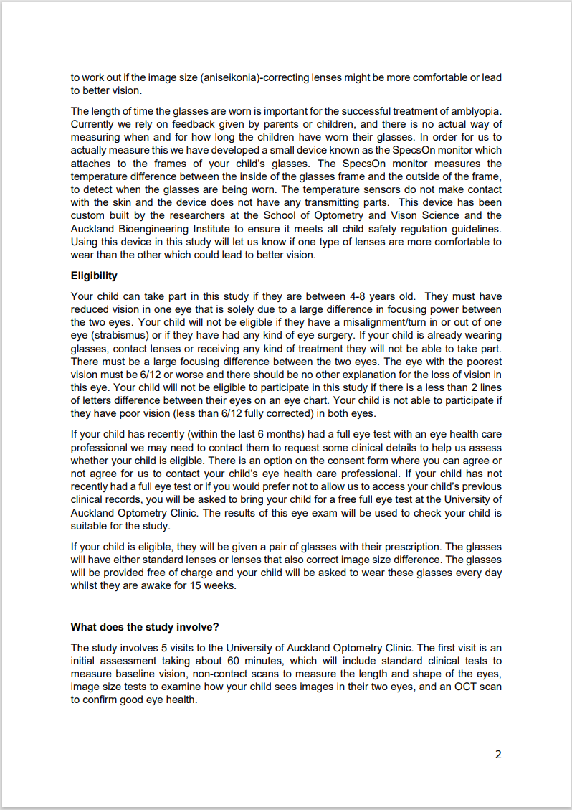

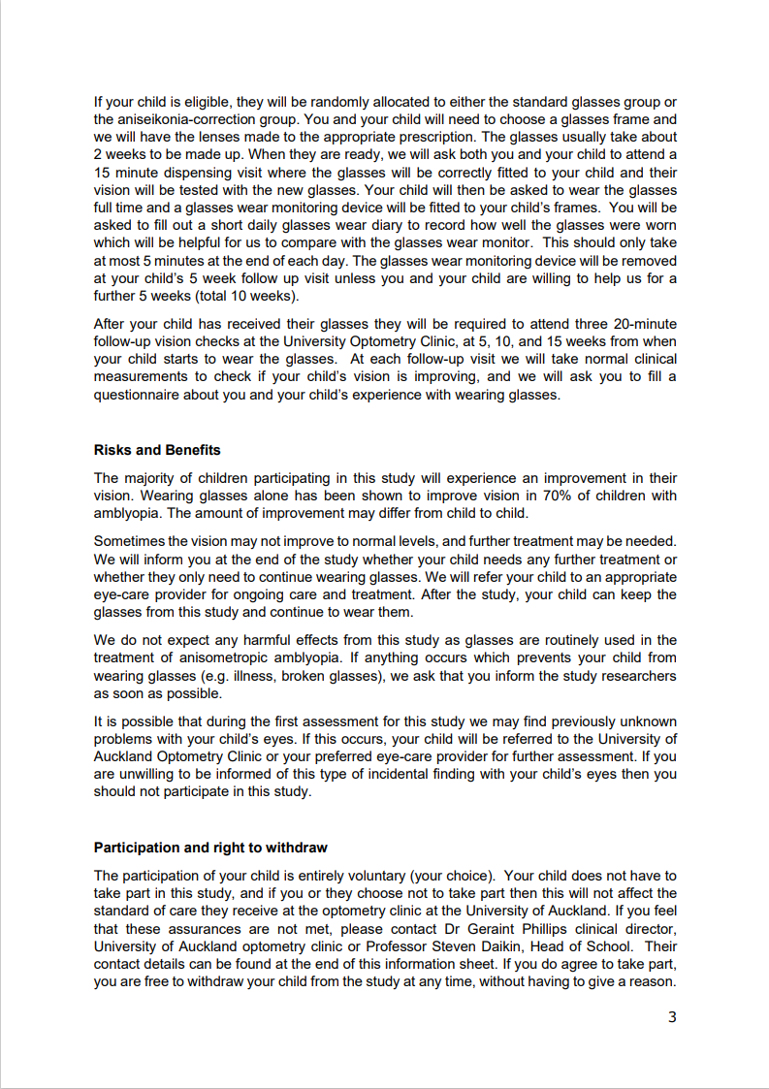

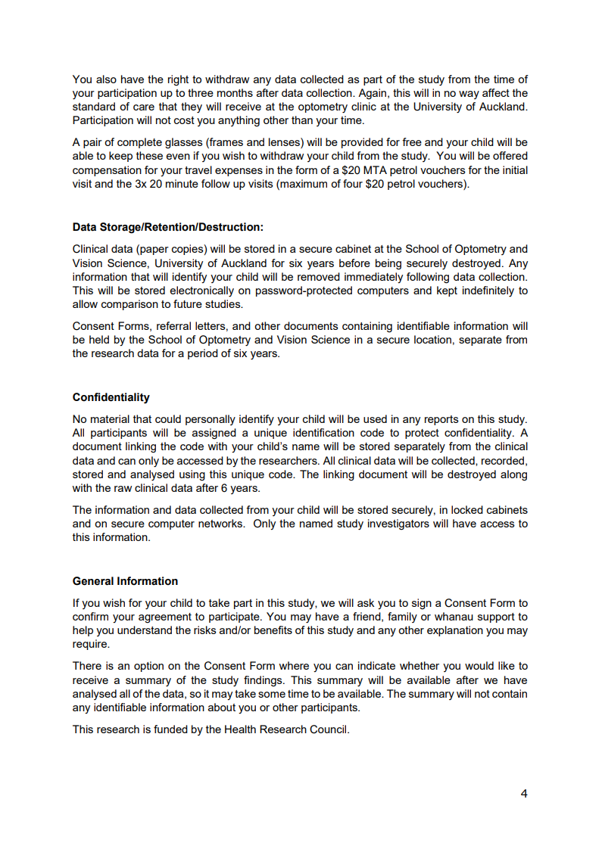

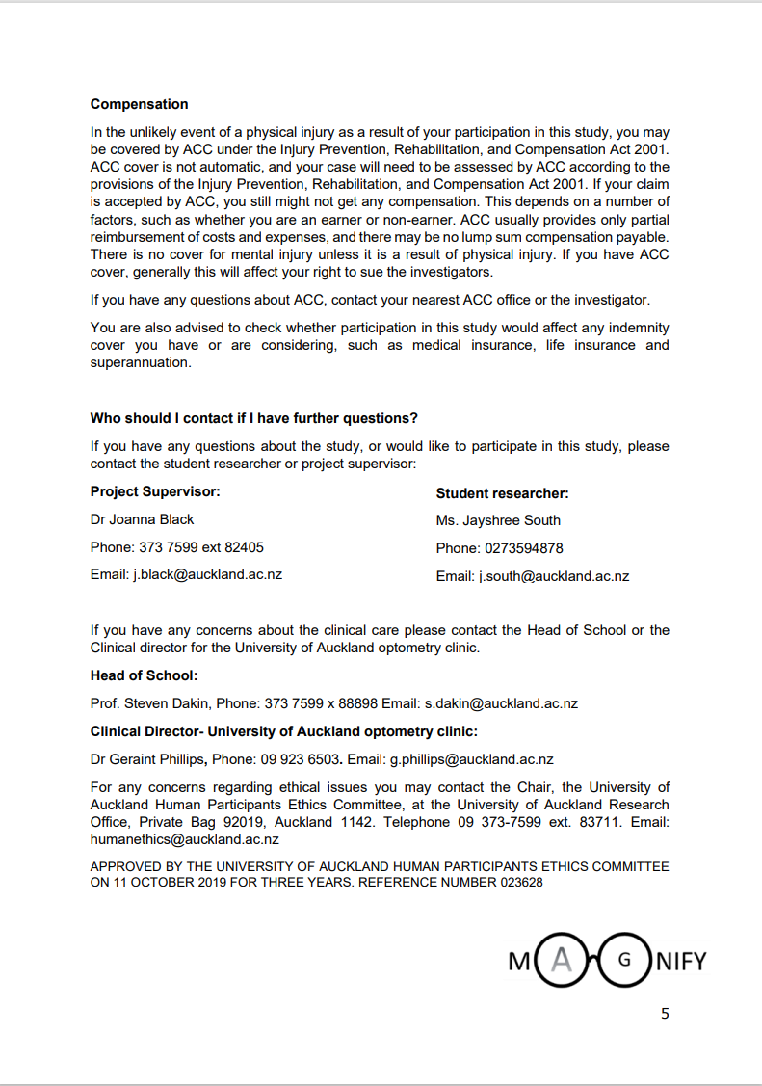

Child Assent Form
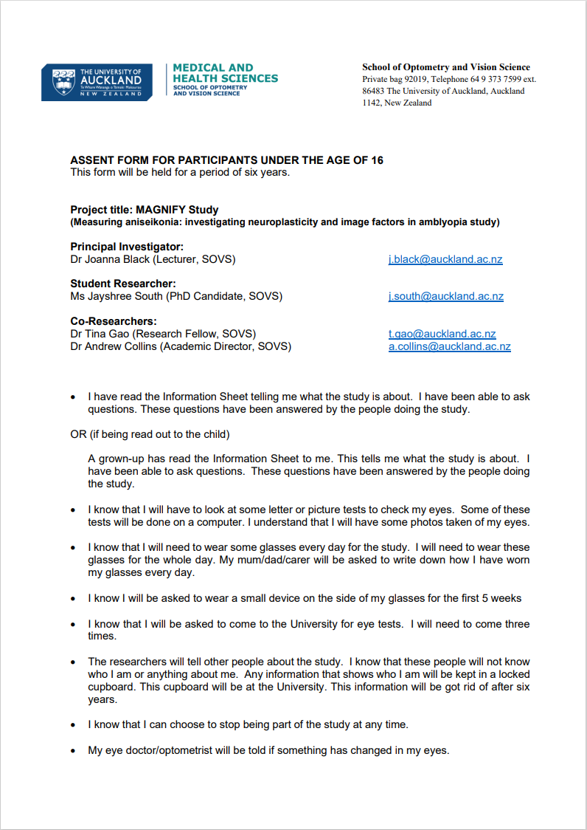

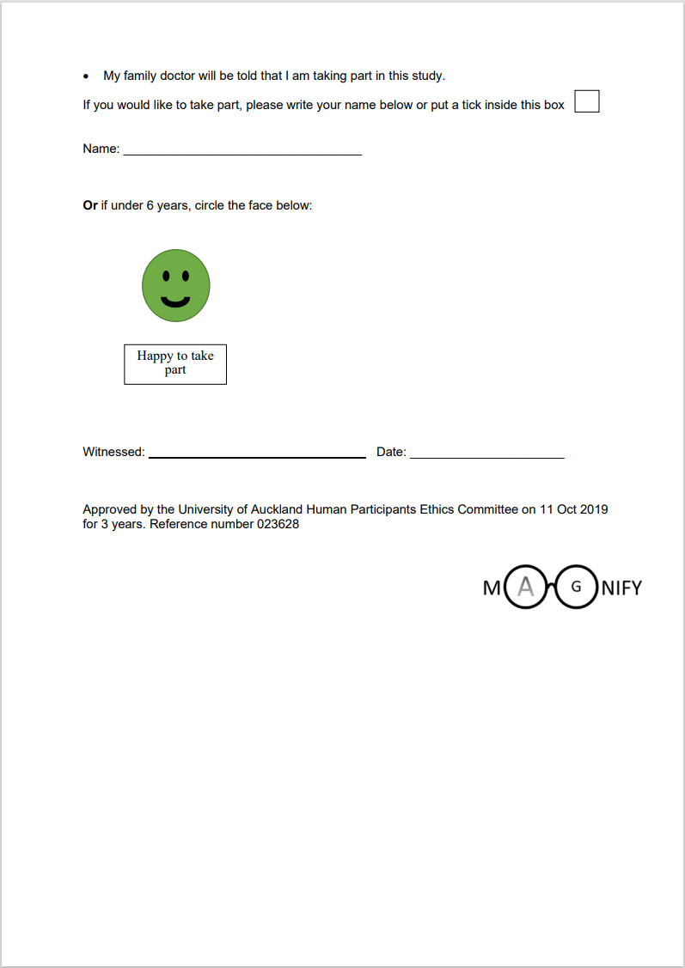

Child Participant Information Sheet
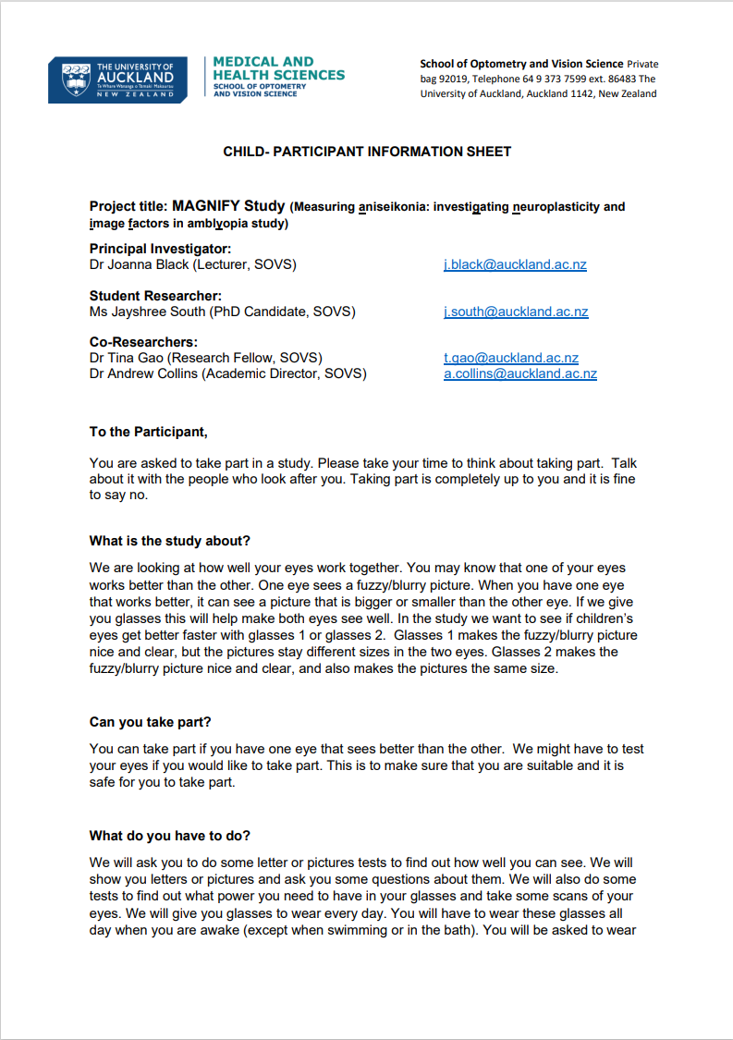

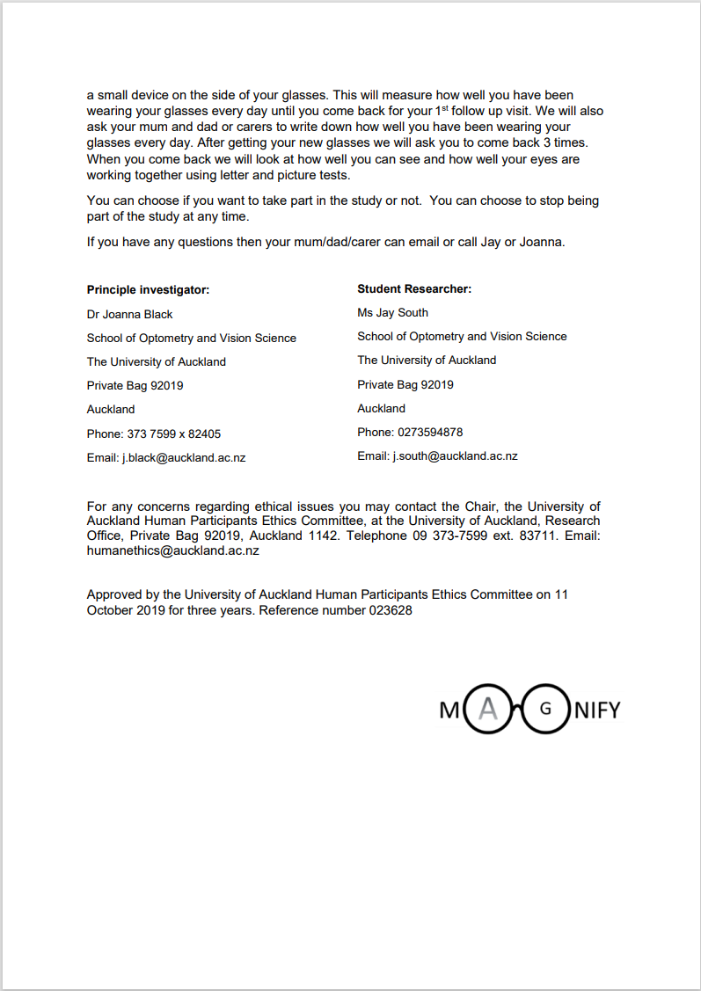

Trial Registration Data Set
Data category | Treatment
Primary registry and trial identifying number | Australia New Zealand Clinical Trials Registry. ACTRN12620000061932
Date of registration in primary registry | 24/1/2020
Secondary identifying numbers | None
Source(s) of monetary or material support | Health Research Council of New Zealand
Primary sponsor | Health Research Council of New Zealand
Secondary sponsor(s) | none
Contact for public queries | Mrs Jayshree South  School of Optometry and Vision Science  The University of Auckland  85 Park Road, Grafton  Auckland  1023  New Zealand  Phone: +64 273594878  Email: J.south@auckland,ac,nz
Contact for scientific queries | Dr Joanna Black  School of Optometry and Vision Science  The University of Auckland  85 Park Road, Grafton  Auckland  1023  Country  New Zealand  Phone: +64 99232405  Email: j.black@auckland.ac.nz
Public title | Effect of standard versus customised spectacle treatment for children with asymmetric refractive error
Scientific title | Measuring aniseikonia: investigating neuroplasticity and image factors in amblyopic children using aniseikonia-correcting spectacles (MAGNIFY) study
Countries of recruitment | New Zealand
Health condition(s) or problem(s) studied | Anisometropia, Aniseikonia, Amblyopia
Intervention(s) | Active comparator: Aniseikonia correction lenses (spectacle lenses are designed to equalise focus and also reduce aniseikonia (image size differences) between the two eyes
Intervention(s) | Placebo comparator: Standard Spectacle lens (spectacle lens which corrects image focus only)
Key inclusion and exclusion criteria | Ages eligible for study: 4 to 8 years old  Sexes eligible for study: both  Accepts healthy volunteers: no
Key inclusion and exclusion criteria | Inclusion criteria:  • 4-8 Years of age  • Anisometropia equal to or greater than 1.50 DS difference in spherical equivalent between eyes  • Uncorrected Vision in the worst eye of 6/12 (0.30 logMAR) or worse with an interocular difference of 2 lines or more. Visual acuity will be measured using the ATS-HOTV protocol on the Electronic Visual Acuity tester (EVA).  • No manifest strabismus at near or distance on cover test  • Refractive corrections meet the following criteria and are based on a cycloplegic refraction that is not more than six months old. The criteria are: 1) Hyperopia: not be under-corrected by more than +1.50D spherical equivalent and the reduction in plus sphere must be identical between the two eyes. 2) Anisometropia: full correction of the anisometropic difference. 3) Astigmatism: full cylindrical power will be prescribed. 4) Cylinder axis in the spectacle lenses in both eyes must be equal to or less than +/-6 degrees of the axis of the cycloplegic refraction when cylinder power is equal to or greater than 1.00 D.  • Willing and being able to provide written informed consent for participation in the study
Key inclusion and exclusion criteria | Exclusion criteria: Presence of a constant or alternating strabismus at any distance, previous amblyopia treatment, Myopia > 6.00D, previous intraocular surgery, any co-existent ocular pathology and any known neurological conditions. Not willing to wear spectacle refractive correction
Study type | Interventional
Study type | Allocation: Randomised controlled trial.  Allocation concealment: Participants will be randomized to the standard lenses or aniseikonia-correcting lenses group after they are consented to take part and confirmed to be eligible for the trial. Randomization will be conducted using an envelope or computer-based system. Allocation to each group will be made using a 1:1 ratio
Study type | Primary purpose: Treatment
Date of first enrolment | Jan 2020
Target sample size | 50
Recruitment status | Recruiting
Primary outcome(s) | Change in best-corrected distance visual acuity in the amblyopic eye from baseline (dispensing visit) to 15 weeks post-randomisation, measured using the highly standardised HOTV protocol EVA testing system (Time frame: From baseline (Dispensing visit) to 15 weeks post-randomisation)
Key secondary outcomes | Change from baseline (dispensing visit) in best-corrected distance visual acuity in the amblyopic eye, fellow eye and both eyes at 5, 10 and 15 weeks analysed post-randomisation as a composite score measured using the highly standardised HOTV protocol EVA testing system (time frame: From baseline to 5-, 10- and 15-weeks post-randomisation)  Change from baseline in stereopsis at 5-, 10- and 15-weeks post-randomisation measured using Randot Preschool Stereotest (Baseline measurements from dispensing visit and 5, 10 and 15 weeks after randomization to standard lenses group or aniseikonia correcting lenses group)  Spectacle wear compliance will be based on the total time the participants wore their glasses as recorded in the participants daily wear diary. A participant is considered compliant if they have worn their glasses for equal to or greater than 75% of their awake time (At follow up visits 5, 10 and 15 weeks after randomization)  Change in quality of life using the PedEyeQ Quality of life questionnaire. (Baseline measurement (Dispensing visit) and 15 weeks post randomization to standard lenses or aniseikonia correcting lenses group)  Serious adverse events such as eye strain or headaches, reported by the participants or identified via eye exams during follow-up visits. (5, 10 and 15 weeks after randomization)

