Flowchart
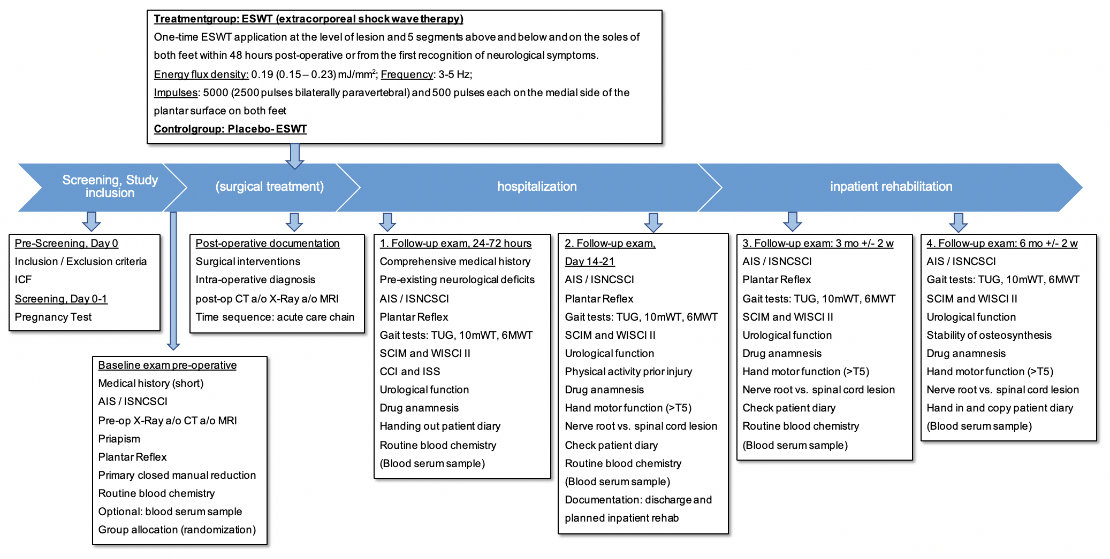

Visits | Visit 1 | Visit 2 | Visit 3 | Visit 4 | Visit 5 | Visit 6 | Visit 7 | Visit 8
Visits | Pre-Screening | Screening | Baseline  pre-operative | Post-operative documenta-tion | Follow-up 1 | Follow-up 2 | Follow-up 3 | Follow-up 4
 |  |  |  |  | 24-72 hours | Day 14-21 | 3 Mon  +/-2 We | 6 Mon  +/-2 We
Informed Consent NeuroWave | x
Informed Consent ASCIS (only in Austria) | x
Inclusion/Exclusion Criteria | x
Pregnancy test (women with child bearing potential) |  | x
Short Medical History |  |  | x
AIS/ISNCSCI |  |  | x |  | x | x | x | x
Pre-op CT/MRI/X-ray |  |  | x
Priapism (in male patients) |  |  | x
Plantar Reflex (Babinski) |  |  | x |  | x | x | x
Primary closed manual reduction |  |  | x
Documentation of routine blood chemistry |  |  | x |  | x | x | x
Optional: blood serum samples |  |  | (x) |  | (x) | (x) | (x) | (x)
Group allocation: Randomization |  |  | x
Surgical interventions and intra-operative diagnosis |  |  |  | x
Post-op CT/MRI/X-ray |  |  |  | x
Time course of acute care chain |  |  |  | x
Documentation of ESWT |  |  |  | x
Comprehensive Medical History |  |  |  |  | x
Pre-existing neurological deficits |  |  |  |  | x
Gait tests |  |  |  |  | x | x | x | x
SCIM an d WISCI II |  |  |  |  | x | x | x | x
CCI and ISS |  |  |  |  | x
Urological function |  |  |  |  | x | x | x | x
Drug anamnesis / concomitant Medication |  |  |  |  | x | x | x | x
Patient`s diary |  |  |  |  | x | x | x | x
Retrospective: physical activity prior trauma |  |  |  |  |  | x
Hand motor function (>T5) |  |  |  |  |  | x | x | x
Nerve root vs. spinal cord lesion |  |  |  |  |  | x | x | x
Documentation of discharge and planned inpatient rehabilitation |  |  |  |  |  | x
AEs und SAEs |  |  |  |  | x | x
CT/MRI/X-ray: Stability of osteosynthesis |  |  |  |  |  |  |  | x

