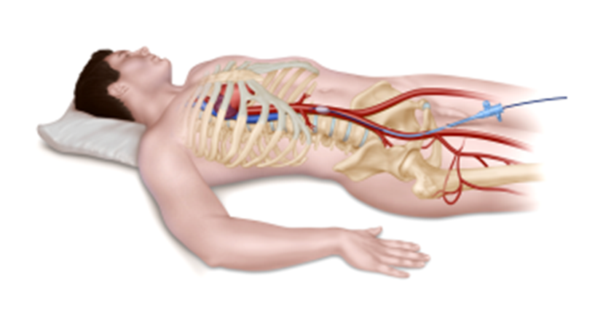
Depiction of the REBOA procedure.
The balloon can be deployed in the descending thoracic aorta (referred to as “zone I”) or the distal

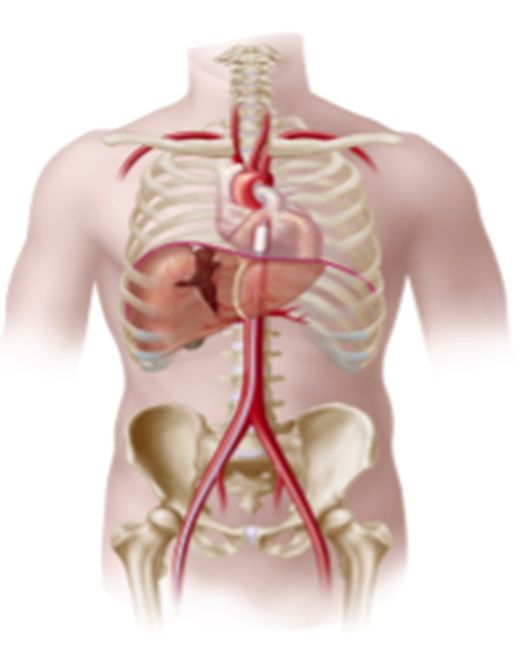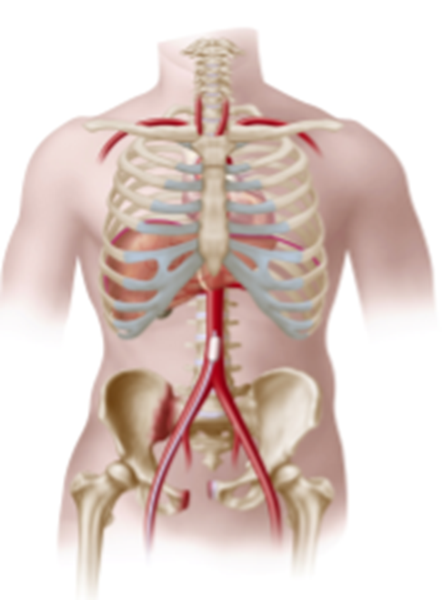
The REBOA balloon inserted in the distal abdominal aorta (referred to as “zone III”).
The REBOA balloon inserted in the descending thoracic aorta (referred to as “zone I”).

