Supplementary file 1

Appendix 1 –trials whose staff experiences added to this paper

Trial Name | Page number
AddAspirin | 2
AML LI-1 | 3
ATLANTIS | 4
Brain Matrix | 5
CompARE | 6
FLAIR | 7
FOCUS4 | 8
National Lung Matrix Trial | 9-10
OCTOPUS | 11-12
PHOENIX | 13-14
plasmaMATCH | 15
PLATO | 16-17
PrecisionPanc | 18
STAMPEDE | 19
TASTER | 20

Acronym | AddAspirin
Trial name | A phase III, double-blind, placebo-controlled, randomised trial assessing the effects of aspirin on disease recurrence and survival after primary therapy in common non-metastatic solid tumours
Registration links | ISRCTN74358648
Disease setting | Breast, colorectal, upper GI and prostate cancer. Participants have undergone primary treatment with curative intent
Current status | Recruiting International (UK, Ireland and India)
Reason for inclusion as example | Phase III basket trial with four parallel cohorts
Coordinating trials unit  Website | MRC Clinical Trials Unit at UCL, London  http://www.addaspirintrial.org/
Flow chart
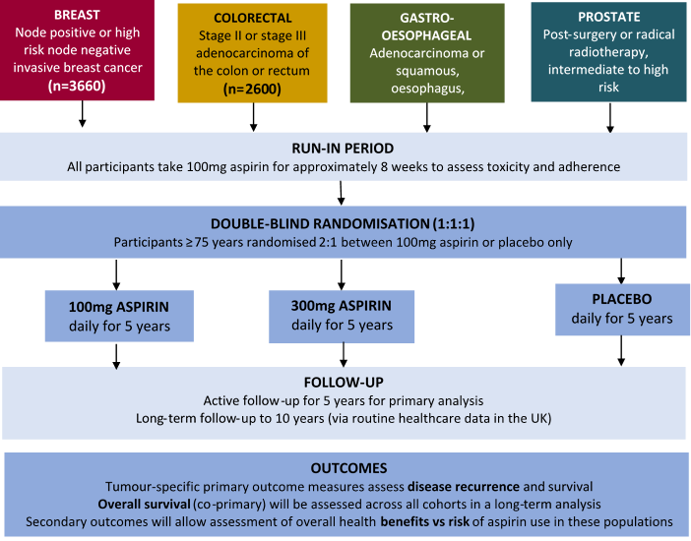

Acronym | AML LI-1 – a platform trial
Trial name | (as acronym)
Registration links | ISRCTN40571019
Disease setting | Acute Myeloid Lymphoma (AML) patients over the age of 60 and not fit for intensive chemotherapy
Current status | Closed to recruitment
Reason for inclusion as example | Adaptive multi-arm pick-a-winner phase II/III trial
Coordinating trials unit  Website | Centre for Trials Research, Cardiff  https://www.cardiff.ac.uk/centre-for-trials-research/research/studies-and-trials/view/aml-li-1
Flow chart
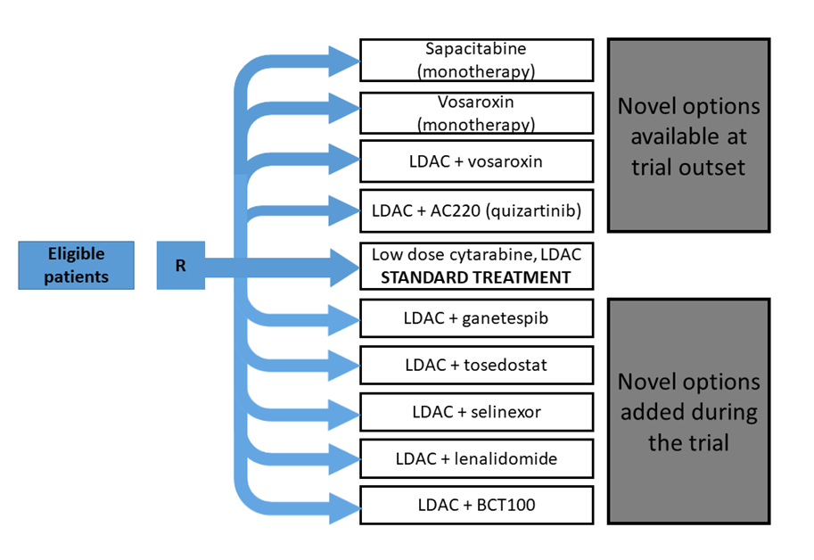

Acronym | ATLANTIS
Trial name | An adaptive multi-arm phase II trial of maintenance targeted therapy after chemotherapy in advanced/metastatic urothelial cancer
Registration links | ISRCTN25859465
Disease setting | maintenance targeted therapy after chemotherapy in advanced/ metastatic urothelial cancer
Current status | Recruiting
Reason for inclusion as example | Umbrella screening trial with an adaptive multi-arm phase II
Coordinating trials unit | CRUK Clinical Trials Unit Glasgow
Website | -
Flow chart
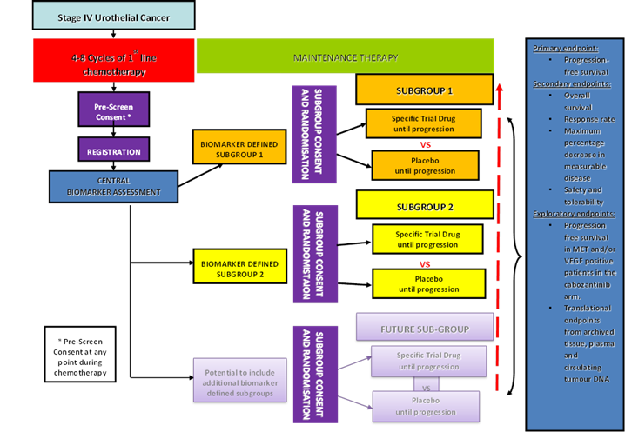

Acronym | Tessa Jowel BRAIN MATRIX
Trial name | A BRitish feasibility study of molecular stratification and targeted therapy to optimize the clinical mAnagement of patIeNts with glioMA by enhancing clinical ouTcomes, Reducing avoIdable toXicity, improving management of postoperative residual & recurrent disease and improving survivorship
Registration links | ISRCTN14218060
Disease setting | Glioma
Current status | Recruiting International (UK, Ireland and India)
Reason for inclusion as example | Platform protocol
Coordinating trials unit  Website | CRUK Clinical Trials Unit, Birmingham  https://www.birmingham.ac.uk/research/crctu/trials/brain-matrix/index.aspx
Flow chart
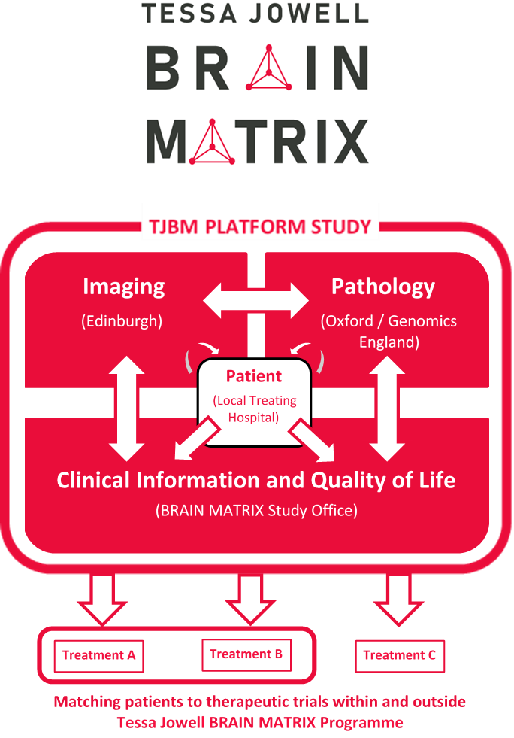

Acronym | CompARE
Trial name | A phase III randomised controlled trial Comparing Alternative Regimens for escalating treatment of intermediate and high-risk oropharyngeal cancer
Registration links | ISRCTN4148539
Disease setting | Oropharyngeal cancer
Current status | Recruiting International (UK, Ireland and India)
Reason for inclusion as example | Phase III MAMS trial
Coordinating trials unit  Website | CRUK Clinical Trials Unit, Birmingham  https://www.birmingham.ac.uk/research/crctu/trials/compare/index.aspx
Flow chart
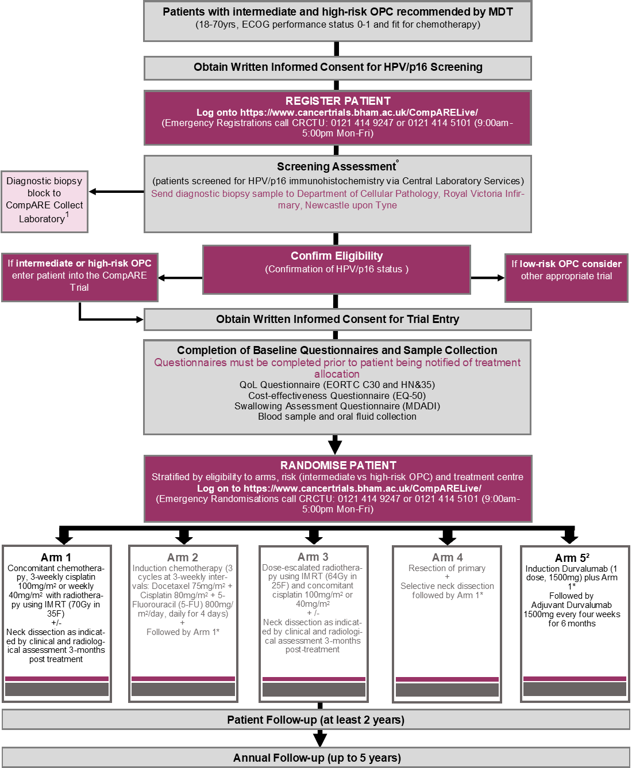
Acronym | FLAIR
Trial name | Front-Line therapy in CLL: Assessment of Ibrutinib-containing Regimes:  a randomised controlled trial
Registration links | ISRCTN01844152
Disease setting | CLL
Current status | Recruiting high risk
Reason for inclusion as example | Phase III platform
Coordinating trials unit  Website | Leeds Institute of Clinical Trials Research  -
Flow chart

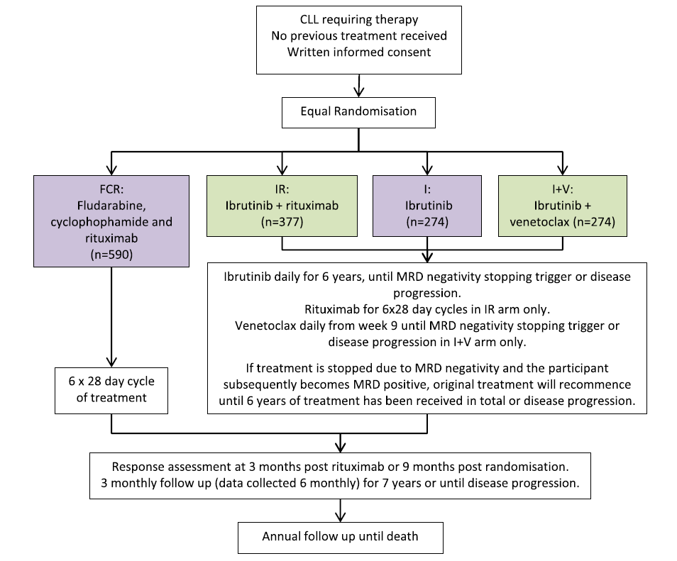

Acronym | FOCUS4
Trial name | FOCUS4 is a molecularly stratified, multi-site randomised trial programme for patients with colorectal cancer
Registration links | ISRCTN90061546
Disease setting | Colorectal cancer
Current status | In follow-up
Reason for inclusion as example | A master protocol umbrella design
Coordinating trials unit  Website | MRC Clinical Trials Unit at UCL, London  http://www.focus4trial.org/
Flow chart

Acronym | National Lung Matrix Trial
Trial name | Multi-drug, genetic marker-directed, non-comparative, multi-centre, multi-arm phase II trial in non-small cell lung cancer
Registration links | ISRCTN38344105
Disease setting | Non-small cell lung cancer
Current status | Recruiting
Reason for inclusion as example | Umbrella study
Coordinating trials unit  Website | CRUK Clinical Trials Unit, Birmingham  https://www.birmingham.ac.uk/research/crctu/trials/lung-matrix/index.aspx
Flow chart on next page

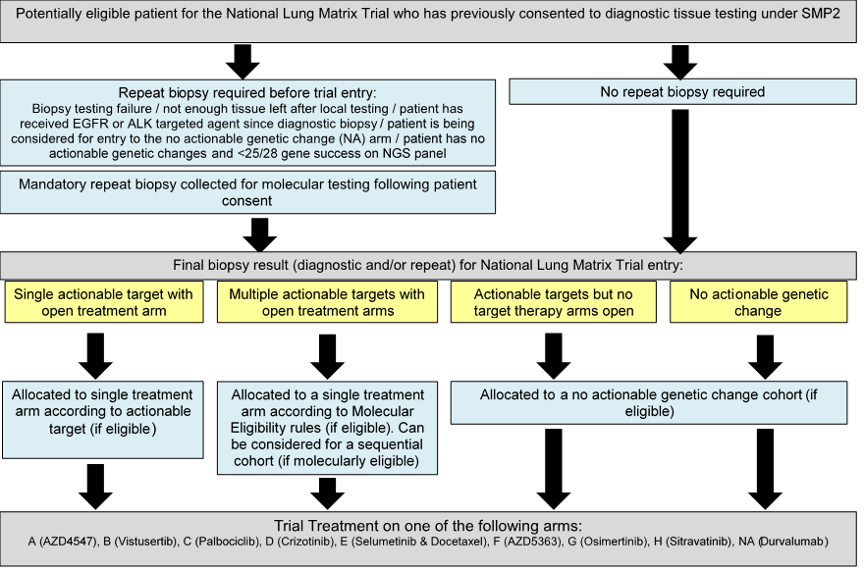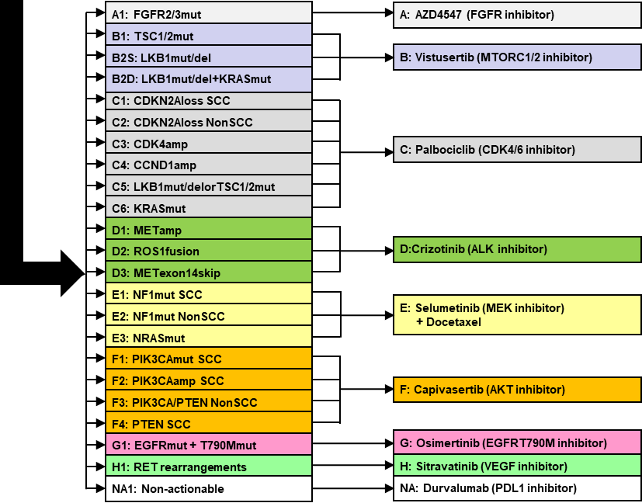

Middleton, G., Fletcher, P., Popat, S. et al. The National Lung Matrix Trial of personalized therapy in lung cancer. Nature 583, 807–812 (2020). https://doi.org/10.1038/s41586-020-2481-8

Acronym | OCTOPUS
Trial name | A Randomised, Phase II Umbrella Trial of Weekly Paclitaxel +/- Novel Agents in Platinum-Resistant Ovarian Cancer
Registration links | ISRCTN16426935
Disease setting | Breast, colorectal, upper GI and prostate cancer. Participants have undergone primary treatment with curative intent
Current status | In follow-up
Reason for inclusion as example | An umbrella trial
Coordinating trials unit  Website | CRUK Clinical Trials Unit Glasgow  -
Flow chart on next page

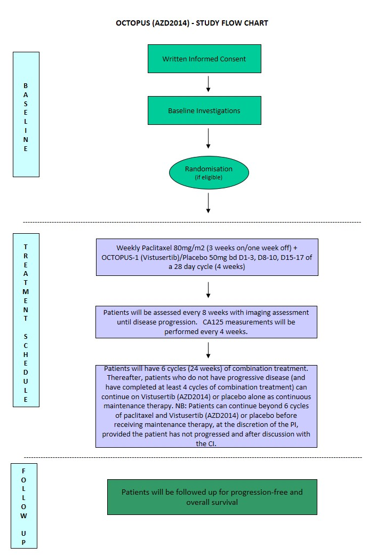

Acronym | PHOENIX
Trial name | A pre-surgical window of opportunity and post-surgical adjuvant biomarker study of DNA damage response inhibition and/or anti-PD-L1 immunotherapy in patients with neoadjuvant chemotherapy resistant residual triple negative breast cancer.
Registration links | ISRCTN47127434
Disease setting | Breast cancer
Current status | Recruiting
Reason for inclusion as example | A platform trial
Coordinating trials unit  Website | ICR-CTSU, Sutton  https://www.icr.ac.uk/our-research/centres-and-collaborations/centres-at-the-icr/clinical-trials-and-statistics-unit/clinical-trials/phoenix
Flow chart on next page

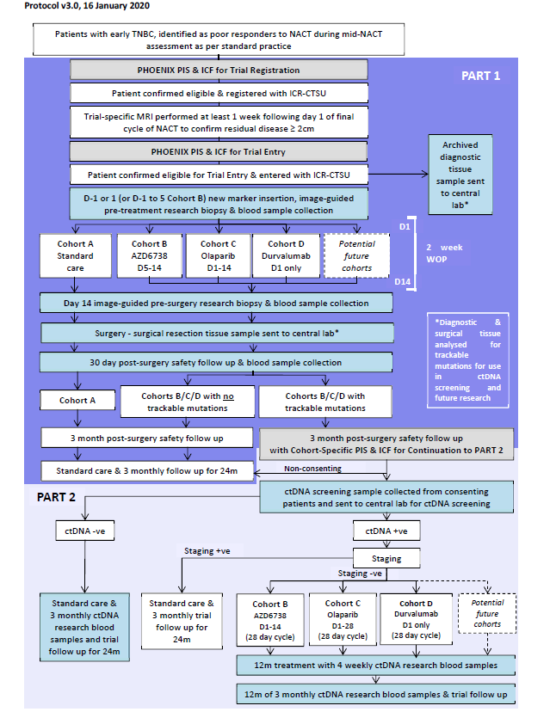
Acronym | plasmaMATCH
Trial name | A multiple parallel cohort, open-label, multicentre phase IIa clinical trial aiming to provide proof of principle efficacy for designated targeted therapies in patients with advanced breast cancer where the targetable mutation is identified through ctDNA screening
Registration links | ISRCTN16945804
Disease setting | Breast cancer
Current status | Closed
Reason for inclusion as example | An umbrella trial
Coordinating trials unit  Website | ICR-CTSU, Sutton  https://www.icr.ac.uk/our-research/centres-and-collaborations/centres-at-the-icr/clinical-trials-and-statistics-unit/clinical-trials/plasmamatch
Flow chart

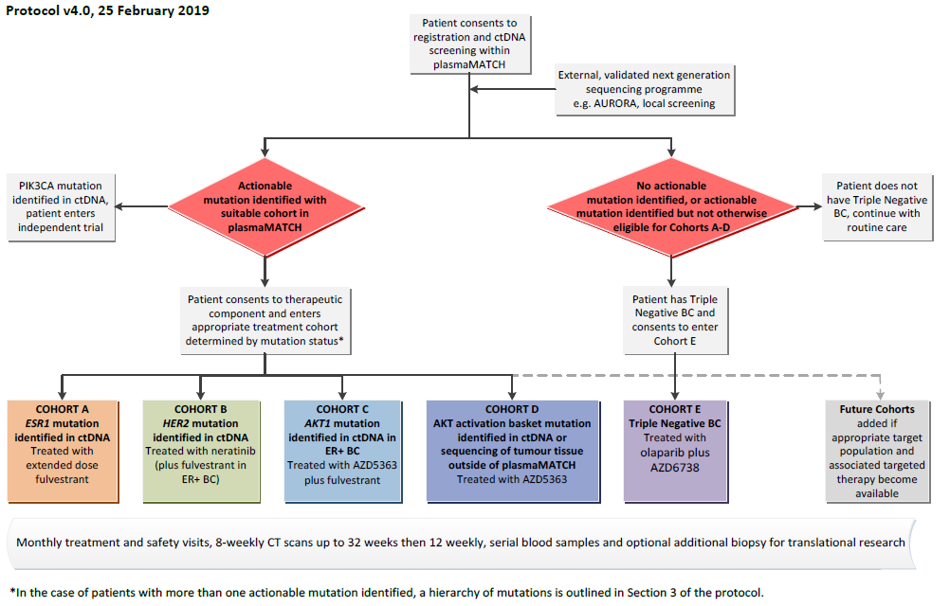

Acronym | PLATO
Trial name | PersonaLising Anal cancer radiotherapy dOse
Registration links | ISRCTN88455282
Disease setting | Anal cancer
Current status | Recruiting
Reason for inclusion as example | An umbrella trial with platform elements
Coordinating trials unit  Website | Leeds Institute of Clinical Trials Research  -
Flow chart on the next page


PLATO
PersonaLising Anal cancer radioTherapy dOse
ACT3
Low-risk disease

ACT4
Intermediate-risk disease
ACT5
High-risk disease

Standard treatment strategy

Dose de-escalation

Dose escalation

- Study of multiple targeting therapies in parallel in a single disease
- Disease is classified into different subgroups, depending on the presence of a particular biomarker/mutation, disease stage, and risk groups, for example
- One overarching protocol was designed to answer multiple research questions
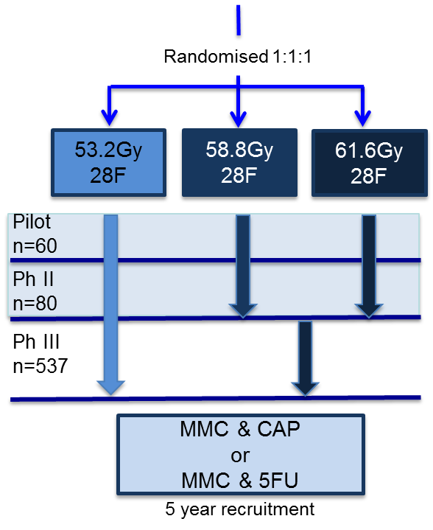
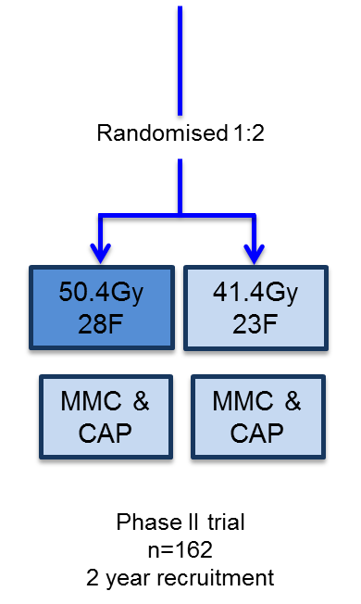
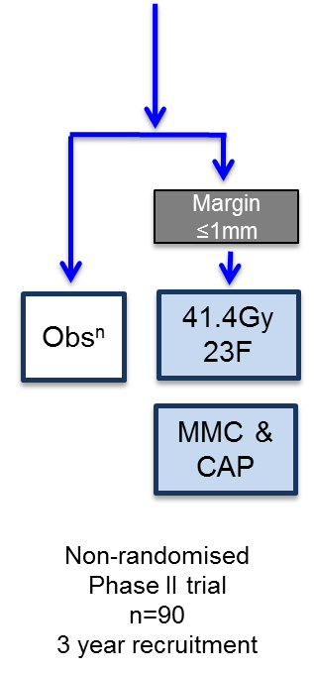
n=500
ACT5
ACT4
ACT3
Intermediate-risk disease
High-risk disease
Low-risk disease

Acronym | Precision-Panc
Trial name | The Precision-Panc Master Protocol is a “portal” protocol for patients with known or suspected pancreatic cancer to be accrued through multiple centres in the UK, with the option of being subsequently recruited into PRIMUS (Pancreatic canceR Individualised Multi-arm Umbrella Studies) examining different treatment regimens and/or biomarker development.
Registration links | ISRCTN14879538
Disease setting | Pancreatic cancer
Current status | Recruiting
Reason for inclusion as example | Master protocol
Coordinating trials unit  Website | CRUK Clinical Trials Unit Glasgow  https://www.precisionpanc.org/
Flow chart

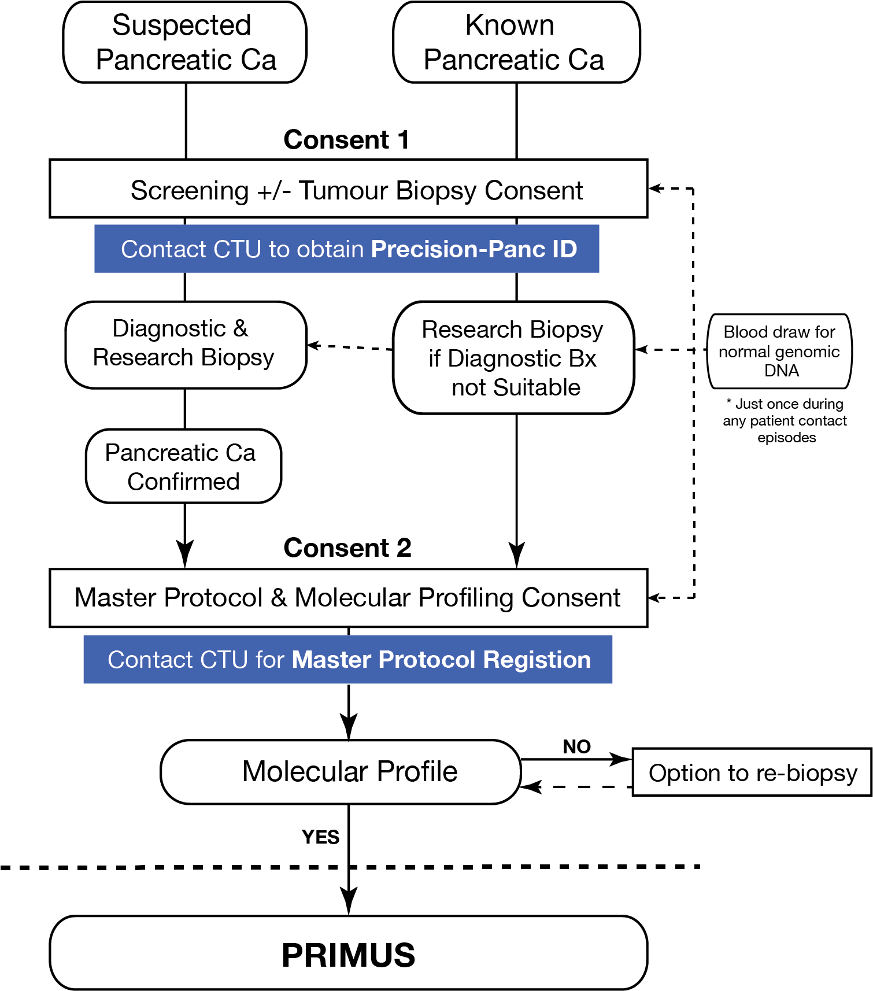

Acronym | STAMPEDE
Trial name | Systemic Therapy in Advancing or Metastatic Prostate Cancer: Evaluation of Drug Efficacy
Registration links | ISRCTN78818544
Disease setting | Prostate cancer
Current status | Recruiting
Reason for inclusion as example | Phase III MAMS trial
Coordinating trials unit  Website | MRC Clinical Trials Unit at UCL, London  http://www.stampedetrial.org/
Flow chart

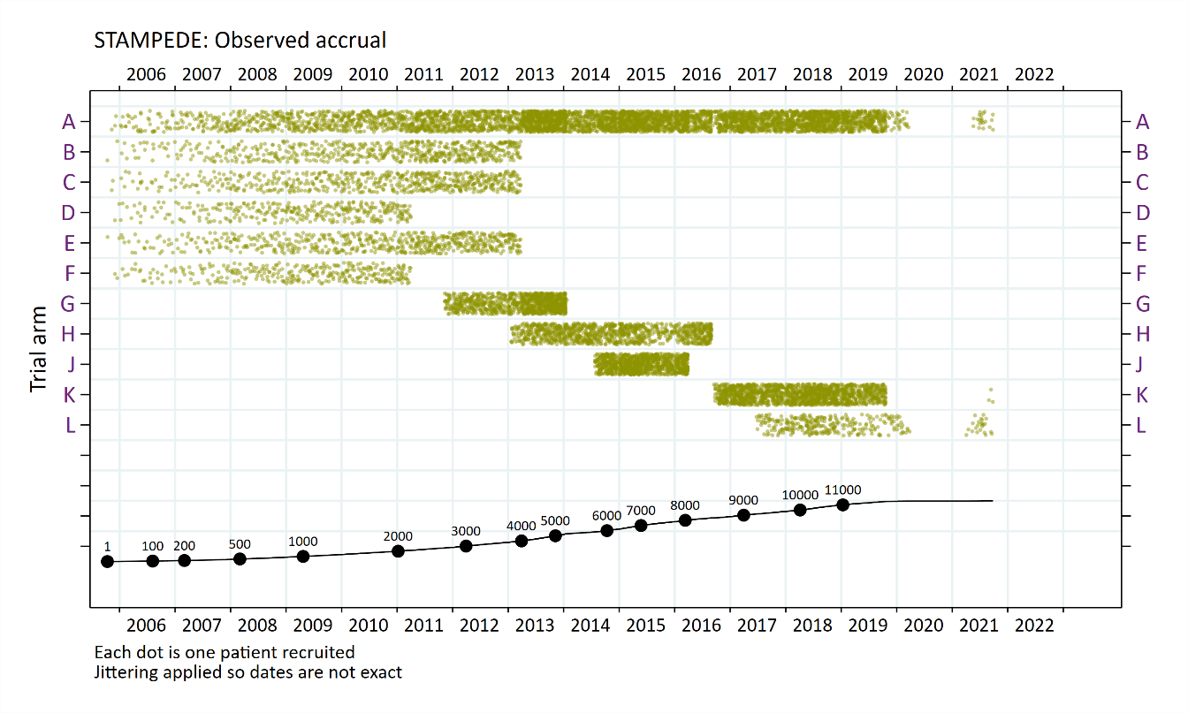
Key to trial arms  A = Standard-of-care (SOC)  B = SOC+zoledronic acid  C = SOC+docetaxel  D = SOC+celecoxib  E = SOC+zoledronic acid+docetaxel  F = SOC+zoledronic acid+celecoxib | G =SOC+abiraterone  H =SOC+radiotherapy  J = SOC+enzalutamide+abiraterone  K = SOC+metformin  L = SOC+transdermal oestradiol

Acronym | Taster
Trial name | An umbrella adaptive randomised multi-arm screening phase II trial for patients with 2nd / 3rd generation TKI resistant chronic myeloid leukaemia in chronic or accelerated phase
Registration links | ISRCTN68270067
Disease setting | CML
Current status | On hold
Reason for inclusion as example | An umbrella screening trial
Coordinating trials unit  Website | CRUK Clinical Trials Unit Glasgow  -
Flow chart

