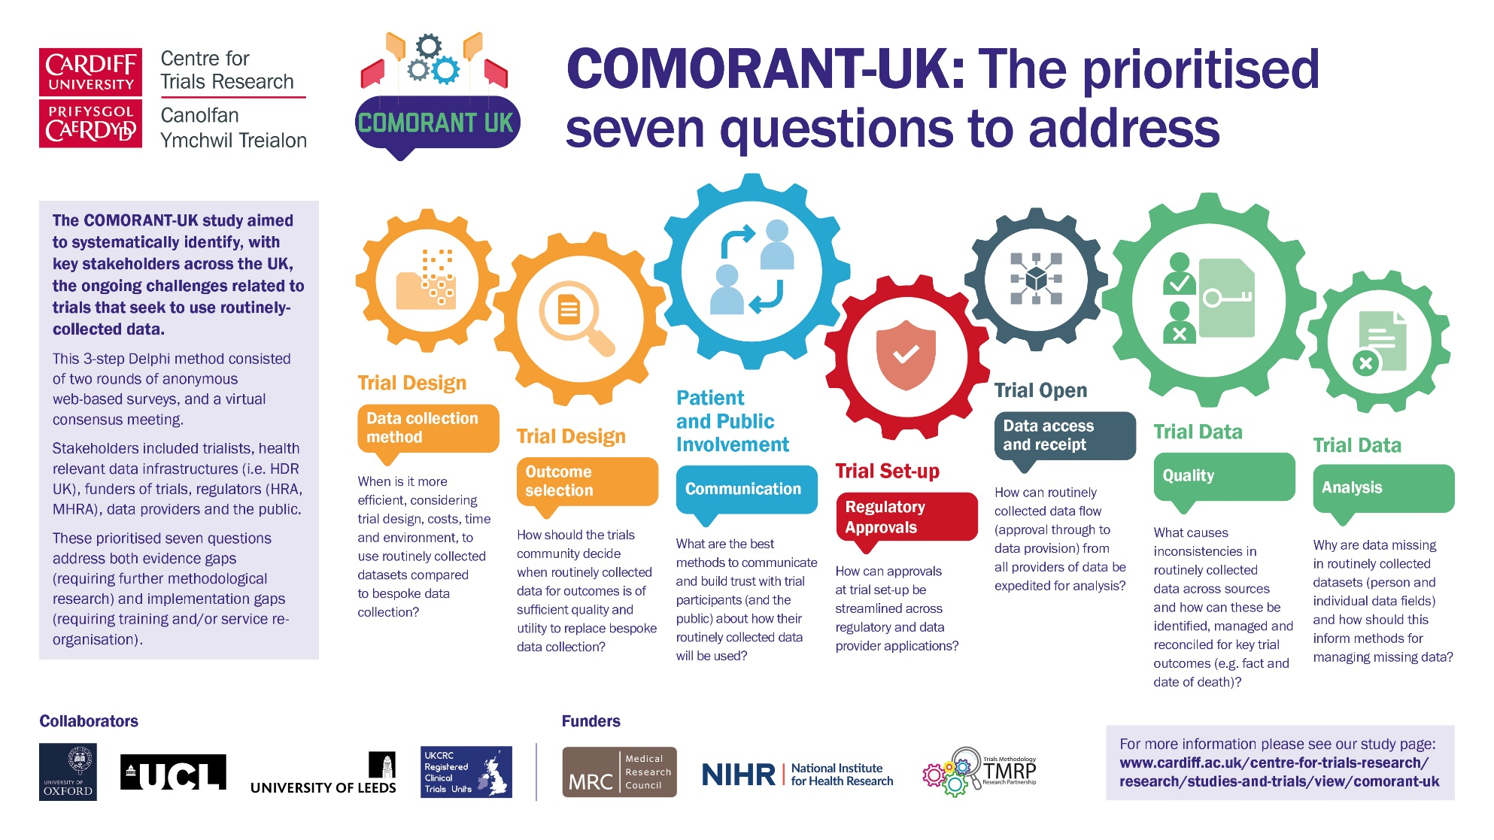
Additional file 4: Infographic. Also, available on study page: https://www.cardiff.ac.uk/centre-for-trials-research/research/studies-and-trials/view/comorant-uk

