Supplementary Materials for: More efficient and inclusive time-to-event trials with covariate adjustment: a simulation study
Raphaëlle Momal¹*, Honghao Li¹*, Paul Trichelair¹, Michael G.B. Blum¹, Félix Balazard^{1$}

1. Owkin Inc., New York, USA
*: contributed equally
$: corresponding author felix.balazard@owkin.com

Supplementary Tables
Quantity | Notation | Values
Cumulative incidence | $$Λ$$ | {0.1, 0.2, 0.3, 0.4, 0.5, 0.6, 0.7, 0.8, 0.9}
C-index | $$C$$ | {0.55, 0.65, 0.75, 0.85}
Weibull shape | $$w$$ | {0.5, 1, 1.5}
Drop-out rate | $$d$$ | {0.01, 0.1}
Treatment hazard ratio | $$hr$$ | {0.4, 0.7}

Table S1: Description of simulation parameters used for parametric simulations of the time-to-event model.

Supplementary Figures
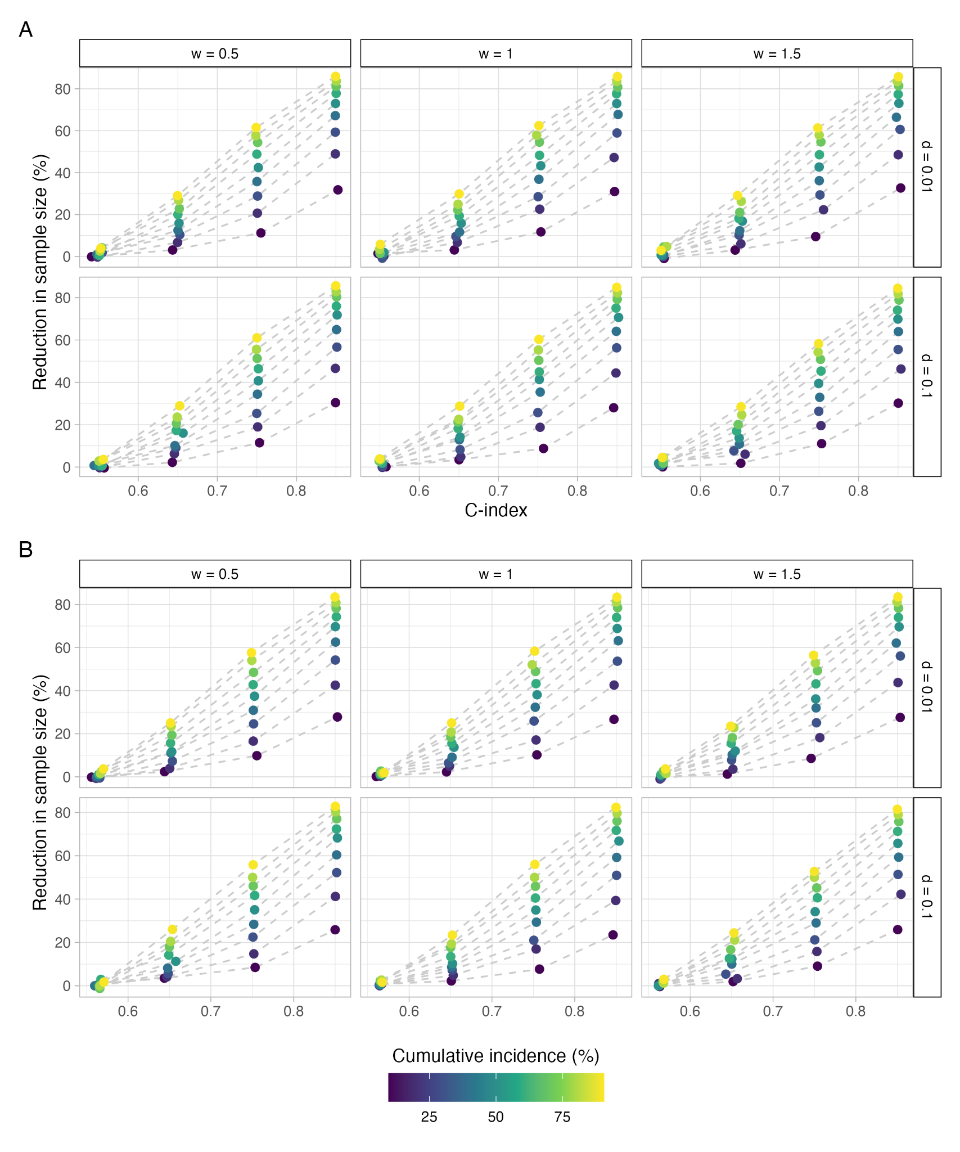
Figure S1: Evolution of $R_{obs}^{2}$ as a function of C-index, cumulative incidence, treatment effect, Weibull shape w and drop-out rate d. A: $θ=0.7$, B: $θ=0.4$.
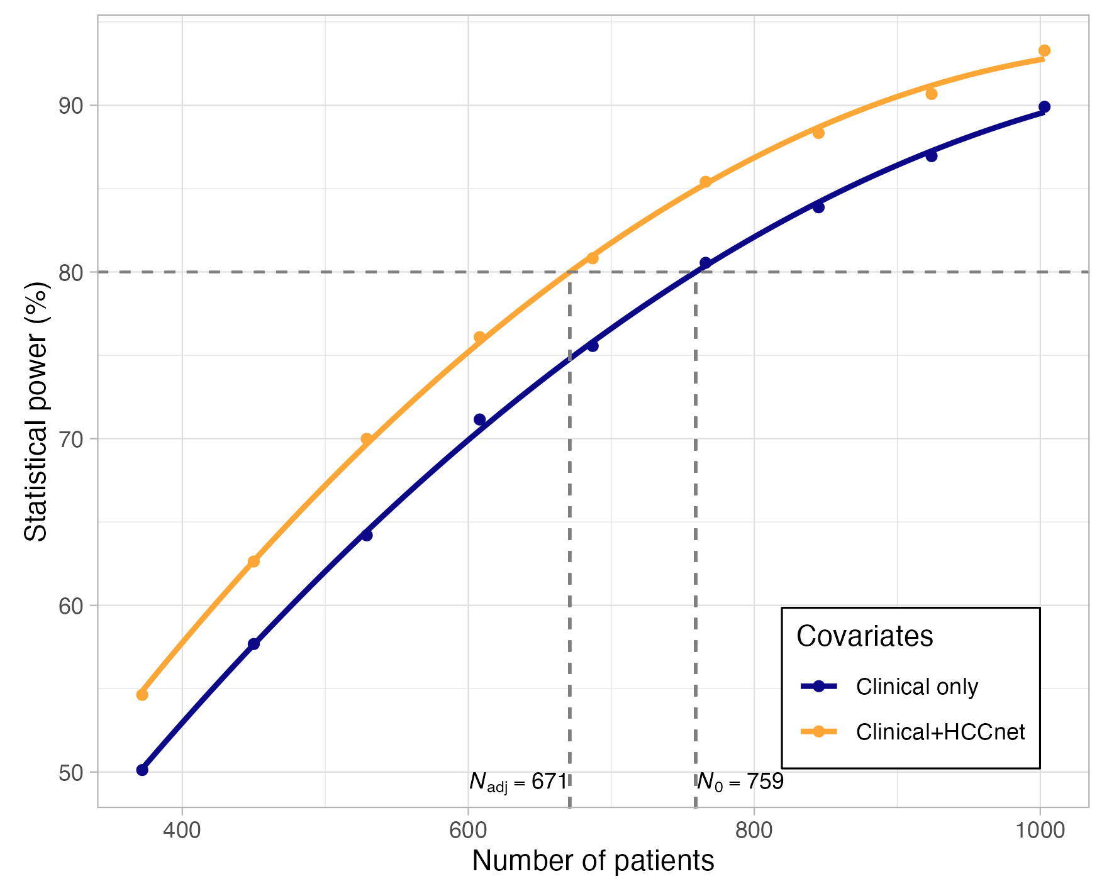
Figure S2: Power curves resulting from adjustment with clinical variables only (tumor staging and ECOG score) or with the additional deep learning HCCnet covariate. Covariates are sampled from the HCC patients of the TCGA dataset.
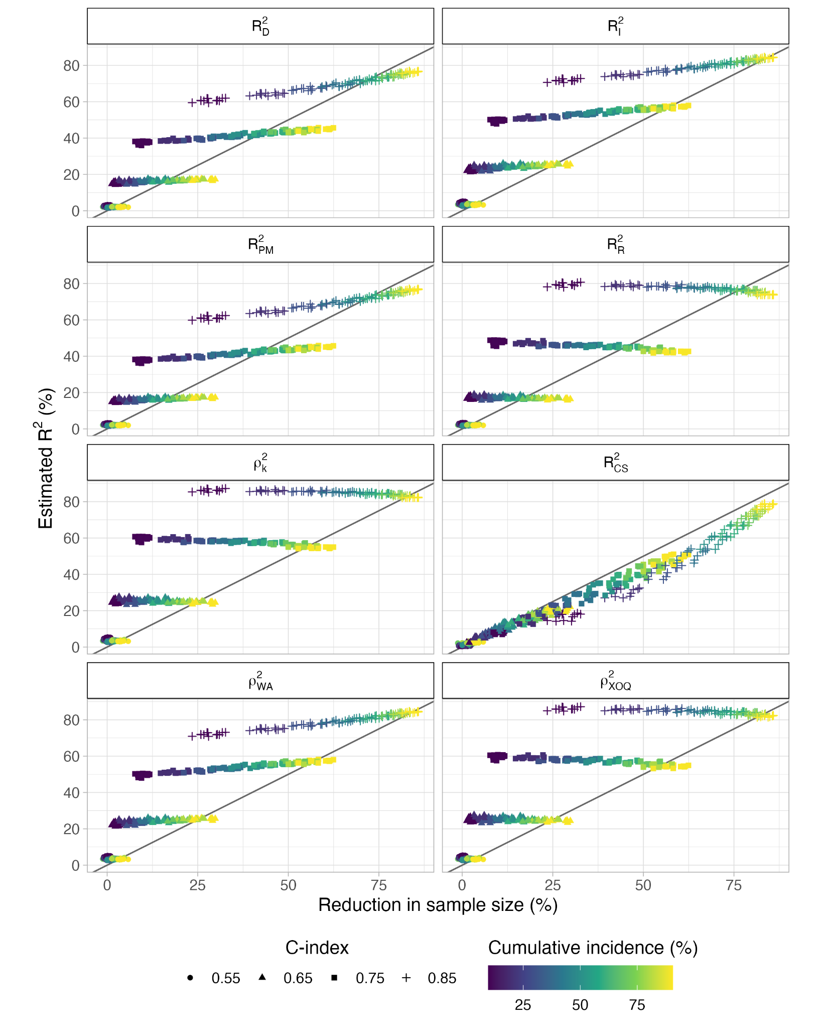
Figure S3: Relationships between proposed $R^{2}$ measures and the reduction of sample size provided by covariate adjustment $R_{obs}^{2}$ over the grid of parameters described in table S1. Each point on each panel corresponds to a unique combination of values for the five parameters in Table S1. Each unique combination of parameters has therefore eight corresponding $R^{2}$ measures. The notations for different measures of $R^{2}$ follow mainly [28]. $R_{CS}^{2}$ is the Cox-Snell $R_{CS}^{2}$ which is related to the likelihood ratio between the model of interest and a null model. $ρ_{k}^{2}$ is a variation of $R_{CS}^{2}$. $R_{D}^{2}$ is a transformation of the $D$ measure. $R_{I}^{2}$ is a variation of $R_{D}^{2}$. $R_{PM}^{2}$ is a measure related to the squared Pearson correlation between the logarithm of transformed survival time and the term $βX$. $R_{R}^{2}$ is the measure proposed by Royston in the same paper of reference [28]. $ρ_{WA}^{2}$ is an approximated version of a more complex measure related to the Weibull model. $ρ_{XOQ}^{2}$ is a measure named after the authors of the paper: Xu, O’Quigley [30].

