Supplementary Figure 1: The number of blood units collected per 10,000 attendances during the feasibility phase of the STRIDES trial whilst varying combinations of interventions were implemented.
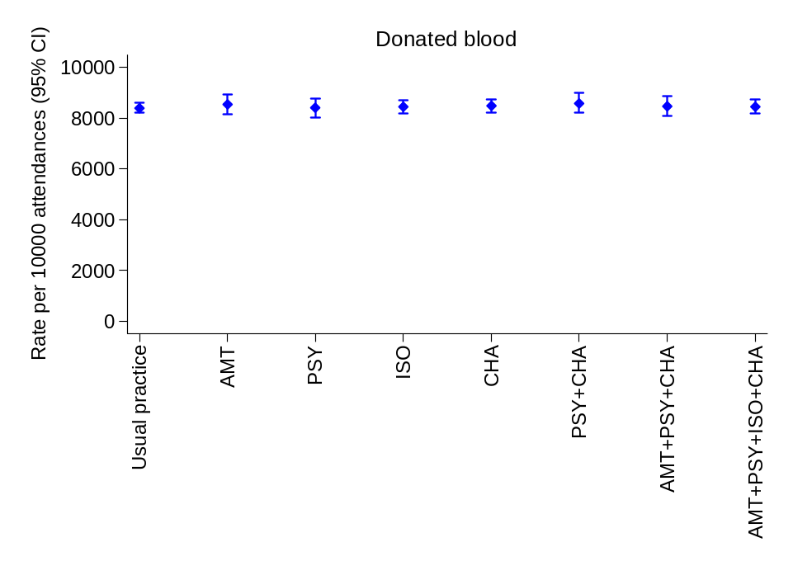

Main effects adjusted for team, month

Intervention | parm | rr_ci | P-value
AMT | 1.amt | 1.01 (0.98, 1.04) | 0.602
PSY | 1.psy | 1.00 (0.98, 1.03) | 0.784
ISO | 1.iso | 1.00 (0.96, 1.03) | 0.803
CHA | 1.cha | 1.02 (0.98, 1.05) | 0.335

Abbreviations: AMT = New Applied muscle tension; PSY = New Psychosocial handout; ISO = New Isotonic drink; CHA = New Chair time.

Supplementary Figure 2: Responses provided by blood donors during the feasibility phase of the STRIDES trial.
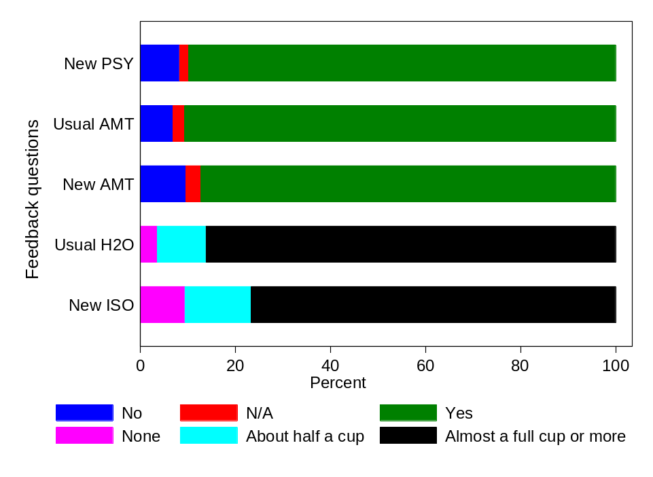

Questions asked:
New PSY Did you read the new information handout today?
Usual AMT Did you practice the muscle tension exercise at the donation clinic today?
New AMT Did you practice the new muscle tension exercise at the donation clinic today?
Usual H2O How much water did you drink at the donation clinic today prior to donating?
New ISO How much did you drink of the new tablet-based drink at the donation clinic today prior to donating?

Abbreviations: AMT = New Applied muscle tension; PSY = New Psychosocial handout; ISO = New Isotonic drink; CHA = New Chair time.

Supplementary Figure 3: Trial schema
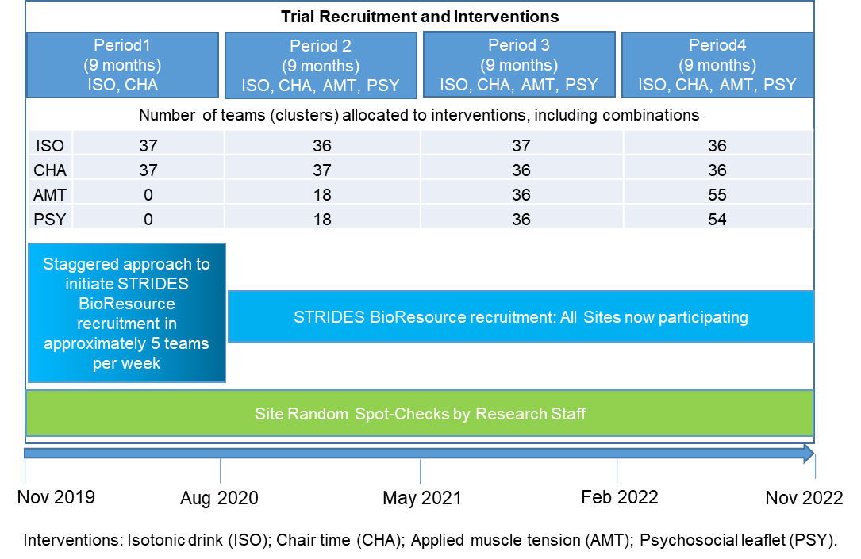

Supplementary Table 1: STRIDES trial randomisation sequence
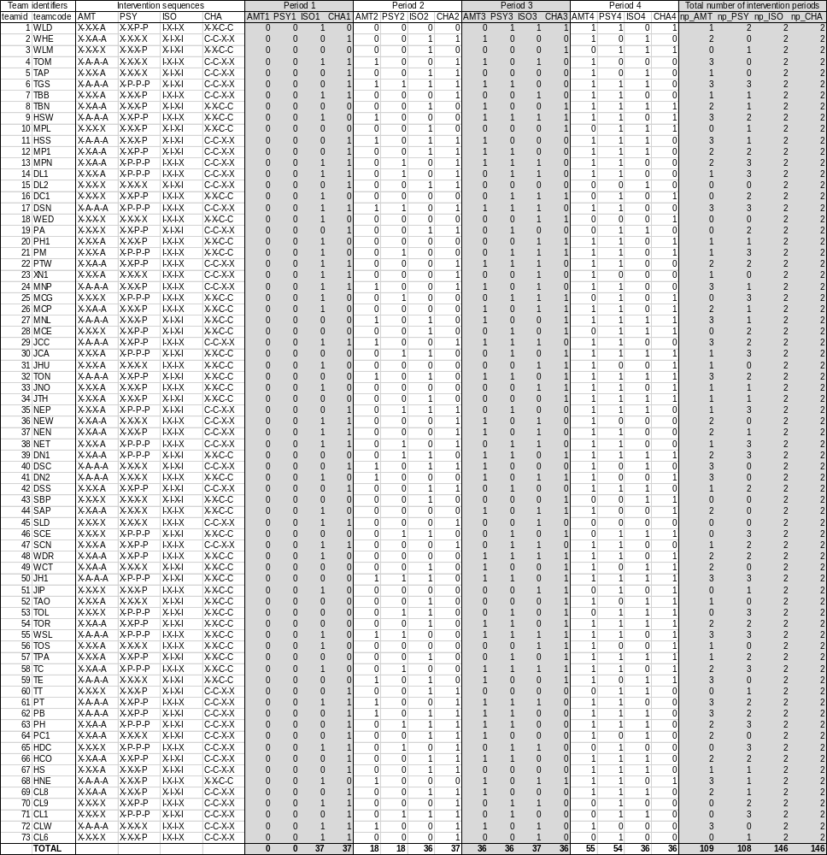

73 sites were randomised to possible sequences for conducting interventions during four 9-month periods (Period 1 to Period 4). The sequences for applied muscle tension (AMT) and psychosocial (PSY) interventions followed a stepped wedge design, whereas the sequences for Isotonic drink (ISO) and time on recovery chair (CHA) interventions followed a cross-over design. Their combination gives a hybrid stepped-wedge, cross-over, factorial trial design, in which sites could conduct one or more interventions (or none) at a period. The indicator variables (0/1) denote the interventions allocated to the sites for each period. The column totals summarise the number of sites conducting each intervention during each period. The row totals summarise the number of periods that each site will have carried out each intervention at the trial conclusion.

