Supplementary File

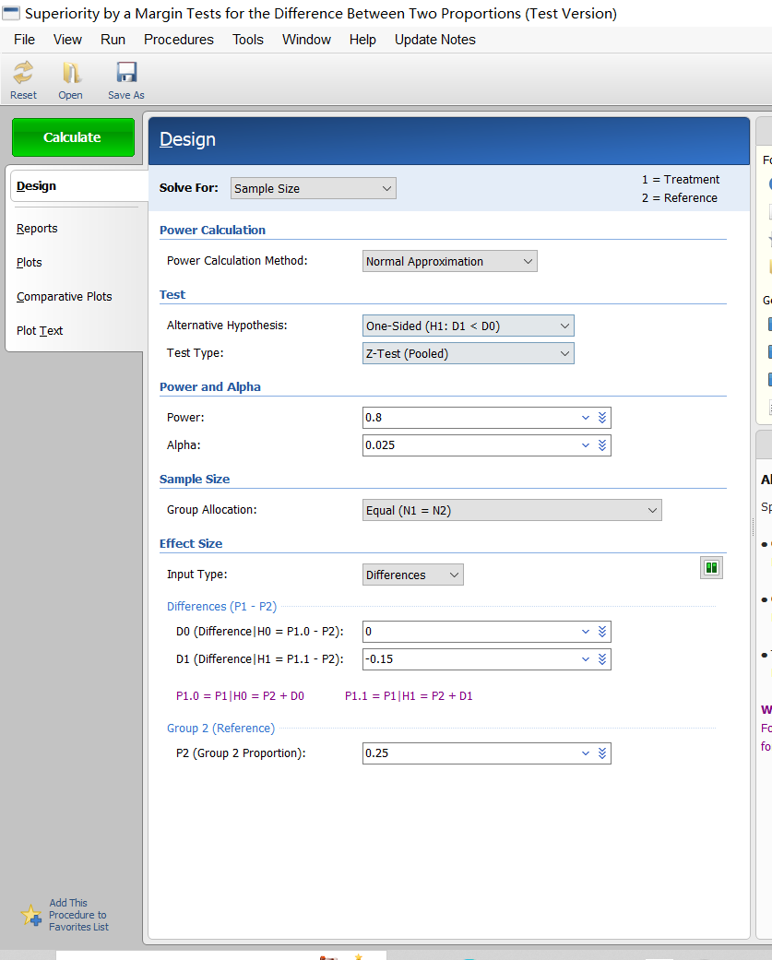
Figure 1.Screenshot of sample size calculation
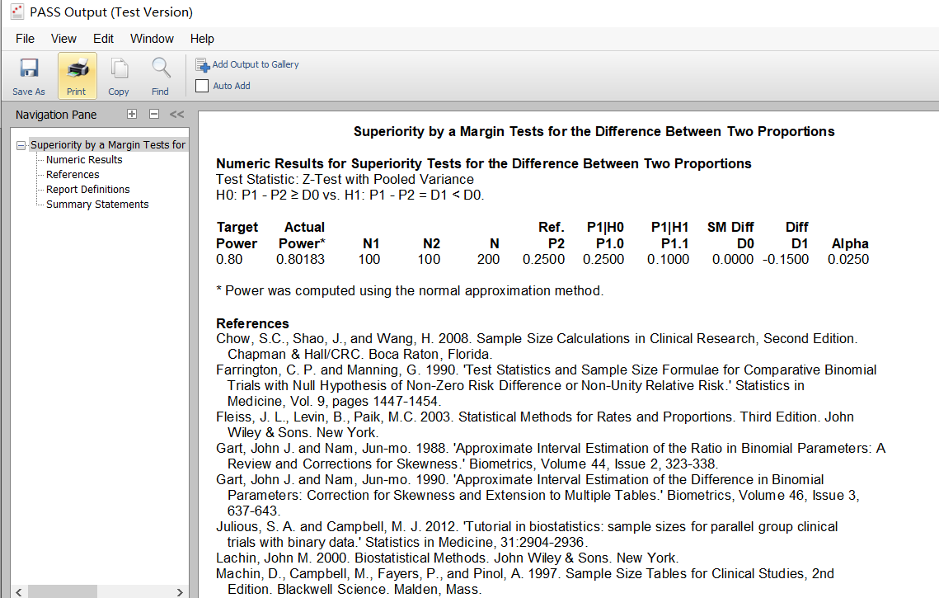

Figure 2.Screenshot of sample size calculation

