Appendices
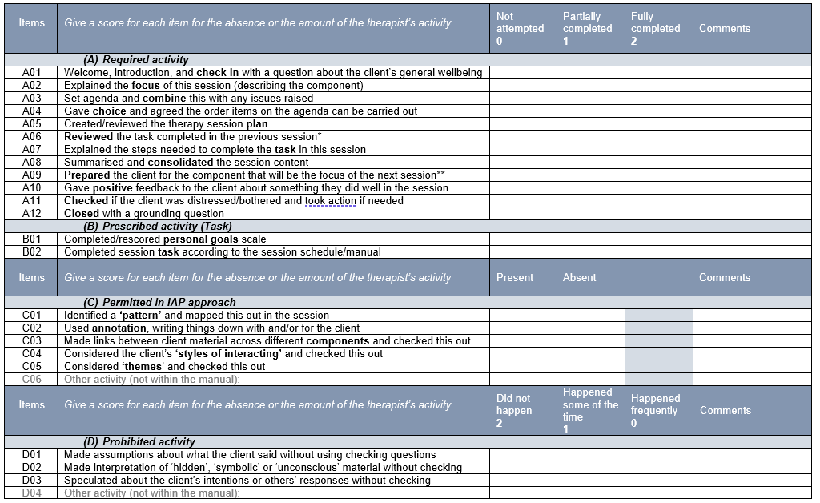
Appendix A – Interpersonal Art Psychotherapy Treatment Fidelity Checklist
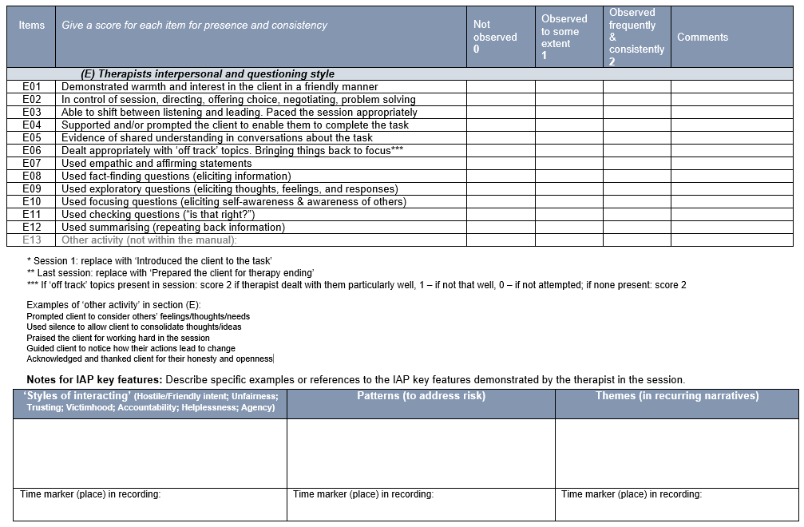

Appendix B – Adapted EQ-5D-3L Questionnaire
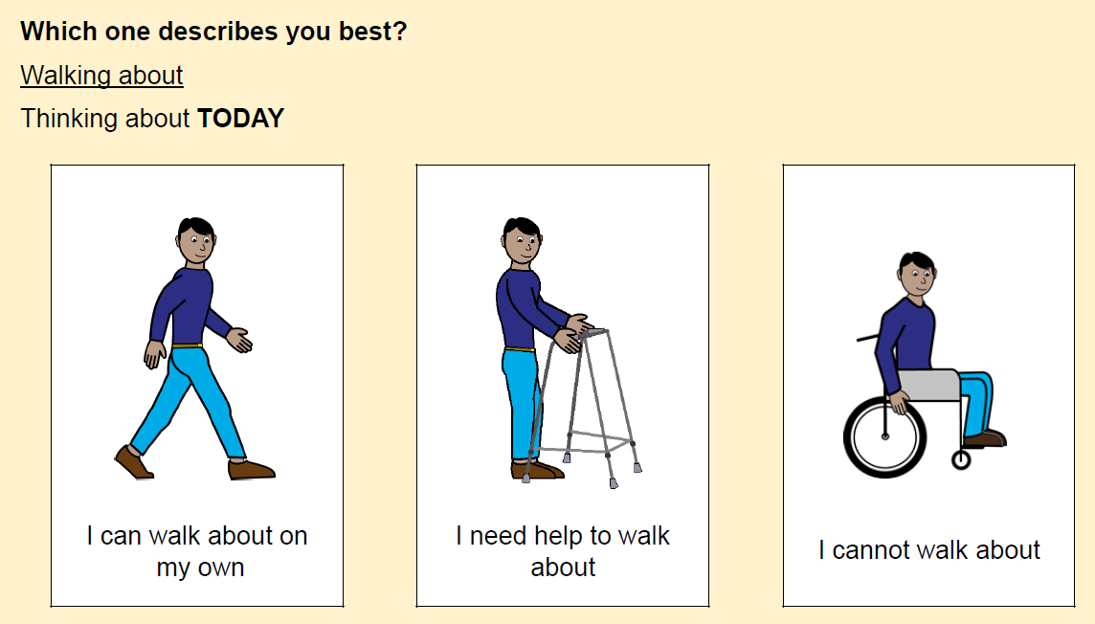
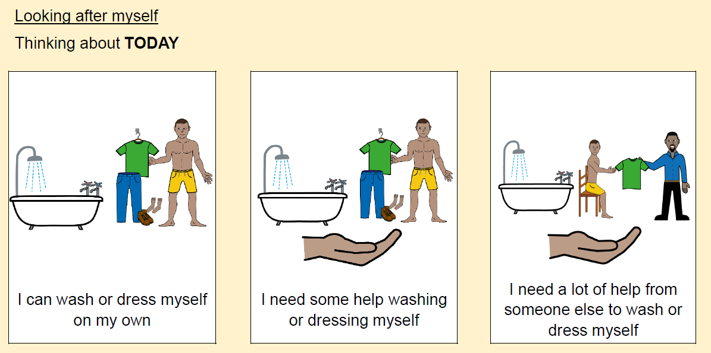
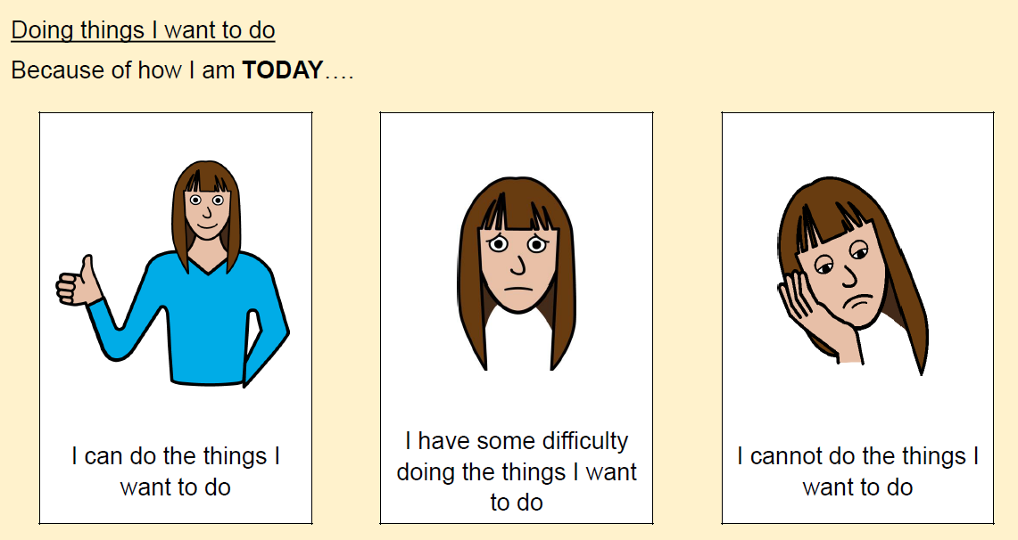
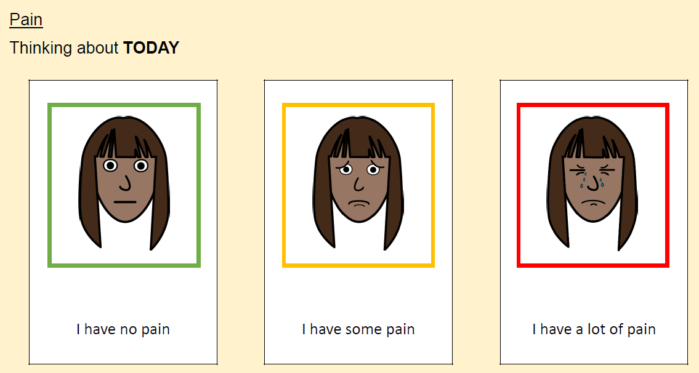
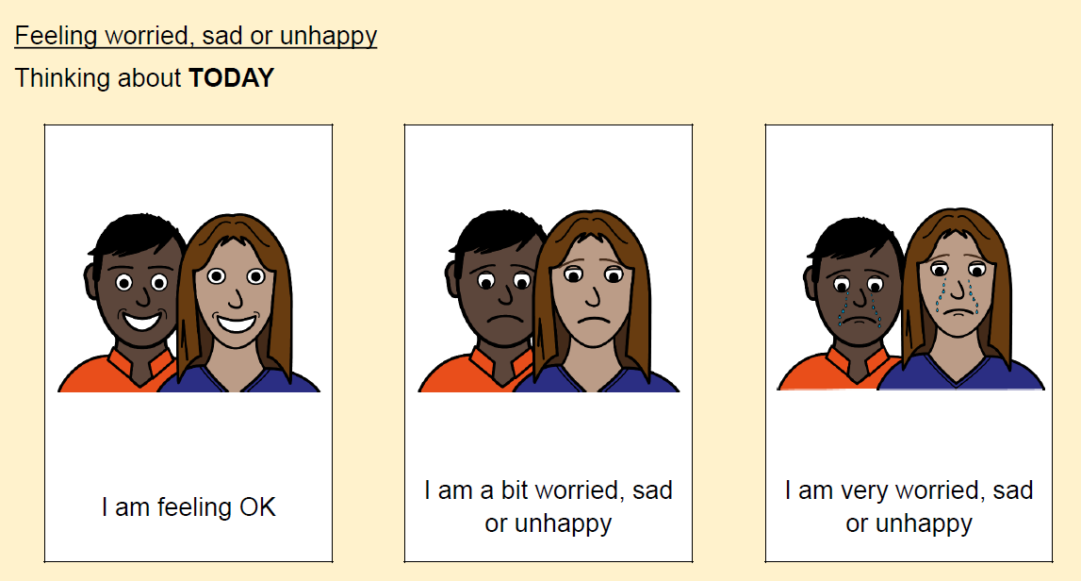
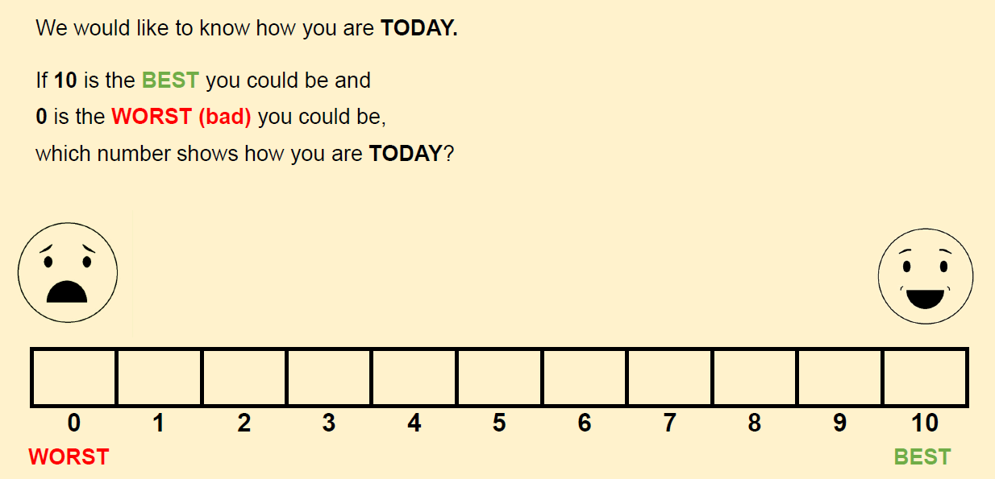

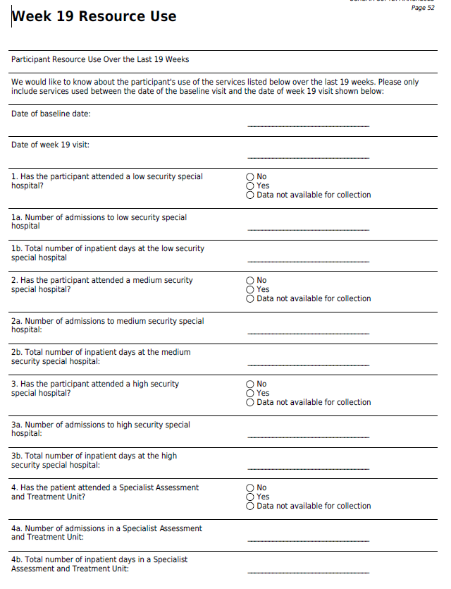
Appendix C – Week 19 and 38 resource use questionnaires

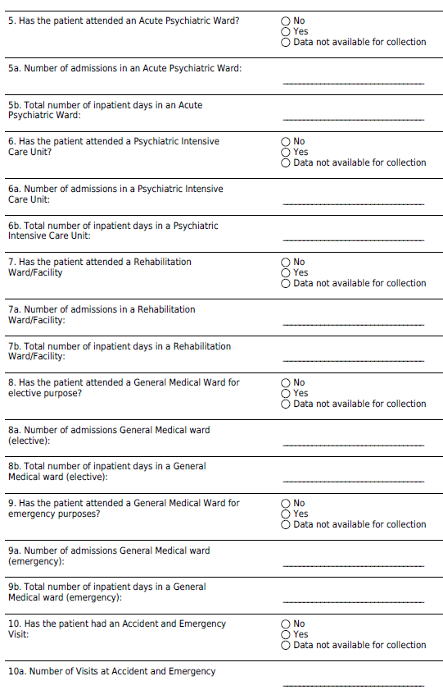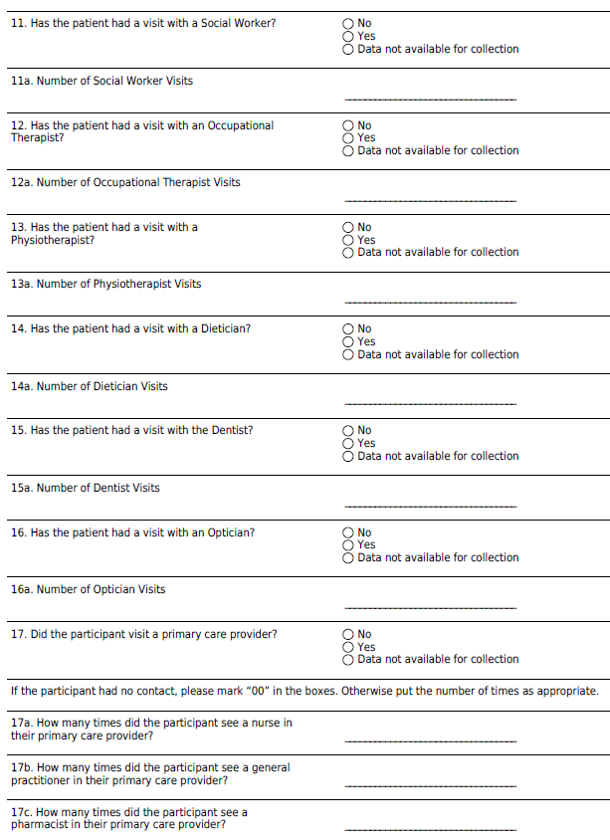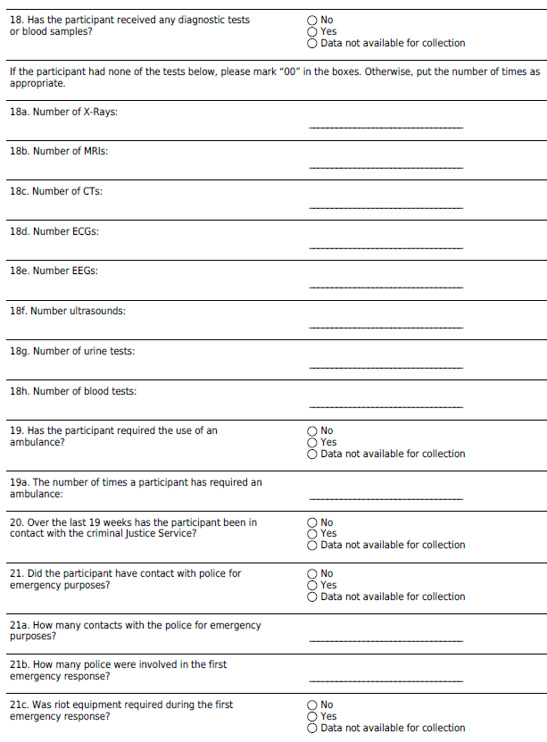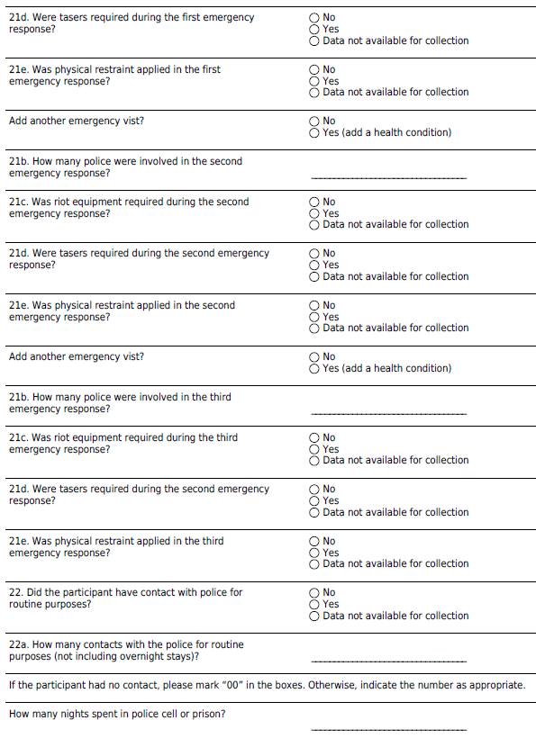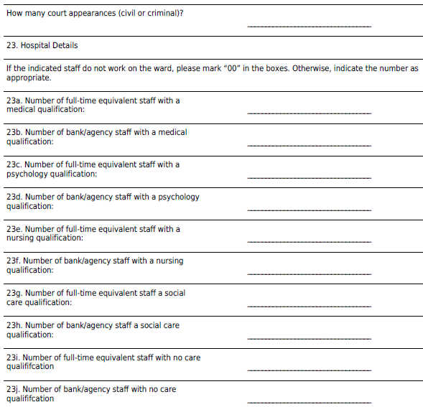

Appendix D: Statistical Analysis Plan (SAP) Guidance [14]
Section/Item | Index | Description | Reported on page #
Section 1: Administrative information
Trial and Trial registration | 1a | Descriptive title that matches the protocol, with SAP either as a forerunner or subtitle,  and trial acronym (if applicable) | 1
 | 1b | Trial registration number | 2
SAP Version | 2 | SAP version number with dates | N/A
Protocol Version | 3 | Reference to version of protocol being used | 3
SAP revisions | 4a | SAP revision history | N/A
 | 4b | Justification for each SAP revision | N/A
 | 4c | Timing of SAP revisions in relation to interim analyses, etc. | N/A
Roles and responsibility | 5 | Names, affiliations, and roles of SAP contributors | 31, 32
Signatures of: | 6a | Person writing the SAP | N/A
 | 6b | Senior statistician responsible | N/A
 | 6c | Chief investigator/clinical lead | N/A
Section 2: Introduction
Background and rationale | 7 | Synopsis of trial background and rationale including a brief description of research question  and brief justification for undertaking the trial | 2,3
Objectives | 8 | Description of specific objectives or hypotheses | 3,4
Section 3: Study Methods
Trial design | 9 | Brief description of trial design including type of trial (e.g., parallel group, multi-arm, crossover, factorial)  and allocation ratio and may include brief description of interventions | 4,5
Randomization | 10 | Randomization details, e.g., whether any minimization or stratification occurred (including stratifying  factors used or the location of that information if it is not held within the SAP) | 5
Sample size | 11 | Full sample size calculation or reference to sample size calculation in protocol  (instead of replication in SAP) | 6
Framework | 12 | Superiority, equivalence, or noninferiority hypothesis testing framework, including which comparisons  will be presented on this basis | 7
Statistical interim analysis and stopping guidance | 13a | Information on interim analyses specifying what interim analyses will be carried out  and listing of time points | 7
 | 13b | Any planned adjustment of the significance level due to interim analysis | N/A
 | 13c | Details of guidelines for stopping the trial early | N/A
Timing of final analysis | 14 | Timing of final analysis, e.g., all outcomes analysed collectively or timing stratified  by planned length of follow-up | 7
Timing of outcome assessments | 15 | Time points at which the outcomes are measured including visit “windows” | 7,8
Section 4: Statistical Principals
Confidence intervals and P values | 16 | Level of statistical significance | 8
 | 17 | Description and rationale for any adjustment for multiplicity and, if so, detailing how the type 1 error  is to be controlled | 8
 | 18 | Confidence intervals to be reported | 8
Adherence and Protocol deviations | 19a | Definition of adherence to the intervention and how this is assessed including extent  of exposure | 8, 9
 | 19b | Description of how adherence to the intervention will be presented | 8, 9
 | 19c | Definition of protocol deviations for the trial | 9
 | 19d | Description of which protocol deviations will be summarized | 9
Analysis populations | 20 | Definition of analysis populations, e.g., intention to treat, per protocol,  complete case, safety | 9
Section 5: Trial Population
Screening data | 21 | Reporting of screening data (if collected) to describe representativeness  of trial sample | 10
Eligibility | 22 | Summary of eligibility criteria | 10, 11
Recruitment | 23 | Information to be included in the CONSORT flow diagram | 12
Withdrawal/ Follow-up | 24a | Level of withdrawal, e.g., from intervention and/or from follow-up | 12
 | 24b | Timing of withdrawal/lost to follow-up data | 12, 13
 | 24c | Reasons and details of how withdrawal/lost to follow-up data will be presented | 12, 13
Baseline patient characteristics | 25a | List of baseline characteristics to be summarized | 13
 | 25b | Details of how baseline characteristics will be descriptively summarized | 19
Section 6: Analysis
Outcome definitions |  | List and describe each primary and secondary outcome including details of:
 | 26a | Specification of outcomes and timings. If applicable include the order of importance of primary  or key secondary end points (e.g., order in which they will be tested) | 13-18
 | 26b | Specific measurement and units (e.g., glucose control, hbA1c [mmol/mol or %]) | 13-18
 | 26c | Any calculation or transformation used to derive the outcome (e.g., change from baseline, QoL score,  Time to event, logarithm, etc.) | 13-18
Analysis methods | 27a | What analysis method will be used and how the treatment effects will be presented | 18-21
 | 27b | Any adjustment for covariates | 21
 | 27c | Methods used for assumptions to be checked for statistical methods | 21, 22
 | 27d | Details of alternative methods to be used if distributional assumptions do not hold, e.g., normality,  proportional hazards, etc. | 22
 | 27e | Any planned sensitivity analyses for each outcome where applicable | 23
 | 27f | Any planned subgroup analyses for each outcome including how subgroups are defined | 22
Missing data | 28 | Reporting and assumptions/statistical methods to handle missing data (e.g., multiple imputation) | 23
Additional analyses | 29 | Details of any additional statistical analyses required, e.g., complier-average causal effect10 analysis | 24-27
Harms | 30 | Sufficient detail on summarizing safety data, e.g., information on severity, expectedness, and causality;  details of how adverse events are coded or categorized; how adverse event data will be analysed,  i.e., grade 3/4 only, incidence case analysis, intervention emergent analysis | 23-24
Statistical software | 31 | Details of statistical packages to be used to carry out analyses | 28
References | 32a | References to be provided for nonstandard statistical methods | 32-37
 | 32b | Reference to Data Management Plan | N/A
 | 32c | Reference to the Trial Master File and Statistical Master File | N/A
 | 32d | Reference to other standard operating procedures or documents to be adhered to | 32
Abbreviations: CONSORT, Consolidated Standards of Reporting Trials; hbA1c, haemoglobin A1c; QoL, quality of life; SAP, statistical analysis plan.

