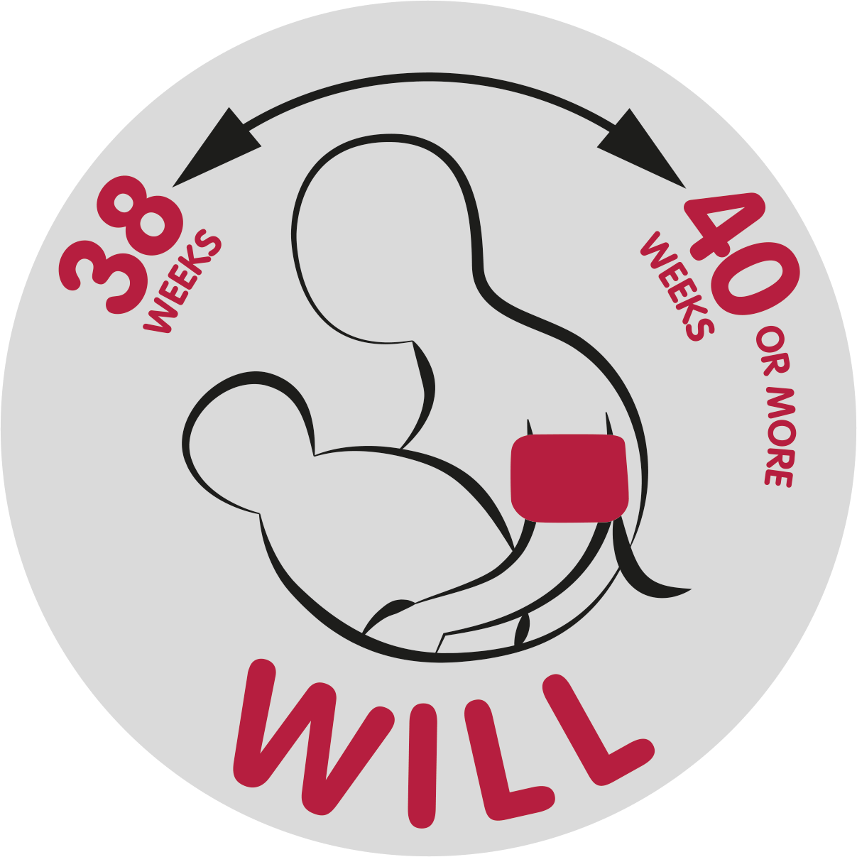
Terms of reference
This document contains the terms of reference (TOR) for the Patient and Public Involvement (PPI) Group for The WILL Trial (WILL – When to Induce Labour to Limit risks in pregnancy hypertension).
WILL is funded by National Institute for Health Research – Health Technology Assessment programme (NIHR HTA).
WILL is co-sponsored by Kings College London and Guys and St Thomas’s Hospital (KCL/GSTT).
WILL’s Chief Investigator (CI) is Professor Laura Magee
WILL is managed by Birmingham Clinical Trials Unit – University of Birmingham (BCTU), and the Senior Trial Manager is Katie Kirkham
WILL Lead Research Midwife and PPI Officer is Sue Tohill
Senior Research Midwife is Julie Wade

Purpose / role of the group:
This PPI Group was established in January 2022. Its purpose is to be a centralised contact for Patient and Public Involvement for the WILL Trial.
Its aims are:
- To enable lay members to influence clinical research within WILL
- To identify opportunities for the PPI group to improve the participant experience in WILL
- To enable lay members to influence the design and objectives of WILL
- To enable PPI group members to have an active partnership with researchers working in the area of Reproductive and Child Health
- To provide a platform for researchers to access patients and members of the public who wish to be involved with clinical research and specifically WILL
- To advise on the most suitable ways to engage the public and raise awareness of WILL
The PPI Officer will facilitate group activities and help foster relationships between researcher and group members to achieve the above.

Membership
The group will be comprised of individuals who wish to be involved in clinical research but not necessarily as research participants. They may act as a member of a research project steering group, be an advisor for the research team, or help review the project’s literature such as patient information sheets. Anyone can be a PPI representative for any research study / trial, unless they are actually taking part or intend to take part in that particular trial as a participant.

Membership to this group is open to:
- Research participants on past, future or existing clinical research studies
- Carers and parents of research participants
- Patients and members of the public who are not participating in a research study but with an interest in clinical research.

Members will be expected to:
- Make a reasonable contribution of time to attend meetings
- Make an effort to read through information sent in advance of meetings
- Offer constructive feedback and take an active role within group discussions
- Make honest mileage and expenses claims, using original receipts where possible.
- Inform the PPI officer prior to meetings if they are unable to attend.

Terms of reference (TOR)
The group will:
- respect anonymity of discussion
- take into account all representative views
- determine areas of particular priority for discussion
- be informed of the research topics prior to the meeting
- be informed of the attendance of specialists / researchers prior to the meeting

Any reasonable travel costs to the lay members will be met by the WILL Trial.
Group members will also be compensated for time spent attending group / study specific meetings.
In recognition of data protection, members who use their personal emails will be blind carbon copied to protect their personal details.
These terms of reference are related specifically to the WILL PPI Group.

Accountability
Members of the PPI Group are accountable to the PPI officer while acting within the role of group member and the Chief Investigator for WILL. Whilst in this capacity, they will be referred to as PPI representatives.

Review
The TOR will be initially reviewed with the PPI Group members and thereafter the group will review the TOR annually. The PPI Officer will compile an annual report of PPI activity which will be used within the NIHR HTA progress reports.

Ways of working
- Research conducted by the WILL Trial Team can be discussed within the group.
- Group members will have the opportunity to share their current experiences of working on research projects. They will be able to identify areas where additional training may be required, and can access the group for shared advice and support.

Meetings
Adequate information about the event will be given to group members one week prior to the meeting so they can make informed decisions on whether to attend. This will include information on the context of the event and purpose of the day. Participants are under no obligation to attend. The PPI group has agreed that a minimum of 3 PPI representatives must confirm planned attendance for the meeting to take place (a quorum).
Meetings will be held initially four times a year with ongoing reviews on their frequency. They will be held via video/tele conference.
Meetings will be chaired by either the PPI Officer or a WILL Team member. Group members can assume the role of secretary or chair of the meetings. They will be supported in this role by the PPI Officer.
The PPI Officer will generate an agenda which will include topics to be discussed at the meeting. Group members are encouraged to inform the PPI Officer of any topics they would like raised at the meeting.
The agenda will be generated by;
- Review of the minutes of the last meeting
- Group members requesting support or that want to share their experiences about specific studies they have worked on.
- Researchers on WILL who want to access PPI advice
- Generic items that have arisen within the WILL Trial
- Any other business
The PPI Officer will write and circulate the minutes to the group members within a week. Presentations can also be attached to the minutes with the permission of the author.

Sharing information
Information sharing will primarily be though email contact, unless specified differently. Lengthy meeting papers should be sent with no less than 1 week notice and are available as electronic or paper copies. Short documents (<2 pages) can be made available on the day of the meeting although efforts to send them prior to the meeting should be made.

