Z-drug Quantity Defaults
Pre-Intervention Period Z-drug Quantity Defaults
Drug | Dosages | Quantity | Number of Refills | Total Days Supply
zolpidem (Ambien) | 5 mg, 10 mg | 90 | 1 | 180
zolpidem (Ambien CR) | 6.25 mg | 30 | 2 | 90
zolpidem (Ambien CR) | 12.5 mg | 90 | 1 | 180
eszopiclone (Lunesta) | 2 mg, 3 mg | 30 | 2 | 90
zaleplon (Sonata) | 10 mg | 30 | 2 | 90

Intervention Period Z-Drug Quantity Defaults
(Z-drug Quantity Default and Combined arms only)
Drug | Dosages | Quantity | Number of Refills | Total Days Supply
zolpidem (Ambien) | 5 mg, 10 mg | 10 | 0 | 10
zolpidem (Ambien CR) | 6.25 mg | 10 | 0 | 10
zolpidem (Ambien CR) | 12.5 mg | 10 | 0 | 10
eszopiclone (Lunesta) | 1 mg*, 2 mg, 3 mg | 10 | 0 | 10
zaleplon (Sonata) | 5 mg*, 10 mg | 10 | 0 | 10
* eszopiclone 1 mg and zaleplon 5 mg were not included in the preference list and had no default dispense quantity prior to the intervention period. These dosages were added to clinicians’ preference list and a default dispense quantity was created for the trial.

Redirection + Accountable Justification Alert
CASE 1: SHORT-TERM USE PATIENT WITHOUT A CBT-I REFERRAL
During an encounter with a patient who has been prescribed 180 or fewer days of Z-drugs in the past 365 days AND CBT-I is not in the current order and has not been prescribed in the previous 180 days, the following displays when a Z-drug is added to the order:
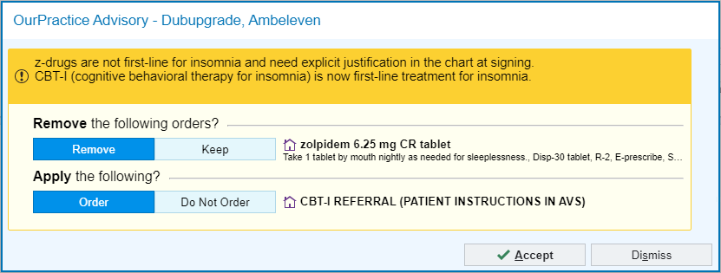

If Keep Z-drug order and Do Not Order CBT-I Referral are selected, the following displays at order signing:
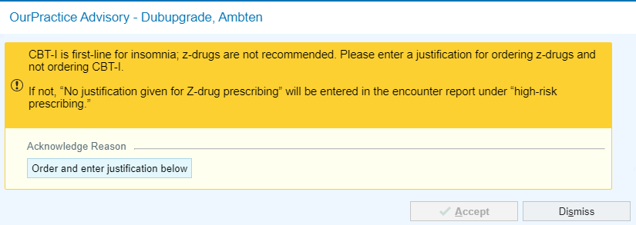

OR If Keep Z-drug order and Order CBT-I Referral are selected, the following displays at order signing:

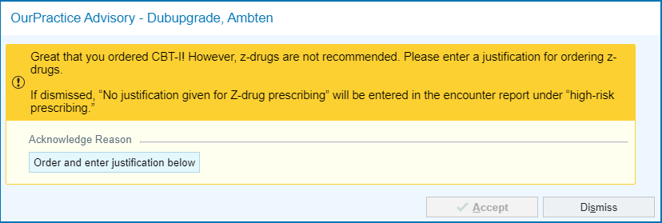
OR If Remove Z-drug order is selected:
[No alert displays]

CASE 2A: SHORT-TERM USE PATIENT WITH A CBT-I REFERRAL RECENTLY ORDERED
During an encounter with a patient who has been prescribed 180 or fewer days of Z-drugs in the past 365 days AND CBT-I Referral has been ordered in the previous 180 days, the following displays when a Z-drug is added to the order:

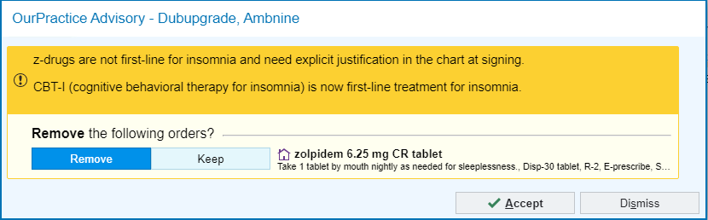

If Keep Z-drug order is selected, the following displays at order signing:
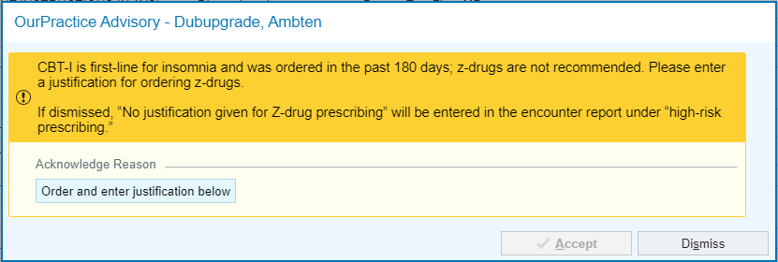
OR If Remove Z-drug order is selected:
[No alert displays]

CASE 2B: SHORT-TERM USE PATIENT WITH A CBT-I REFERRAL IN CURRENT ORDER
During an encounter with a patient who has been prescribed 180 or fewer days of Z-drugs in the past 365 days AND CBT-I Referral is in the current order, the following displays if a Z-drug is added to the order:
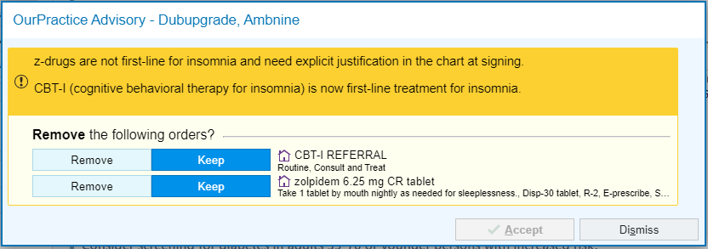

If Keep Z-drug order is selected, the following displays at order signing:
OR If Remove Z-drug order is selected:
[No alert displays]

CASE 3: LONG-TERM USE PATIENT WITHOUT A CBT-I REFERRAL
During an encounter with a patient who has been prescribed more than 180 days of Z-drugs in the past 365 days AND CBT-I Referral is not in the current order and has not been prescribed in the previous 180 days, the following displays when a Z-drug is added to the order:
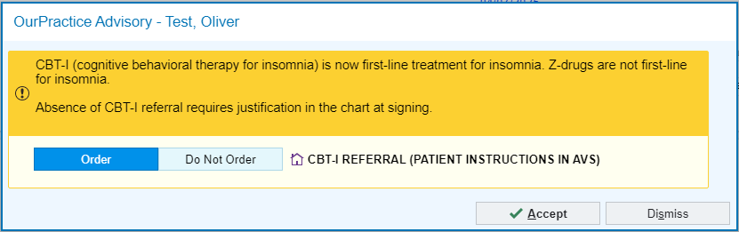

If Do Not Order CBT-I Referral is selected, the following displays at order signing:
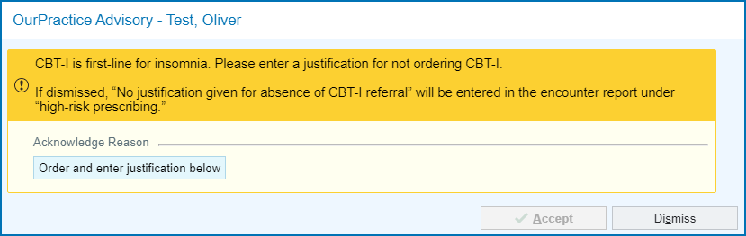

OR If Order CBT-I Referral is selected, the following displays at order signing:
[No alert displays]

CASE 4: LONG-TERM USE PATIENT WITH A CBT-I REFERRAL
During an encounter with a patient who has been prescribed more than 180 days of Z-drugs in the past 365 days AND CBT-I Referral is in the order or has been prescribed in the previous 180 days, the following displays when a Z-drug is added to the order:

[No alert displays]

Concomitant Intervention Alert
The following alert may appear for clinicians assigned to receive the Redirection + Accountable Justification alerts in the SOMNUS trial who are also enrolled in the High-risk Polypharmacy trial during overlapping intervention periods occurring at Northwestern Medicine.
