Supplementary material for:

Treatment guided by cerebral oximetry in mechanically ventilated newborns: a statistical analysis plan for step one of the SafeBoosC-IIIv randomised clinical trial

For updated information and the full protocol, central data monitoring plan, and data monitoring safety committee charter, please see www.safeboosc.eu

Table of contents
Definitions of serious adverse events 3
Sample size 5
Guidelines for the Content of Statistical Analysis Plans in Clinical Trials 11
CONSORT flow diagram 15
Baseline table 16
Outcome table 19

Definitions of serious adverse events
One or more serious adverse events within 90 days of randomisation: death from any cause, bronchopulmonary dysplasia, any brain injury diagnosed by imaging (if both ultrasound and MRI are available, MRI will be prioritized), seizures treated with antiepileptic medicine, hemodynamic insufficiency that needs cardiovascular support, spontaneous bowel perforation or necrotizing enterocolitis defined as Bell’s grade 2 or more, extracorporeal membrane oxygenation treatment, renal replacement therapy, and nosocomial infection.

The diagnoses of any of the serious adverse events will be made by the outcome assessor using clinical records, however, the following definitions are recommended.

The following neonatal outcomes expressed as the grades outlined below or above
(adapted from: European Newborn Study: Early Markers for a Better Life-ENSEMBLE;
International Neonatal Consortium (doi: 10.1136/archdischild-2019-317399); European Standards of Care for Newborn Care (EFCNI)).

Bronchopulmonary dysplasia (grade 2):
- Supplemental oxygen at 28 days AND need for 22-30% oxygen at 36 weeks PMA in infants born <32 weeks' gestation; need for 22-30% oxygen by 56 days postnatal age in infants born >32 weeks' gestation; need for 22-30% oxygen at discharge. Note: For conversion of oxygen administered by different modalities to FiO2, see http://nicutools.org/MediCalcs/ActualO2.php3.

Brain injury documented either by cranial ultrasound (CU), magnetic resonance imaging (MRI), or computed tomography (CT):
- Peri-intraventricular hemorrhage (grade 2 or more): Hemorrhage occupying less than 50% of the ventricle volume.
- Periventricular haemorrhagic (venous) infarction.
- Post-haemorrhagic ventricular dilatation: ventricular dilatation with ventricular index > 4mm above the 97th percentile or anterior horn with > 6 mm or need of CSF removal (drain, shunt, reservoir, lumbal puncture).
- Periventricular leukomalacia (grade 2) (CUs diagnosis): Transient periventricular echodensities evolving into small, localized frontal-parietal cysts or persistent diffuse echodensities.
- Extensive punctate white matter injury (MRI diagnosis).
- Perinatal ischemic stroke.
- Acute HI brain damage:
  - (CU diagnosis): i) brain swelling; ii) bilateral-symmetric basal ganglia-thalamic injury or focal (asymmetric) hyperechoic areas; iii) laminar cortical necrosis; iv) periventricular and/or subcortical white matter injury
  - (MRI diagnosis): i) Central and/or peri-rolandic gray matter damage; ii) Hypoxic-ischemic injury in watershead areas.
- Cerebellar injury (ischemic-haemorrhagic) involving vermis or >1/3 of hemisphere.
- Big extra-axial bleeding or parenchymal bleeding/contusion with/without midline shift.
- Other: imaging findings related to CNS acquired infection.

Neonatal seizures that need for treatment
- Neonatal epileptic seizure (grade 2): electroencephalogram (EEG)-proven seizures that are controlled with one anti-seizure drug (no recurrence within three days after treatment).
- Neonatal Convulsions (grade 3): Suspected seizures (no EEG) uncontrolled with one anti-seizure drug (recurrence within three days after treatment or requiring two or more anti-seizure drugs).

Hemodynamic insufficiency
- Persistent hypotension (grade 3): hypotension affecting perfusion; requiring major care change (e.g., vaso-active drugs or hydrocortisone).
- Clinical signs of compromised perfusion regardless blood pressure (raised serum lactate, poor urine output, central-to-peripheral temperature gap, prolonged skin refill-time, echocardiographic parameters) requiring major care change (e.g., vaso-active drugs or hydrocortisone).

Bowel AE
- Neonatal spontaneous intestinal perforation (grade 3): presence of spontaneous intestinal perforation (SIP), non-urgent medical stabilization and surgical intervention indicated.
- NEC (Bell’s stage 2): confirmed NEC with lack of bowel sounds, pain, and tenderness in the abdomen, low or no intestinal movement, presence of gasfilled spaces in the intestinal walls, including stage 1 clinical signs (lethargy, vomiting, bloody stools abdominal bloating, slow heart rate and unstable temperature).

Renal replacement therapy
- Infants receiving any of the following therapies: peritoneal dialysis, hemodialysis, or hemofiltration.

Nosocomial infection
- Late-onset sepsis: Defined as antibiotics prescribed after 72 hours and given for 5 days or more.
- Invasive mechanical ventilation (endotracheal or tracheostomy)-related infection

Sample size
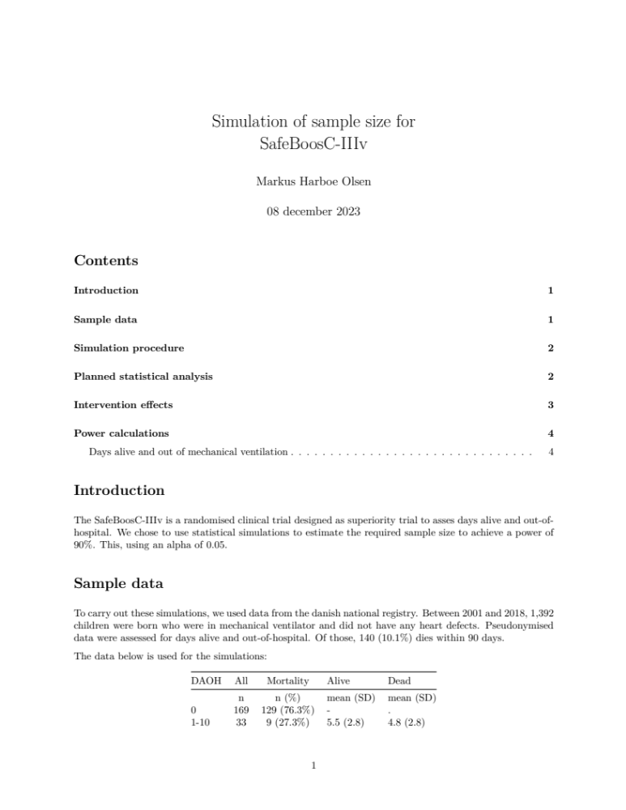

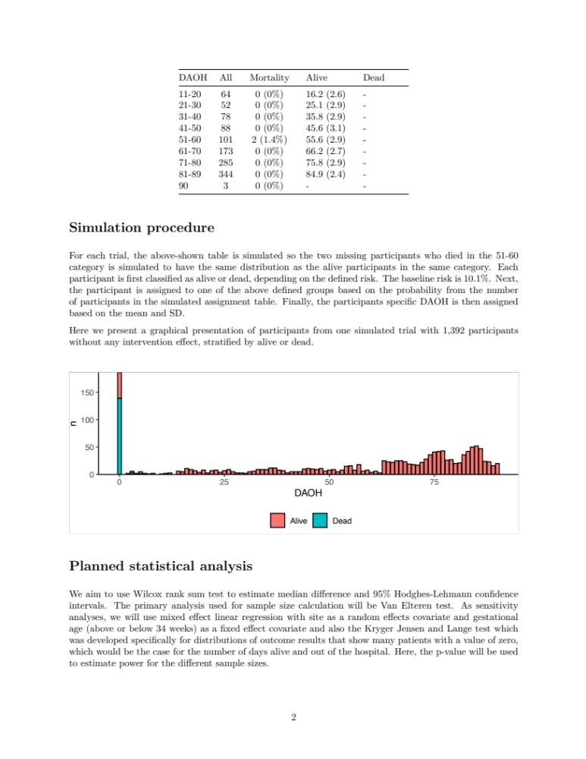
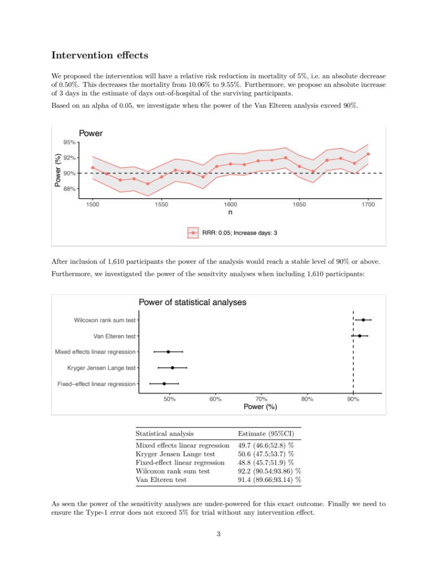
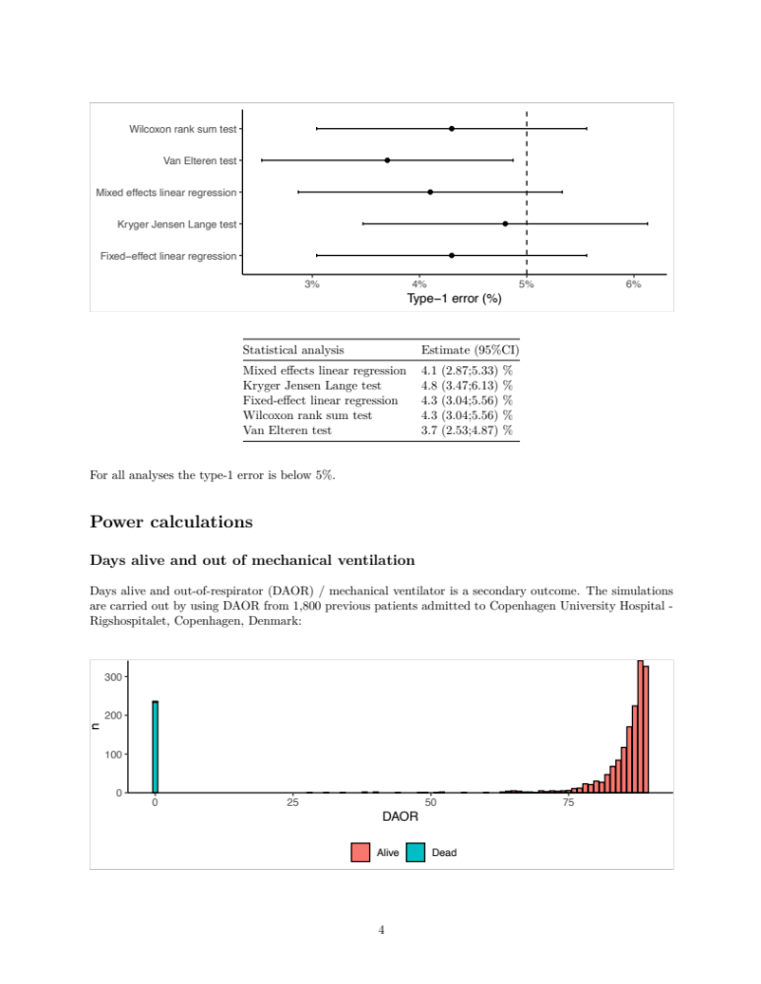
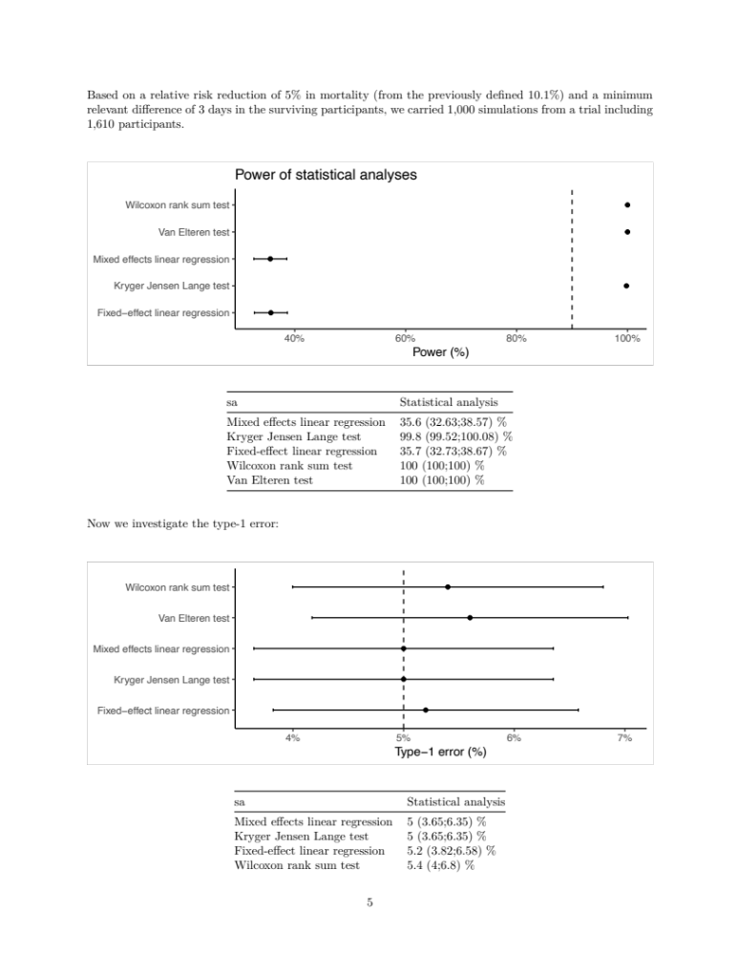


Guidelines for the Content of Statistical Analysis Plans in Clinical Trials

Statistical Analysis Plan (SAP) Checklist v 1.0 2019
Section/Item | Index | Description | Reported on page #
Section 1: Administrative information
Trial and Trial registration | 1a | Descriptive title that matches the protocol, with SAP either as a forerunner or subtitle,  and trial acronym (if applicable) | 1
 | 1b | Trial registration number | 7
SAP Version | 2 | SAP version number with dates | 9
Protocol Version | 3 | Reference to version of protocol being used | 9
SAP revisions | 4a | SAP revision history | NA
 | 4b | Justification for each SAP revision | NA
 | 4c | Timing of SAP revisions in relation to interim analyses, etc. | NA
Roles and responsibility | 5 | Names, affiliations, and roles of SAP contributors | 1-5, 19, 22
Signatures of: | 6a | Person writing the SAP | 22
 | 6b | Senior statistician responsible | 19
 | 6c | Chief investigator/clinical lead | 19
Section 2: Introduction
Background and rationale | 7 | Synopsis of trial background and rationale including a brief description of research question  and brief justification for undertaking the trial | 8-9
Objectives | 8 | Description of specific objectives or hypotheses | 8-9
Section 3: Study Methods
Trial design | 9 | Brief description of trial design including type of trial (e.g., parallel group, multi-arm, crossover, factorial)  and allocation ratio and may include brief description of interventions | 10
Randomization | 10 | Randomization details, e.g., whether any minimization or stratification occurred (including stratifying  factors used or the location of that information if it is not held within the SAP) | 10
Sample size | 11 | Full sample size calculation or reference to sample size calculation in protocol  (instead of replication in SAP) | 13-14 and supplementary materials
Framework | 12 | Superiority, equivalence, or noninferiority hypothesis testing framework, including which comparisons will be presented on this basis | 14
Statistical interim analysis and stopping guidance | 13a | Information on interim analyses specifying what interim analyses will be carried out  and listing of time points | NA
 | 13b | Any planned adjustment of the significance level due to interim analysis | NA
 | 13c | Details of guidelines for stopping the trial early | NA
Timing of final analysis | 14 | Timing of final analysis, e.g., all outcomes analysed collectively or timing stratified  by planned length of follow-up | 14
Timing of outcome assessments | 15 | Time points at which the outcomes are measured including visit “windows” | 12-13
Section 4: Statistical Principals
Confidence intervals and P values | 16 | Level of statistical significance | 13
 | 17 | Description and rationale for any adjustment for multiplicity and, if so, detailing how the type 1 error is to be controlled | NA
 | 18 | Confidence intervals to be reported | 15-16
Adherence and Protocol deviations | 19a | Definition of adherence to the intervention and how this is assessed including extent  of exposure | 11
 | 19b | Description of how adherence to the intervention will be presented | Supplementary materials
 | 19c | Definition of protocol deviations for the trial | 11
 | 19d | Description of which protocol deviations will be summarized | Supplementary materials
Analysis populations | 20 | Definition of analysis populations, e.g., intention to treat, per protocol,  complete case, safety | 14
Section 5: Trial Population
Screening data | 21 | Reporting of screening data (if collected) to describe representativeness  of trial sample | 10
Eligibility | 22 | Summary of eligibility criteria | 9-10
Recruitment | 23 | Information to be included in the CONSORT flow diagram | Supplementary materials
Withdrawal/ Follow-up | 24a | Level of withdrawal, e.g., from intervention and/or from follow-up | 16
 | 24b | Timing of withdrawal/lost to follow-up data | 16
 | 24c | Reasons and details of how withdrawal/lost to follow-up data will be presented | 16
Baseline patient characteristics | 25a | List of baseline characteristics to be summarized | Supplementary materials
 | 25b | Details of how baseline characteristics will be descriptively summarized | Supplementary materials
Section 6: Analysis
Outcome definitions |  | List and describe each primary and secondary outcome including details of: | 12-13
 | 26a | Specification of outcomes and timings. If applicable include the order of importance of primary  or key secondary end points (e.g., order in which they will be tested) | 12-13
 | 26b | Specific measurement and units (e.g., glucose control, hbA1c [mmol/mol or %]) | 12-13
 | 26c | Any calculation or transformation used to derive the outcome (e.g., change from baseline, QoL score,  Time to event, logarithm, etc.) | 12-13
Analysis methods | 27a | What analysis method will be used and how the treatment effects will be presented | 15-16
 | 27b | Any adjustment for covariates | 15-16
 | 27c | Methods used for assumptions to be checked for statistical methods | 17-19
 | 27d | Details of alternative methods to be used if distributional assumptions do not hold, e.g., normality,  proportional hazards, etc. | 17-19
 | 27e | Any planned sensitivity analyses for each outcome where applicable | 14-16
 | 27f | Any planned subgroup analyses for each outcome including how subgroups are defined | 14-15
Missing data | 28 | Reporting and assumptions/statistical methods to handle missing data (e.g., multiple imputation) | 16
Additional analyses | 29 | Details of any additional statistical analyses required, e.g., complier-average causal effect10 analysis | NA
Harms | 30 | Sufficient detail on summarizing safety data, e.g., information on severity, expectedness, and causality;  details of how adverse events are coded or categorized; how adverse event data will be analysed,  i.e., grade 3/4 only, incidence case analysis, intervention emergent analysis | 12-14 and supplementary materials
Statistical software | 31 | Details of statistical packages to be used to carry out analyses | 16
References | 32a | References to be provided for nonstandard statistical methods | 9
 | 32b | Reference to Data Management Plan | 9
 | 32c | Reference to the Trial Master File and Statistical Master File | 9
 | 32d | Reference to other standard operating procedures or documents to be adhered to | 9

Taken from the paper: Gamble C, Krishan A, Stocken D, Lewis S, Juszczak E, Doré C, et al. Guidelines for the Content of Statistical Analysis Plans in Clinical Trials. JAMA. 2017;318(23):2337-43.
Abbreviations: CONSORT, Consolidated Standards of Reporting Trials; hbA1c, haemoglobin A1c; QoL, quality of life; SAP, statistical analysis plan.
For more information visit:

The development of this checklist was funded by the MRC Hubs for Trials Methodology Research

CONSORT flow diagram
Analyzed for primary outcome (n= )
- Consent not obtained/withdrawn and not allowed to use future data (n= )
- No data available (n= )

Analyzed for primary outcome (n= )
- Consent not obtained/withdrawn and not allowed to use future data (n= )
- No data available (n= )

Lost to follow-up (n= )

Lost to follow-up (n= )

Follow-Up
Analysis
Allocation
Enrollment
Allocated to treatment guided by cerebral oximetry (n= )
- Adhered to allocated intervention (n= )
- Did not adhere to allocated intervention (n= )
Allocated to usual care (n= )
- Adhered to allocated intervention (n= )
- Did not adhere to allocated intervention (n= )
Randomized (n= )
Excluded (n= )
- Not meeting inclusion criteria (n= )
- Declined to participate (n= )
- Other reasons (n= )
Assessed for eligibility (n= )

Baseline table

Variables | Treatment guided by cerebral oximetry (n=) | Usual care (n=)
Baseline characteristics
Birth weight, g - median (IQR)
Age at inclusion, days – median (IQR)
Gestational age, weeks - median (IQR)
Gestational age >28 weeks - no. (%)
Twins or triplets - no. (%)
Male sex - no. (%)
Apgar score, 1 minute - median (IQR)
Apgar score, 5 minutes - median (IQR)
Race or ethnic group
White - no. (%)
Black or African American - no. (%)
Asian - no. (%)
Hispanc or Latino - no. (%)
Mixed - no. (%)
Other - no. (%)
Primary reason for intubation
Surgery to allow optimal pain relief - no. (%)
Surgery for physiological/anatomical reasons - no. (%)
Primary pulmonary problem - no. (%)
Other - no. (%)
Clinical and treatment characteristics
Surfactant treatment - no. (%)
Cardiovascular support until end of monitoring - no. (%)
Major malformation of congination disease - no. (%)
Reintubated beyond the first episode of invasive mechanical ventilation - no. (%)
Treatment for patent ductus arteriosus - no. (%)
Last weight before follow up - median (IQR)
Cerebral oximetry
Time from intubation to initiation of cerebral oximetry monitoring, hours – median (IQR)
Cerebral oximetry monitoring discontinued >12 hours - no. (%)
Days of cerebral oximetry during the index episode of mechincal ventilation - median (IQR)
Change of medical management due to cerebral hypoxia – no. (%)
Cerebral oximetry monitoring despite being in the control group - no. (%)
Unblinded cerebral oximetry monitoring despite being in the control group - no. (%)
Reason for termination of cerebral oximetry monitoring
Cardio-pulmonary function stabilized – no. (%)
Extubation – no. (%)
Infant exceeded 28 dags from birth – no. (%)
Death – no. (%)
Other – no. (%)

Outcome table

Primary outcome
 | Treatment guided by cerebral oximetry (n=) | Usual care  (n= ) | Mean difference (95% CI)
Hospital-free days – median (IQR)
Secondary outcomes
 | Treatment guided by cerebral oximetry (n=) | Usual care  (n= ) | Relative risk (95% CI)
Serious adverse events – no. (%)
 | Treatment guided by cerebral oximetry (n=) | Usual care  (n= ) | Mean difference (95% CI)
Invasive mechincal ventilation-free days – median (IQR)

