DETAILED DESCRIPTION OF THE INTERVENTION PROTOCOL

The experimental group received the five-session active tDCS intervention followed by the neural mobilization exercise protocol on five consecutive days. The control group received the intervention with five sessions of sham tDCS followed by the neural mobilization exercise protocol on five consecutive days.
The direct current will be applied with 35 cm² (5 cm × 7 cm) surface electrodes, which were covered with a pad moistened in 0.9% sodium chloride (NaCl) saline solution, as a means of conducting the current. The electrodes were placed according to the 10–20 system for electroencephalography, where the anode electrode was positioned in the primary motor area (M1), corresponding to the C3 area, and the cathode electrode will be placed in the contralateral supraorbital region (Fp2) (Figure 1) for 20 minutes, with a current intensity of two milliamps (mA).
The control group followed the same electrode positioning configuration but with the application of a decreasing ramp until the intensity reached zero mA after 30 s, after which it remained inactive for the remaining time.
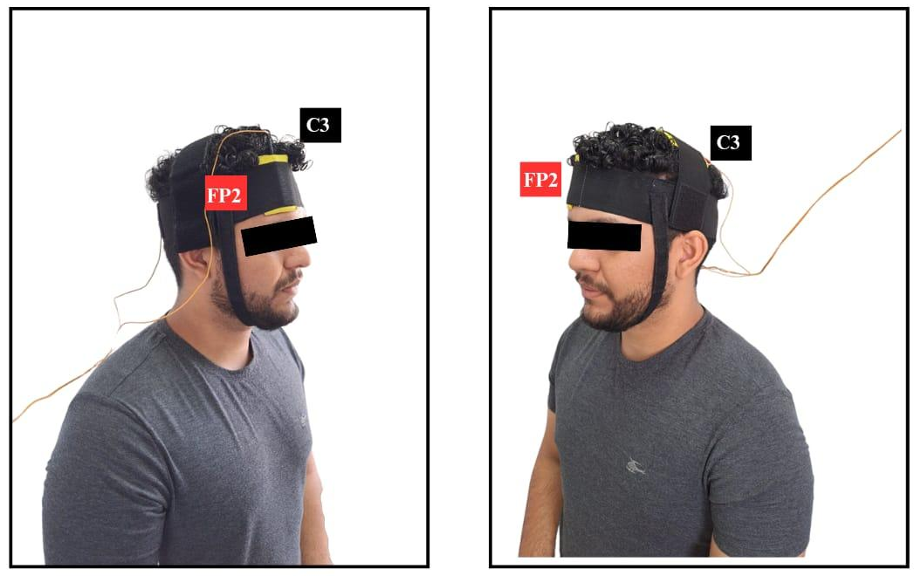
Figure 1 - Electrode montage.

After each application of active and sham tDCS, the patients underwent a neural mobilization protocol, which consisted of the following maneuvers: lumbosacral root sliding mobilization (Figure 3), slump sliding (Figure 4), and distal ischiatic tensioning mobilization (Figure 5).
Thirty movements were performed over 60 seconds, with 3 sets with a 60-second interval between movements. The same interval will be observed between mobilizations. The sequence will be adopted starting with the sliding mobilizations and ending with the tensioning mobilization. Given that the participants suffer from chronic radicular pain, it is hoped that they will not have tissue irritability that would not allow the procedure. Even so, a moderate level of pain will be tolerated during the procedure (up to 5 on the NRPS), and positional adaptations may be implemented during the procedure according to the intensity of the symptoms to ensure that the application of the technique does not aggravate the participant's clinical condition; the research team will be previously trained for these adaptations.
Lumbosacral Root Sliding Mobilization: Participant in the supine position on a gurney, ankles crossed, hip and knee flexed at 90°, upper limbs alongside the body. Therapist is positioned contralateral to the limb to be treated, supports both lower limbs and uses them as a lever for passive oscillations in the lumbar lateral inclination contralateral to the symptomatic leg.
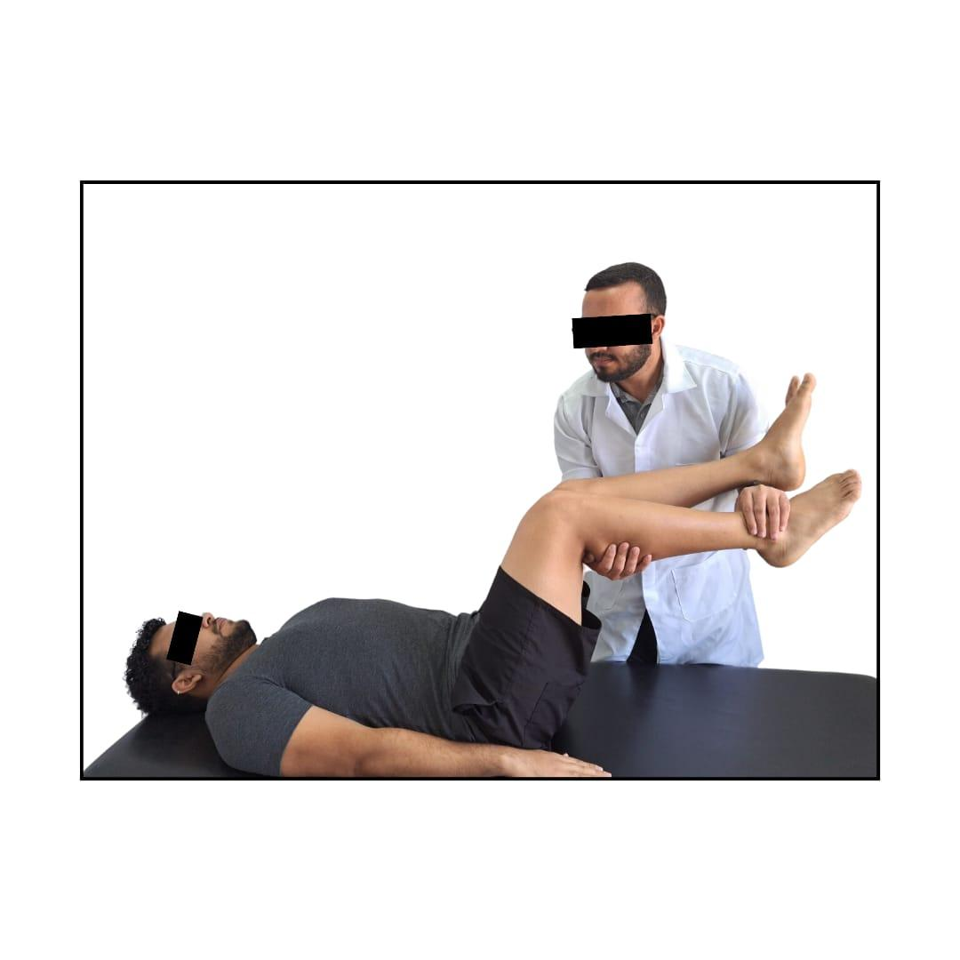
Figure 2 - Demonstration of sliding mobilization positioning.

Slump slide: Participants were seated with their upper limbs crossed behind the back, with slight lumbar and thoracic flexion, and the knee of the affected limb was slightly extended. The patient actively and simultaneously performs cervical flexion and plantar flexion of the ankle, changing the movement to cervical extension associated with ankle dorsiflexion.

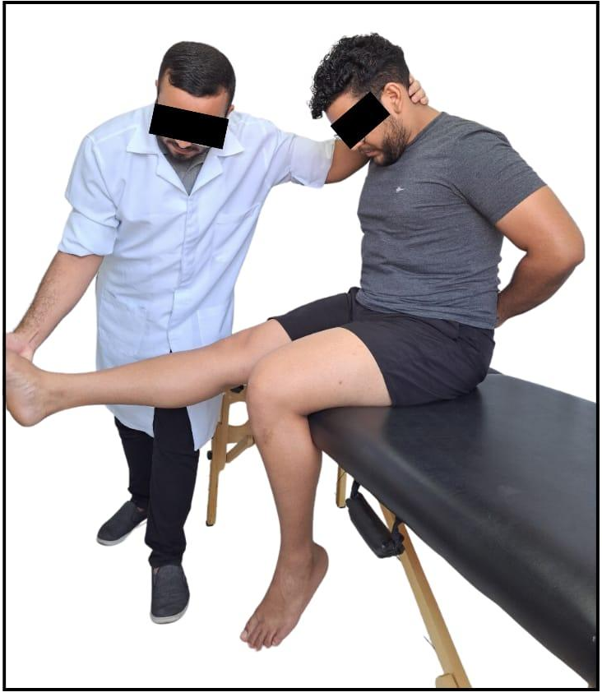
Figure - Demonstration of Sliding Slump Mobilization positioning

Distal Sciatic Tension Mobilization: Participants were in the supine position, with their bodies aligned. The therapist lifts the limb in extension until the patient reports the onset of pain. The therapist then takes a position to the side of the affected limb, stabilizes the knee in extension with the forearms and raises the limb to close to the range at which the symptom manifests itself. Upon returning to the starting position, the traction is released.
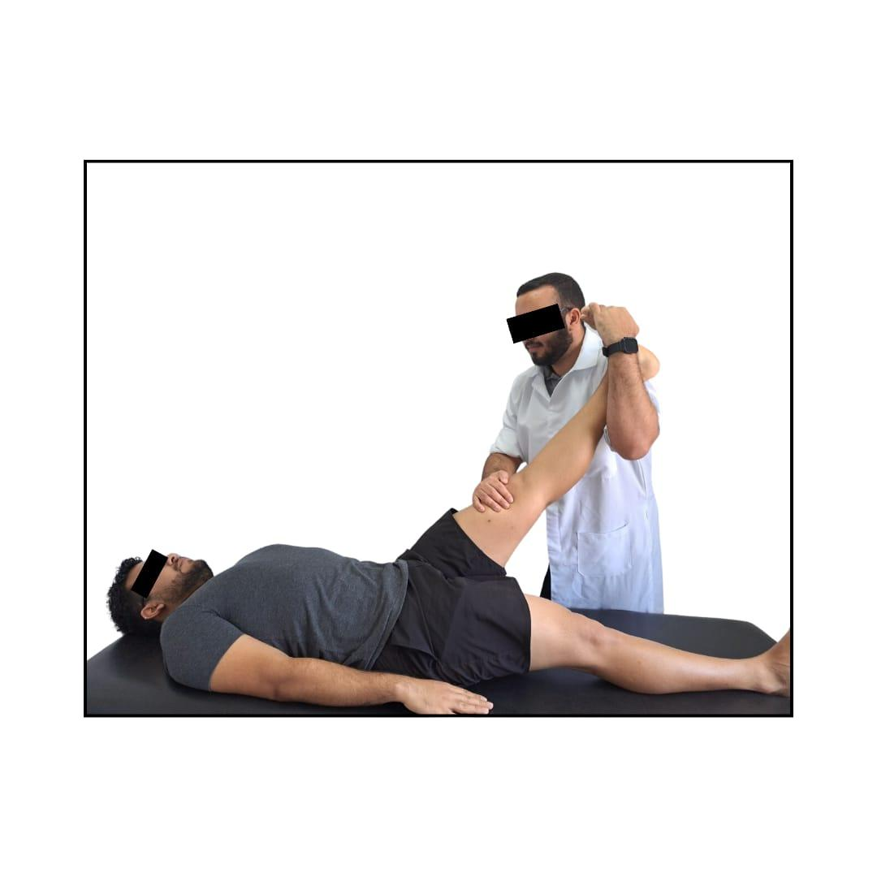
Figura 4 – Demonstration of Distal Sciatic Tension Mobilization positioning.

