“Karl-Heinz”-
Diary

- For Patients -

ASSESSMENT OF YOUR CONDITION
Please give us daily assessments of how you felt on that day (preferably in the evening).
To do this, enter the date and tick the box below the
corresponding face:

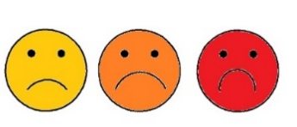
26 3 2024
Example:
How did you feel overall today, on ___ . ___ . ________?
☐ ☐ ☐ ☐ ☐ ☐
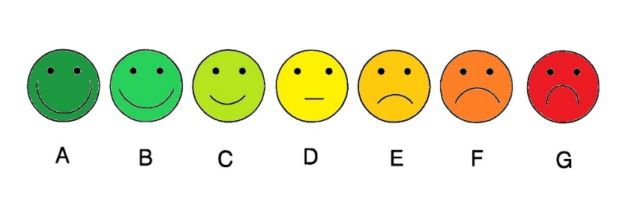
How did you feel overall today, on ___ . ___ . ________?

☐ ☐ ☐ ☐ ☐ ☐
How did you feel overall today, on ___ . ___ . ________?

☐ ☐ ☐ ☐ ☐ ☐
X
Assessment of the Sessions
Please rate the session you just received.
The numbers refer to the numbering in the white booklet (from page 8).
Please make a mark on the line:

Example: The session no. 5 was …
Much too
exhausting

Much too easy
X

The session no. 1 was …
Much too
exhausting

Much too easy

The session no. 2 was …
Much too
exhausting

Much too easy

The session no. 3 was …
Much too
exhausting

Much too easy

“Karl-Heinz”-
Diary

- For Health Professionals -
Part A

The content of the session ...
☐ was carried out as planned ☐ was adjusted ☐ not applicable

The session took place on _____. _____ . ________ [date]
from ____:____ to ____:_____ o’ clock.
Are you standing in for a colleague? ☐ yes ☐ no
Module 1: Sports and exercise therapy  ☐ Aerobic endurance training  ☐ Strength/flexibility training  ☐ Coordination training  ☐ Respiratory therapy  Module 2: Occupational therapy  ☐ ADL (activities of daily living)  ☐ Brain performance training  Module 3: Cognitive training  ☐ Everyday memory strategies  ☐ Attention Training  ☐ Orientation strategies  ☐ Mediation of procedure / daily routine  Module 4: Psychosocial support  ☐ Session 1 ☐ Session 2 | Module 5: Disease-specific education  ☐ Prevention  ☐ Coping with the disease  ☐ Coping with complications  ☐ Implementation of a healthy lifestyle  ☐ Smoking cessation  ☐ Information about the cardiac  interventions  ☐ Mindfulness and dealing with stress  Other  ☐ Progressive muscle relaxation  ☐ Massage  ☐ hygiene training/nutrition  The following adjustments have been made:
☐ Gruppentherapie
☐ Einzelbehandlung

“Karl-Heinz”-
Diary

- For Health Professionals -
Part B

Documentation General Implementation of "Karl-Heinz"
- Were the minimum therapy requirements met during the prehabilitation program? ☐ yes ☐ no
If no, please specify:

Documentation “Informative talks with Relatives”
- Informative talk with relatives
  - The talk with relatives has taken place:
☐ yes ☐ no
(If no: please give reasons in the box below)
  - Who was spoken to?
_____________________________
  - Did anything noteworthy occur during the talk?
If yes, please specify:
☐ yes ☐ no

Documentation „Module 1: Sports and Exercise Therapy“
- Aerobic endurance training
  - Has an exercise ECG been carried out? ☐ yes ☐ no
    - If yes, what was the maximum power load in watts?
    - How high did the patient rate the subjective maximum
strain (Borg scale)?
    - Why was the exercise ECG terminated?
☐ Gen. exhaustion | ☐ Fatigue | ☐ Motivation
☐ Leg weakness | ☐ Dizziness | ☐ Drop in blood  pressure
☐ Leg pain | ☐ Cold sweat | ☐ Angina Pectoris
☐ Shortness of  breath | ☐ Pallor
☐ ECG deviations, namely: _____________________
☐ Other deviations, namely: __________________

  - How many sessions were completed during the prehabilitation
program?
  - How high was the average training load in watts?
  - What was the average training duration in minutes?
  - What was the average resting heart rate in beats/min.?
  - What was the average training heart rate in beats/min.?
  - What was the average resting heart rate in beats/min.
(2 minutes after the end of exercise)?

  - On average, how high was the training load subjectively
rated by the patient (Borg scale)?

  - Did anything noteworthy occur during the training sessions?
☐ yes ☐ no
If yes, please specify:

- Strength/flexibility training
  - How many sessions were completed during the prehabilitation
program?
  - How many strength exercises were performed on average per training session?
  - Which strength exercises were completed? Tick the appropriate boxes:
☐ Leg extensions | ☐ Leg press | ☐ Rowing
☐ Back extensor | ☐ Lat pulldown | ☐ Dips
☐ Other: _____________________________________________________

  - On average, how high was the training load subjectively rated by the patient (Borg scale)?
  - Did anything noteworthy occur during the training sessions?
☐ yes ☐ no

If yes, please specify:

- Coordination training
  - How many sessions were completed during the prehabilitation
program?
  - Did anything noteworthy occur during the training sessions?
☐ yes ☐ no

- Respiratory therapy
  - How many sessions were completed during the prehabilitation
program?
  - Did anything noteworthy occur during the training sessions?
☐ yes ☐ no
If yes, please specify:
If yes, please specify:

Documentation „Module 2: Occupational Therapy“
- ADL (activities of daily living)
  - How many sessions were completed during the prehabilitation
program?
  - Which content was realized?

  - Did anything noteworthy occur during the training sessions?
If yes, please specify:

☐ yes ☐ no

- Brain performance training
  - How many sessions were completed during the prehabilitation
program?
  - Which content was realized?

  - Did anything noteworthy occur during the training sessions?
☐ yes ☐ no
If yes, please specify:

Documentation „Module 3: Cognitive Training”
- Everyday memory strategies
  - How many sessions were completed during the prehabilitation
program?
  - Which content was realized?

  - Did anything noteworthy occur during the training sessions?
☐ yes ☐ no
If yes, please specify:

- Attention training
  - How many sessions were completed during the prehabilitation
program?
  - Which content was realized?

  - Did anything noteworthy occur during the training sessions?
☐ yes ☐ no
If yes, please specify:

Documentation „Module 3: Cognitive training”
- Orientation strategies
  - How many sessions were completed during the prehabilitation
program?
  - Which content was realized?

  - Did anything noteworthy occur during the training sessions?
☐ yes ☐ no
If yes, please specify:

- Mediation of procedure / daily routine
  - How many sessions were completed during the prehabilitation
program?
  - Which content was realized?

  - Did anything noteworthy occur during the training sessions?
☐ yes ☐ no
If yes, please specify:

Documentation „Module 5: Disease-specific Education”
- Video education: Prevention, detection, and treatment of
cardiovascular risk factors and high-risk diseases
  - Has the video been watched to the end? ☐ yes ☐ no
  - Were the questions that arose answered? ☐ yes ☐ no
Comments:

- Video education: Help and psychological support in coping with the
disease
  - Has the video been watched to the end? ☐ yes ☐ no
  - Were the questions that arose answered? ☐ yes ☐ no
Comments:

- Video education: Implementation of a healthy lifestyle
  - Has the video been watched to the end? ☐ yes ☐ no
  - Were the questions that arose answered? ☐ yes ☐ no
Comments:

- Video education: Smoking cessation
  - Has the video been watched to the end? ☐ yes ☐ no
  - Were the questions that arose answered? ☐ yes ☐ no
Comments:

- Video education: Information about major cardiology or cardiac surgery procedures
  - Has the video been watched to the end? ☐ yes ☐ no
  - Were the questions that arose answered? ☐ yes ☐ no
Comments:

- Video education: Mindfulness and dealing with stress
  - Has the video been watched to the end? ☐ yes ☐ no
  - Were the questions that arose answered? ☐ yes ☐ no
Comments:

- Video education: Recognition and behavior in acute disease-related complications in cardiac surgery or cardiology
  - Has the video been watched to the end? ☐ yes ☐ no
  - Were the questions that arose answered? ☐ yes ☐ no
Comments:

