Supplementary file 1 – additional results

Meta-analysis of previous similar SWATs for Du et al 2009 analysis
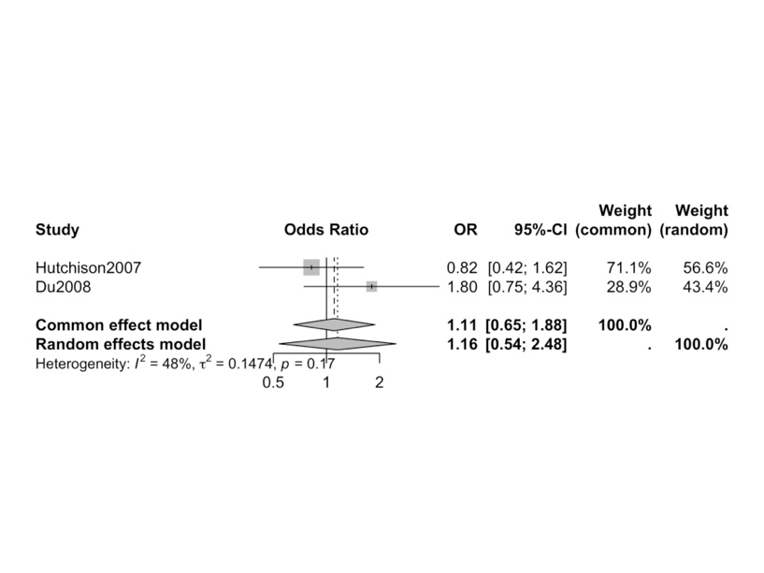
Figure S1 - Meta-analysis of previous similar SWATs to form priors for Du et al 2009 analysis

Meta-analysis of previous similar SWATs for Mattock et al 2020 HSHS analysis:
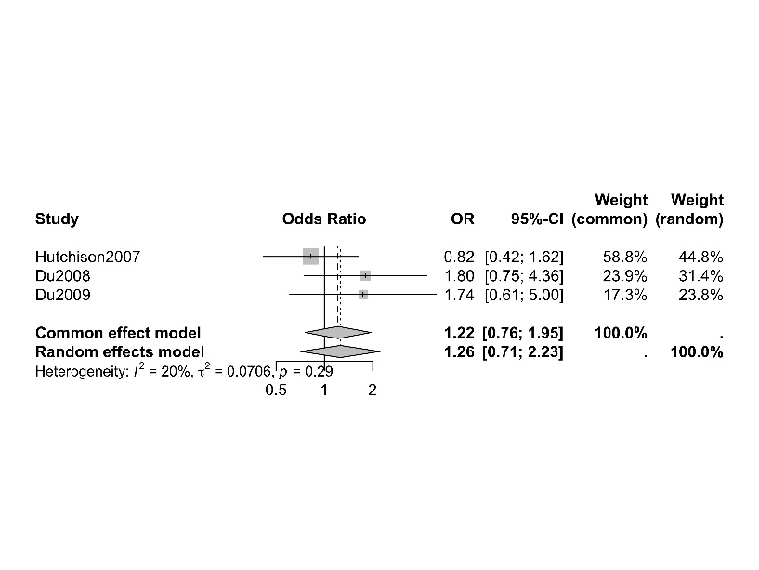
Figure S2 - Meta-analysis of previous similar SWATs to form priors for Mattock et al 2020 analysis

Additional results for Du et al SWAT sensitivity analysis

Weakly informative Gelman prior:

Pr(OR > 1) = 0.85
MMSE estimate = 1.96
95% CI = (0.42, 4.16)

Informative Sullivan prior:

Pr(OR > 1) = 0.82
MMSE estimate = 1.40
95% CI = (0.63, 2.31)

Combined prior:
Pr(OR > 1) = 0.83
MMSE estimate = 1.51
95% CI = (0.58, 2.76)

Additional results for HSHS SWAT sensitivity analysis – adjusted

Weakly informative Gelman prior, adjusted analysis:
Pr(OR > 1) = 0.0009
MMSE estimate = 0.28
95% CI = (0.07, 0.54)

Informative Sullivan prior, adjusted analysis:
Pr(OR > 1) = 0.12
MMSE estimate = 0.78
95% CI = (0.43, 1.15)

Combined prior, adjusted analysis:
Pr(OR > 1) = 0.008
MMSE estimate = 0.31
95% CI = (0.07, 0.69)

Additional sensitivity analysis for HSHS SWAT – unadjusted
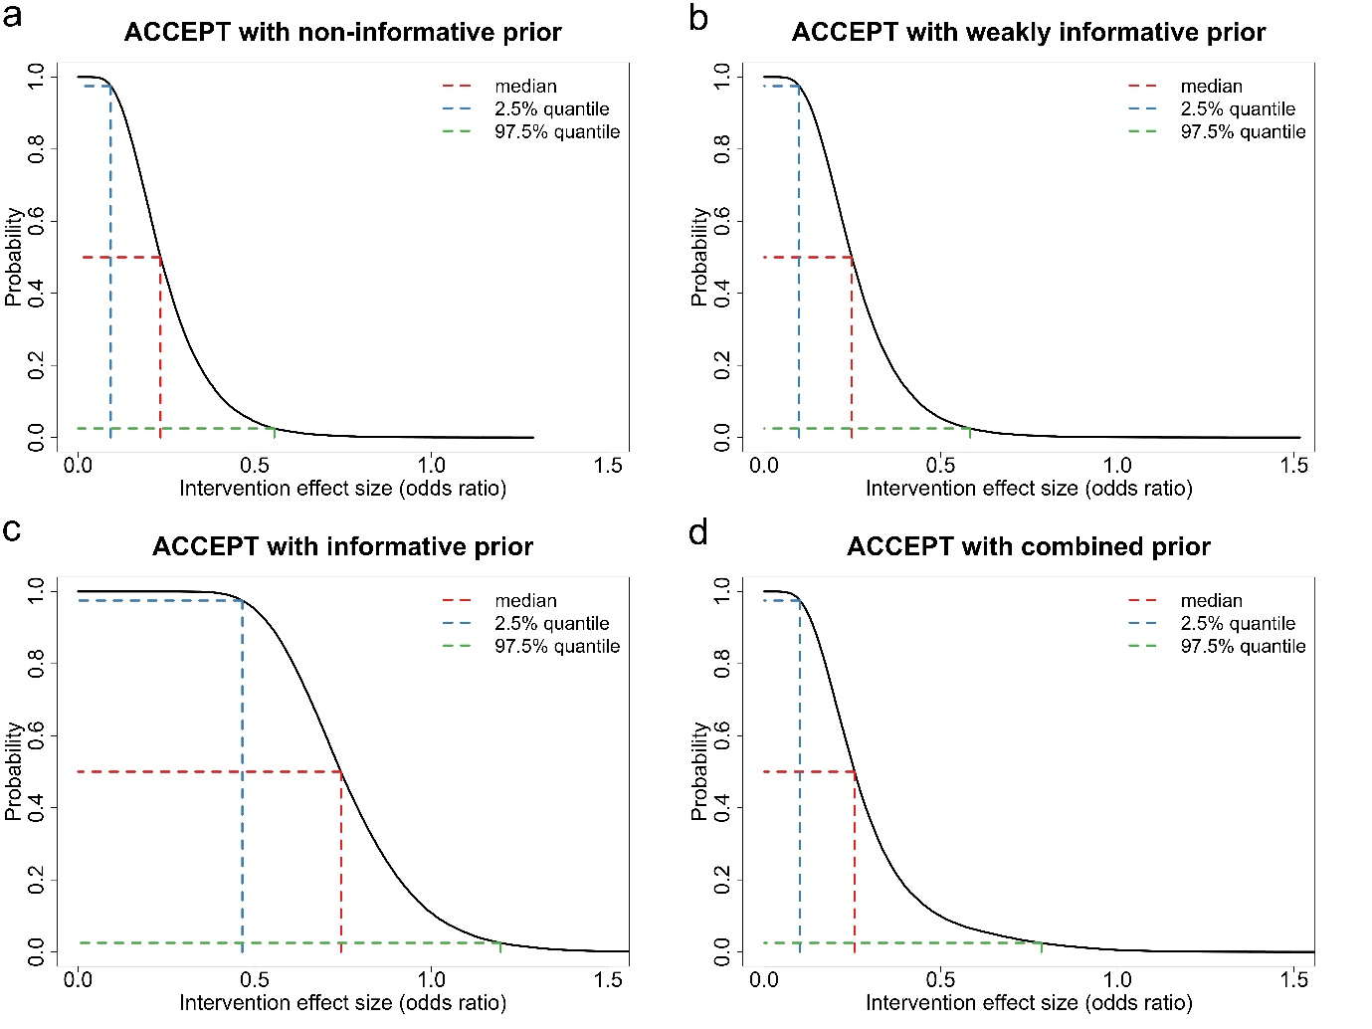

Figure S3 - Bayesian unadjusted analysis for HSHS SWAT including primary and sensitivity analysis. OR represents odds of recruitment for video intervention relative to standard patient information.

Non-informative Uniform prior:
Pr(OR > 1) = 0.0004
MMSE OR estimate = 0.26
95% CrI = (0.07, 0.50)

Weakly informative Gelman prior:
Pr(OR > 1) = 0.0006
MMSE estimate = 0.27
95% CrI = (0.08, 0.53)

Informative Sullivan prior:
Pr(OR > 1) = 0.11
MMSE estimate = 0.76
95% CrI = (0.43, 1.14)

Combined prior:
Pr(OR > 1) = 0.006
MMSE estimate = 0.30
95% CrI = (0.07, 0.64)

