Supplementary material: Long-term participant-reported outcomes after the GeneRAtiNg StUdent recruiters for randomised triaLs (GRANULE) course: a longitudinal, survey-based, international cohort study
Omar Kouli¹, Jane M Blazeby², Nicola Mills³, Kenneth A McLean⁴, Sivesh K Kamarajah⁵, Rohan R Gujjuri⁶, Simon Bach⁷, Daniel M Baker⁸, Aneel Bhangu⁹, Ruth Blanco-Colino¹⁰, Afsana Elanko¹¹, Marcus Jepson³, Emily C Mills¹², Victoria Murray¹³, Dmitri Nepogodiev⁹, Francesco Pata^{14,15}, Peter Pockney¹⁶, Leila Rooshenas³, Alessandro Sgrò¹⁷, James C Glasbey⁹
Author institutions:
- Department of Neurosurgery, The Walton Centre NHS Foundation Trust, Liverpool, UK
- NIHR Bristol Biomedical Research Centre, University of Bristol and University Hospitals Bristol and Weston NHS Foundation Trust, Bristol, UK
- Population Health Sciences, Bristol Medical School, University of Bristol, Bristol, UK
- Centre for Medical Informatics, Usher Institute, University of Edinburgh, Edinburgh, UK
- Department of Applied Health Sciences, School of Health Sciences, College of Medicine and Health, University of Birmingham, Birmingham, UK
- Department of Surgery. Sandwell and West Birmingham NHS Trust, Birmingham, UK
- Department of Surgery, University Hospitals Birmingham, Birmingham, UK
- Leeds Teaching Hospitals NHS Trust, Leeds, UK
- Surgical Data Institute, Institute of Translational Medicine, University of Birmingham, Birmingham, UK
- Department of Liver Transplantation and Hepatobiliary Surgery, Leeds Teaching Hospitals NHS Trust, Leeds, UK
- BASO- association for Cancer Surgery, The Royal College of Surgeons of England, London, UK
- Mid and South Essex University Hospitals, Basildon, UK
- Central and North West London NHS Foundation Trust, London, UK
- Department of Pharmacy, Health and Nutritional Sciences, University of Calabria, Rende, Italy
- General Surgery Unit, Department of Surgery, A. O. Annunziata, Cosenza, Italy
- University of Newcastle, Newcastle, New South Wales, Australia
- Department of Clinical Surgery, The University of Edinburgh, Edinburgh, UK
Corresponding author: Mr James Glasbey MBBCh BSc MRCS PhD, Surgical Data Institute, Institute of Translational Medicine, University of Birmingham, Birmingham, B152TH, UK. Email: j.glasbey@bham.ac.uk

Table of Contents
Supplementary Figure 1: Cumulative number of delegates between 2016 and 2020, stratified by course type 3
Supplementary Table 1: Generating Student Recruiters for Randomised Trials (GRANULE) course content 4
Generating Student Recruiters for Randomised Trials (GRANULE): Course Application Form 8
Instrument 1: GRANULE post-course questionnaire 9
Instrument 2: GRANULE and mini-GRANULE long-term follow-up questionnaire 14
Supplementary Table 2: Thematic analysis regarding GRANULE educational outcomes 17
Supplementary Figure 2: Mean Likert score difference between participants by trial exposure on follow-up 20
Supplementary Table 3: Thematic analysis regarding participation in clinical trials 21
Supplementary Table 4: Sensitivity analysis for paired Likert-item comparisons between immediate post-course and long-term follow-up responses 23
Supplementary table 5: Sensitivity analysis of follow-up duration and paired change scores in GRANULE delegates 26
Supplementary table 6: Exploratory comparison of UK/ROI and international respondents at long-term follow-up 28
Supplementary table 7: Checklist for Reporting Of Survey Studies (CROSS) 30

Supplementary Figure 1: Cumulative number of delegates between 2016 and 2020, stratified by course type

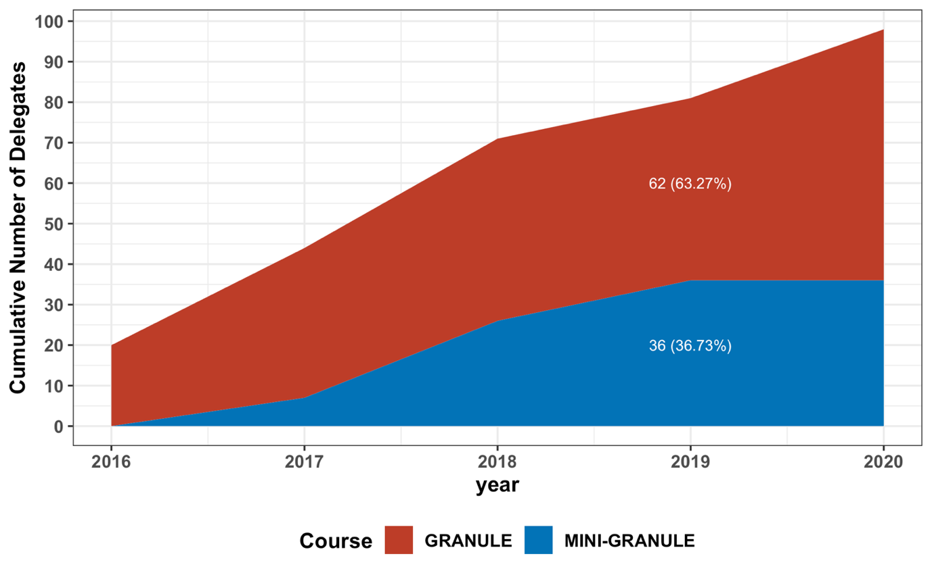

Supplementary Table 1: Generating Student Recruiters for Randomised Trials (GRANULE) course content

Domain | Learning objective | Details | Mode of Assessment
1) Communication skills
Conducting a consultation | Communicate clinical equipoise and uncertainty effectively  Demonstrate an understanding of ethical principles in trial recruitment | - Greets patient appropriately and checks identity  - Introduces self and role, explains process and gains consent to proceed  - Demonstrates a clear and sound understanding of a study protocol  - Explains to the patient aspects of confidentiality and their rights during the interaction  - Relates to the patient and establishes rapport  - Adopts an ordered approach which flows smoothly  - Clarifies what the patient already knows about the study  - Delivers the information in an appropriate manner (i.e., in small chunks), using open and closed questions  - Uses techniques to check and confirm patient understanding (i.e., ‘chunking and checking’)  - Demonstrates the ability to tailor information to the patient’s ideas, concerns, and expectations  - Uses additional information such as the study patient information sheets and emphasises important points to consider  - Avoids the use of unnecessary jargon, appropriate to the individual patient  - Thanks patient and clearly communicates timeframes involved  - Respects the patient’s comfort, perspectives, dignity, and rights during the consultation | Simulated Patient Scenario
Gaining consent | Seek and document valid consent during research recruitment  Demonstrate an understanding of ethical principles in trial recruitment | - Attempts to gain consent appropriately and sensitively  - Applies knowledge of the process of consenting a patient to a clinical trial in line with good clinical practice  - Explains why consent is a dynamic process  - Describes how consent is proportional to what is being asked of the patient  - Communicates the rights of the patient both during the consent process and in the study  - Avoids coercion and presenting unbalanced choices | Simulated Patient Scenario, Multiple Choice Questions
2) Understanding complex, interventional trials in surgery
Understanding levels of evidence | Explain the theoretical basis of randomised trial design  Appreciate the challenges to conducting randomised trials in surgery | - Understands ‘levels of evidence’ and the pitfalls of this classification  - Understands the rationale behind different study designs, strengths, and weaknesses (pragmatic versus explanatory)  - Appreciates how randomisation reduces bias in interventional studies  - Appreciates challenges within randomised trials in surgery  - Recognises appropriate strategies for recruiting patients  - Describes experimental methods which can minimise bias and maximise external validity | Multiple Choice Questions
Application of research ethics | Demonstrate an understanding of ethical principles in trial recruitment | - Understands the principles of clinical equipoise and uncertainty  - Applies core ethical principles in trial design, and when recruiting participants to studies  - Identifies barriers to gaining ethical approval and how to avoid common pitfalls  - Uses effective communication to enable patients to make an informed decision  - Supplies adjuncts to inform decision-making (patient information leaflets, videos) | Simulated Patient Scenario, Multiple Choice Questions
Principles of randomised trials | Explain the theoretical basis of randomised trial designs.  Demonstrate a good understanding of Good Clinical Practice (GCP). | - Can generate appropriate research questions that can be answered using a randomised trial.  - Describes the importance of clear Inclusion and exclusion criteria  - Identifies appropriate strategies for recruiting patients  - Identifies key stakeholder groups and input into decision (e.g., patient and public involvement, multidisciplinary design)  - Describes different methods of randomisation and how they work  - Explains why publication of a trial protocol prior to undertaking the study is important in terms of sources of bias.  - Describes the role of trials registries.  - Prepares and interprets study timelines.  - Identifies different types of funding sources.  - Explains the principles of pilot studies and feasibility testing.  - Outlines basic statistical analyses and simple statistical tests (i.e., Chi-Squared tests, T-tests and interprets risk or odds ratios alongside their appropriate measures of confidence). | Multiple Choice Questions
Conducting randomised trials | Demonstrate a working understanding of Good Clinical Practice (GCP) principles | - Appreciates the process of trial management in line with Good Clinical Practice principles  - Summarises the importance of data monitoring groups  - Outlines mechanisms for dealing with breaches in trial protocols  - Explains mechanisms for reporting serious adverse events and maintaining patient safety as the first concern | Multiple Choice Questions

Generating Student Recruiters for Randomised Trials (GRANULE): Course Application Form

The Generating Student Recruiters for Randomised Trials (GRANULE) course aims to teach students how to recruit patients into randomised controlled trials. Gathering a world class faculty of international trial leaders, the course will cover principles of equipoise, communicating using trials ‘language’ and give you practical experience with simulated patients. This will give you a skillset for meaningful participation in future randomized clinical studies. We will link successful students with ongoing and developing trial management groups. Please fill in this application form to apply for the GRANULE course and we will get in touch with you following the deadline of this application once it has been marked. Thank you!
* Required

1. Email *
2. Name *
3. Year of Study * Mark only one.
- Penultimate Year Medical Student
- Final Year Medical Student
- Foundation Doctor
- Other:

Personal Specifications
For each question below, please enter no more than 200 words. This application will be triple marked, with each question scored out of 3 marks, to a total of 12 marks.

4. Why would you be a good candidate for the GRANULE course? (1000 characters) *
5. Describe your interaction with collaborative research groups to date. (1000 characters) *
6. Describe your communication skills, giving examples. (1000 characters) *
7. How will you use the skills learnt in the GRANULE course in the future? (1000 characters) *

Instrument 1: GRANULE post-course questionnaire

Section Header | Field Label | Choices
Participant demographics | Full name | Free text
 | Have you completed your NIHR Good Clinical Practice training? | 1, Yes | 2, No
 | Stage of training | 1, Year 1-3 medical student | 2, Intercalating degree | 3, Year 4 medical student | 4, Year 5 medical student | 5, Foundation year 1 doctor | 6, Foundation year 2 doctor | 7, Academic foundation doctor (AFP) | 8, Core Trainee or equivalent | 9, Academic clinical fellowship (ACF) | 10, Speciality trainee (Registrar) | 11, Other
 | Sex | 1, Male | 2, Female
 | Which areas of medicine are you currently interested in pursuing as a career? | Free text
 | Do you have an additional postgraduate research degree? (e.g. BSc, MSc, MD, PhD) | 1, Yes | 2, No
 | If yes, what sort of degree is this? | 1, Not applicable | 2, Bachelors degree (intercalated) | 3, Bachelors degree (undergraduate) | 4, Masters degree (intercalated)
Previous research and clinical trial experience | Have you had previous teaching/training in conducting research? | 1, Yes | 2, No
 | Have you consented a patient to participate in research? | 1, Yes | 2, No
 | In what ways have you been involved in randomised clinical trials? | 1, Recruitment of participants | 2, Protocol development | 3, Trial management group | 4, Randomisation | 5, Delivering an intervention | 6, Follow-up/outcome assessment | 7, Other: please specify
 | How many full peer-reviewed publications do you have (with a PubMed ID)? | Free text
Recall of GRANULE principles - how confident do you feel in the following | Understanding clinical equipoise | 5, Very confident | 4, Confident | 3, Unsure | 2, Not confident | 1, Very unconfident
 | Communicating clinical equipoise and uncertainty effectively | 5, Very confident | 4, Confident | 3, Unsure | 2, Not confident | 1, Very unconfident
 | Seeking and documenting valid consent during research recruitment | 5, Very confident | 4, Confident | 3, Unsure | 2, Not confident | 1, Very unconfident
 | Understanding the ethical principles in trial recruitment | 5, Very confident | 4, Confident | 3, Unsure | 2, Not confident | 1, Very unconfident
 | Explaining th purpose and process of randomisation | 5, Very confident | 4, Confident | 3, Unsure | 2, Not confident | 1, Very unconfident
 | Appreciating the challenges to conducting randomised trials in surgery | 5, Very confident | 4, Confident | 3, Unsure | 2, Not confident | 1, Very unconfident
 | Demonstrating a working understanding of Good Clinical Practice | 5, Very confident | 4, Confident | 3, Unsure | 2, Not confident | 1, Very unconfident
 | Challenging patient preferences and ensuring the patient has complete information | 5, Very confident | 4, Confident | 3, Unsure | 2, Not confident | 1, Very unconfident
Recall of GRANULE principles - how do you feel about the following statements? | I would feel confident to discuss the risks and benefits of enrolling into a randomised trial with a patient | 5, Strongly agree | 4, Agree | 3, Neither agree nor disagree | 2, Disagree | 1, Strongly disagree
 | I would feel comfortable to gain valid consent for a patient to take part in a trial | 5, Strongly agree | 4, Agree | 3, Neither agree nor disagree | 2, Disagree | 1, Strongly disagree
 | I would feel comfortable in documenting consent accurately | 5, Strongly agree | 4, Agree | 3, Neither agree nor disagree | 2, Disagree | 1, Strongly disagree
 | Participation as a researcher in randomised trials is straight forward | 5, Strongly agree | 4, Agree | 3, Neither agree nor disagree | 2, Disagree | 1, Strongly disagree
 | Participation in randomised trials is relevant as a medical student | 5, Strongly agree | 4, Agree | 3, Neither agree nor disagree | 2, Disagree | 1, Strongly disagree
 | I am aware of the opportunities and pathways to partaking in clinical research | 5, Strongly agree | 4, Agree | 3, Neither agree nor disagree | 2, Disagree | 1, Strongly disagree
 | I am interested in pursuing a career in clinical academia / I am pursuing a career in clinical academia | 5, Strongly agree | 4, Agree | 3, Neither agree nor disagree | 2, Disagree | 1, Strongly disagree
 | I would be interested to participate as a researcher in a randomised trial in the future | 5, Strongly agree | 4, Agree | 3, Neither agree nor disagree | 2, Disagree | 1, Strongly disagree
Course evaluation feedback | Regarding the structure of the GRANULE course, how do you feel about the following statements? [The learning objectives were made clear at the start of the day] | 4, Excellent | 3, Good | 2, Okay | 1, Poor
 | Regarding the structure of the GRANULE course, how do you feel about the following statements? [The teaching on the day was pitched appropriately to my level] | 4, Excellent | 3, Good | 2, Okay | 1, Poor
 | Regarding the structure of the GRANULE course, how do you feel about the following statements? [The faculty student ratio was appropriate] | 4, Excellent | 3, Good | 2, Okay | 1, Poor
 | Regarding the structure of the GRANULE course, how do you feel about the following statements? [I felt comfortable to ask questions to the faculty] | 4, Excellent | 3, Good | 2, Okay | 1, Poor
 | Regarding the structure of the GRANULE course, how do you feel about the following statements? [The venue was appropriate] | 4, Excellent | 3, Good | 2, Okay | 1, Poor
 | How would you rate the following sessions? [Lecture 1: Welcome & introductions] | 4, Excellent | 3, Good | 2, Okay | 1, Poor
 | How would you rate the following sessions? [Interactive session: Introduction to surgical trial design] | 4, Excellent | 3, Good | 2, Okay | 1, Poor
 | How would you rate the following sessions? [Lecture 2: Why we need surgical RCTs] | 4, Excellent | 3, Good | 2, Okay | 1, Poor
 | How would you rate the following sessions? [Lecture 3: Conveying clinical equipoise] | 4, Excellent | 3, Good | 2, Okay | 1, Poor
 | How would you rate the following sessions? [Lecture 4: Explaining randomisation] | 4, Excellent | 3, Good | 2, Okay | 1, Poor
 | How would you rate the following sessions? [Lecture 5: Addressing patient preferences] | 4, Excellent | 3, Good | 2, Okay | 1, Poor
 | How would you rate the following sessions? [Lecture 6: Overview of the recruitment consultation] | 4, Excellent | 3, Good | 2, Okay | 1, Poor
 | How would you rate the following sessions? [Live-demonstration: The ideal consent (the good, the bad and the ugly)] | 4, Excellent | 3, Good | 2, Okay | 1, Poor
 | How would you rate the following sessions? [Lecture 7: Introducing the RCTs (3 RCT's of individual years)] | 4, Excellent | 3, Good | 2, Okay | 1, Poor
 | How would you rate the following sessions? [Workshop: Peer-to-peer small group practice, without simulated actors] | 4, Excellent | 3, Good | 2, Okay | 1, Poor
 | How would you rate the following sessions? [Workshops: Interactive recruitment sessions, with simulated actors] | 4, Excellent | 3, Good | 2, Okay | 1, Poor
 | Would you recommend this course to a friend or colleague? | 1, Yes | 2, No
 | What worked well on the course? | Free text
 | How could this course be improved? | Free text
 | Any other comments? | Free text

Instrument 2: GRANULE and mini-GRANULE long-term follow-up questionnaire

Section Header | Field Label | Choices
Participant demographics | Full name | Free text
 | Current stage of training | 1, Undergraduate | 2, Postgraduate
 | Undergraduate training level | 1, Year 1-3 medical student | 2, Intercalating degree | 3, Year 4 medical student | 4, Year 5 medical student
 | Postgraduate training level | 1, Foundation year 1 doctor | 2, Foundation year 2 doctor | 3, Academic foundation doctor (AFP) | 4, Core Trainee or equivalent | 5, Academic clinical fellowship (ACF) | 7, Speciality trainee (Registrar) | 8, Consultant | 9, Other
 | Other postgraduate training level | Free text
Experience with clinical trials | Have you been involved in a clinical trial | 1, Yes | 2, No
 | Number of trials you have participated in | 1, 1 | 2, 2 | 3, 3 | 4, 4 | 5, ≥5
 | Please enter the names of the trial/s you were involved in | Free text
 | Which of the following roles were you involved in (please tick all that apply) | 1, Recruitment of participants | 2, Protocol development | 3, Trial management group | 4, Randomisation | 5, Delivering an intervention | 6, Follow-up/outcome assessment | 7, Other: please specify
 | Other role | Free text
 | Have you recruited any participants to the trial(s)? | Free text
 | How many participants have you recruited? | Free text
 | How many trial outcomes have you managed to assess? | Free text
 | Please enter reason why you haven't been able to recruit any participants to the trial(s) | Free text
 | Have you approached anyone about participating in a clinical trial? | 1, Yes | 2, No
 | Please enter the reason why you have not been able to get involved in a clinical trial | Free text
 | Please enter the reason why you have not been able to approach anyone to get involved in a clinical trial | Free text
Recall of GRANULE principles - how confident do you feel in the following | Understanding clinical equipoise | 5, Very confident | 4, Confident | 3, Unsure | 2, Not confident | 1, Very unconfident
 | Communicating clinical equipoise and uncertainty effectively | 5, Very confident | 4, Confident | 3, Unsure | 2, Not confident | 1, Very unconfident
 | Seeking and documenting valid consent during research recruitment | 5, Very confident | 4, Confident | 3, Unsure | 2, Not confident | 1, Very unconfident
 | Understanding the ethical principles in trial recruitment | 5, Very confident | 4, Confident | 3, Unsure | 2, Not confident | 1, Very unconfident
 | Explaining the purpose and process of randomisation | 5, Very confident | 4, Confident | 3, Unsure | 2, Not confident | 1, Very unconfident
 | Appreciating the challenges to conducting randomised trials in surgery | 5, Very confident | 4, Confident | 3, Unsure | 2, Not confident | 1, Very unconfident
 | Demonstrating a working understanding of Good Clinical Practice | 5, Very confident | 4, Confident | 3, Unsure | 2, Not confident | 1, Very unconfident
 | Challenging patient preferences and ensuring the patient has complete information | 5, Very confident | 4, Confident | 3, Unsure | 2, Not confident | 1, Very unconfident
Recall of GRANULE principles - how do you feel about the following statements? | I would feel confident to discuss the risks and benefits of enrolling into a randomised trial with a patient | 5, Strongly agree | 4, Agree | 3, Neither agree nor disagree | 2, Disagree | 1, Strongly disagree
 | I would feel comfortable to gain valid consent for a patient to take part in a trial | 5, Strongly agree | 4, Agree | 3, Neither agree nor disagree | 2, Disagree | 1, Strongly disagree
 | I would feel comfortable in documenting consent accurately | 5, Strongly agree | 4, Agree | 3, Neither agree nor disagree | 2, Disagree | 1, Strongly disagree
 | Participation as a researcher in randomised trials is straight forward | 5, Strongly agree | 4, Agree | 3, Neither agree nor disagree | 2, Disagree | 1, Strongly disagree
 | Participation in randomised trials is relevant as a medical student | 5, Strongly agree | 4, Agree | 3, Neither agree nor disagree | 2, Disagree | 1, Strongly disagree
 | I am aware of the opportunities and pathways to partaking in clinical research | 5, Strongly agree | 4, Agree | 3, Neither agree nor disagree | 2, Disagree | 1, Strongly disagree
 | I am interested in pursuing a career in clinical academia / I am pursuing a career in clinical academia | 5, Strongly agree | 4, Agree | 3, Neither agree nor disagree | 2, Disagree | 1, Strongly disagree
 | I would be interested to participate as a researcher in a randomised trial in the future | 5, Strongly agree | 4, Agree | 3, Neither agree nor disagree | 2, Disagree | 1, Strongly disagree
Feedback | Have you found the skills learnt in Granule transferable to your clinical practice outside research, for example consenting patients for surgery | Free text
 | How has the Granule course impacted on your approach to consent patients outside of research? (e.g. consenting patients for surgery) | Free text
 | How has the Granule course impacted on your career development and involvement in research? | Free text
 | Any other comments or feedback | Free text

Supplementary Table 2: Thematic analysis regarding GRANULE educational outcomes

Code | Theme | Subtheme | Reported | Example
Negative | No direct impact | N/A | 3 | “Not changed anything”
Neutral | No direct impact on progression/development | N/A | 5 | “This course, whilst has been useful to undertake, has not had any direct impact on my career progression/development.”
Neutral | Not involved in research | N/A | 1 | “I am currently not involved in research”
Positive | Generally helped in clinical practice (Not otherwise specified) | N/A | 3 | “It made me more comfortable especially when starting f1”
Positive | Generally helped in improving knowledge in RCT (Not otherwise specified) | N/A | 3 | “Extending my vision in RCTs”
Positive | Concept – Equipoise and Randomization | Understanding importance of clinical equipoise | 9 | “I am more aware of the importance of maintaining equipoise and I am able to apply similar principles from the course in my daily job.”
Positive | Concept – Equipoise and Randomization | Including equipoise in patient discussions | 7 | “I was able to sign up to be a recruiter for the RECOVERY trial very easily due to my GRANULE training. The GRANULE course also improved my understanding of trial methodology and I use the concept of equipoise in my own practice on an at least weekly basis.”
Positive | Concept – Equipoise and Randomization | Increased confidence/understanding in recruiting patients | 3 | “Increased confidence and understanding of trial recruitment and randomisation”
Positive | Concept - Consent | Increased understanding of consent process | 9 | “I have learned important generic skills for consent such as explaining benefits and risks of procedures, and the concept of joint decision making between clinician and patient”
Positive | Concept - Consent | Consent process | 5 | “Has provided a useful framework for consent, providing information and gaining informed consent for non-randomized research studies”
Positive | Concept - Consent | Communicating risk | 7 | “By trying to ensure that the Patient has an understanding for the procedure, and the risks involved”
Positive | Concept - Consent | Increased confidence in obtaining consent in normal clinical practice | 6 | “Has provided a useful framework for informed consent more generally and has increased my confidence in consenting for surgery”
Positive | Concept - Consent | Increased confidence in obtaining consent in research areas | 2 | “Consenting patients for data collection”
Positive | Concept - Participation | Methodology | 7 | “enhanced overall understanding of trial methodology, improved appreciation of complexity of surgical trials and recruitment of patients”
Positive | Concept - Participation | Recruitment process | 7 | “I was quite involved into research prior to GRANULE course, however this course made me more confident to enrol patients also it helped me to better design future trials.”
Positive | Concept - Participation | Increased confidence in RCT involvement | 14 | “It has made me feel more confident in getting involved in trials. I have not participated in a trial just yet, but if the opportunity arose, I would take part in one”
Positive | Concept - Participation | Empowered involvement even at early career stage | 3 | “Built confidence in what is expected / required when recruiting patients to research, in particular giving a clear framework to guide conversation and ensure all relevant points are addressed in consultation. Gave confidence to pursue involvement in recruitment in a clinical trial, which I likely wouldn't have considered at my clinical stage otherwise”
Positive | Concept - Participation | Not specified | 8 | “Allowed me to consider different avenues of clinical research for my own career progression and development”
Positive | Concept - Other | Ethical principles | 2 | “I have learned a lot about research, and this has allowed me to present my own multicenter End-of-Degree project as principal investigator and obtain the relevant ethical approval for its realization.”
Positive | Concept - Other | Communication | 5 | “structured way of communicating with patients about research”
Positive | Concept - Other | Communication using appropriate language | 4 | “Has made me reflect more on the meaning of the words I'm using both to myself but also to others and how words may be interpreted differently depending on the context.”
Positive | Concept - Other | Generally improved patient communication | 6 | “I improved my knowledge about this type of conversations.”

Supplementary Figure 2: Mean Likert score difference between participants by trial exposure on follow-up

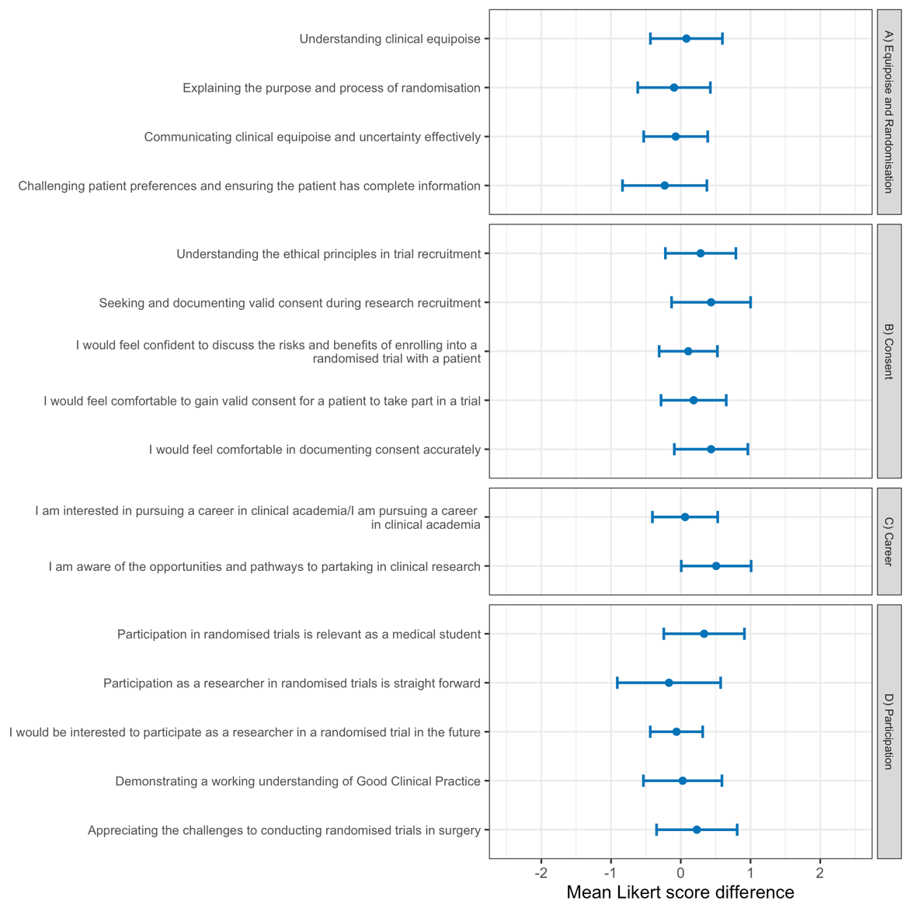

Supplementary Table 3: Thematic analysis regarding participation in clinical trials

Approached a trial team to seek involvement | Code | Theme | Subtheme | Number reported | Example
Yes | Negative | Lack of opportunities | No active trial available | 1 | “it's quite hard to find a clinical and surgical trial”
Yes | Negative | No available opportunities | Deemed not suitable for medical students | 3 | “At the hospital where I am a student, normally only residents and attending physicians are allowed in clinical trials. It is not a trend in our center to invite students to participate in clinical trials.”
Yes | Neutral | In the process of getting involved | N/A | 1 | “Am in the process of setting one up”
Yes | Neutral | No available opportunities | COVID-19 pandemic | 4 | “Due to the current pandemic such opportunities are limited”
Yes | Neutral | No patients identified | N/A | 1 | “No patients identified then left trust”
No | Negative | Lack of experience | N/A | 1 | “During the early stages nit enough exposure and not enough experience.”
No | Negative | Lack of opportunities | No active trial available | 8 | “No active surgical trials at present hospital”
No | Negative | Unsure who to approach | N/A | 2 | “Not sure who to approach”
No | Neutral | Lack of interest | N/A | 1 | “Not interested”
No | Neutral | Lack of time | Clinical commitments | 6 | “Time pressures”
No | Neutral | No specific cause | N/A | 2 | “No reason”
No | Neutral | Undertaking different research type | N/A | 1 | “undertaking different research currently”
No | Neutral | Lack of opportunities | COVID-19 pandemic | 2 | “COVID-19 has meant that clinical placements were cancelled and since then I have started an intercalation”

Supplementary Table 4: Sensitivity analysis for paired Likert-item comparisons between immediate post-course and long-term follow-up responses

Item | mean_postcourse | mean_followup | mean_difference | shapiro_p | ttest_p | wilcoxon_p | ttest_ci_low | ttest_ci_high | ttest_fdr | wilcoxon_fdr
Understanding clinical equipoise | 4.69 | 4.16 | -0.53 | 0.0000 | 0.0012 | 0.0006 | -0.83 | -0.23 | 0.0096 | 0.0064
Communicating clinical equipoise and uncertainty effectively | 4.25 | 4.09 | -0.16 | 0.0000 | 0.3251 | 0.4374 | -0.47 | 0.16 | 0.4335 | 0.5383
Seeking and documenting valid consent during research recruitment | 4.16 | 4.09 | -0.06 | 0.0003 | 0.7512 | 0.9798 | -0.46 | 0.34 | 0.7512 | 0.9798
Understanding the ethical principles in trial recruitment | 4.38 | 4.19 | -0.19 | 0.0000 | 0.2802 | 0.3621 | -0.54 | 0.16 | 0.4105 | 0.4828
Explaining the purpose and process of randomisation | 4.50 | 4.19 | -0.31 | 0.0000 | 0.0863 | 0.0921 | -0.67 | 0.05 | 0.2301 | 0.2456
Appreciating the challenges to conducting randomised trials in surgery | 4.72 | 4.06 | -0.66 | 0.0001 | 0.0008 | 0.0008 | -1.02 | -0.29 | 0.0096 | 0.0064
Demonstrating a working understanding of Good Clinical Practice | 4.28 | 4.03 | -0.25 | 0.0000 | 0.1181 | 0.1200 | -0.57 | 0.07 | 0.2699 | 0.2743
Challenging patient preferences and ensuring the patient has complete information | 4.50 | 3.94 | -0.56 | 0.0000 | 0.0059 | 0.0065 | -0.95 | -0.17 | 0.0315 | 0.0347
Discussing the risks and benefits of enrolling into a randomised trial | 4.50 | 4.22 | -0.28 | 0.0001 | 0.0367 | 0.0425 | -0.54 | -0.02 | 0.1468 | 0.1700
Gaining valid consent for a patient to take part in a trial | 4.44 | 4.25 | -0.19 | 0.0000 | 0.1606 | 0.1658 | -0.45 | 0.08 | 0.3212 | 0.3316
Documenting consent accurately | 3.84 | 4.09 | 0.25 | 0.0046 | 0.1867 | 0.1965 | -0.13 | 0.63 | 0.3319 | 0.3493
Participation as a researcher in randomised trials is straightforward | 3.56 | 3.34 | -0.22 | 0.0047 | 0.3621 | 0.2797 | -0.70 | 0.26 | 0.4457 | 0.4303
Participation in randomised trials is relevant as a medical student | 4.25 | 4.16 | -0.09 | 0.0001 | 0.4756 | 0.4835 | -0.36 | 0.17 | 0.5435 | 0.5526
Awareness of opportunities and pathways to partake in clinical research | 4.06 | 3.97 | -0.09 | 0.0014 | 0.5213 | 0.5385 | -0.39 | 0.20 | 0.5561 | 0.5744
Interest in pursuing a career in clinical academia | 4.56 | 4.41 | -0.16 | 0.0009 | 0.2822 | 0.2958 | -0.45 | 0.13 | 0.4105 | 0.4303
Interest in participating as a researcher in a randomised trial in the future | 4.75 | 4.56 | -0.19 | 0.0000 | 0.0831 | 0.0915 | -0.40 | 0.03 | 0.2301 | 0.2456

Supplementary table 5: Sensitivity analysis of follow-up duration and paired change scores in GRANULE delegates

Item | mean_postcourse | mean_followup | mean_difference | spearman_rho | spearman_p | spearman_fdr
Understanding clinical equipoise | 4.69 | 4.16 | -0.53 | -0.388 | 0.0281 | 0.1135
Communicating clinical equipoise and uncertainty effectively | 4.25 | 4.09 | -0.16 | -0.197 | 0.2805 | 0.4987
Seeking and documenting valid consent during research recruitment | 4.16 | 4.09 | -0.06 | 0.275 | 0.1276 | 0.2916
Understanding the ethical principles in trial recruitment | 4.38 | 4.19 | -0.19 | -0.049 | 0.7894 | 0.8567
Explaining the purpose and process of randomisation | 4.50 | 4.19 | -0.31 | -0.388 | 0.0284 | 0.1135
Appreciating the challenges to conducting randomised trials in surgery | 4.72 | 4.06 | -0.66 | -0.327 | 0.0679 | 0.1811
Demonstrating a working understanding of Good Clinical Practice | 4.28 | 4.03 | -0.25 | -0.087 | 0.6343 | 0.8567
Challenging patient preferences and ensuring the patient has complete information | 4.50 | 3.94 | -0.56 | -0.058 | 0.7543 | 0.8567
Discussing the risks and benefits of enrolling into a randomised trial | 4.50 | 4.22 | -0.28 | 0.081 | 0.6578 | 0.8567
Gaining valid consent for a patient to take part in a trial | 4.44 | 4.25 | -0.19 | 0.119 | 0.5165 | 0.8264
Documenting consent accurately | 3.84 | 4.09 | 0.25 | 0.477 | 0.0057 | 0.0915
Participation as a researcher in randomised trials is straightforward | 3.56 | 3.34 | -0.22 | -0.043 | 0.8162 | 0.8567
Participation in randomised trials is relevant as a medical student | 4.25 | 4.16 | -0.09 | 0.227 | 0.2114 | 0.4229
Awareness of opportunities and pathways to partake in clinical research | 4.06 | 3.97 | -0.09 | -0.033 | 0.8567 | 0.8567
Interest in pursuing a career in clinical academia | 4.56 | 4.41 | -0.16 | -0.333 | 0.0624 | 0.1811
Interest in participating as a researcher in a randomised trial in the future | 4.75 | 4.56 | -0.19 | -0.397 | 0.0244 | 0.1135

Supplementary table 6: Exploratory comparison of UK/ROI and international respondents at long-term follow-up

Item | n_uk | n_intl | mean_uk | mean_intl | median_uk | median_intl | wilcoxon_p | wilcoxon_fdr
Understanding clinical equipoise | 39 | 19 | 4.15 | 4.32 | 4 | 4 | 0.3963 | 0.5284
Communicating clinical equipoise and uncertainty effectively | 39 | 19 | 4.05 | 4.16 | 4 | 4 | 0.8705 | 0.8705
Seeking and documenting valid consent during research recruitment | 39 | 19 | 4.08 | 4.47 | 4 | 5 | 0.1010 | 0.3557
Understanding the ethical principles in trial recruitment | 39 | 19 | 4.15 | 4.63 | 4 | 5 | 0.0171 | 0.1493
Explaining the purpose and process of randomisation | 39 | 19 | 4.18 | 4.47 | 4 | 4 | 0.2464 | 0.4380
Appreciating the challenges to conducting randomised trials in surgery | 39 | 19 | 4.10 | 4.47 | 4 | 5 | 0.1112 | 0.3557
Demonstrating a working understanding of Good Clinical Practice | 39 | 19 | 4.05 | 4.37 | 4 | 5 | 0.1582 | 0.4218
Challenging patient preferences and ensuring the patient has complete information | 39 | 19 | 3.90 | 4.37 | 4 | 4 | 0.0250 | 0.1493
Discussing the risks and benefits of enrolling into a randomised trial | 39 | 19 | 4.23 | 4.42 | 4 | 4 | 0.3521 | 0.5121
Gaining valid consent for a patient to take part in a trial | 39 | 19 | 4.28 | 4.47 | 4 | 4 | 0.3280 | 0.5121
Documenting consent accurately | 39 | 19 | 4.15 | 4.42 | 4 | 5 | 0.2207 | 0.4380
Participation as a researcher in randomised trials is straightforward | 39 | 19 | 3.28 | 3.95 | 3 | 4 | 0.0280 | 0.1493
Participation in randomised trials is relevant as a medical student | 39 | 19 | 4.21 | 4.53 | 4 | 5 | 0.2110 | 0.4380
Awareness of opportunities and pathways to partake in clinical research | 39 | 19 | 4.05 | 4.16 | 4 | 4 | 0.5642 | 0.6944
Interest in pursuing a career in clinical academia | 39 | 19 | 4.46 | 4.05 | 5 | 5 | 0.6637 | 0.7586
Interest in participating as a researcher in a randomised trial in the future | 39 | 19 | 4.62 | 4.42 | 5 | 5 | 0.7737 | 0.8253

Supplementary table 7: Checklist for Reporting Of Survey Studies (CROSS)

Section/topic | Item | Item description | Reported on page #
Title and abstract
Title and abstract | 1a | State the word “survey” along with a commonly used term in title or abstract to introduce the study’s design. | 1,2
Title and abstract | 1b | Provide an informative summary in the abstract, covering background, objectives, methods, findings/results, interpretation/discussion, and conclusions. | 2
Introduction
Background | 2 | Provide a background about the rationale of study, what has been previously done, and why this survey is needed. | 3
Purpose/aim | 3 | Identify specific purposes, aims, goals, or objectives of the study. | 3
Methods
Study design | 4 | Specify the study design in the methods section with a commonly used term (e.g., cross-sectional or longitudinal). | 5,6
 | 5a | Describe the questionnaire (e.g., number of sections, number of questions, number and names of instruments used). | 6
Data collection methods | 5b | Describe all questionnaire instruments that were used in the survey to measure particular concepts. Report target population, reported validity and reliability information, scoring/classification procedure, and reference links (if any).
Data collection methods | 5c | Provide information on pretesting of the questionnaire, if performed (in the article or in an online supplement). Report the method of pretesting, number of times questionnaire was pre-tested, number and demographics of participants used for pretesting, and the level of similarity of demographics between pre-testing participants and sample population. | 5,6
Data collection methods | 5d | Questionnaire if possible, should be fully provided (in the article, or as appendices or as an online supplement). | Appendix instruments 1 and 2
Sample characteristics | 6a | Describe the study population (i.e., background, locations, eligibility criteria for participant inclusion in survey, exclusion criteria). | 4
Sample characteristics | 6b | Describe the sampling techniques used (e.g., single stage or multistage sampling, simple random sampling, stratified sampling, cluster sampling, convenience sampling). Specify the locations of sample participants whenever clustered sampling was applied. | Not performed
Sample characteristics | 6c | Provide information on sample size, along with details of sample size calculation. | Not applicable
Sample characteristics | 6d | Describe how representative the sample is of the study population (or target population if possible), particularly for population-based surveys. | 4
Survey  administration | 7a | Provide information on modes of questionnaire administration, including the type and number of contacts, the location where the survey was conducted (e.g., outpatient room or by use of online tools, such as SurveyMonkey). | 6
Survey  administration | 7b | Provide information of survey’s time frame, such as periods of recruitment, exposure, and follow-up days. | 6
Survey  administration | 7c | Provide information on the entry process:  –>For non-web-based surveys, provide approaches to minimize human error in data entry.  –>For web-based surveys, provide approaches to prevent “multiple participation” of participants. | 6
Study preparation | 8 | Describe any preparation process before conducting the survey (e.g., interviewers’ training process, advertising the survey). | Not performed
Ethical considerations | 9a | Provide information on ethical approval for the survey if obtained, including informed consent, institutional review board [IRB] approval, Helsinki declaration, and good clinical practice [GCP] declaration (as appropriate). | 6,17
Ethical considerations | 9b | Provide information about survey anonymity and confidentiality and describe what mechanisms were used to protect unauthorized access. | 6
Statistical  analysis | 10a | Describe statistical methods and analytical approach. Report the statistical software that was used for data analysis. | 7
Statistical  analysis | 10b | Report any modification of variables used in the analysis, along with reference (if available). | Not applicable
Statistical  analysis | 10c | Report details about how missing data was handled. Include rate of missing items, missing data mechanism (i.e., missing completely at random [MCAR], missing at random [MAR] or missing not at random [MNAR]) and methods used to deal with missing data (e.g., multiple imputation). | 7,8
Statistical  analysis | 10d | State how non-response error was addressed. | Not performed
Statistical  analysis | 10e | For longitudinal surveys, state how loss to follow-up was addressed. | Not performed
Statistical  analysis | 10f | Indicate whether any methods such as weighting of items or propensity scores have been used to adjust for non-representativeness of the sample. | Not performed
Statistical  analysis | 10g | Describe any sensitivity analysis conducted. | 7,8
Results
Respondent characteristics | 11a | Report numbers of individuals at each stage of the study. Consider using a flow diagram, if possible. | 9, Figure 1
Respondent characteristics | 11b | Provide reasons for non-participation at each stage, if possible. | 9
Respondent characteristics | 11c | Report response rate, present the definition of response rate or the formula used to calculate response rate. | 9
Respondent characteristics | 11d | Provide information to define how unique visitors are determined. Report number of unique visitors along with relevant proportions (e.g., view proportion, participation proportion, completion proportion). | 9
Descriptive  results | 12 | Provide characteristics of study participants, as well as information on potential confounders and assessed outcomes. | 9, Table 1
Main findings | 13a | Give unadjusted estimates and, if applicable, confounder-adjusted estimates along with 95% confidence intervals and p-values. | 9-12
Main findings | 13b | For multivariable analysis, provide information on the model building process, model fit statistics, and model assumptions (as appropriate). | Not applicable
Main findings | 13c | Provide details about any sensitivity analysis performed. If there are considerable amount of missing data, report sensitivity analyses comparing the results of complete cases with that of the imputed dataset (if possible). | Not applicable
Discussion
Limitations | 14 | Discuss the limitations of the study, considering sources of potential biases and imprecisions, such as non-representativeness of sample, study design, important uncontrolled confounders. | 15,16
Interpretations | 15 | Give a cautious overall interpretation of results, based on potential biases and imprecisions and suggest areas for future research. | 13-16
Generalizability | 16 | Discuss the external validity of the results. | 13-16
Other sections
Role of funding source | 17 | State whether any funding organization has had any roles in the survey’s design, implementation, and analysis. | 17
Conflict of interest | 18 | Declare any potential conflict of interest. | 17
Acknowledgements | 19 | Provide names of organizations/persons that are acknowledged along with their contribution to the research. | 17

