Additional File 1: Recruitment materials
Site-specific posters/flyers/banners and business cards
Belfast
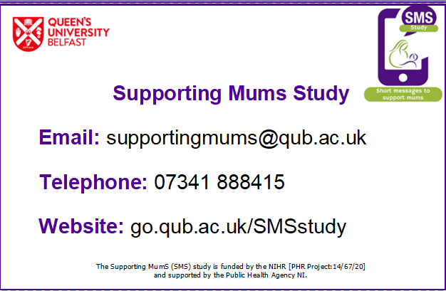
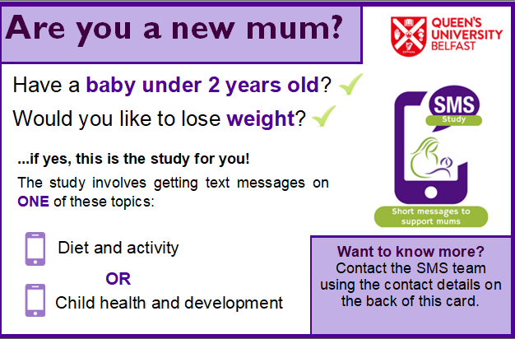
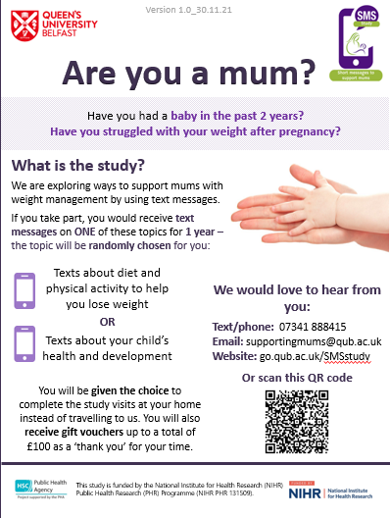

Bradford
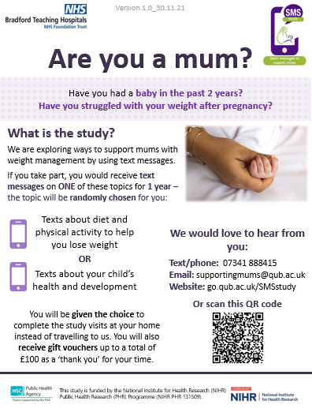
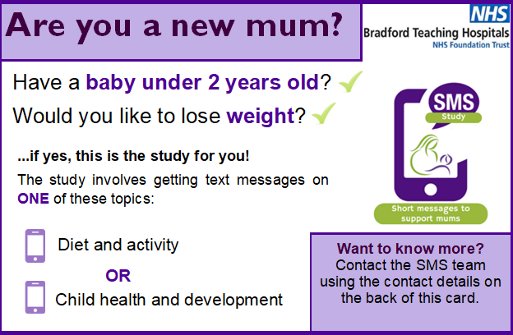

London
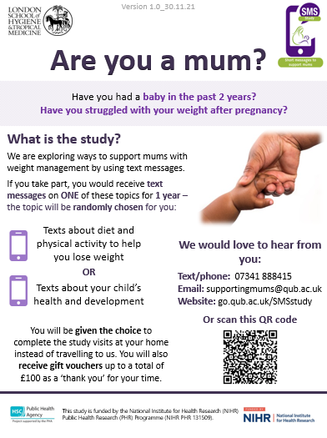
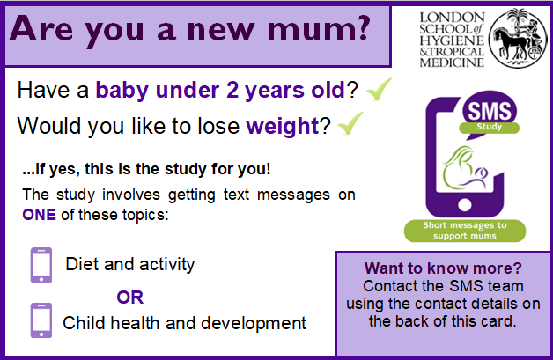

Stirling
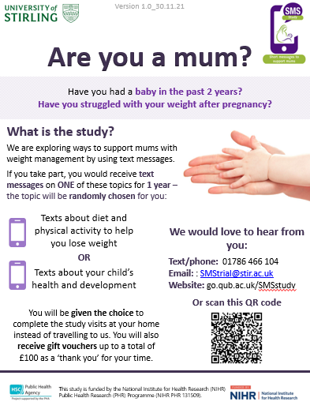
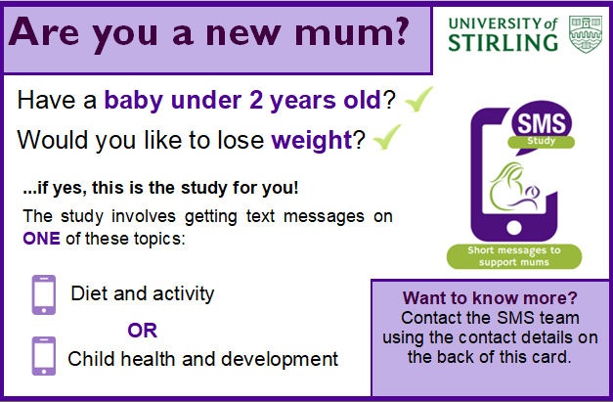

Cardiff
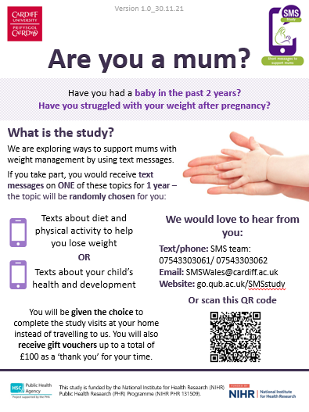
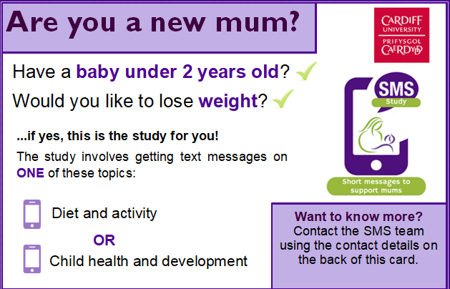

Content for disseminating via social media, text or email
Site logo | 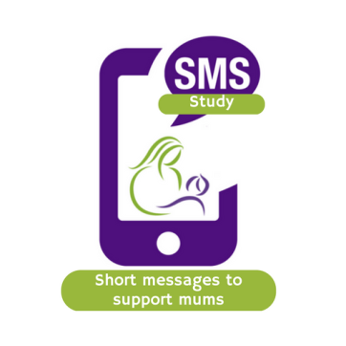

Are you a new mum?
Have you had a baby in the last two years?
Have you struggled with your weight?

We are doing a study to explore ways of supporting mums with weight management by using text messages.

If you take part you would receive text messages on ONE of these topics for 1 year:

Texts about diet and physical activity to help you lose weight

OR

Texts about your child’s health and development

As well as getting text messages, we would also ask you to meet with the SMS study researchers four times over a 24 month period. At each visit some information would be collected from you (e.g. your weight and questionnaires).
You will be given the choice to complete the study visits at your home instead of travelling to us. You will also receive gift vouchers up to a total of £100 as a ‘thank you’ for your time

If you are interested in finding out more, we would love to hear from you:
Text/phone: [phone number]
Email: supportingmums@qub.ac.uk
Website: [website]

 | This study is funded by the National Institute for Health Research (NIHR) Public Health Research (PHR) Programme (NIHR PHR 131509).

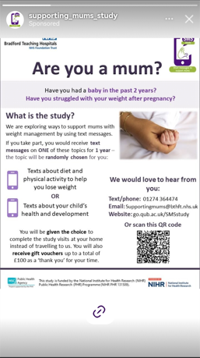
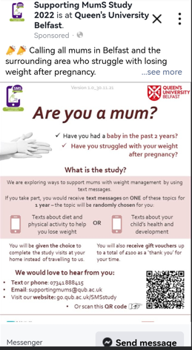
Sample screenshots of site-specific and community group social media posts
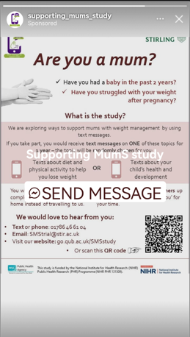
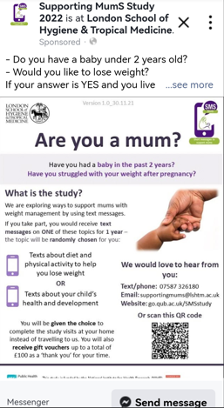
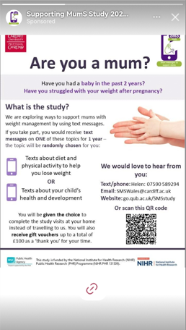
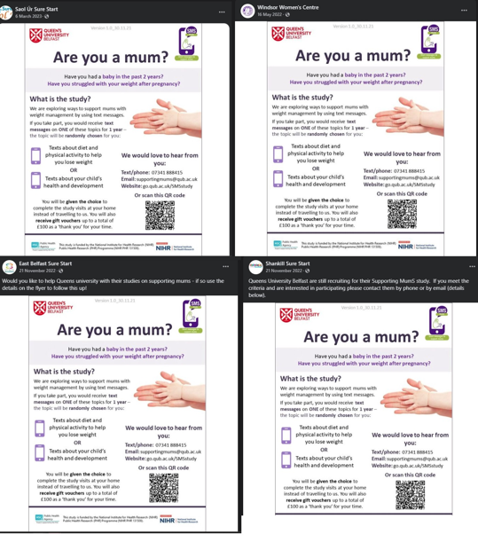
Health professional letters
Template text message for GP recruitment
Brief text

INSERT SITE NAME are doing a study to explore ways of supporting new mums with weight management by using text messages and you may be eligible to take part. If you take part you would receive text messages on ONE of these topics for 1 year: Texts about diet and physical activity to help you lose weight OR Texts about your child’s health and development. You can get in touch with research team here – go.qub.ac.uk/supportingmums & supportingmums@qub.ac.uk.

Longer text

INSERT SITE NAME are doing a study to explore ways of supporting new mums with weight management by using text messages and you may be eligible to take part.

If you take part you would receive text messages on ONE of these topics for 1 year:

Texts about diet and physical activity to help you lose weight

OR

Texts about your child’s health and development

As well as getting text messages, you would also be asked to meet with the study researchers four times over a 24 month period. At each visit some information would be collected from you (e.g. your weight and questionnaires).
You will be given the choice to complete the study visits at your home instead of travelling. You will also receive gift vouchers up to a total of £100 as a ‘thank you’ for your time

If you are interested in finding out more, you can contact the study team by:
Text/phone: [phone number]
Email: supportingmums@qub.ac.uk
Website: [website]

Letter of invitation from GP
[On GP Headed paper]

Encl:
SMS Study flyer

Date

Dear [Patient’s name],
We are contacting you to ask you to consider participating in the Supporting MumS study. This study is being conducted by Queen’s University Belfast, Bradford Teaching Hospitals NHS Foundation Trust, Cardiff University, the University of Stirling, and the London School of Hygiene & Tropical Medicine.
The study is testing ways to support new mums with weight management by using text messages.
If you decide to take part in the study, you will receive text messages to your mobile phone for 12 months. Text messages will focus on ONE of the two topics:
- Information and advice on making healthy food choices and keeping physically active to help you lose weight.
OR
- Information and advice on your child’s health and development.
We are informing you about the study as you are over 18 years old and, according to our files, you have had a baby within the past two years and have a Body Mass Index above 25 Kg/m².
If you think that you would be interested in taking part in the study, please complete and return the pre-paid card that is enclosed with this letter or contact the study team directly via the contact details given on the enclosed flyer.
It is up to you to decide whether you would like to take part in the study. If you do decide to take part, you are free to leave the study at any stage without giving a reason for doing so. Your usual health care will not be affected at any time.
Thank you for taking the time to read this letter.
Kind regards,
[GP signature]

