International Cross-Sectional SURVEY TOOL
PROJECT PANDEMIC QUESTIONNAIRE

ASK ALL
QCOUNTRY
HIDDEN – DO NOT SHOW
SC

- UK
- Australia
- New Zealand
- Ireland
- Canada
- France
- Germany
- USA
- Japan
- Pakistan
- India
- Ghana
- Italy

ASK ALL
QAGE
SC PER DROP DOWN
What is your date of birth?
Year DROP DOWN BOX
Month DROP DOWN BOX

TERMINATE IF <18 OR >65
IF PAKISTAN/INDIA – TERMINATE IF >54, IF GHANA TERMINATE IF >44

ASK ALL
QAGE_RECODE
HIDDEN – DO NOT SHOW
SC
RECODE AGE AS FOLLOWS:

_18_24 [18-24]
_25_34 [25-34]
_35_44 [35-44]
_45_54 [45-54]
_55_65 [55-65]

CHECK QUOTAS

ASK ALL
QGENDER
SC
INSERT STANDARD GENDER QUESTION FOR EACH MARKET
What is your gender?
Please choose one answer only
- Male
- Female

CHECK QUOTAS

ASK ALL
QREGION
SC
INSERT STANDARD REGION QUESTION FOR EACH MARKET
CHECK QUOTAS

ASK ALL
QWORK_STAT
SC
And are you ...?
Please choose one answer only
- Employed full-time
- Employed part-time
- Self-employed
- Unemployed but looking for a job
- Unemployed and not looking for a job / Permanently disabled / Housewife/ Househusband
- Retired
- Pupil / Student / In full- time education
- Other

QWORK_STAT_REC – RECODE QWORK_STAT AS FOLLOWS:
- Working - [IF QWORK_STAT = 1,2 OR 3]
- Not Working - [IF QWORK_STAT = 4 TO 8]

CHECK QUOTAS

MQB

INTRODUCTION

QINTROTEXT1
This survey aims to understand how members of the public would feel about taking part in medical research, through a clinical trial, during a pandemic outbreak if they were severely ill. Throughout this survey we have included images to help you picture the situation and to bring it to life. Please read all of the text carefully and review the images before answering each question.
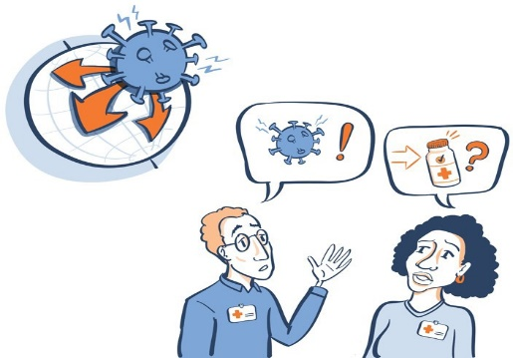
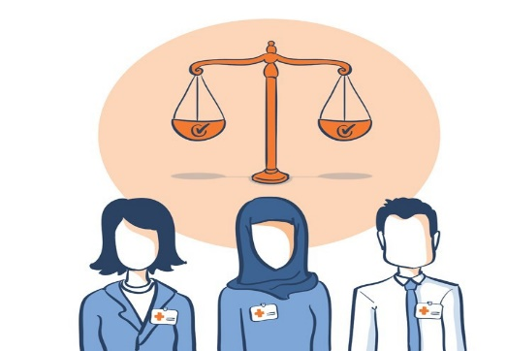

NEW SCREEN
QINTROTEXT2
A pandemic happens when a new virus spreads quickly across the world, like with COVID-19 or a new influenza virus. Many people may get this viral illness, with some people becoming severely ill and admitted to an intensive care unit.

Doctors often don’t know the best way to treat the new infection. To find out, it is necessary to conduct clinical trials.

NEW SCREEN
QINTROTEXT3
Before a clinical trial can be started, a research ethics committee must review it. A research ethics committee is made up of people who review a research proposal to check that it is safe and meets ethical standards (e.g. that the well-being, safety and rights of participants are protected).

NEW SCREEN
QINTROTEXT4
This survey asks you to imagine that there is another pandemic outbreak (for example a new influenza or a variant of COVID-19) and asks how you would feel about taking part in a clinical trial if you became severely ill.

The survey results will be used to let researchers know what the public thinks about doing research in a pandemic. This will help them to be better prepared for any future outbreaks and to design a clinical trial that is important to the public and patients.

Please note, you can always select “prefer not to say” if you can’t or don’t want to answer a question.

SCENARIO 1: INTENSIVE CARE UNIT

NEW SCREEN
QC1INFOTEXT1
Imagine there is a pandemic outbreak. You become very ill with the virus and are admitted to an Intensive Care Unit. A clinical trial is taking place to test the best way of treating very ill patients who have this viral illness using either treatment X or treatment Y. The reason for this trial is to learn which treatment works best in this new outbreak.

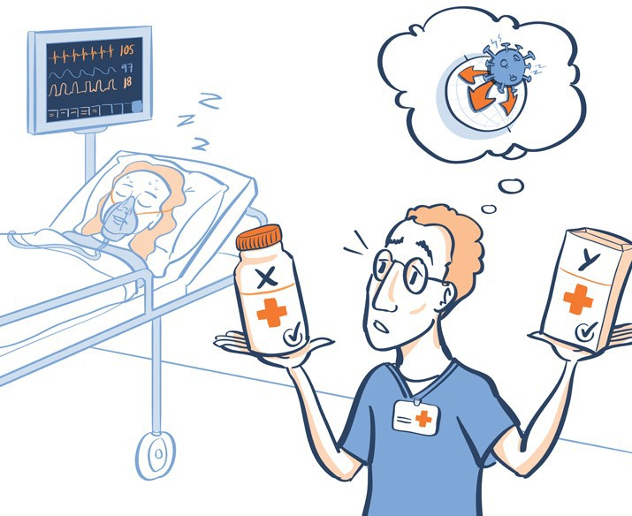

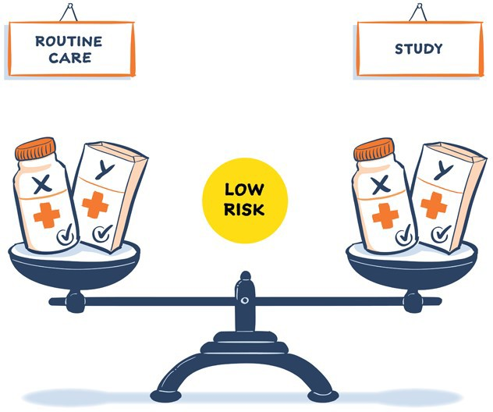
Treatment X and Y are not new treatments - they are already commonly used to treat virus infections around the world and have both passed many safety tests amongst different groups of people. So, the level of risk in taking part in this trial is low and is about the same level of risk as getting usual / routine treatment (i.e. being treated without being part of the trial).

If you took part in the trial, the treatment you receive would be decided randomly, like the flip of a coin. If you didn’t take part in the trial, you would likely still receive treatment X or Y, but the doctor would decide which.

NEW SCREEN
QC1
PROGRESSIVE GRID
SC PER ROW
How much do you agree or disagree with these statements? If you need a reminder of this scenario, please click here RE-DISPLAY INFORMATION TEXT QC1INFOTEXT1
Please select one answer per statement.
ANCHOR STATEMENT 1 - RANDOMISE ORDER STATEMENTS 2-8
FORWARD/REVERSE SCALE 1-5

 |  | 1  Strongly disagree | 2  Tend to disagree | 3  Neither agree nor disagree | 4  Tend to agree | 5  Strongly agree | 97. Don’t know | 99  Prefer not to say
1 | I would want to take part in this clinical trial  ANCHOR
2 | I would be more willing to take part in this type of trial because a pandemic outbreak is happening
3 | I believe a doctor will always know which treatment is better for me
4 | I believe that researchers running this trial would always try to provide each person with the treatment that best meets that person’s individual needs
5 | I believe that a researcher’s most important task is to make sure that the research treatment will help the people who participate
6 | I believe that patients would get the best treatment for their illness by taking part in this clinical trial
7 | The fact that a pandemic outbreak is happening would make me worry that the clinical trial was not being well monitored
8 | I would be more willing to take part in this trial after experiencing a pandemic outbreak (e.g. COVID-19).

NEW SCREEN
QC2INFOTEXT1
Still thinking about this clinical trial to test treatment X vs. treatment Y. Information about this trial would be available on posters and leaflets in the hospital/ICU.

Patients in Intensive Care Units are usually too ill to discuss their wishes. Researchers might ask family members or, if they’re not available (e.g. also ill in the pandemic), another doctor (not involved in the trial) might decide on behalf of the patient.

NEW SCREEN
QC2
To be included in the trial, which option would you prefer?
Please rank these options in order of your preference with 1 being your first choice and 4 being your least preferred.
Please read all options before selecting your order of preference.
You can always select “no option preferred/no further options preferred” if applicable
If you need a reminder of this scenario, please click here RE-DISPLAY INFORMATION TEXT QC1INFOTEXT1

FORWARD/REVERSE OPTIONS 1-4. ANCHOR LAST OPTION
OPTIONS 1 to 4 - SC per column and SC per ROW

IF OPTION 5 IS SELECTED IN ANY OF COLUMN 1 OR COLUMN 2 OR COLUMN 3, THEN OPTION 5 MUST BE SELECTED FOR REMAINING COLUMNS (I.E. CANNOT GIVE RANKING CHOICE AFTER SAYING NO OPTIONS PREFERRED). PLEASE REVIEW ANSWERS AGAIN.
Please select one answerper row, please note you can’t select 1st choice, 2nd choice, 3rd choice or last choice more than once

 |  | 1  My first  choice | 2  My second  choice | 3  My third  choice | 4  My last  choice
1 | Include me immediately, family decides later if that’s ok.  You would be automatically included in the trial. As soon as they could be contacted, a close family member would then decide whether or not you should stay included in the trial.
2 | Include me immediately, doctor decides later if that’s ok.  You would be immediately included in the trial. A hospital doctor who is not a researcher in the trial, but who knows about it, would decide whether or not you should stay included in the trial.
3 | Don’t include me until a family member says it’s ok.  You would not be included in the trial until a close family member could be contacted to make that decision on your behalf.
4 | Don't include me in the trial, I would not be happy for a family member or doctor to say yes on my behalf.  In this case, you would not be included in the trial as the trial treatment would need to be started ASAP and the time window would have passed by the time you are well enough to discuss the trial.
5

- No options preferred / No other options preferred (can be selected if 0 -3 of statements 1-4 selecte, cant be selected if all 4 statements selected. )
- Don’t know EXCLUSIVE
- Prefer not to say EXCLUSIVE

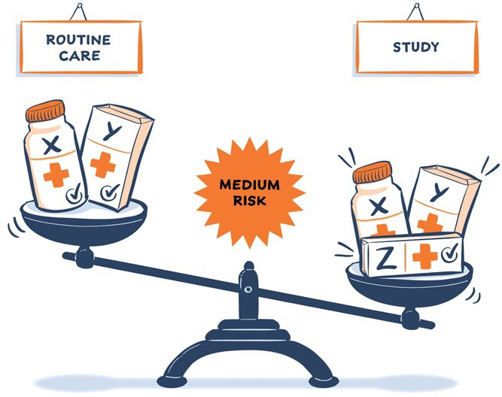
NEW SCREEN
QC3INFOTEXT 1
Imagine that the pandemic was worsening. Doctors in the Intensive Care Unit are
testing a new treatment (Z) which seems to help, as the few people who have taken it get
better faster. The new treatment (Z) has passed many safety tests but is NOT currently
used as a usual / routine treatment for this new virus (e.g. treatment X or treatment Y
is the usual / routine treatment), and so the risk/benefit ratio is more uncertain.

If you agreed to take part in the trial you would get one of treatment X, Y or the new treatment Z. If you don't take part in the trial you would get the usual treatment X or Y and would not receive the new treatment Z.

NEW SCREEN
QC3
PROGRESSIVE GRID
SC PER ROW
How much do you agree or disagree with these statements? If you need a reminder of this scenario, please click here
RE-DISPLAY INFORMATION TEXT QC3INFOTEXT1
Please select one answer per statement.
ANCHOR STATEMENT 1. RANDOMISE ORDER OF STATEMENTS 2-4. FORWARD/REVERSE SCALE 1-5

 |  | 1  Strongly disagree | 2  Tend to disagree | 3  Neither agree nor disagree | 4  Tend to agree | 5  Strongly agree | 97. Don’t know | 99  Prefer not to say
1 | I would want to take part in this clinical trial ANCHOR
2 | I would only want to take part in the trial if I knew I would get the new treatment
3 | Because a pandemic outbreak is happening, I would be more willing to take part in this type of trial
4 | I would be more willing to take part in this trial after experiencing a pandemic outbreak (e.g. COVID-19).

SCENARIO 2: ADAPTIVE CLINICAL TRIALS

NEW SCREEN
QB1AINFOTEXT1
In regular clinical trials, everything is decided before the trial starts, including which two treatments will be tested, how many people will participate in the trial and how the results will be analysed. These decisions do not change from start to end. The trial results are only analysed after the exact number of desired participants have taken part.

QB1AINFOTEXT2
In ‘Adaptive clinical trials’ the results collected are continually analysed as the trial is being carried out - this means that researchers are continually learning during the trial. It means the decisions that were made before the trial can be changed as researchers learn from the results. For example:
- More than 2 treatments can be included, so an individual would receive multiple treatments as part of the trial (this is normal for most patients)
- New treatments can also be added and removed based on the results
As the results are continually analysed, the trial can be stopped or extended if a treatment is found to work or not work. This means not waiting until having the exact number of desired participants before looking at the results.

NEW SCREEN
QB1AINFOTEXT3
In regular clinical trials, it is decided at random (50% chance: like the flip of a coin) if a participant will receive treatment X or treatment Y. An equal number of participants must receive each treatment.

However, an adaptive clinical trial often uses ‘Response adaptive randomization (RAR)’. Again, the results are continually analysed during the trial. If treatment X looks to be more beneficial, RAR means that more participants will receive this treatment (X) and less participants receive the other potentially less beneficial treatment. Therefore, you are more likely to receive the potentially beneficial treatment as the trial includes more participants and gathers more information.

NEW SCREEN
QB1A.
PROGRESSIVE GRID
SC PER ROW
How much do you agree or disagree with the following statements? If you need a reminder of this scenario,
Please click here RE-DISPLAY INFORMATION TEXT QB1AINFOTEXT1, QB1AINFOTEXT2 AND QB1AINFOTEXT3

Please select one answer per statement.
RANDOMISE ROWS 1-5, FORWARD/REVERSE SCALE 1-5

 |  | 1  Strongly disagree | 2  Tend to disagree | 3  Neither agree nor disagree | 4  Tend to agree | 5  Strongly agree | 97. Don’t know | 99  Prefer not to say
1 | The ability to learn and make changes during a clinical trial is important
2 | It is important to be able to test more than one (multiple) treatment in a clinical trial
3 | If possible, clinical trials should use Response adaptive randomization (RAR)
4 | Research funders should prioritize setting up adaptive, clinical trials.even if this may require more planning and/or extra funding than non adaptive trials
5 | Typically only large hospitals with moreresources participate in adaptive trials  I believe smaller hospitals should also be given the opportunity to participate– as long as they have/will be provided with the appropriate resources.

SCENARIO 3: CLINICAL SAMPLES

NEW SCREEN
QC4INFOTEXT 1
Doctors often take clinical samples, like throat swabs or blood tests, to help them make decisions. Some clinical trials take additional samples e.g. a little extra blood or an extra throat swab. These samples can help researchers understand the disease and potentially develop new treatments.
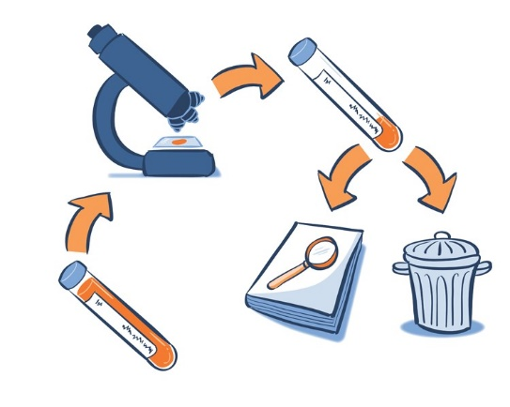

These questions ask how you would feel about clinical samples being stored and then used for research, without asking you each time they are used but following ethical approvals and standards. The samples would not have personal information attached to them that might allow someone to identify you, like your name or address.

Note that for public health purposes, clinical samples are already stored and used without permission to monitor the health of the population.

NEW SCREEN
QC4
PROGRESSIVE
SC PER ROW
For these questions please imagine you had consented to additional clinical samples being taken for research. How much do you agree or disagree with these statements? If you need a reminder of this scenario, please click here RE-DISPLAY INFORMATION TEXT QC4INFOTEXT1
Please select one answer per statement.
ANCHOR STATEMENT 1. RANDOMISE ORDER OF STATEMENTS 2-6. FORWARD/REVERSE SCALE 1-5

 |  | 1  Strongly disagree | 2  Tend to disagree | 3  Neither agree nor disagree | 4  Tend to agree | 5  Strongly agree | 97. Don’t know | 99  Prefer not to say
2 | I am happy for my samples to be stored and used for pandemic-related research during the pandemic outbreak, without asking me each time they are used  For example researchers may want to understand how the virus (or other kind of pathogen) works, to develop ways of testing for it or treating it.
3 | I am happy for my samples to be stored and used for pandemic-related research once the pandemic outbreak is over, without asking me each time they are used.  For example researchers may want to understand if another virus or bacteria may also be involved so they know how best to treat this kind of illness if another pandemic happens in the future.
4 | I am happy for my samples to be used for pandemic-related research using my genetic material (i.e. DNA). This can be important to find out why the disease affects people differently.  For example some people who appear similar may die while some recover. This may allow researchers to develop a test that can quickly identify which people will be more seriously affected in a future pandemic so that these people could get appropriate treatment faster.
5 | I am happy for my samples to be used for future clinical research that is NOT related to the pandemic outbreak without asking me each time they are used.  For example researchers might be developing a new test for a different kind of illness and they would need patient samples to see if this test would work.
6 | I am happy for my samples to be shared with other researchers NOT involved in this study if their study has been approved by an ethics committee (the research could be pandemic or non-pandemic related).  For example other researchers may be carrying out a different study developing a new test and would need patient samples. They may ask for samples to be shared with their study to see if this test would work. They would also have ethics approvals in place.  ANCHOR

ASK ALL
NEW SCREEN

QC4a. And how much do you agree or disagree with this statement? If you need a reminder of this scenario, please click here RE-DISPLAY INFORMATION TEXT QC4INFOTEXT1

“I am happy for additional samples to be taken for pandemic-related research”

Please select one answer only
SINGLE CODE. FORWARD/REVERSE SCALE 1-5

- Strongly disagree
- Tend to disagree
- Neither agree nor disagree
- Tend to agree
- Strongly agree
- Don’t know
- Prefer not to say

NEW SCREEN
QB1INFOTEXT

SCENARIO 4: PERSONALISED OR PRECISION MEDICINE

In some cases, research from these clinical samples (e.g. blood tests) may identify a group of patients that will particularly benefit more from a specific treatment (e.g. treatment A). Doctors are then able to carry out a blood test to identify if you are one of these patients that would benefit from treatment A and if so, you would receive treatment A. This is considered ‘Personalised or Precision medicine’.

Imagine you require treatment and have the option to take a blood test which may reveal that you would benefit from one of the available treatments over another.

NEW SCREEN
QB1
PROGRESSIVE GRID
SC PER ROW
How much do you agree or disagree with the following statements? If you need a reminder of this scenario,
please click here RE-DISPLAY INFORMATION TEXT QB1INFOTEXT

Please select one answer per statement.
RANDOMISE ROWS 1-3. FORWARD/REVERSE SCALE 1-5

 |  | 1  Strongly disagree | 2  Tend to disagree | 3  Neither agree nor disagree | 4  Tend to agree | 5  Strongly agree | 97. Don’t know | 99  Prefer not to answer
1 | I would be happy to take a blood test in order for doctors to guide my treatment
2 | f the result of a blood test couldn’t say whether I might benefit more from a treatment than other people, but the treatment was still safe, I would be happy to receive the treatment
3 | Doctors should routinely collect additional samples during trials to develop new blood tests that identify patients that might benefit more from a treatment

ATTITUDES

ASK ALL
NEW SCREEN
QA1
PROGRESSIVE GRID
SC PER ROW
Thinking now generally about medical research during a pandemic.
How much do you agree or disagree with the following statements?
Please select one answer per statement. Remember, you can always select “prefer not to say” if you can’t or don’t want to answer the question.
RANDOMISE ORDER OF STATEMENTS 1-7. FORWARD/REVERSE SCALE 1-5

 |  | 1  Strongly disagree | 2  Tend to disagree | 3  Neither agree nor disagree |  | 4  Tend to agree | 5  Strongly agree | 97. Don’t know | 99  Prefer not to say
1 | It is important that medical research is done during a pandemic outbreak
2. | Medical research should be established before the pandemic so that it is ready to respond without delay
3. | Medical research should have input from the patients that are affected, and from the public (public and patient involvement).
4 | Special rules should apply that make it quicker and easier to do medical research during a pandemic outbreak
5 | The government is competent to manage a pandemic outbreak
6 | The government would be honest with its citizens when managing a pandemic outbreak
7 | The government would act in the best interests of its citizens when managing a pandemic outbreak

ASK ALL
NEW SCREEN
QA2
SC
Before today, how much, if anything, would you say you knew about a pandemic virus?
Please select one answer only
FORWARD/REVERSE CODES 1-5

- A great deal
- A fair amount
- Just a little
- Heard of, but know nothing about
- Never heard of
- Prefer not to answer ANCHOR

EXTRA QUESTION: NON-PANDEMIC PERSONALISED AND PRECISION MEDICINE (9 MARKETS):

ASK IF UK/US/FRANCE/AUSTRALIA/JAPAN/GERMANY/CANADA/IRELAND/ITALY
NEW SCREEN
QB1CINFOTEXT
We now ask you to imagine that there is NO ongoing pandemic. You become very unwell and are admitted to an Intensive Care Unit with breathing difficulty due to a lung infection. This may be a virus or bacteria, but again it is not a virus causing a pandemic. However, you are still very ill.

ASK IF UK/US/FRANCE/AUSTRALIA/JAPAN/ GERMANY/CANADA/IRELAND/ITALY
NEW SCREEN
QB1C
PROGRESSIVE GRID
SC PER ROW
How much do you agree or disagree with the following statements? If you need a reminder of this scenario,
please click here RE-DISPLAY INFORMATION TEXT QB1CINFOTEXT

Please select one answer only per statement.
ANCHOR STATEMENT 1 - RANDOMISE STATEMENTS 2-4, FORWARD/REVERSE SCALE CODES 1-5

 |  | 1  Strongly disagree | 2  Tend to disagree | 3  Neither agree nor disagree | 4  Tend to agree | 5  Strongly agree | 97. Don’t know | 99  Prefer not to say
 | I would want to take part in a clinical trial testing treatments for this non-pandemic severe illness ANCHOR
2. | I am happy for additional samples to be taken for non-pandemic severe illness research
3. | I would be happy to take a blood test in order for doctors to guide my treatment for a non-pandemic severe illness
4. | Doctors should routinely collect additional samples during non-pandemic trials to develop new blood tests which identify patients that might benefit more from a treatment

ABOUT YOU
ASK ALL
NEW SCREEN
We are now at the last part of the survey and only have a few more questions about you and your household.

ASK ALL
QE1
MC
Which, if any, of the following statements concerning medical care in an Intensive Care Unit (ICU) apply to you?
Please select all that apply
RANDOMISE 1-4
- I have been critically ill in an ICU
- A close family member has been critically ill in an ICU (husband or wife, boyfriend or girlfriend, parent or parent in-law, sibling, close relative, etc.)
- My child has been critically ill in an ICU
- A friend or colleague has been critically ill in an ICU
- No-one I know has been critically ill in an ICU ANCHOR , EXCLUSIVE
- Don’t know ANCHOR , EXCLUSIVE
8. Prefer not to say ANCHOR , EXCLUSIVE

ASK ALL
QE2
SC
How would you describe your overall health?
FORWARD/REVERSE 1-5
- Excellent
- Very good
- Good
- Fair
- Poor
- Prefer not to answer ANCHOR

ASK ALL
QE3
MC
Have any of the following happened to you, or a close family member or friend, as a result of a pandemic virus e.g. COVID-19, swine flu, etc?
Please read each statement fully and select all that apply
KEEP TOGETHER 1 -5 and forward -reverse, and keep together 6- 11 and forward -reverse

- I have been admitted to hospital and treated in ICU due to confirmed or suspected pandemic illness,
- I have been admitted to hospital (and was not treated in ICU) due to confirmed or suspected pandemic illness
- I have experienced severe illness due to a pandemic illness, but was not admitted to hospital
- I have tested positive that I have/have had a pandemic illness
- I have had symptoms resembling a pandemic illness but it was not confirmed by a test
- I have lost a close family member or friend to a pandemic illness
- I have a close family member or friend who has been admitted to hospital and was treated in ICU due to confirmed or suspected pandemic illness
- I have a close family member or friend who has been admitted to hospital (and was not treated in ICU) due to confirmed or suspected pandemic illness
- I have a close family member or friend who has experienced severe illness due to a pandemic illness, but was not admitted to hospital
- I have a close family member or friend who has tested positive that they have/have had a pandemic illness
- I have a close family member or friend who has had symptoms resembling a pandemic illness, but was never confirmed by a test
- None of these ANCHOR, EXCLUSIVE
- Don’t know ANCHOR, EXCLUSIVE
- Prefer not to say ANCHOR, EXCLUSIVE

ASK ALL
QE5
SC
How many children, if any, aged seventeen or under are there in your household?
Please select one answer
- 1
- 2
- 3
- 4
- 5+
- None
- Prefer not to say

ASK ALL
QE7
SC
What is your marital status?
Please select one answer
- Single (never married)
- Living with partner
- Married /Civil partnership
- Separated
- Divorced
- Widowed
- Prefer not to say

ASK ALL
QE8
SC USED MARKET SPECIFIC VERSIONS
Which of the following best describes your highest level of education?
Please select one answer
SHOW COUNTRY-SPECIFIC LIST OF EDUCATIONAL LEVELS
- No completed education
- Primary school
- Secondary education (GCSEs, Scottish Standard Grades, NVQ Levels 1 and 2)
- Higher secondary education (GCE, A/AS Levels, Scottish Highers, NVQ Level 3, GNVQ/GSVQ Advanced)
- HE Access Courses
- University and tertiary education (Undergraduate and Masters degrees, PGCE, NVQ Levels 4 and 5, HNC, HND)
- Doctorate/PhD
- Prefer not to say

ASK ALL
USED MARKET SPECIFIC VERSIONS
QE9b
. SC
Which one of these ethnic groups would you describe yourself as belonging to?
Please select one answer only
SHOW COUNTRY-SPECIFIC LIST OF ETHNICITY

- White – British
- White – Irish
- White – any other white background
- Asian or Asian British – Indian
- Asian or Asian British – Pakistani
- Asian or Asian British – Bangladeshi
- Asian or Asian British – any other Asian background
- Black or black British – Caribbean
- Black or black British – African
- Black or black British – any other black background
- Mixed – white and black Caribbean
- Mixed – white and black African
- Mixed – white and Asian
- Mixed – any other mixed background
- Chinese or other ethnic group – Chinese
- Chinese or other ethnic group – any other background
- Prefer not to answer

ASK ALL
QE10
SC
RANDOMISE
What, if any, faith do you live by?
Please select one answer
- Islam (any denomination)
- Christian (any denomination)
- Jewish
- Hindu
- BuddhistOther ANCHOR, EXCLUSIVE
- None of the above ANCHOR, EXCLUSIVE
- Prefer not to say ANCHOR, EXCLUSIVE

ASK ALL
QE11
SEC (STANDARD FOR ALL MARKETS)
SC
Which of the following best describes the current working status of the main income earner in the household?

The person in the household with the largest income is the main income earner, however this income is obtained. If the main income earner is retired and has an occupational pension, please select according to the previous occupation. If the main income earner is not in paid employment and has been out of work for less than 6 months, please select according to previous occupation.

Please select one answer
FORWARD/REVERSE 1-9

- High managerial, administrative or professional
- Intermediate managerial, administrative or professional
- Junior managerial, administrative or professional, supervisor or clerical
- Skilled manual worker
- In full-time or part-time education / student
- Semi-skilled or unskilled manual worker
- Unemployed/housewife/househusband
- Casual worker / without regular income
- Pensioner
- Prefer not to say ANCHOR

SEC_NET
HIDDEN – DO NOT SHOW
SC
A [QE11=1]
B [QE11=2]
C1 [QE11=3 OR 5]
C2 [QE11=4]
D [QE11=6]
E [QE11=7 OR 8 OR 9]

