Supplemental material

Supplemental Table S1

Score | Definition
0 | No edema
1 | minimal edema
2 | Minimal-medium edema + subcortical involvement
3 | Medium- strong edema + subcortical involvement
4 | Bilateral edema
Table S1. Edema (HE-Staining): Semiquantitative edema score grading the loosening within the intercellular structure.

Supplemental Table S2

Score | Definition
0 | No bleeding
1 | Petechial bleeding
2 | Confluent petechial bleeding
3 | Singular space-occupying bleedings/ ventricular bleeding
4 | Multiple space-occupying bleedings
Table S2. Hemorrhage (HE-Staining): Semiquantitative hemorrhage grading the detection of extravascular erythrocytes as well as red-blood-cell-conglomerates.

Supplemental Table S3

Score | Definition
0 | No relevant additional stained cells (no reactivity)
1 | Cortical reaction
2 | Weak subcortical reaction
3 | Reaction within the whole hemisphere
4 | Bilateral reaction
Table S3. Iba-1 Score (Microglia/Macrophages activation as sign of immunoreactivity): Semiquantitative analysis of immunoreactivity using Iba-1 staining (activation of microglia and macrophages).

Supplemental Table S4

Histopathological scores
 | C5 inhibitor | Control | p value
hemorrhage score | 3 (2.25-3.75) | 3 (2-4) | >0.9
edema score | 2 (2-2) | 2 (2-3) | 0.82
Iba1 score | 0 (0-0.75) | 0 (0-1) | 0.73
Table S4. Histopathological scores for hemorrhage, edema and Iba1 are depicted as median with interquartile range (IQR)

Supplemental Table S5

Histopathological scores
 | C5 inhibitor | Control | p value
hemorrhage score | 1 (1-2) | 1 (1-1) | 0.13
edema score | 2 (2-3) | 2 (1.5-3) | 0.97
Iba1 score | 3 (2-3) | 2 (2-3) | 0.43
Table S5: Histopathological scores for hemorrhage, edema and Iba1 are depicted as median with interquartile range (IQR)

Sensitivity Analysis Edema Estimation

Edema estimation using the Kaplan method is prone to inaccuracies, particularly when tissue loss at the contusion site leads to necrosis and atrophy, potentially resulting in non-meaningful negative values. We therefore reanalyzed the data by setting 0% as the lower bound and repeated all relevant analyses. However, the extent of edema remained similar between the two groups (median extent of edema in % of contralateral hemisphere for C5 inhibitor group= 1.5 (0 – 4.8) vs. control group= 1.9 (0 – 5.1), p= 0.81, Figure S1).

Figure S1
Figure S1. Edema volumes expressed as a percentage of the contralateral hemisphere were quantified using post-mortem MRI 7 days after CCI, thick lines indicate medians, and thin lines represent the IQR, n=13 mice per group.

Inter-Animal variability

Figure S2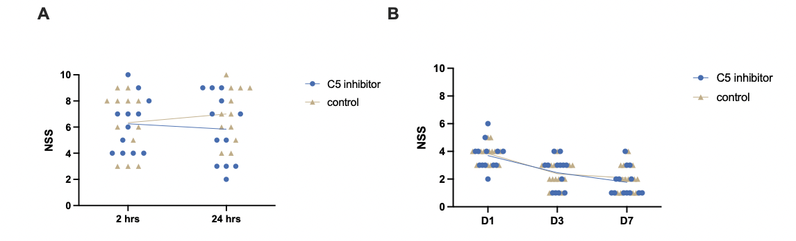
Figure S2. Graphical representation of individual datapoints illustrating inter-animal variability in functional outcomes: (A) short-term outcome and (B) long-term outcome

Exemplary images of Iba-1 Staining (Microglia/Macrophages activation as sign of immunoreactivity)

Figure S3
Figure S3. Representative images of Iba1-staining: 24 h control group (A) and the C5 inhibition group (B), both scored as 0. Black scale bar = 100 µm

Figure S4
Figure S4. Representative images of Iba1-staining: long-term control group (C) and C5 inhibition group (D), both scored as 3. Black scale bar = 100 µm

