Table S1: Image derived spinal cord uptake before use of analgesic
Region | SNI Mean | SD | Sham Mean | SD
C1 | 0.119 | 0.008 | 0.118 | 0.013
C2 | 0.137 | 0.016 | 0.123 | 0.014
C3 | 0.140 | 0.018 | 0.125 | 0.007
C4 | 0.141 | 0.017 | 0.127 | 0.008
C5 | 0.142 | 0.018 | 0.125 | 0.005
C6 | 0.144 | 0.019 | 0.127 | 0.005
C7 | 0.141 | 0.013 | 0.125 | 0.004
T1 | 0.136 | 0.011 | 0.125 | 0.002
T2 | 0.136 | 0.013 | 0.121 | 0.005
T3 | 0.140 | 0.022 | 0.120 | 0.009
T4 | 0.149 | 0.025 | 0.125 | 0.012
T5 | 0.163 | 0.026 | 0.137 | 0.014
T6 | 0.171 | 0.033 | 0.146 | 0.007
T7 | 0.182 | 0.017 | 0.147 | 0.009
T8 | 0.180 | 0.015 | 0.150 | 0.013
T9 | 0.179 | 0.018 | 0.157 | 0.014
T10 | 0.176 | 0.014 | 0.156 | 0.014
T11 | 0.157 | 0.024 | 0.142 | 0.002
T12 | 0.138 | 0.003 | 0.111 | 0.010
T13 | 0.128 | 0.008 | 0.099 | 0.007
L1 | 0.138 | 0.017 | 0.100 | 0.008
L2 | 0.142 | 0.017 | 0.107 | 0.008
L3 | 0.142 | 0.014 | 0.102 | 0.009
L4 | 0.158 | 0.010 | 0.120 | 0.013
L5 | 0.164 | 0.007 | 0.131 | 0.014
L6 | 0.163 | 0.006 | 0.125 | 0.014

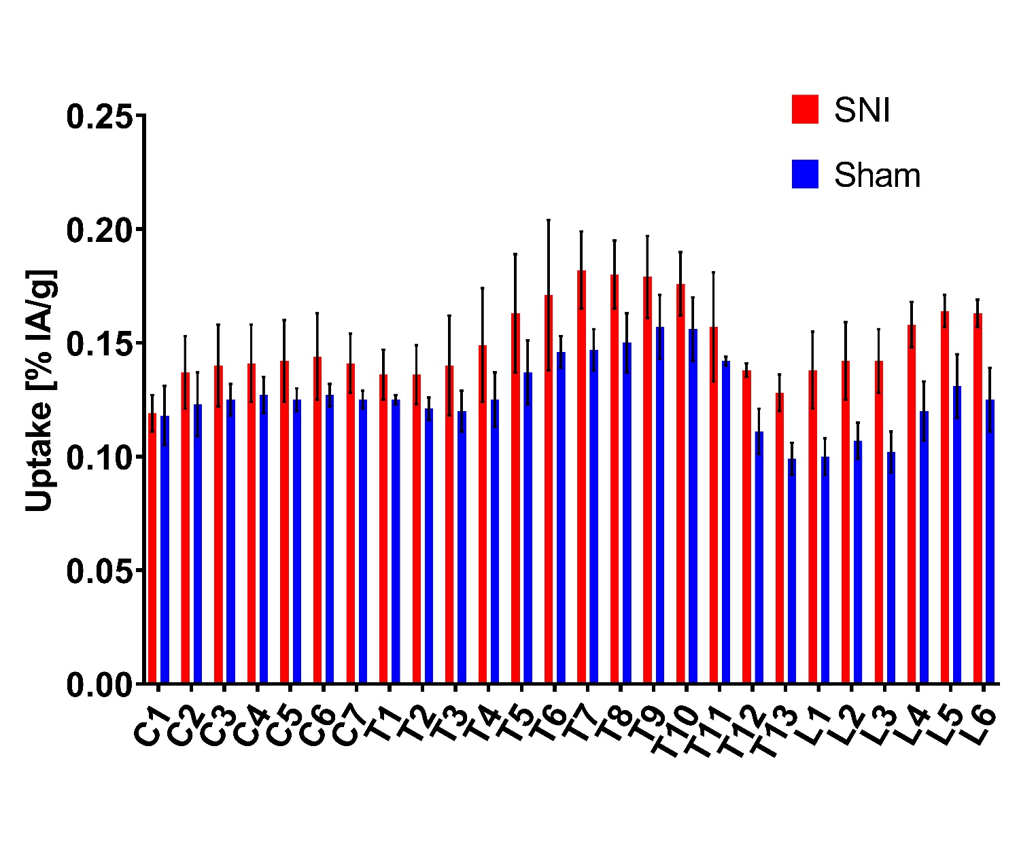Figure S1: Image derived spinal cord uptake of ⁵¹Mn in animals with SNI surgery (n=5, red), and with sham surgery (n=3, blue), before use of analgesic

Region | SNI Mean | SD | Sham Mean | SD
C1 | 0.111 | 0.012 | 0.093 | 0.016
C2 | 0.118 | 0.013 | 0.108 | 0.009
C3 | 0.121 | 0.013 | 0.113 | 0.010
C4 | 0.119 | 0.013 | 0.113 | 0.009
C5 | 0.121 | 0.011 | 0.115 | 0.011
C6 | 0.124 | 0.011 | 0.115 | 0.012
C7 | 0.125 | 0.010 | 0.113 | 0.012
T1 | 0.122 | 0.009 | 0.124 | 0.014
T2 | 0.121 | 0.009 | 0.120 | 0.013
T3 | 0.124 | 0.012 | 0.122 | 0.011
T4 | 0.133 | 0.019 | 0.127 | 0.015
T5 | 0.149 | 0.014 | 0.133 | 0.025
T6 | 0.161 | 0.018 | 0.143 | 0.023
T7 | 0.170 | 0.018 | 0.141 | 0.021
T8 | 0.164 | 0.014 | 0.141 | 0.022
T9 | 0.160 | 0.017 | 0.145 | 0.028
T10 | 0.159 | 0.019 | 0.141 | 0.028
T11 | 0.142 | 0.021 | 0.131 | 0.020
T12 | 0.123 | 0.019 | 0.119 | 0.013
T13 | 0.115 | 0.012 | 0.107 | 0.017
L1 | 0.114 | 0.009 | 0.105 | 0.018
L2 | 0.124 | 0.011 | 0.106 | 0.017
L3 | 0.129 | 0.011 | 0.103 | 0.020
L4 | 0.145 | 0.024 | 0.111 | 0.018
L5 | 0.157 | 0.031 | 0.127 | 0.015
L6 | 0.158 | 0.032 | 0.132 | 0.019
Table S2: Image derived spinal cord uptake after use of analgesic

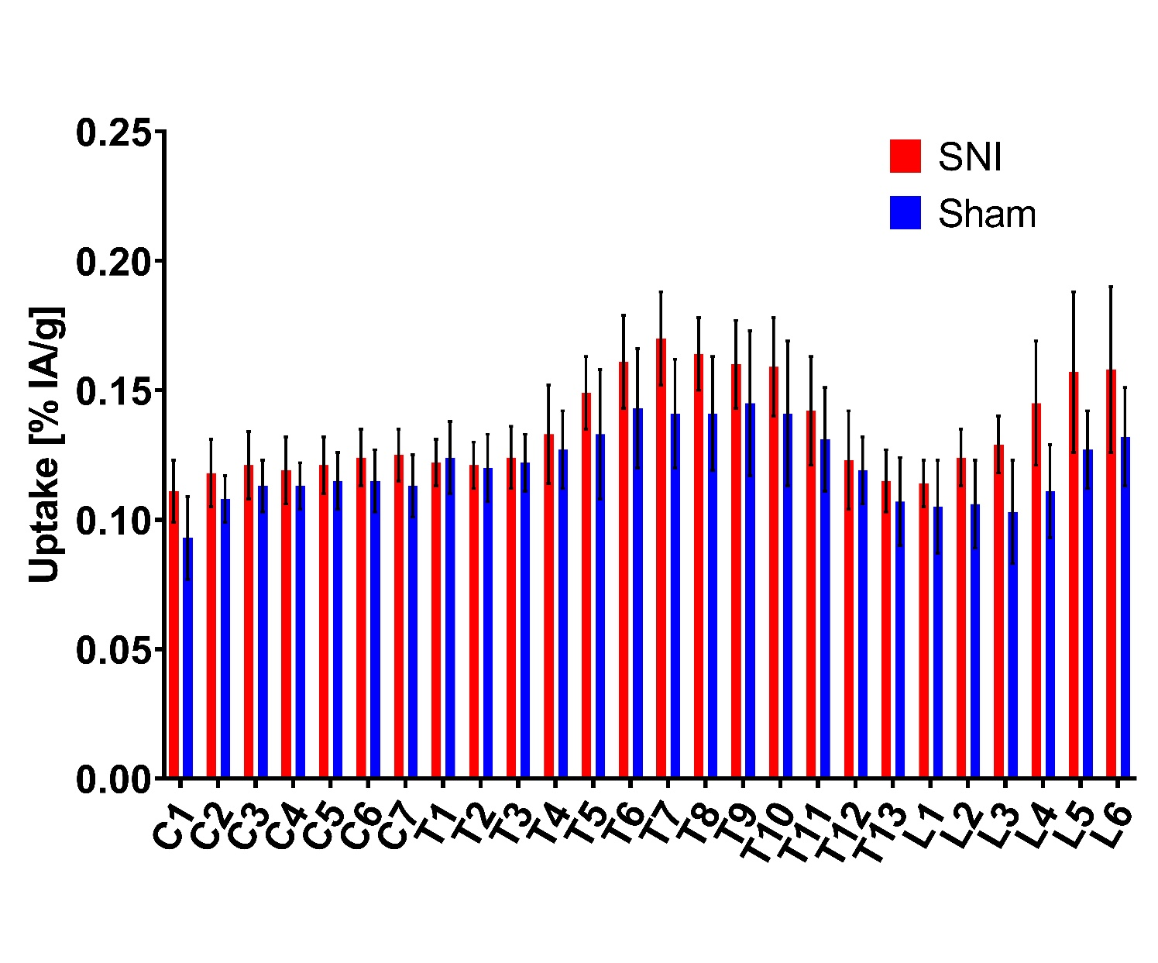
Figure S2: Image derived spinal cord uptake of ⁵¹Mn in animals with SNI surgery (n=5, red), and with sham surgery (n=3, blue), after use of analgesic

