New method for sequestration of silver nanoparticles in aqueous media: In route toward municipal wastewater

Supporting information

Marie-Laine Roy (marie-laine_roy@hotmail.com)
Christian Gagnon (christian.gagnon@ec.gc.ca)
Jonathan Gagnon (jonathan_gagnon@uqar.ca)

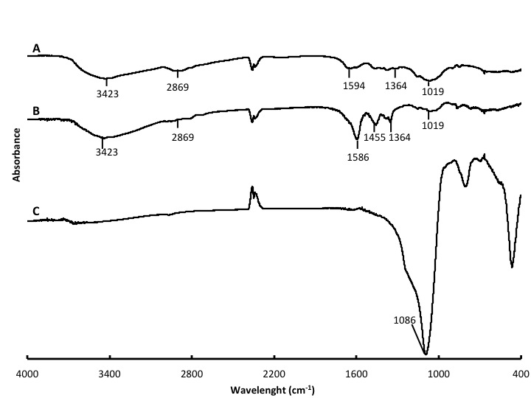
Figure S1. Infrared spectra of (A) immobilized DMC after washing; (B) DMC; (C) silica propyl bromide

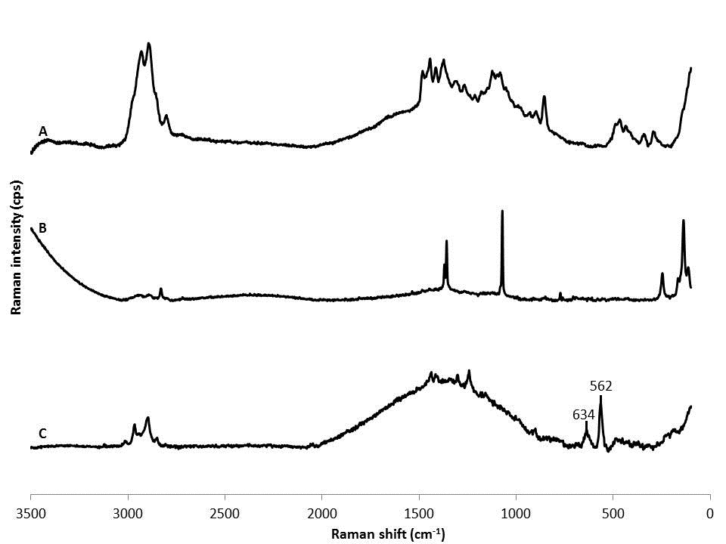
Figure S2. Raman spectra of (A) immobilized DMC; (B) DMC; (C) silica propyl bromide

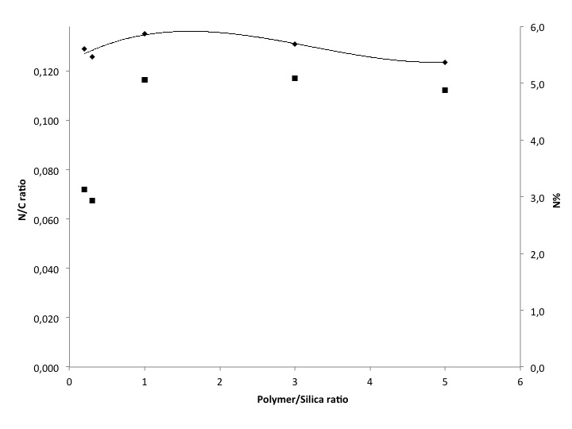Figure S3. Nitrogen/carbon ratio (♦) and nitrogen percentage () of immobilized DMC on modified silica with the variation of the polymer/silica ratio

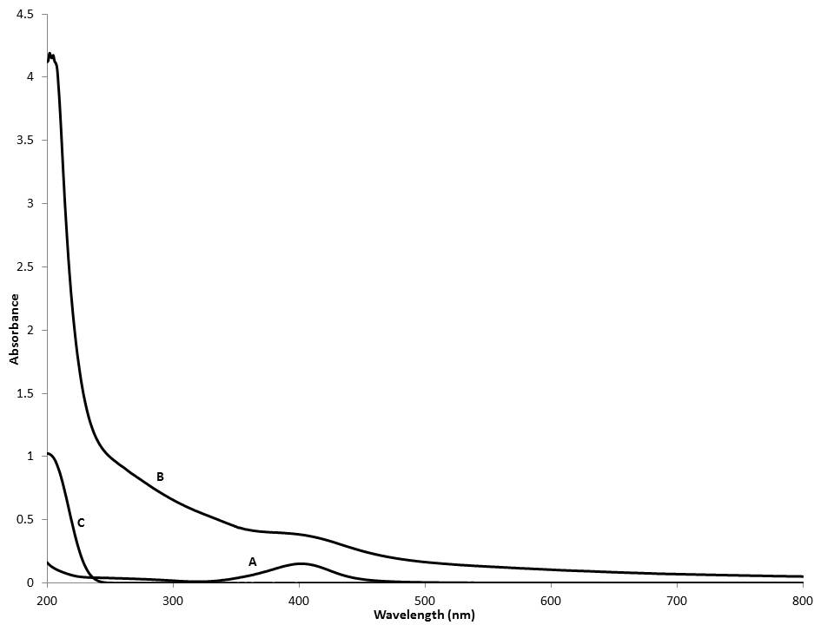
Figure S4. UV-visible spectra of a solution of A) citrate Ag NPs; B) supernatant after sequestration; C) acetic acid

