ADDITIONAL INFORMATION

Synthesis and analytical characterization of new thiazol-2-(3H)-ones as human neutrophil elastase (HNE) inhibitors

Letizia Crocettiª, Gianluca Bartolucciª, Agostino Cilibrizzi^{b}, Maria Paola Giovannoni^{a*}, Gabriella Guerriniª, Antonella Iacovoneª, Marta Menicattiª, Igor A. Schepetkin^{c}, Andrei I. Khlebnikov^{d,e}, Mark T. Quinn^{c}, and Claudia Vergelliª

ªNEUROFARBA, Sezione di Farmaceutica e Nutraceutica, Università degli Studi di Firenze, Via Ugo Schiff 6, 50019 Sesto Fiorentino, Italy.
^{b}Institute of Pharmaceutical Science, King’s College London, 150 Stamford Street, London SE1 9NH, UK
^{c}Department of Microbiology and Immunology, Montana State University, Bozeman, MT 59717, USA.
^{d}Department of Biotechnology and Organic Chemistry, Tomsk Polytechnic University, Tomsk 634050, Russia
^{e}Scientific Research Institute of Biological Medicine, Altai State University, Barnaul 656049, Russia

Table of contents

1. ¹H-NMR, ¹³C-NMR, HMBC and HSQC spectra of compounds 2a, 2f, 5b, 10a and 10b.
2. ¹H-NMR, ¹³C-NMR, HMBC and HSQC spectra of isomers 5a/6a and 8/9 (the red circle show the presence or the absence of distinctive cross-peaks between proton and carbon to assign the OH and NH tautomer form).
3. Elemental analysis (Table S1).

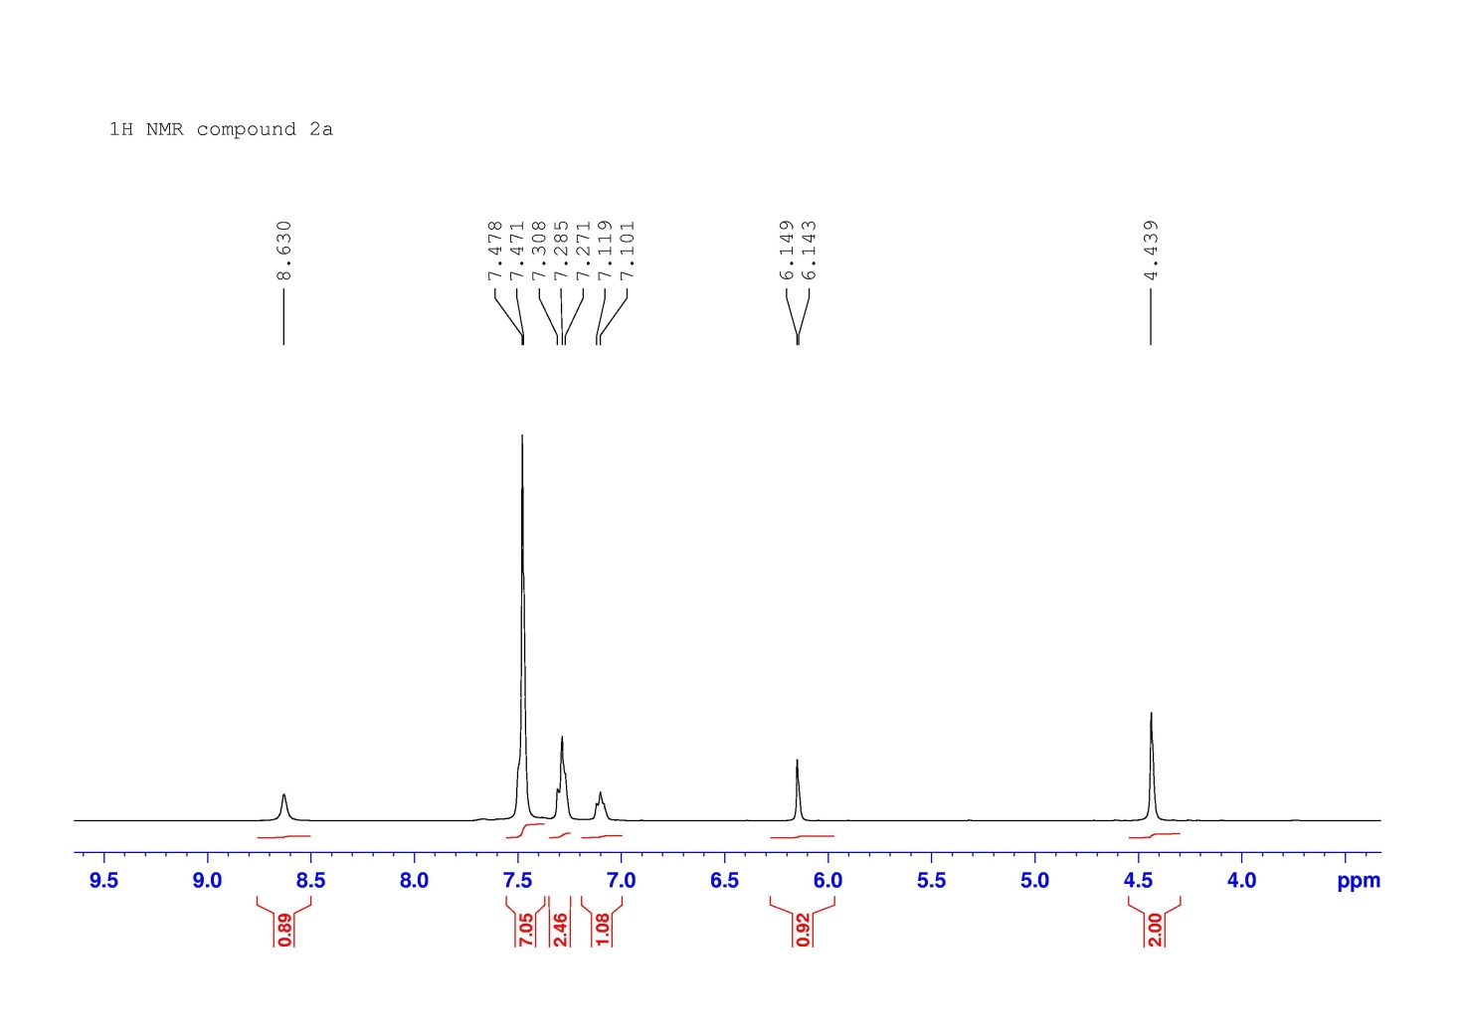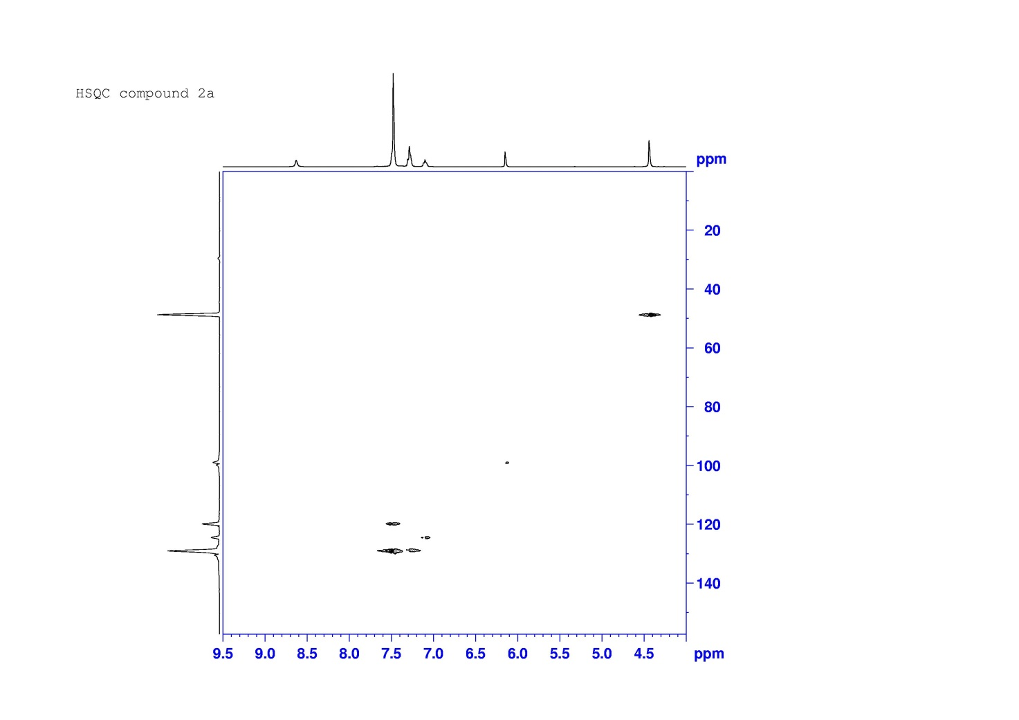

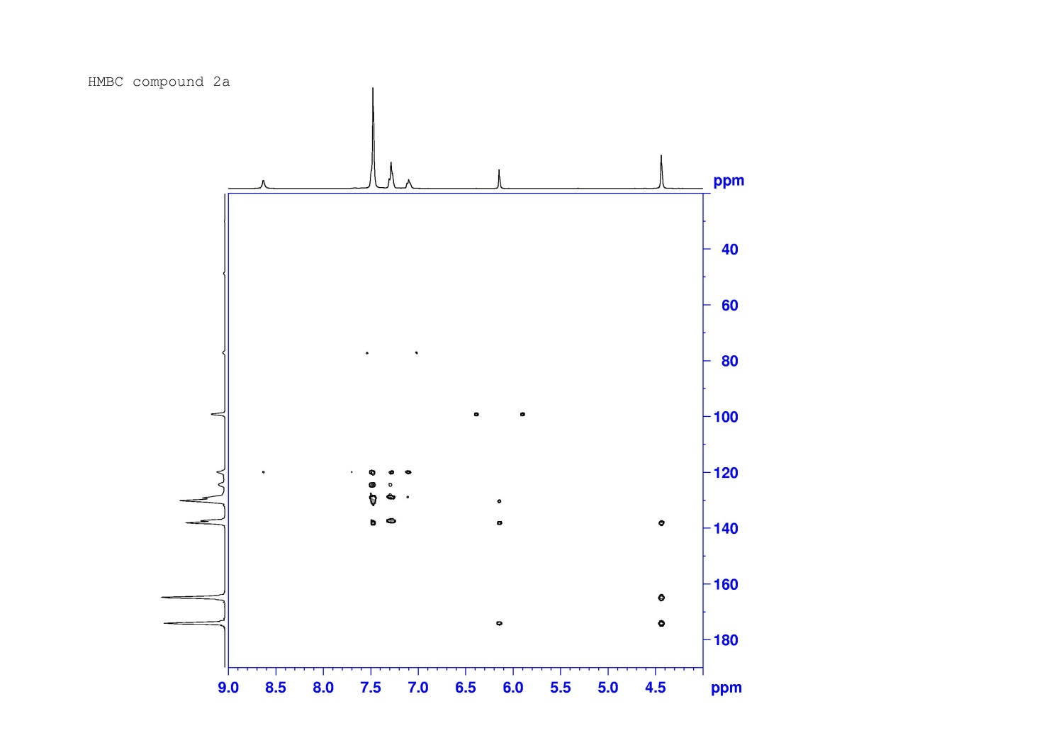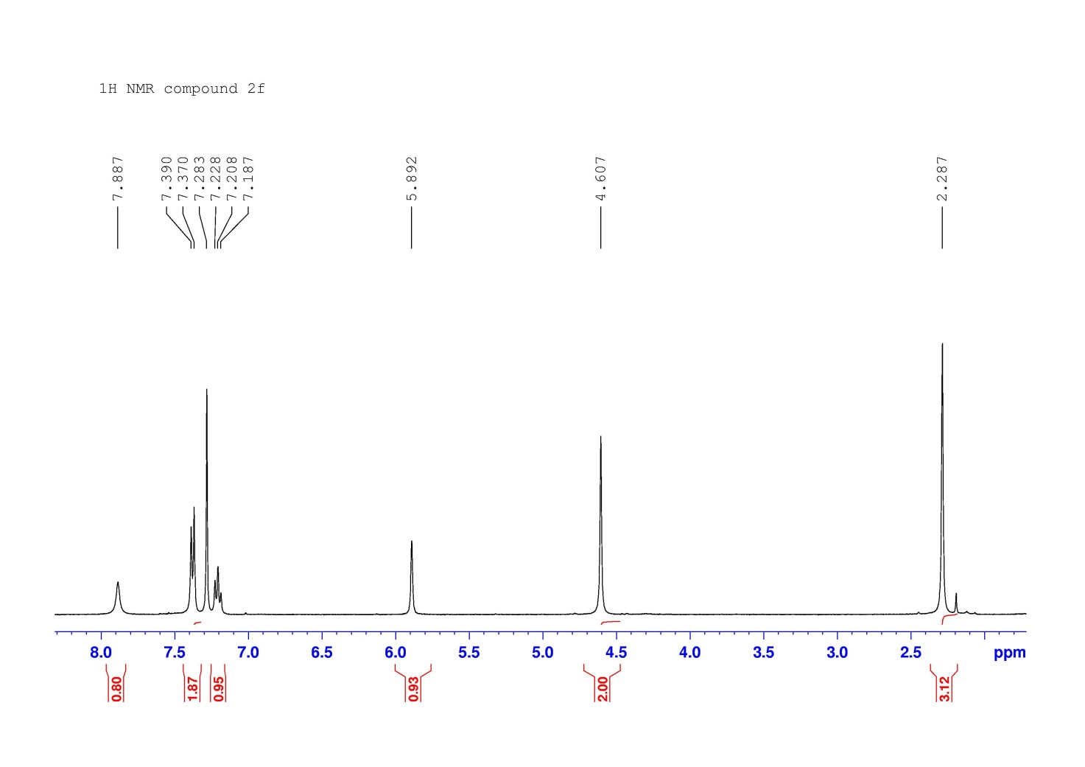

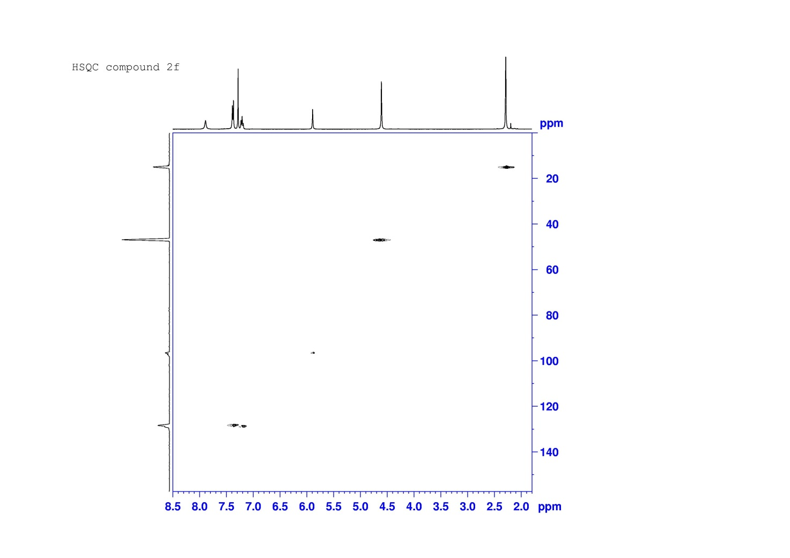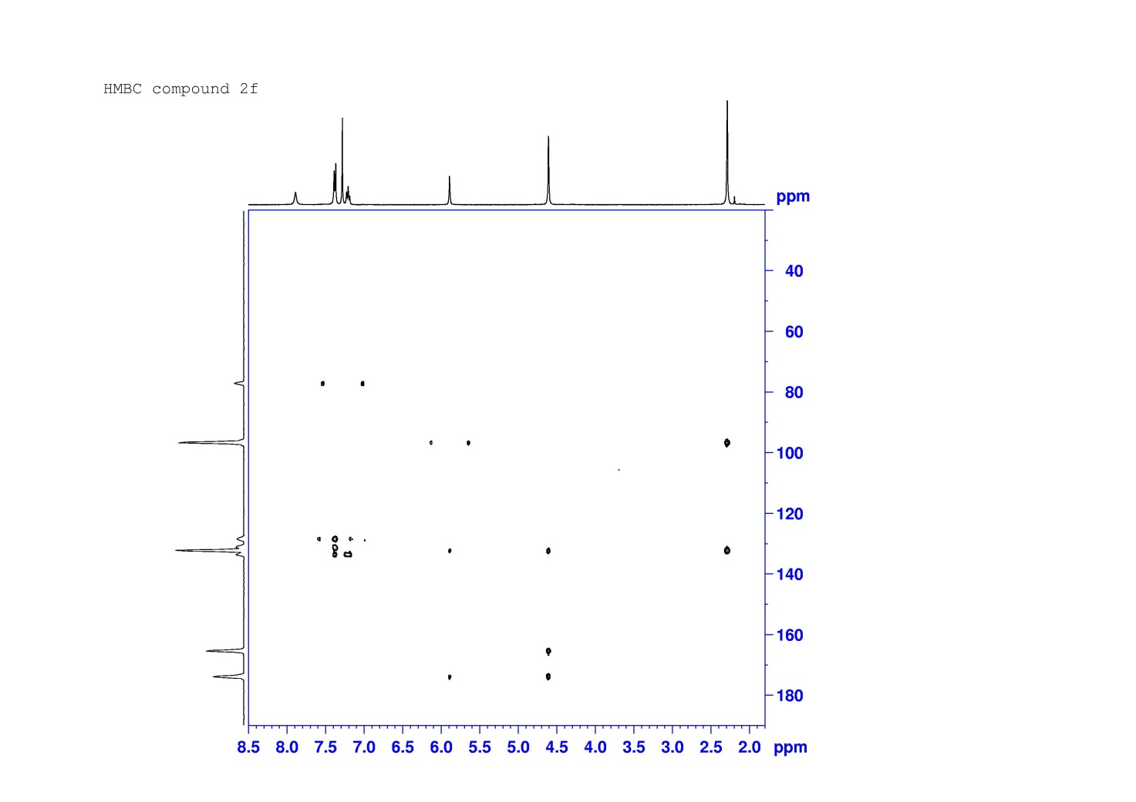

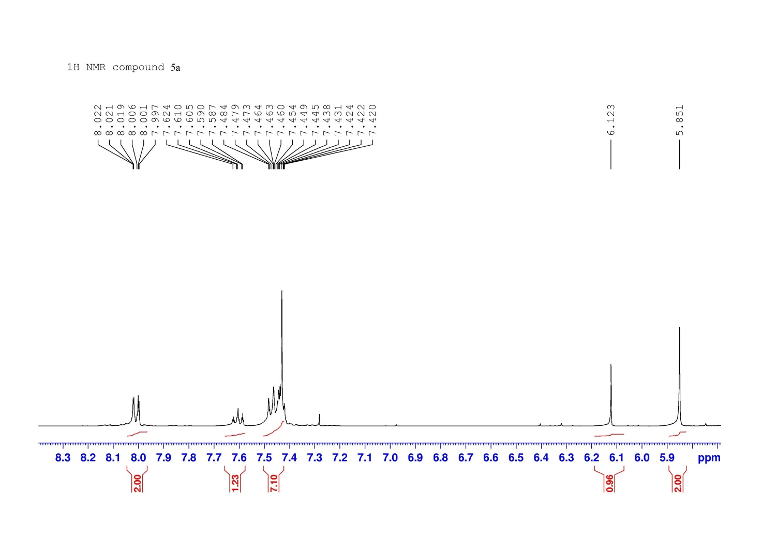
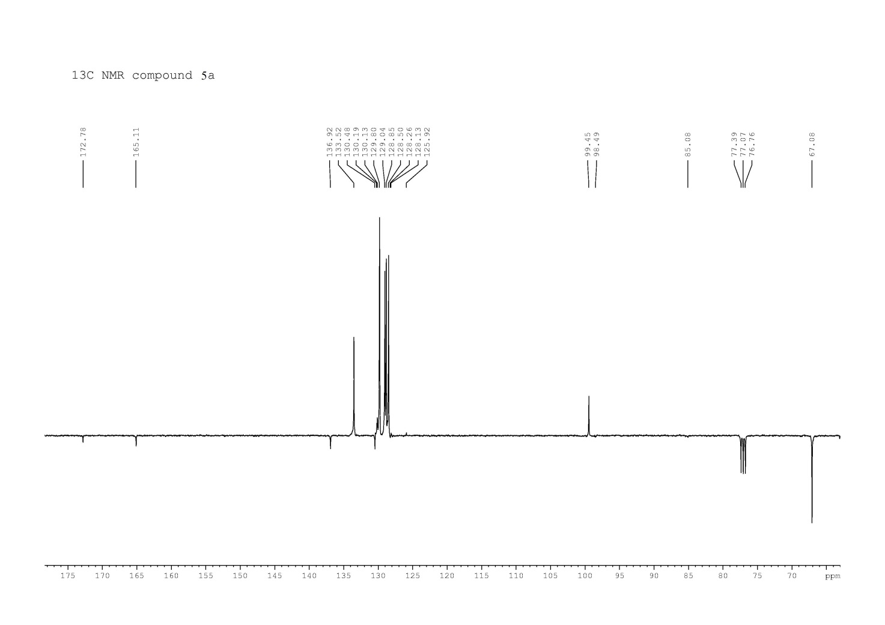

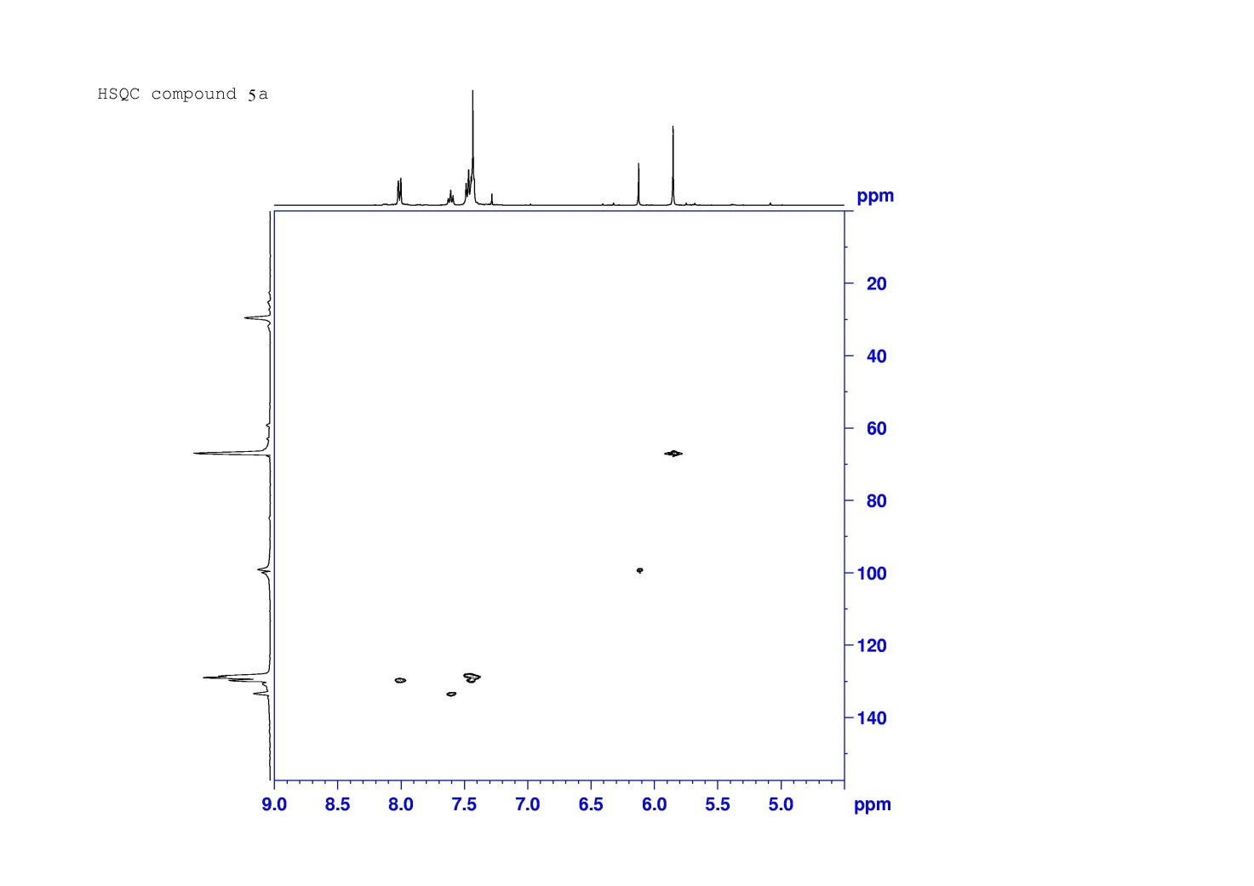
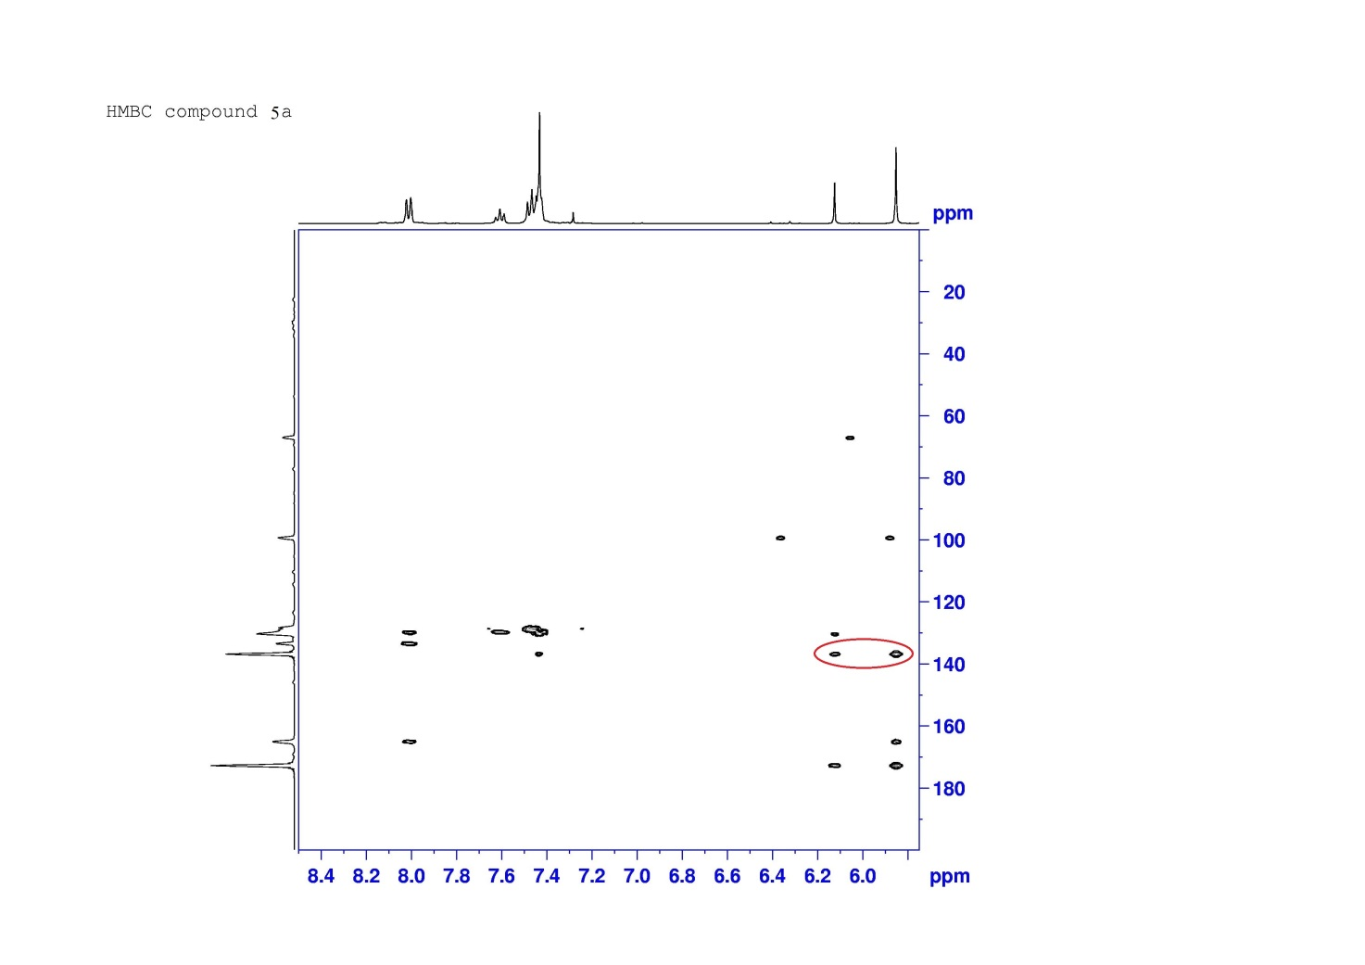

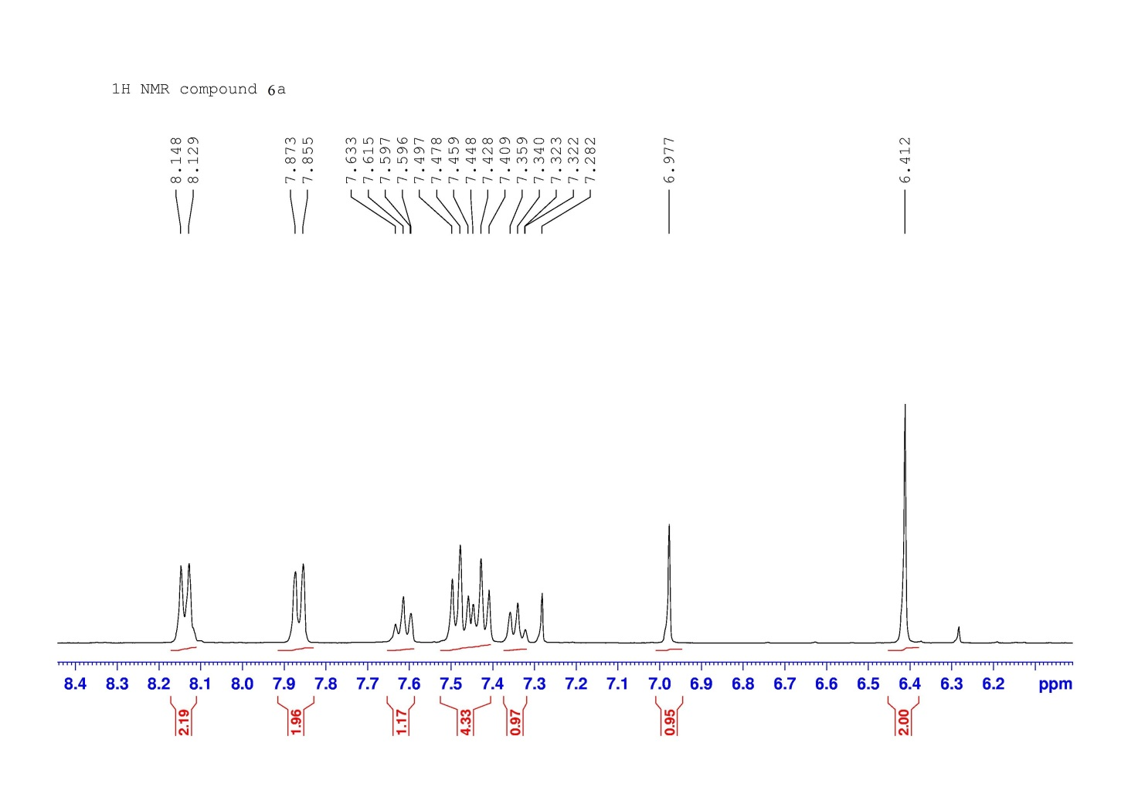
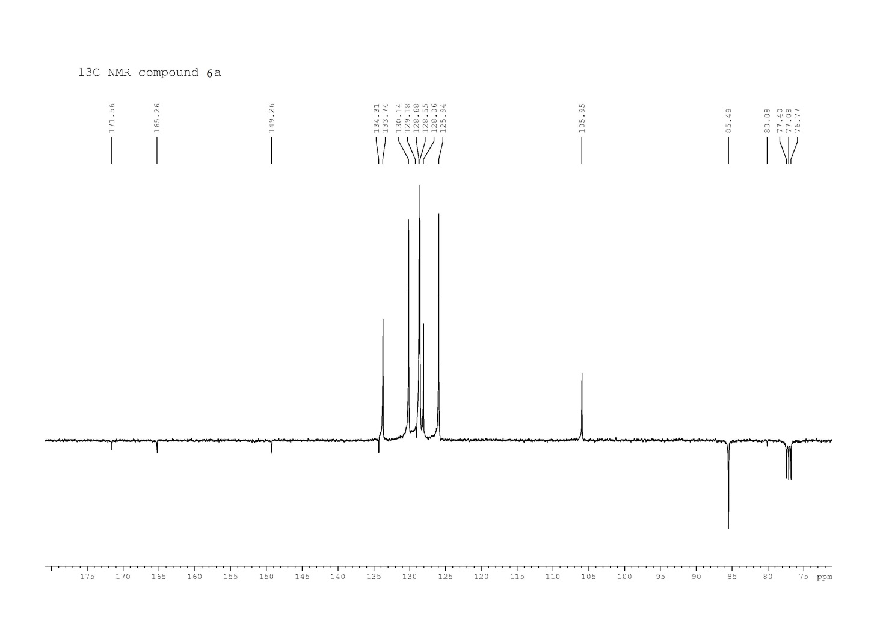

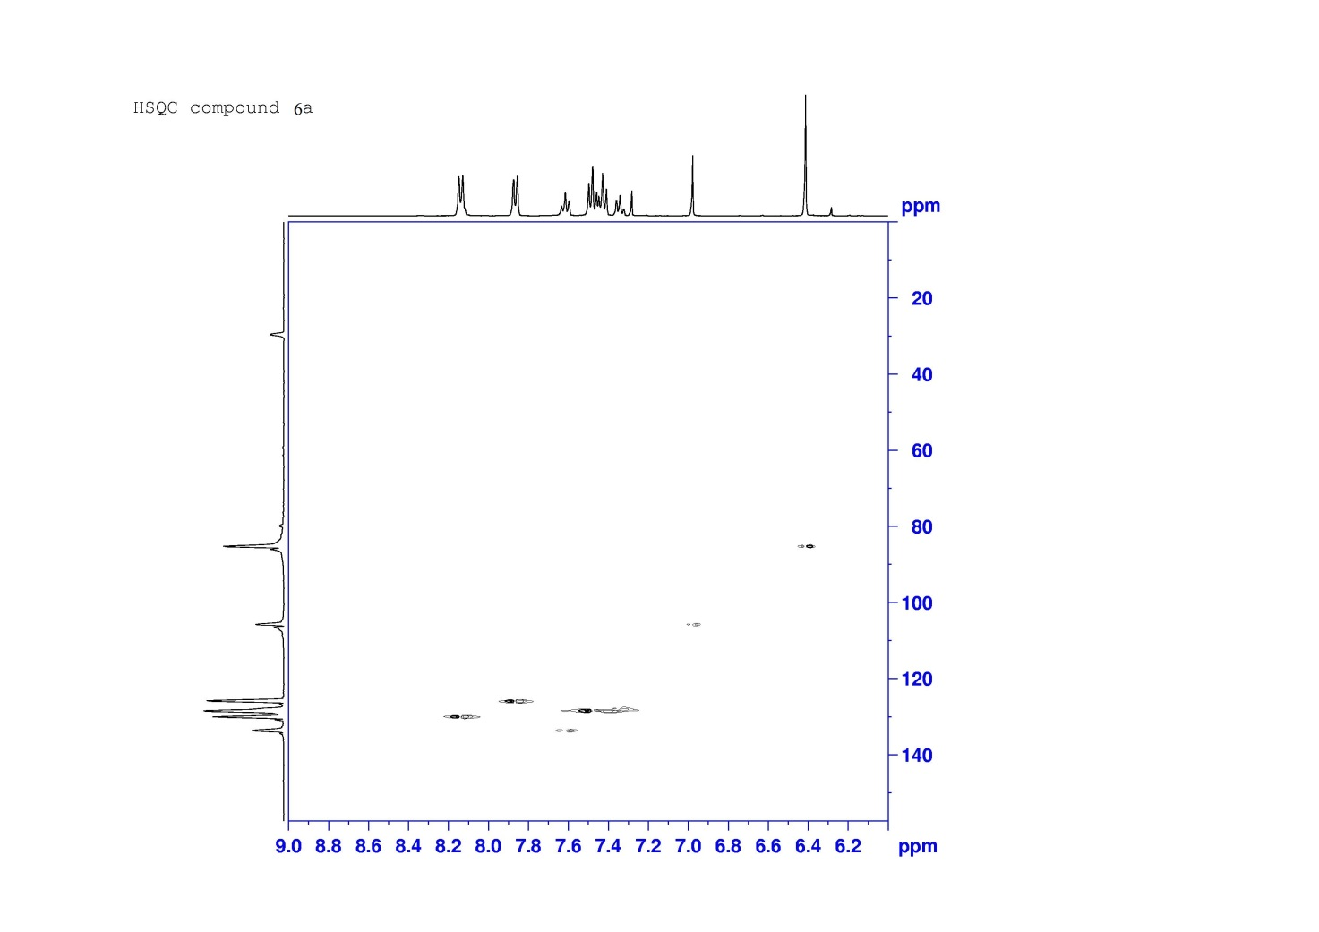
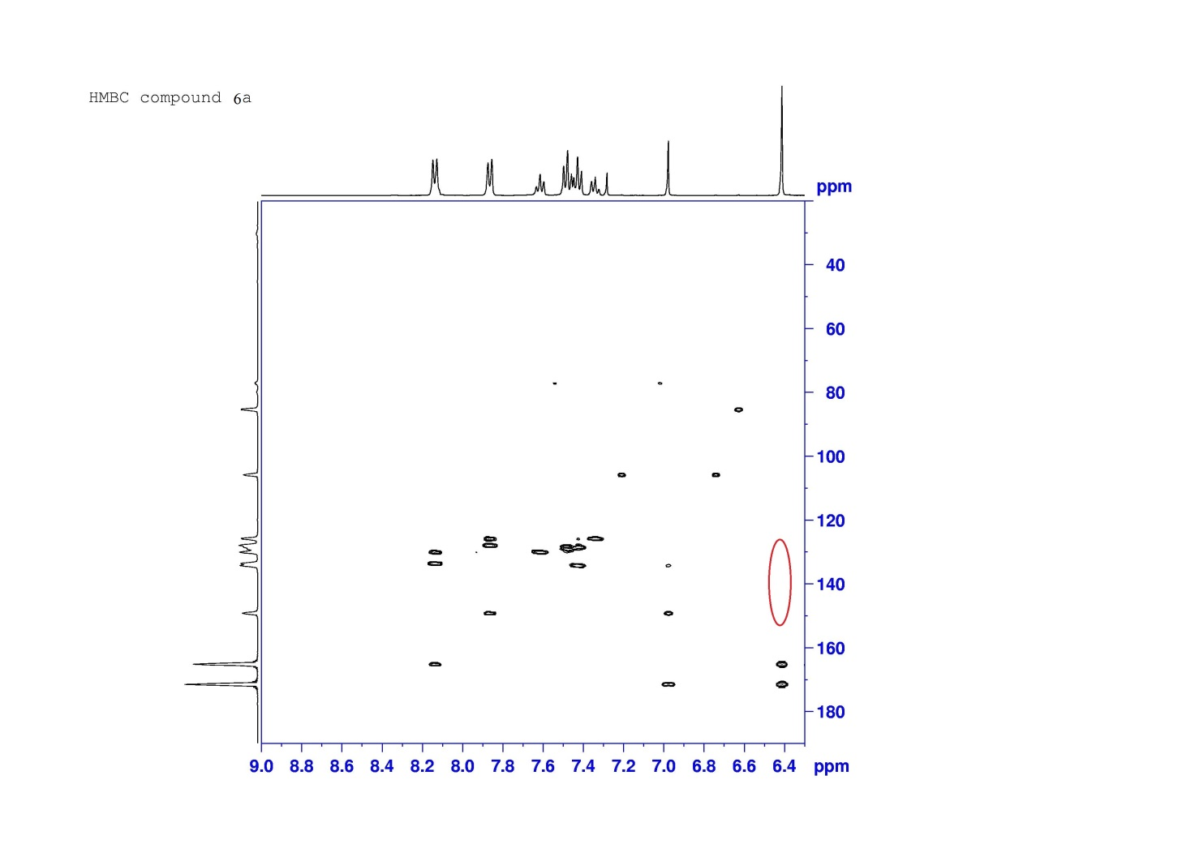

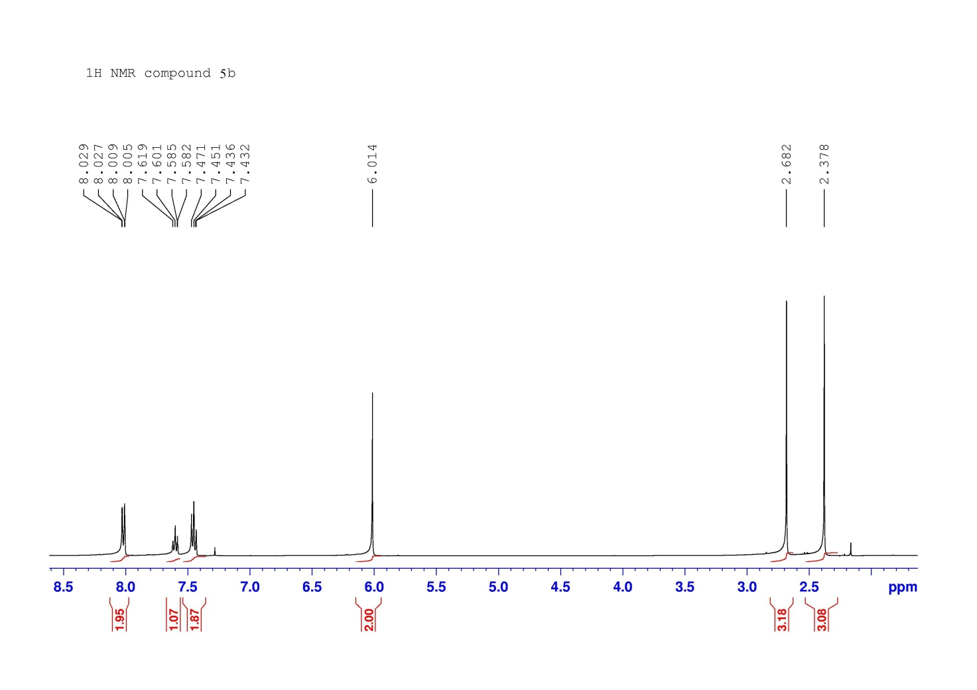
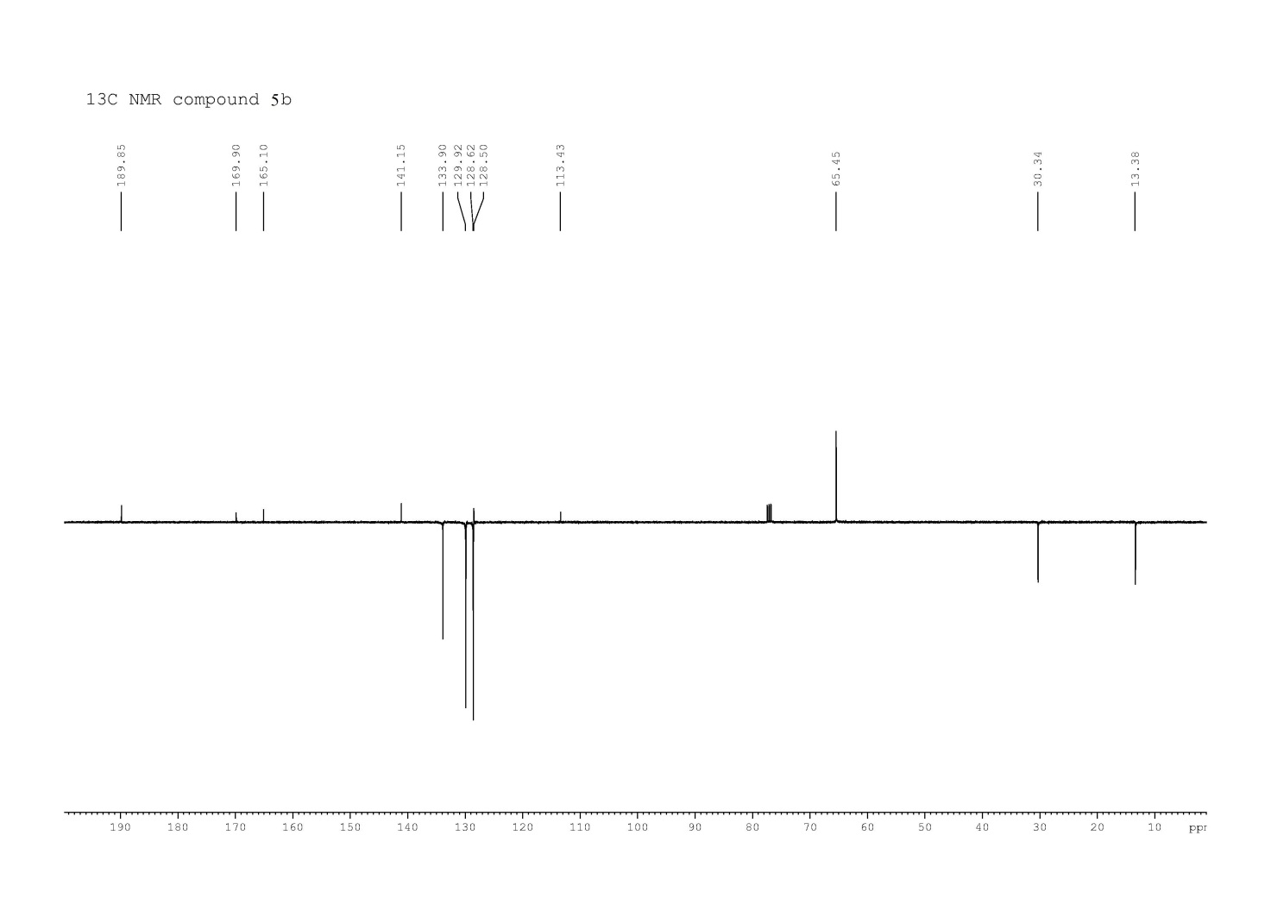

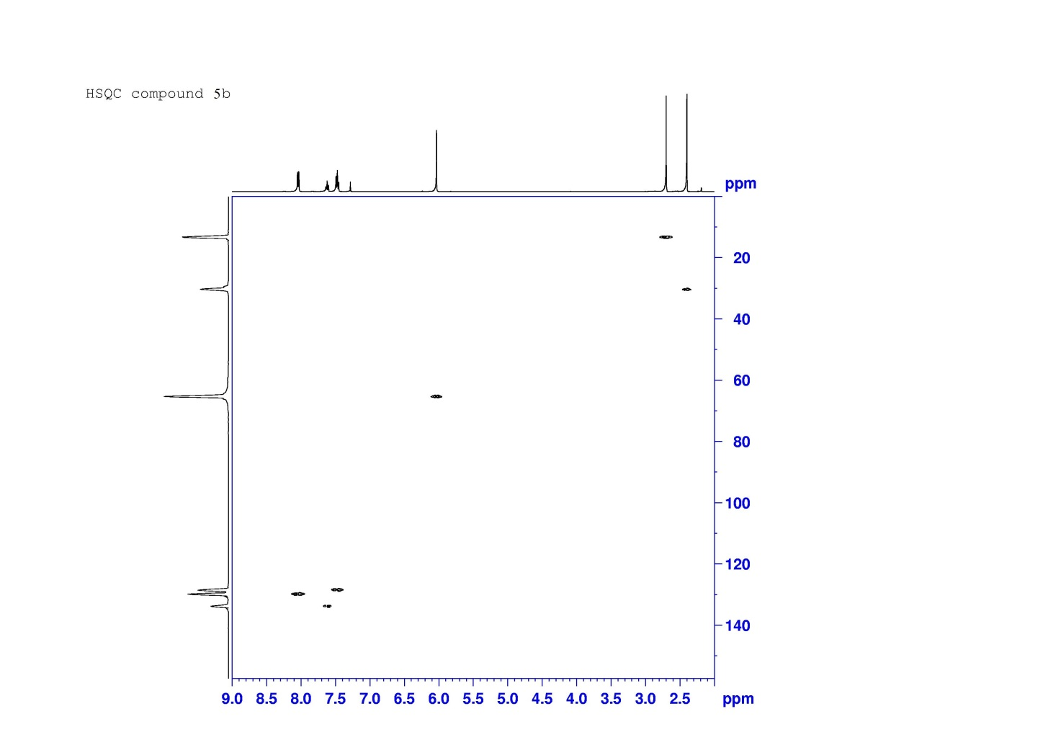
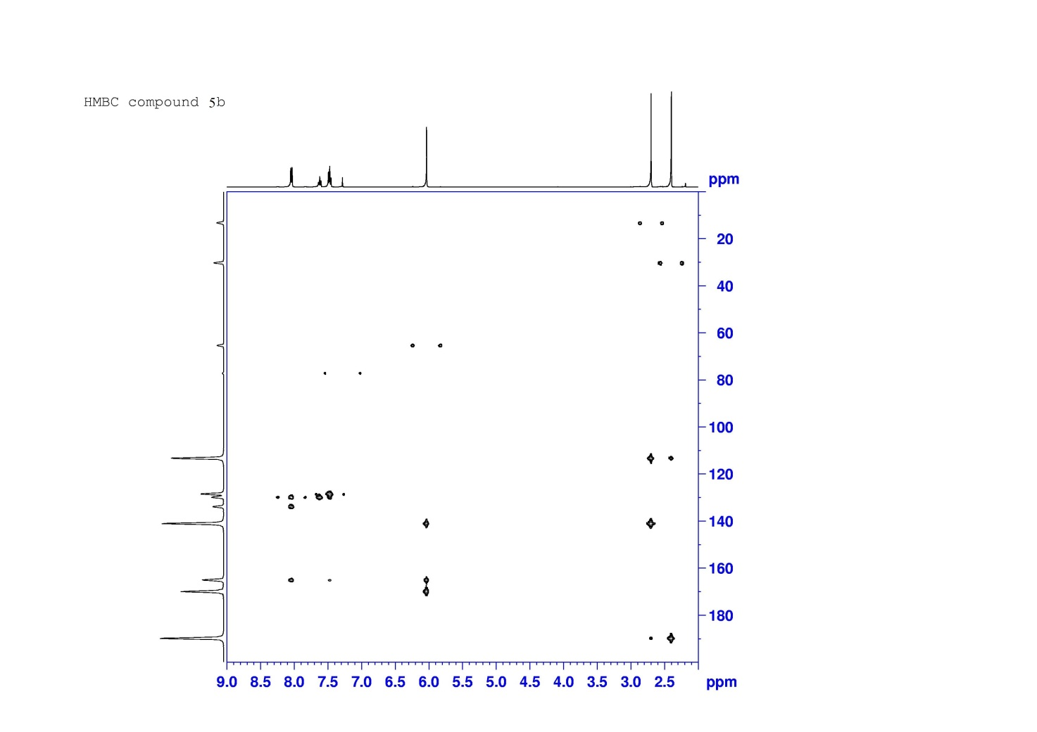

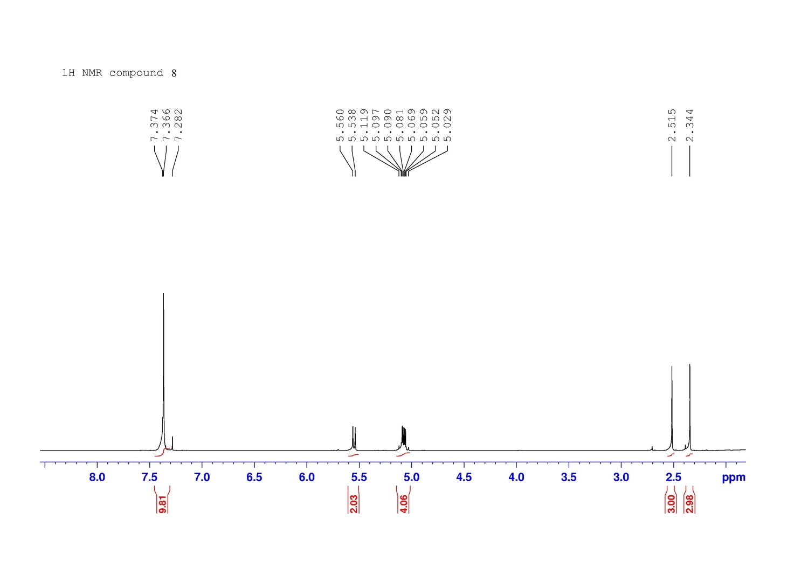
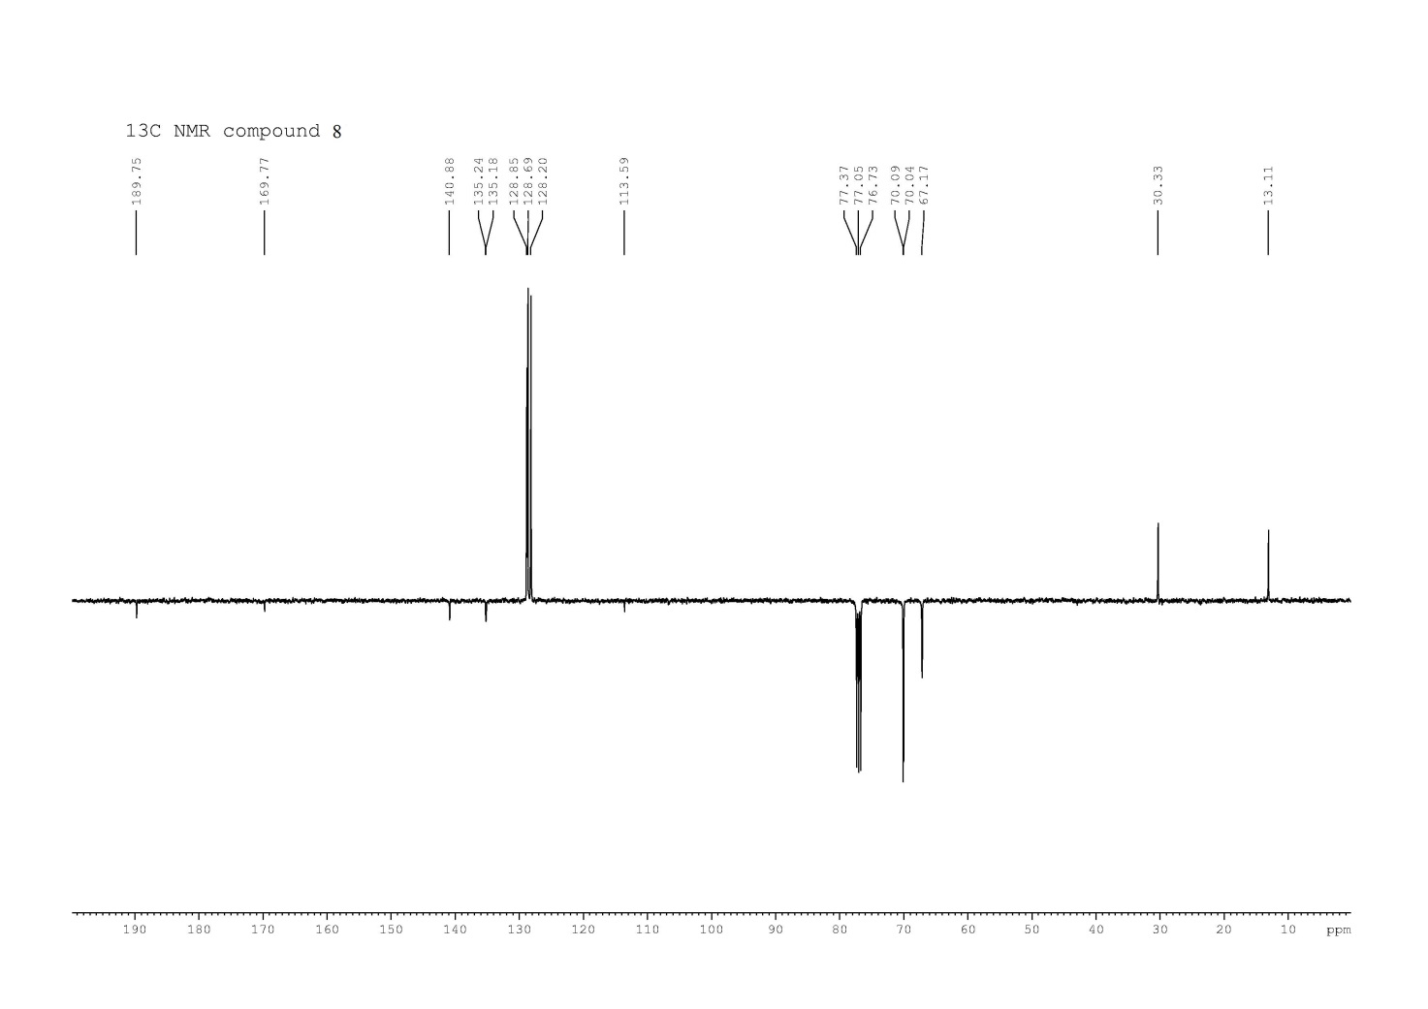

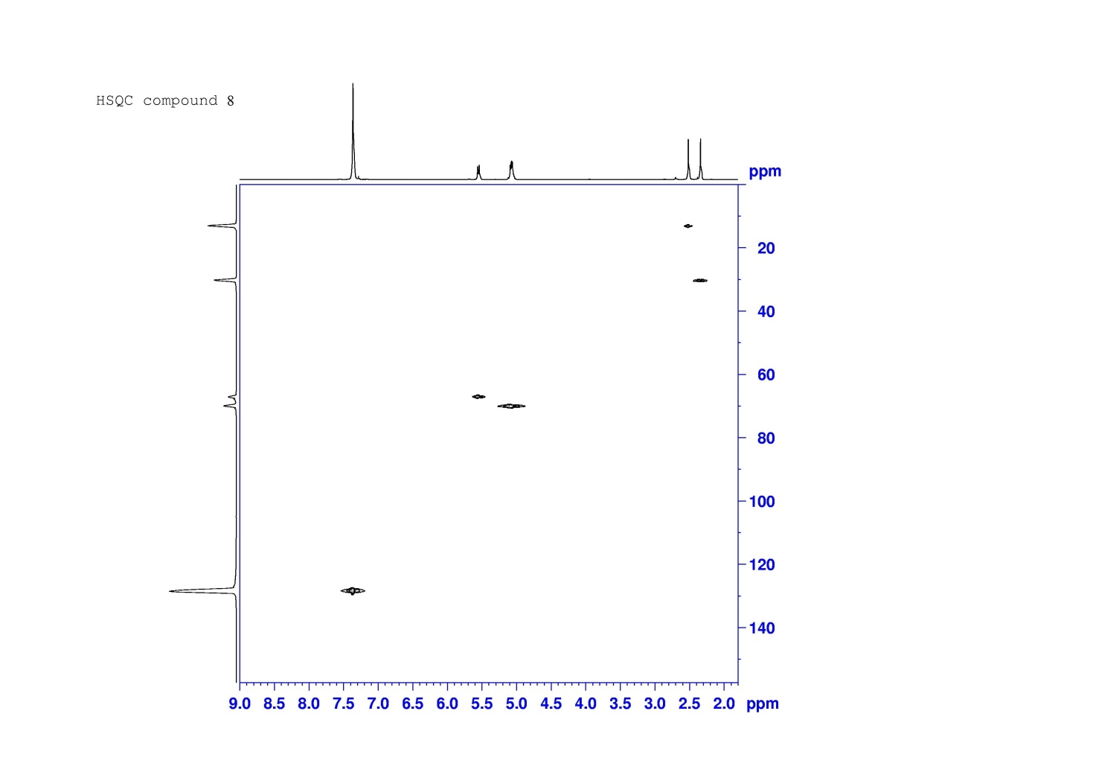
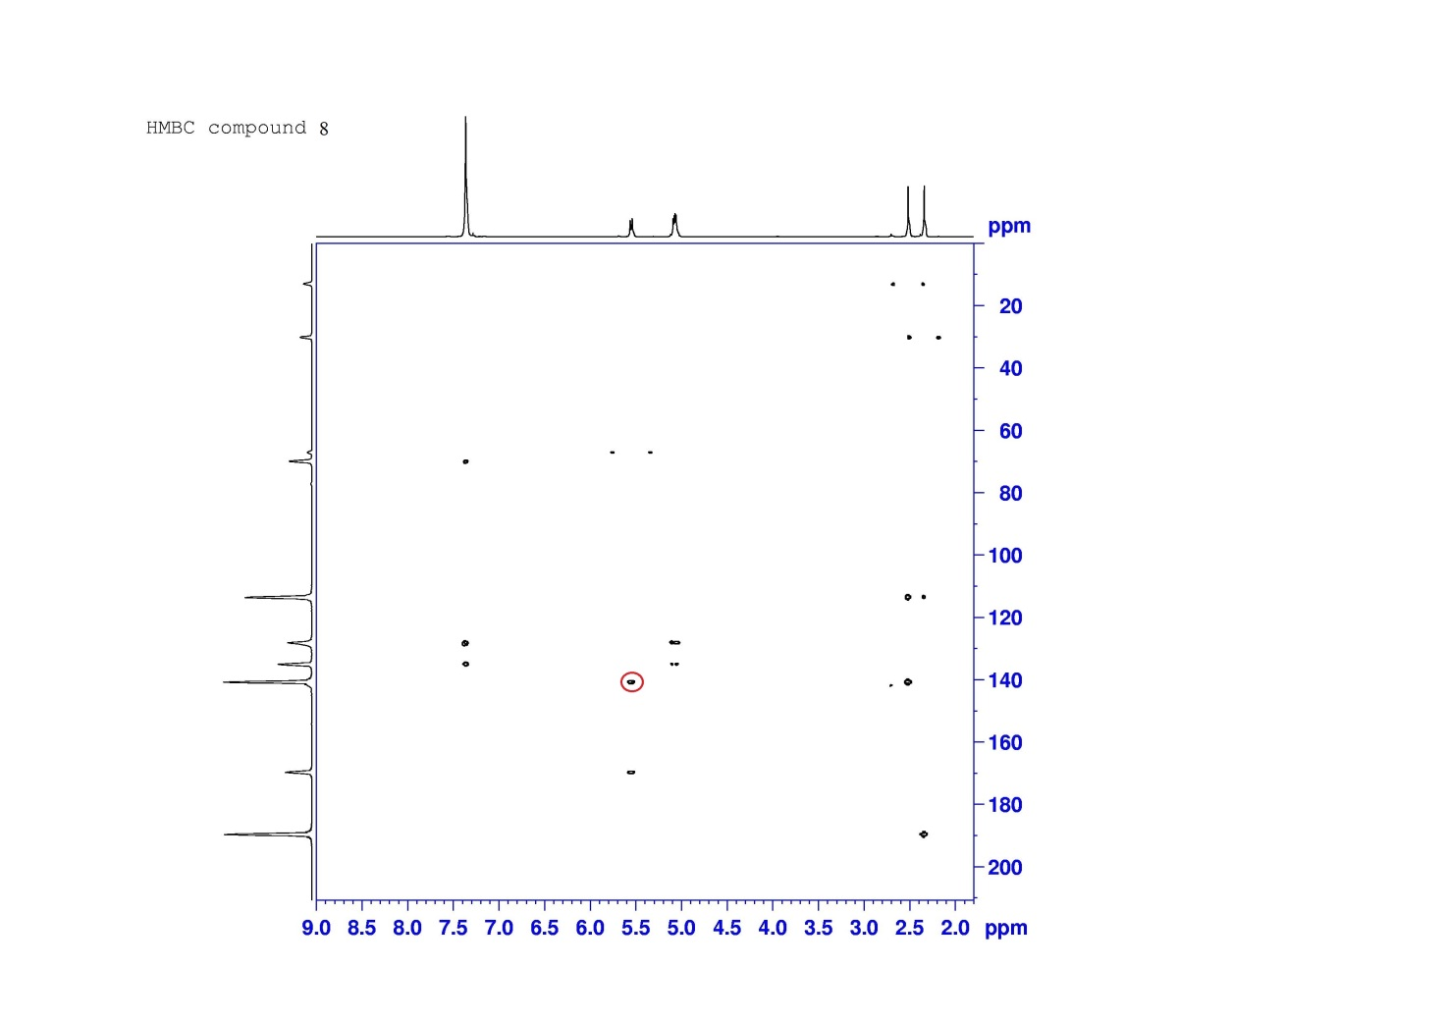

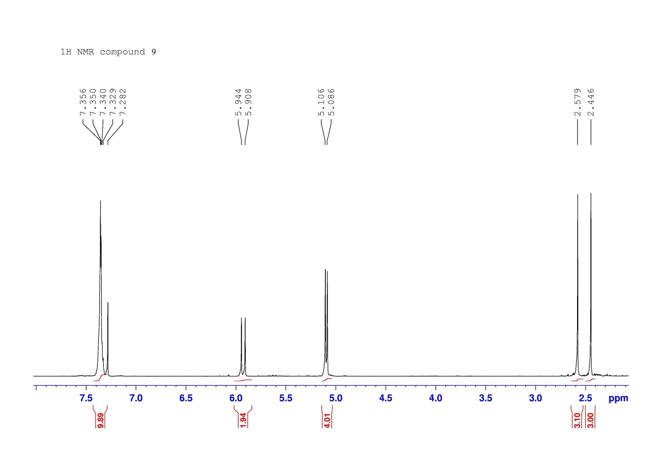
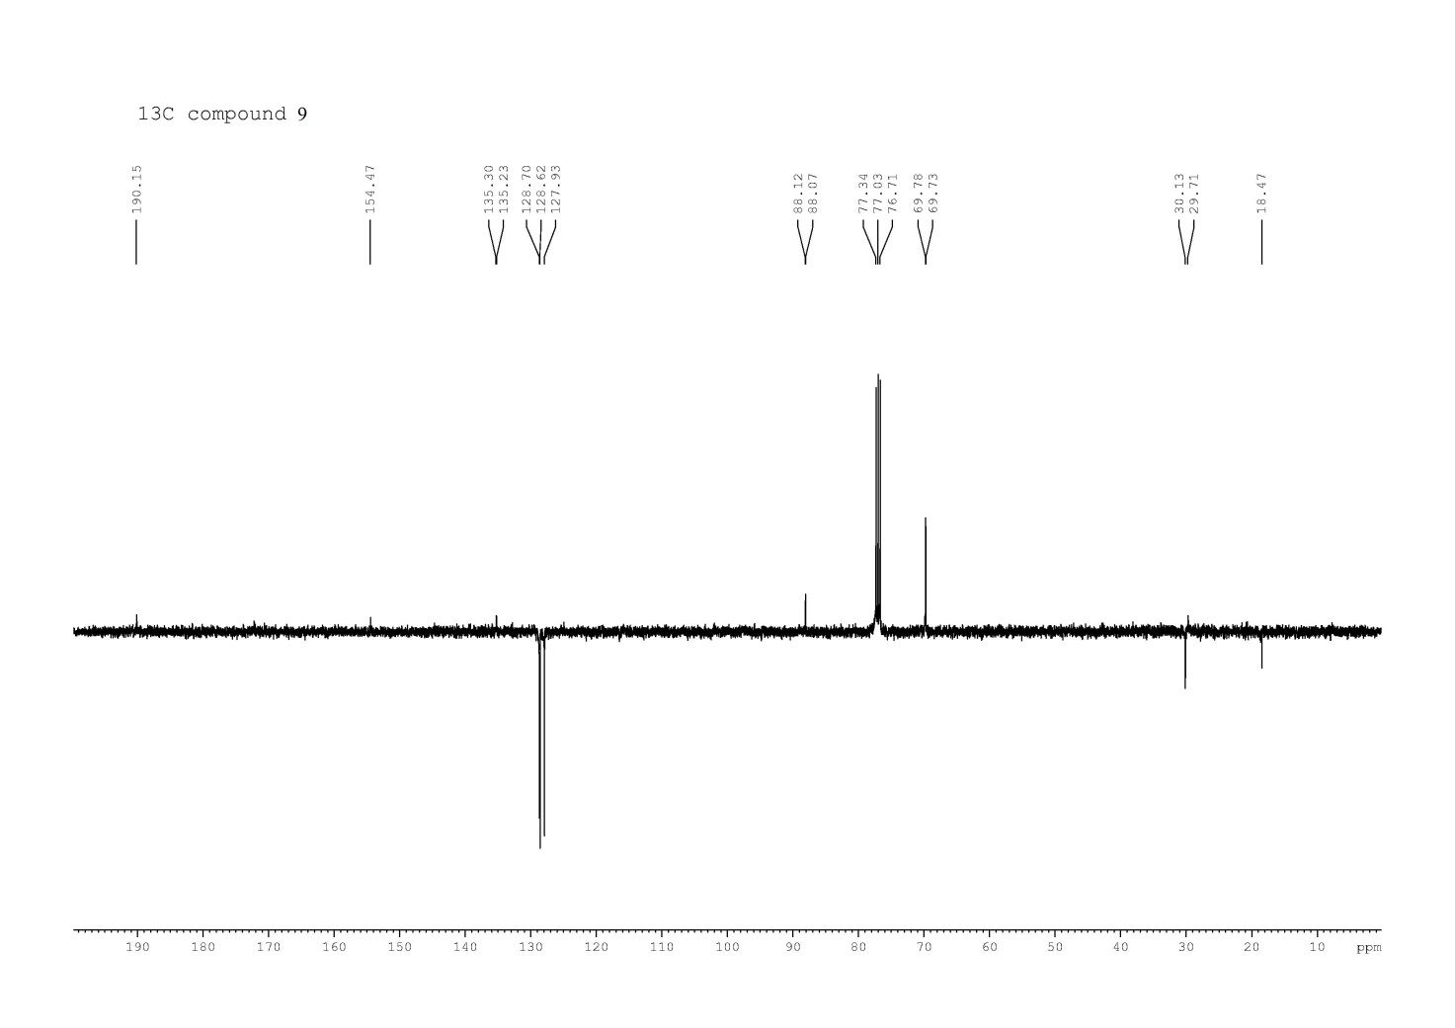

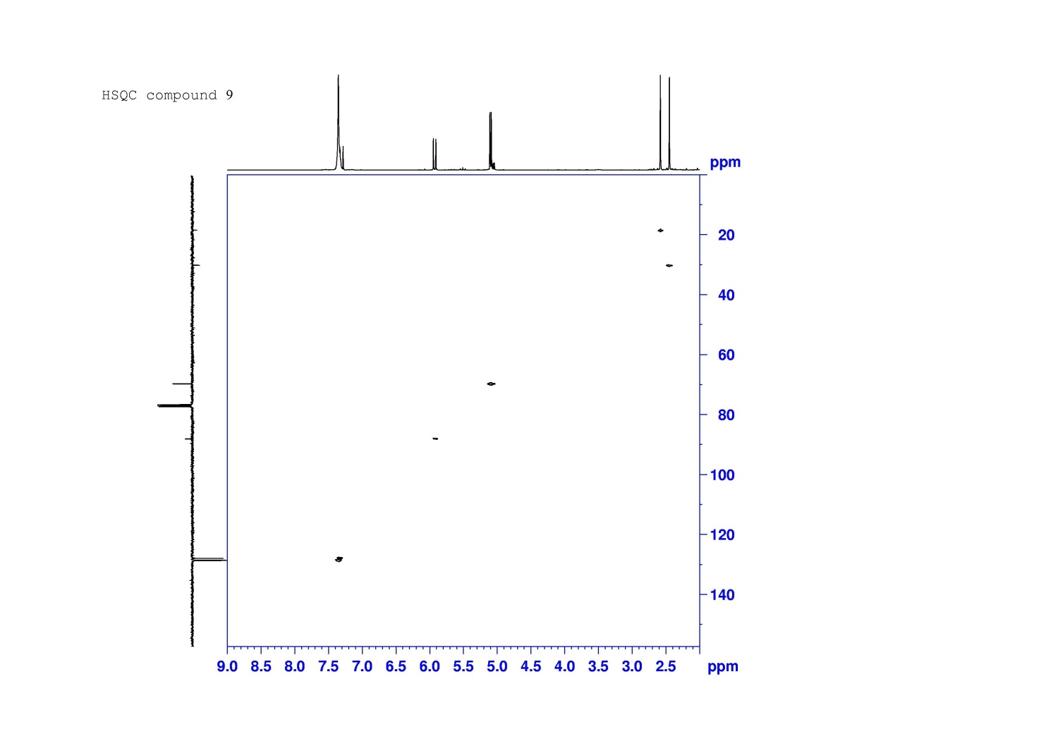
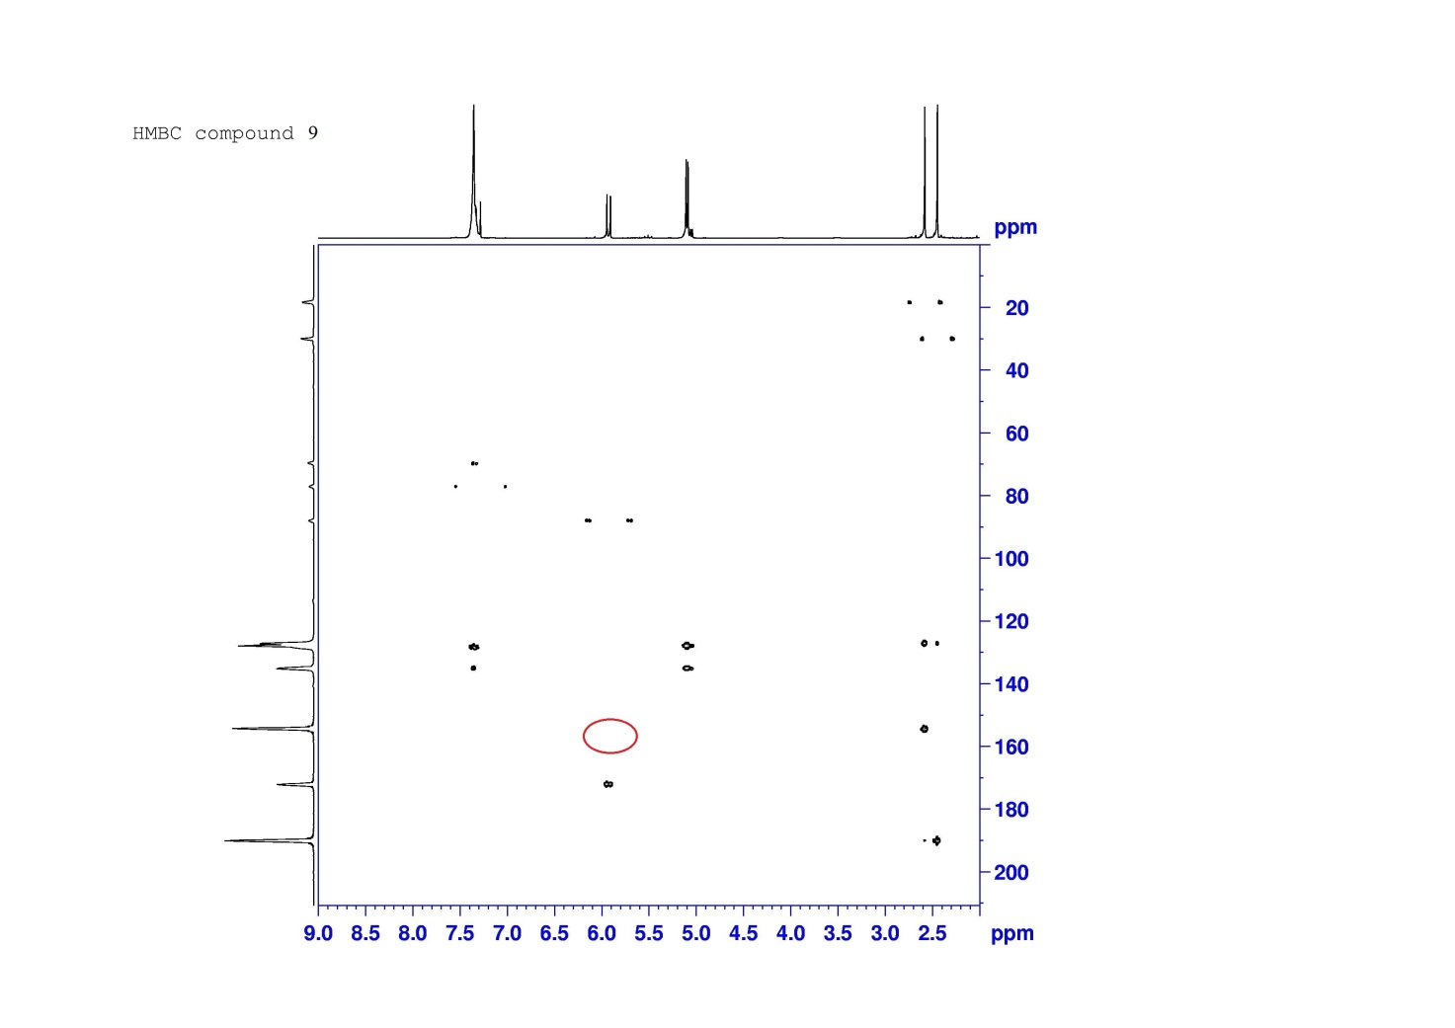

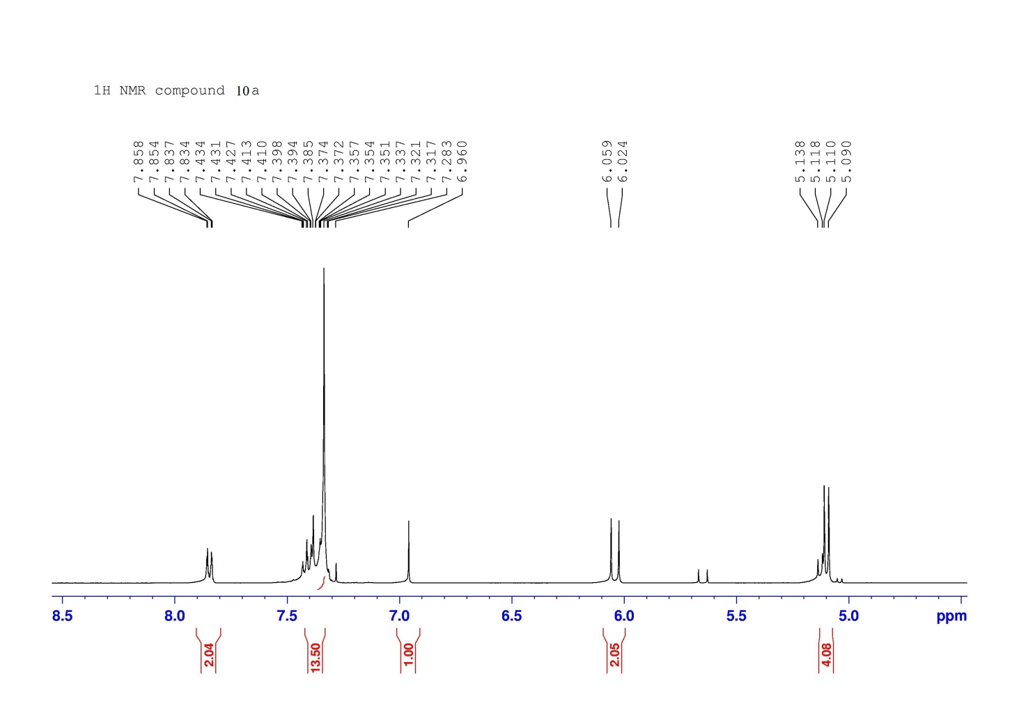
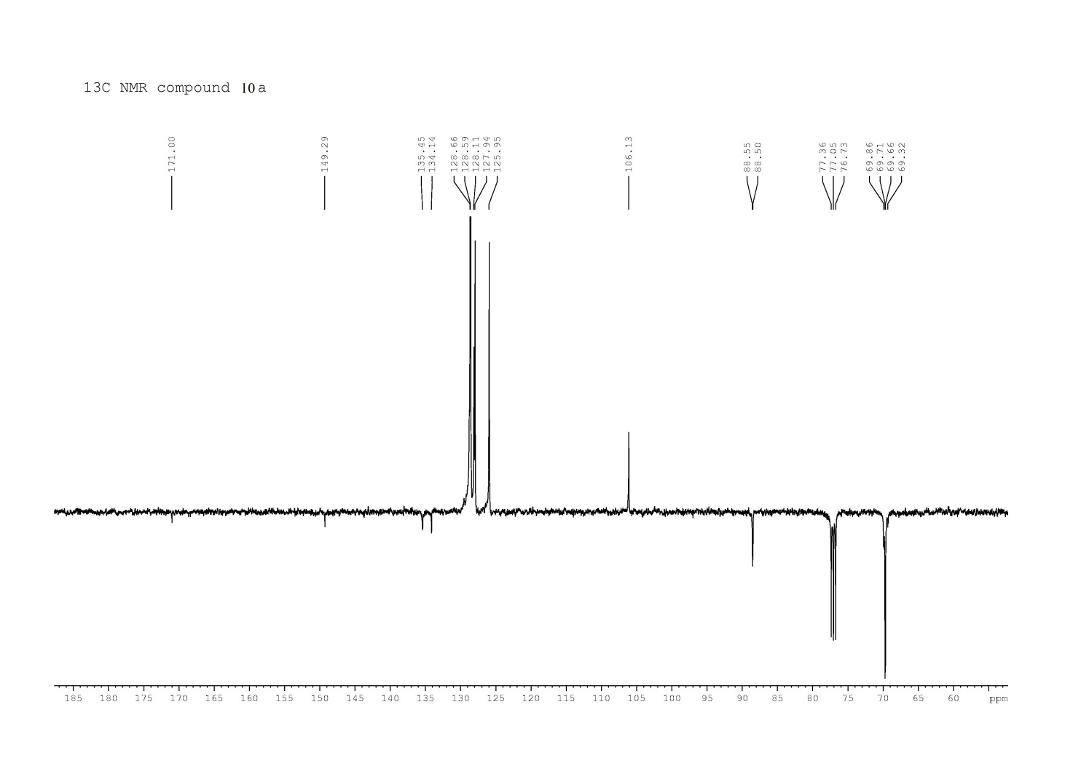

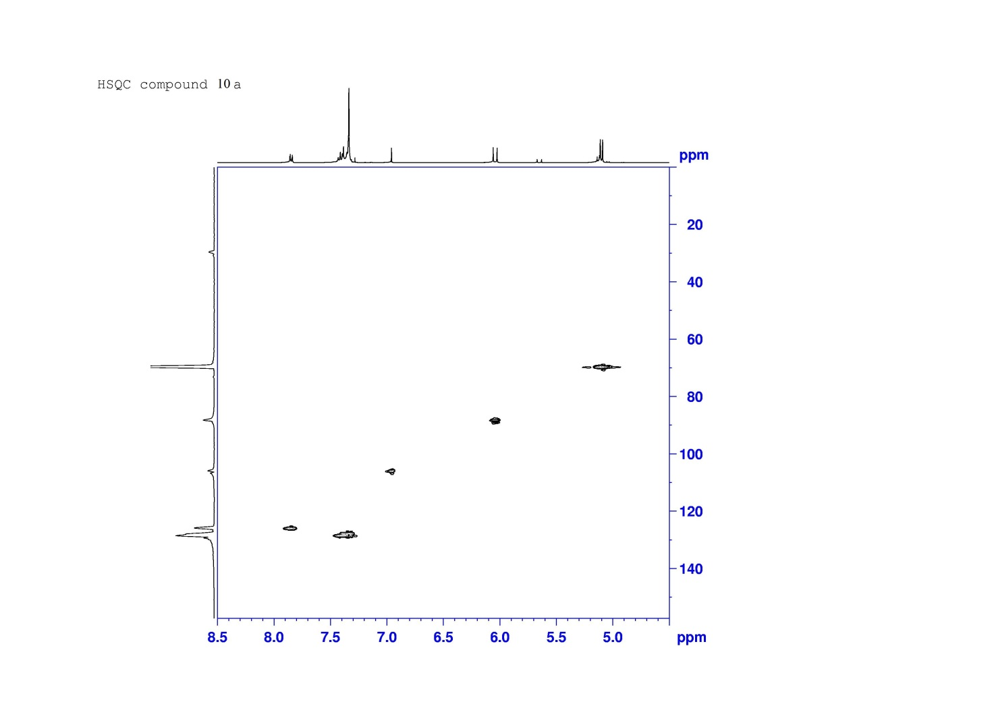
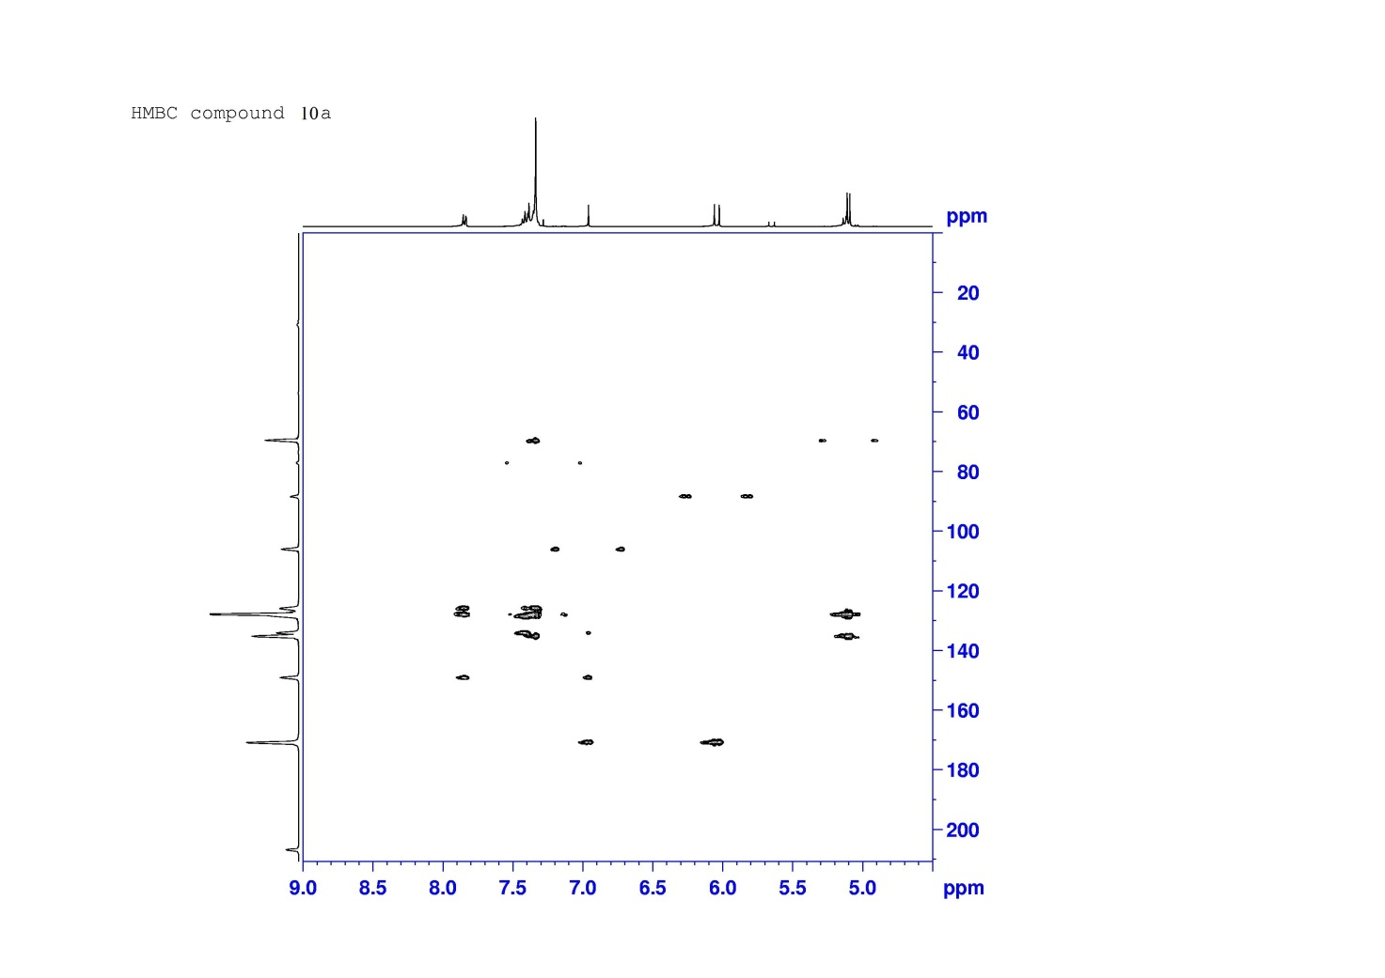

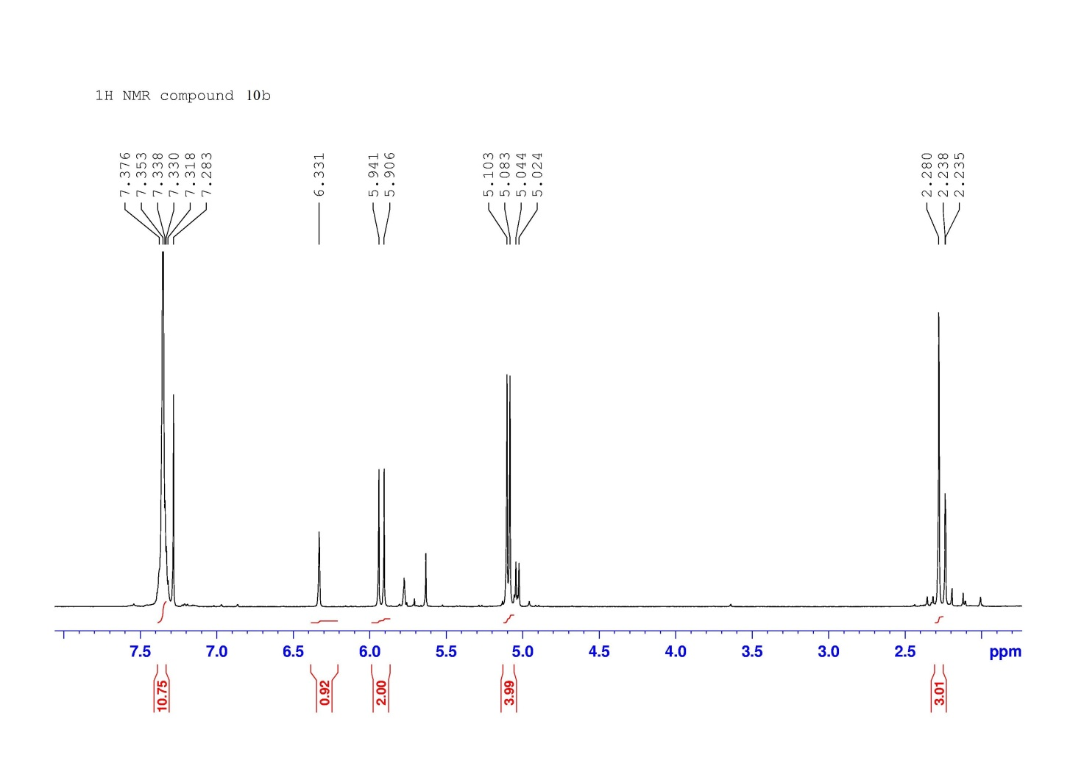
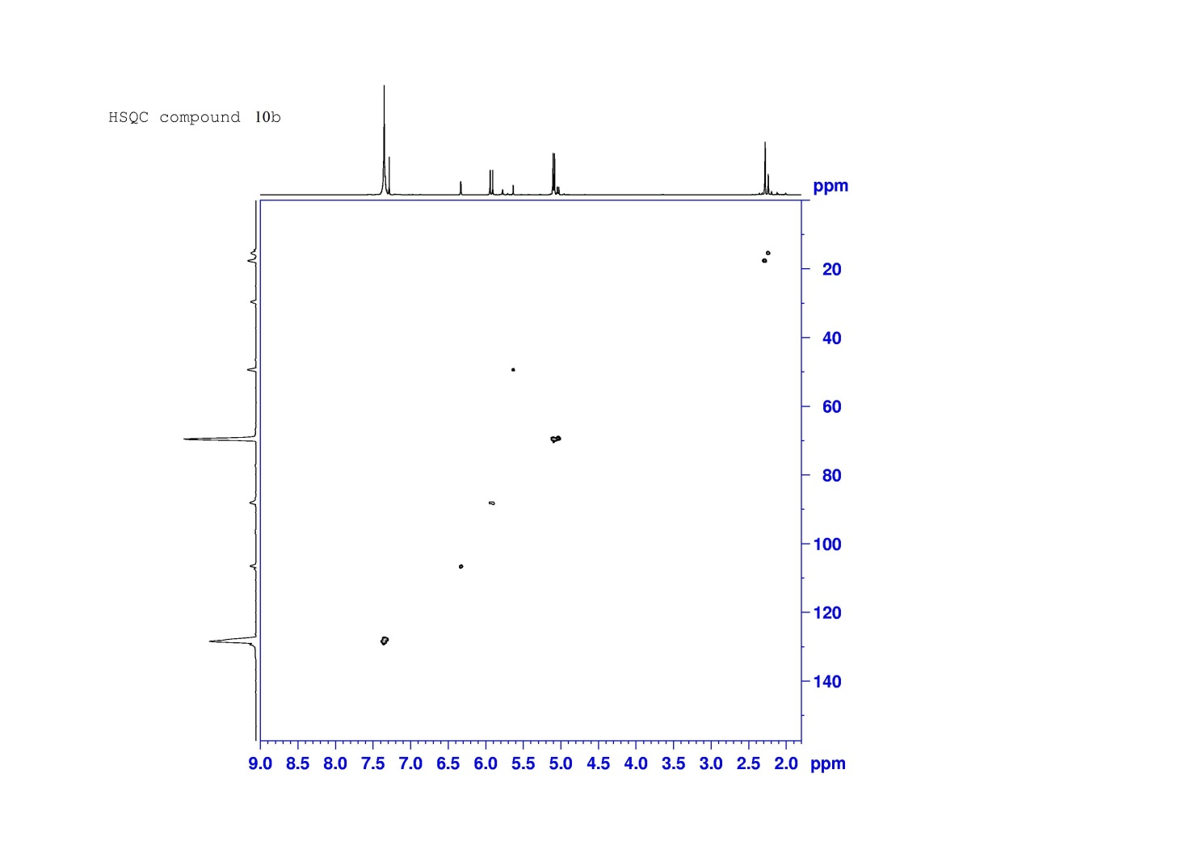

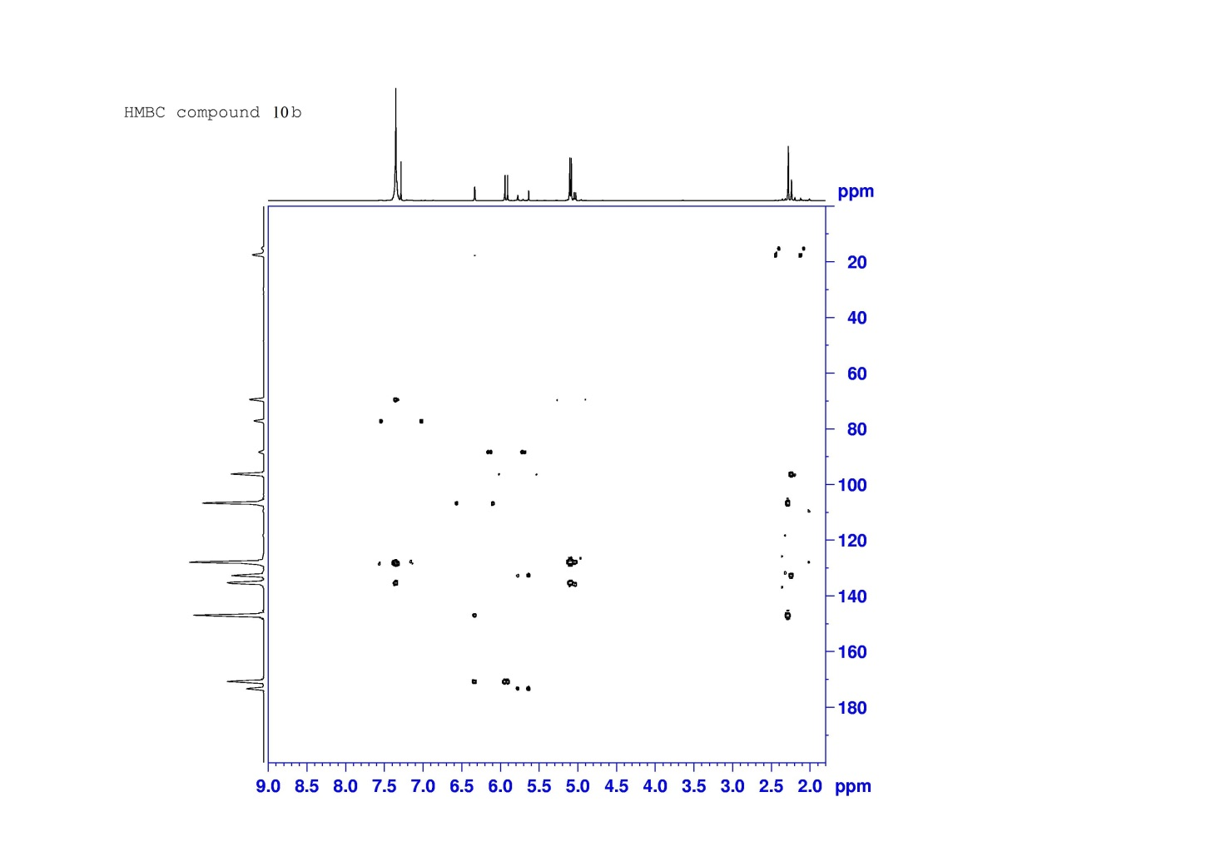

Table S1. Elemental analysis
Comp. | Formula (MW) | Anal. Calcd. |  |  |  | Anal. Found
 |  | C | H | N |  | C | H | N
2a | C₁₇H₁₄N₂O₂S (310.37) | 65.79 | 4.55 | 9.03 |  | 66.05 | 4.57 | 9.06
2b | C₁₇H₁₂Cl₂N₂O₂S (379.26) | 53.84 | 3.19 | 7.39 |  | 54.05 | 3.20 | 7.41
2c | C₁₄H₁₄N₂O₃S (290.34) | 57.92 | 4.86 | 9.65 |  | 58.15 | 4.88 | 9.68
2d | C₁₄H₁₂Cl₂N₂O₃S (359.23) | 46.81 | 3.37 | 7.80 |  | 46.99 | 3.38 | 7.83
2e | C₁₂H₁₂N₂O₂S (248.30) | 58.05 | 4.87 | 11.28 |  | 58.28 | 4.89 | 11.32
2f | C₁₂H₁₀Cl₂N₂O₂S (317.19) | 45.44 | 3.18 | 8.83 |  | 45.62 | 3.19 | 8.86
3a | C₁₆H₁₃NOS (267.35) | 71.88 | 4.90 | 5.24 |  | 72.16 | 4.92 | 5.26
3b | C₁₆H₁₀F₃NOS (321.32) | 59.81 | 3.14 | 4.36 |  | 60.04 | 3.15 | 4.37
3c | C₁₃H₁₃NO₂S (247.31) | 63.13 | 5.30 | 5.66 |  | 63.38 | 5.32 | 5.68
3d | C₁₃H₁₀F₃NO₂S (301.28) | 51.82 | 3.35 | 4.65 |  | 52.02 | 3.36 | 4.67
3e | C₁₁H₁₁NOS (205.28) | 64.36 | 5.40 | 6.82 |  | 64.61 | 5.42 | 6.85
3f | C₁₁H₈F₃NOS (259.25) | 50.96 | 3.11 | 5.40 |  | 51.16 | 3.12 | 5.42
5a | C₁₇H₁₃NO₃S (311.36) | 65.58 | 4.21 | 4.50 |  | 65.84 | 4.22 | 4.52
5b | C₁₄H₁₃NO₄S (291.32) | 57.72 | 4.50 | 4.81 |  | 57.95 | 4.52 | 4.83
5c | C₁₇H₁₅NOS (281.37) | 72.57 | 5.37 | 4.98 |  | 72.86 | 5.39 | 4.99
6a | C₁₇H₁₃NO₃S (311.36) | 65.58 | 4.21 | 4.50 |  | 65.84 | 4.22 | 4.52
6b | C₁₄H₁₃NO₄S (291.32) | 57.72 | 4.50 | 4.81 |  | 57.95 | 4.52 | 4.83
6c | C₁₇H₁₅NOS (281.37) | 72.57 | 5.37 | 4.98 |  | 72.86 | 5.39 | 4.99
8 | C₂₁H₂₂NO₆PS (447.44) | 56.37 | 4.96 | 3.13 |  | 56.59 | 4.98 | 3.14
9 | C₂₁H₂₂NO₆PS (447.44) | 56.37 | 4.96 | 3.13 |  | 56.59 | 4.98 | 3.14
10a | C₂₄H₂₂NO₅PS (467.47) | 61.66 | 4.74 | 3.00 |  | 61.90 | 4.76 | 3.01
10b | C₁₉H₂₀NO₅PS (405.40) | 56.29 | 4.97 | 3.45 |  | 56.51 | 4.99 | 3.46

