Synthesis, anti-microbial activity, cytotoxicity of some novel substituted (5-(3-(1H-benzo[d]imidazol-2-yl)-4-hydroxy benzyl) benzofuran-2-yl)(phenyl)methanone analogs
Bhookya Shankar ¹, Jalapathi Pochampally ^{1, *}, Balabadra Saikrishna ², Shaym perugu ³, Vijjulatha Manga ²
¹Department of chemistry, University College of Science, Osmania University, Saifabad, Hyderabad- 500004, India
²Molecular Modeling and Medicinal Chemistry Group, Department of Chemistry, Osmania University, Hyderabad, Telangana-500 007, India
³Biomedical Informatics Center, National Institute of Nutrition, Hyderabad-500 007, Telangana, India

Pochampally Jalapathi
pochampalli.ou.chemi@gmail.com

1) Predicted ADME properties: Page number 2-3
2) Specters’ 4-13

Supporting Information
Predicted ADME properties:
QikProp module of Schrodinger was used computationally to evaluate (absorption, distribution, metabolism and excretion) properties of synthesized compounds. The physically significant descriptors and pharmaceutically relevant properties of synthesized molecules with compliance to Lipinski’s rule of five are calculated by QikProp 3.0.
Drug-likeness of newly synthesized compounds was analyzed by applying Lipinski's rule of five (Table 4 provided in supplementary material). The Lipinski’s rule for the drug-like molecules, states that the molecule should have molecular weight <650 Da, H-bond donors <5, H-bond acceptors <10, and a log P of <5. For the synthesized compounds, the partition coefficient (QPlogPo/w) and water solubility (QPlogS) is critical for estimating the absorption and distribution of drugs within the body, which ranged between 5.06–7.19 and 7.32–9.98, respectively. Crossing the blood-brain barrier (BBB), which is a prerequisite for the entry of drugs into CNS, was originated to be in the acceptable range (0.72–1.34) (except 4e, 4m). Caco-2 cell permeability (QPPCaco), a model governing gut-blood barrier, ranged from 398.96 to 821.53 (except 4e, 4m). MDCK cell permeability (QPPMDCK), a model that mimics the blood-brain barrier, ranges from 199.8 to 4664 (except 4e, 4m). Further, the predicted percentage human oral absorption, ranges from 82.11 to 100 (except 4e, 4m). All these pharmacokinetic parameters were found to be good and acceptable range.

Table 4
ADME properties of synthesized compounds
Mol | M.Wt | QPlogPo/wª | QPlogS^{b} | QPP  Caco^{c} | QPlog  BB^{d} | QPP  MDCK^{e} | %Human Oral Absorption^{f}
4a | 444.5 | 5.77 | -7.74 | 805.16 | -1.02 | 391.4 | 100
4b | 523.4 | 6.34 | -8.73 | 761.88 | -0.91 | 978.4 | 89.74
4c | 458.5 | 6.08 | -8.45 | 761.26 | -1.1 | 368.4 | 100
4d | 513.4 | 6.69 | -9.23 | 761.55 | -0.8 | 1887 | 91.8
4e | 489.5 | 5.08 | -7.93 | 96.756 | -2.24 | 39.63 | 79.27
4f | 462.5 | 5.88 | -7.98 | 705.6 | -0.98 | 611.8 | 100
4g | 472.5 | 6.35 | -8.87 | 761.54 | -1.12 | 368.5 | 100
4h | 478.9 | 6.24 | -8.49 | 749.45 | -0.91 | 893.9 | 100
4i | 478.9 | 6.26 | -8.47 | 806.03 | -0.87 | 967.5 | 100
4j | 557.8 | 6.84 | -9.48 | 761.14 | -0.76 | 2413 | 92.64
4k | 493 | 6.58 | -9.2 | 761.11 | -0.95 | 909.3 | 100
4l | 547.8 | 7.19 | -9.98 | 762.25 | -0.64 | 4664 | 94.72
4m | 523.9 | 5.58 | -8.69 | 96.617 | -2.11 | 97.69 | 69.21
4n | 496.9 | 6.49 | -8.85 | 804.66 | -0.77 | 1741 | 100
4o | 507 | 6.85 | -9.62 | 768.66 | -0.96 | 919.1 | 92.77
4p | 513.4 | 6.75 | -9.22 | 804.96 | -0.72 | 2375 | 92.57
4q | 494.5 | 6.71 | -8.95 | 821.53 | -1.07 | 400 | 100
4r | 445.5 | 5.06 | -7.32 | 432.14 | -1.34 | 199.8 | 90.76
4s | 524.4 | 5.67 | -8.2 | 473.37 | -1.14 | 605.1 | 82.11
4t | 479.9 | 5.54 | -8.04 | 432.95 | -1.19 | 494.2 | 93.62
4u | 558.8 | 6 | -8.78 | 398.96 | -1.07 | 1232 | 82.73
* Predicted ªpartition coefficient,^{b}water solubility, ^{c}Caco-2 cell permeability, ^{d}Crossing the blood-brain barrier, ^{e}MDCK cell permeability, ^{f}percentage human oral absorption

¹H NMR spectrum of 5-((2-benzoylbenzofuran-5-yl)methyl)-2-hydroxybenzaldehyde (3a):
¹³C NMR spectrum of 5-((2-benzoylbenzofuran-5-yl)methyl)-2-hydroxybenzaldehyde (3a):
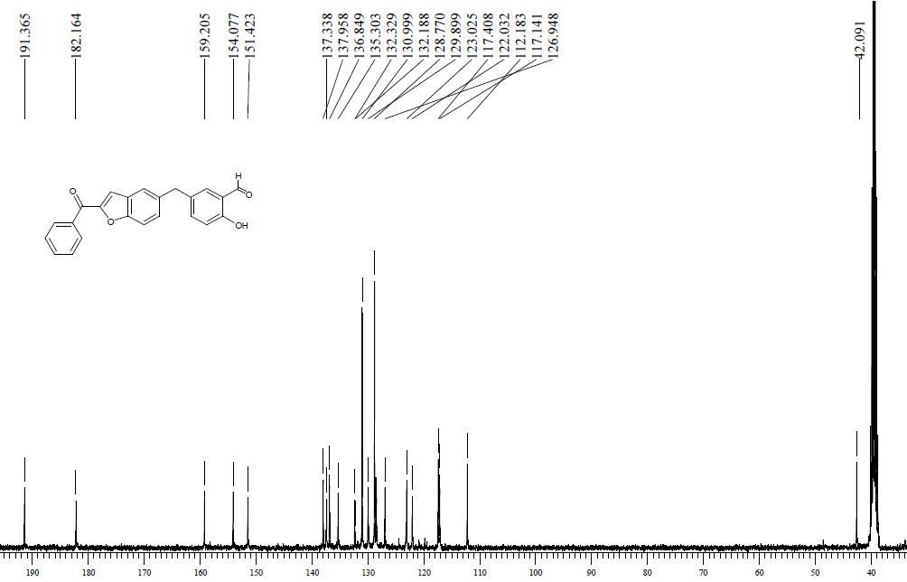

HRMS spectrum of 5-((2-benzoylbenzofuran-5-yl)methyl)-2-hydroxybenzaldehyde (3a):
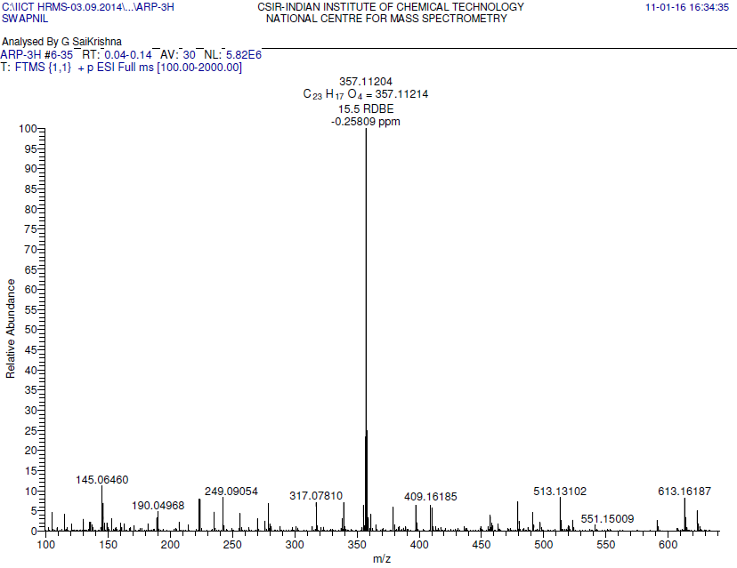
¹H NMR spectrum of 5-((2-(4-chlorobenzoyl)benzofuran-5-yl)methyl)-2-hydroxybenzalde- hyde (3b):
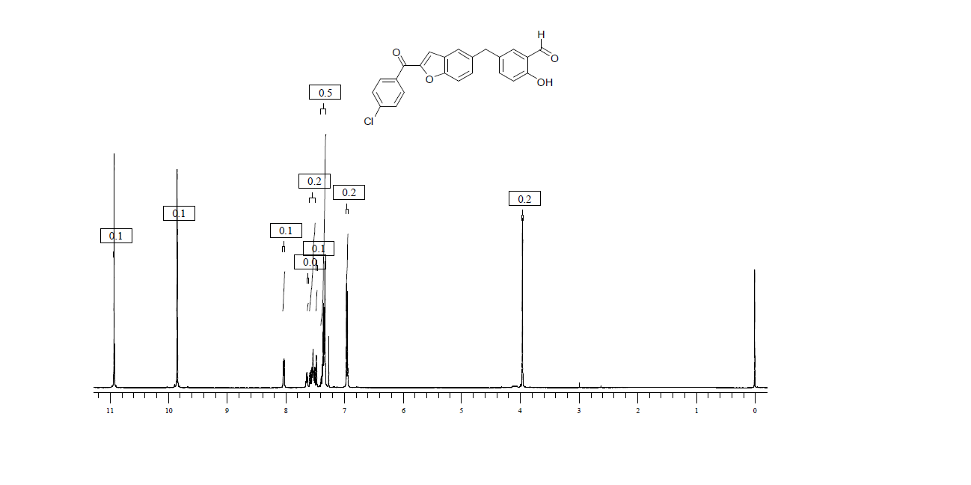
¹³C-NMR spectrum of 5-((2-(4-chlorobenzoyl) benzofuran-5-yl) methyl)-2-hydroxybenza- ldehyde (3b):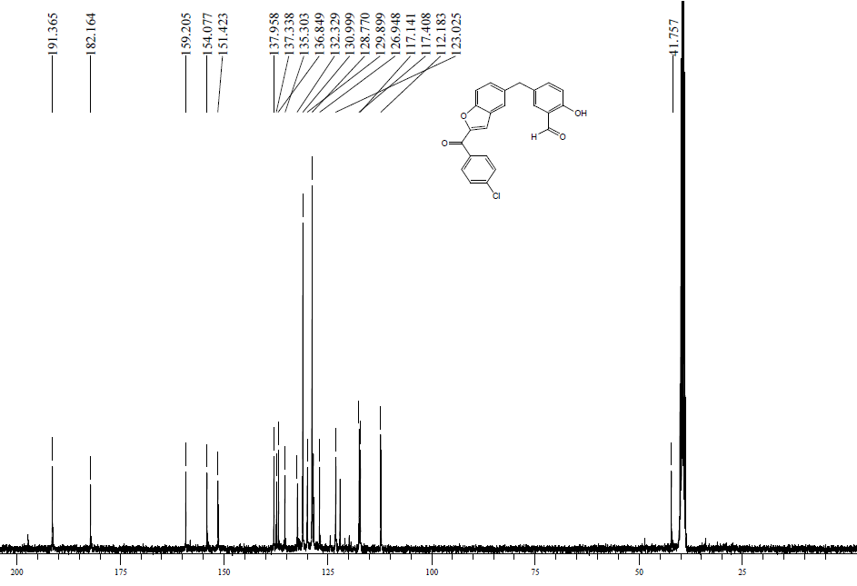
HRMS spectrum of 5-((2-(4-chlorobenzoyl) benzofuran-5-yl) methyl)-2-hydroxybenzaldehy - de (3b):
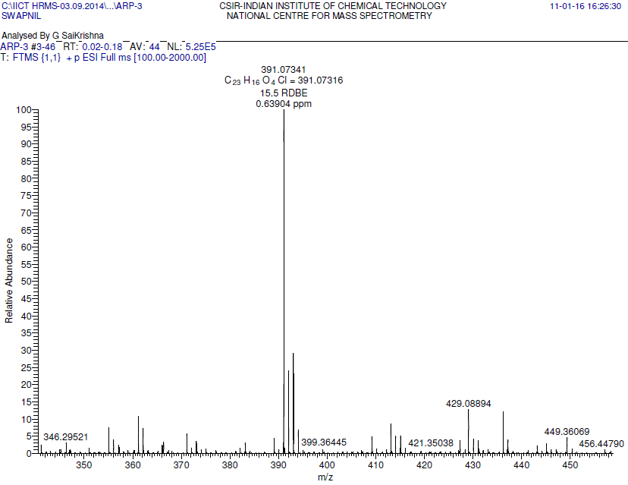
¹H NMR spectrum of (5-(3-(1H-benzo[d]imidazol-2-yl)-4-hydroxybenzyl)benzofuran-2-yl) (phenyl)methanone (4a):
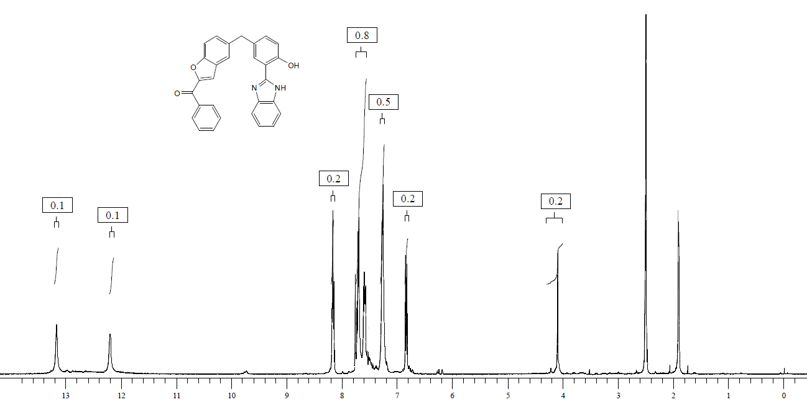
¹³C NMR spectrum of (5-(3-(1H-benzo[d]imidazol-2-yl)-4-ydroxybenzyl)benzofuran-2-yl) (phenyl)methanone (4a):
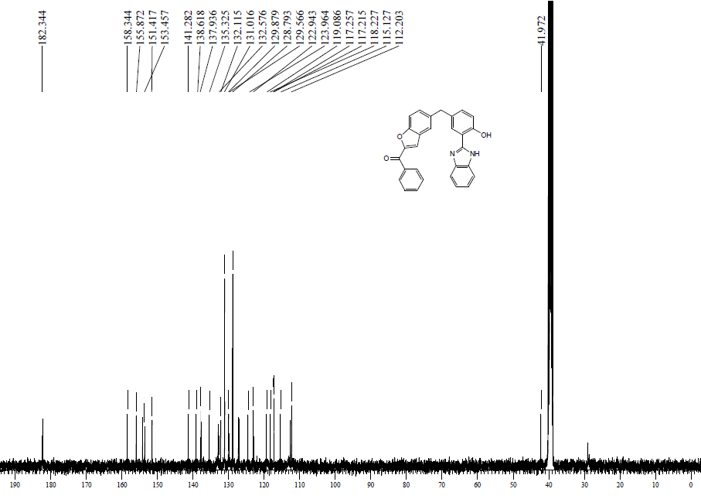
Mass spectrum of (5-(3-(1H-benzo[d]imidazol-2-yl)-4-hydroxybenzyl)benzofuran-2-yl) (phenyl)methanone (4a):
¹H NMR spectrum of (5-(3-(5-fluoro-1H-benzo[d]imidazol-2-yl)-4-hydroxybenzyl)benzo furan-2-yl)(phenyl)methanone(4f):
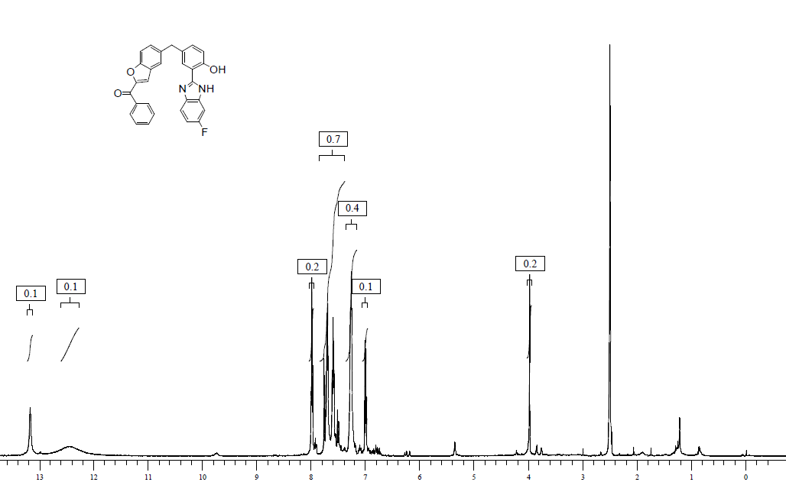
¹³C NMR spectrum of (5-(3-(5-fluoro-1H-benzo[d]imidazol-2-yl)-4-hydroxybenzyl)benzo furan-2-yl)(phenyl)methanone(4f):
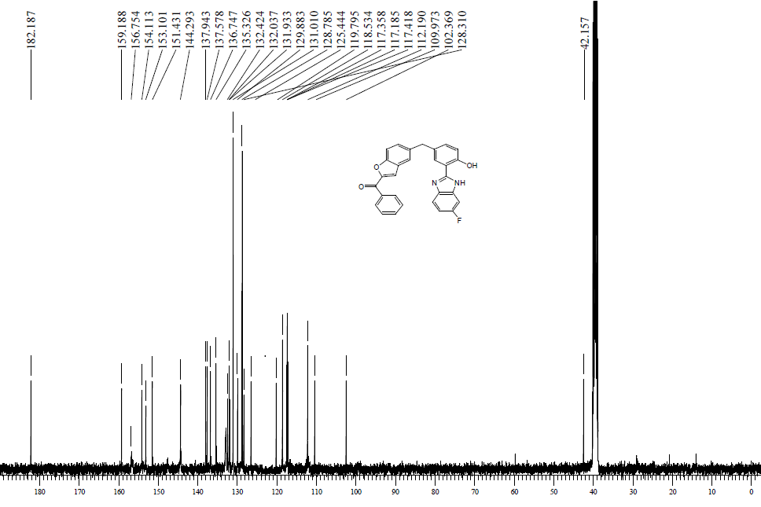
HRMS spectrum of (5-(3-(5-fluoro-1H-benzo[d]imidazol-2-yl)-4-hydroxybenzyl)benzo furan-2-yl) (phenyl)methanone(49f):
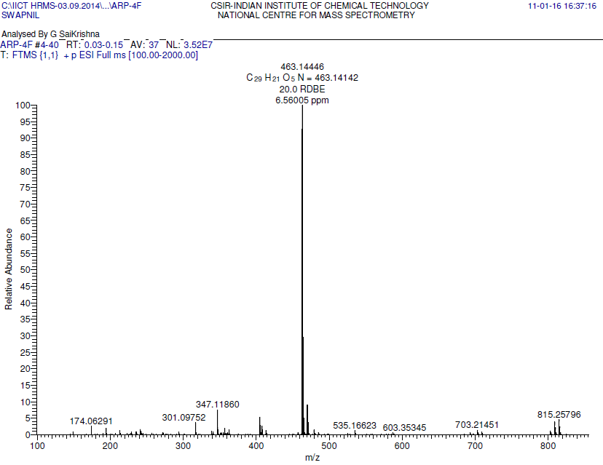
¹H NMR Spectrum of (5-(3-(6-bromo-1H-benzo[d]imidazol-2-yl)-4-hydroxybenzyl) benzofuran-2-yl)(4-chlorophenyl)methanone (4u):
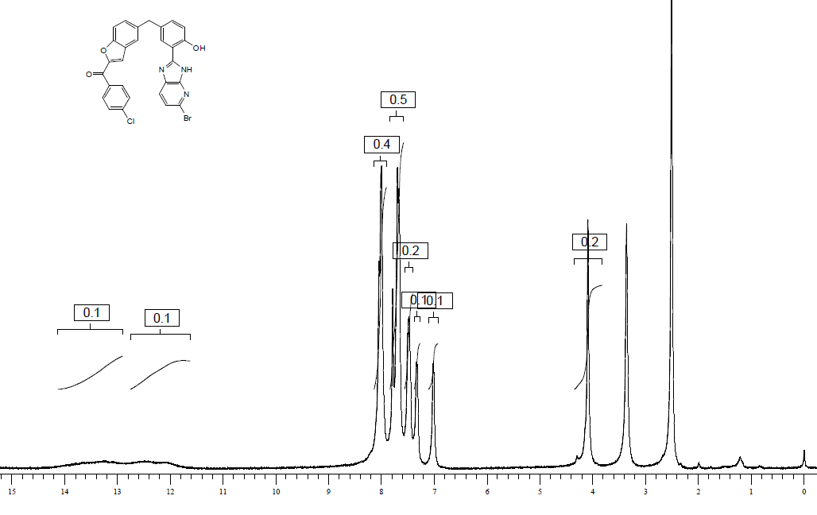
¹³C NMR Spectrum of (5-(3-(6-bromo-1H-benzo[d]imidazol-2-yl)-4-hydroxybenzyl) benzofuran-2-yl)(4-chlorophenyl)methanone (4u):
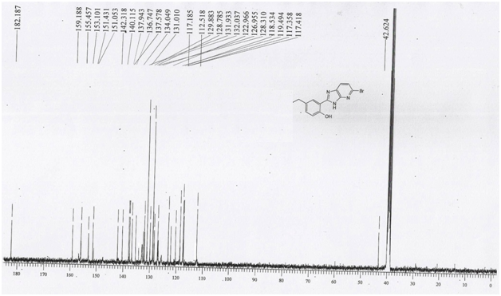
HRMS Spectrum of (5-(3-(6-bromo-1H-benzo[d]imidazol-2-yl)-4-hydroxybenzyl) benzo furan-2-yl) (4-chlorophenyl)methanone (4u):
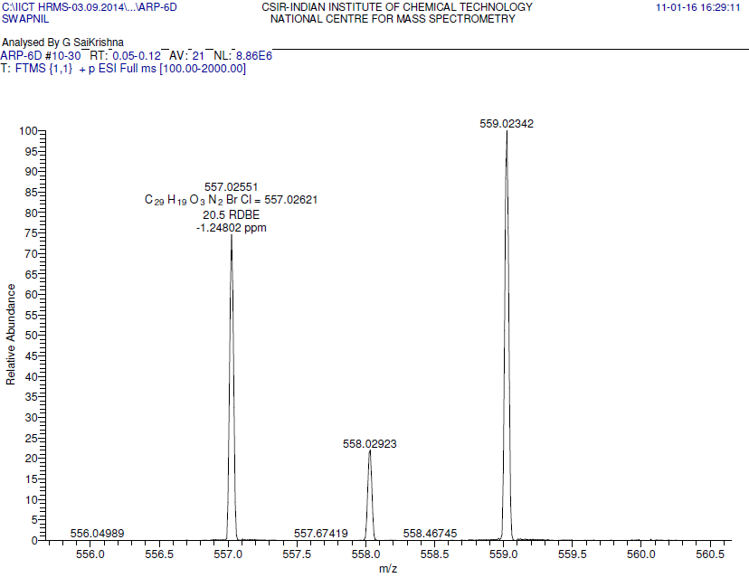
¹H NMR Spectrum of (4-chlorophenyl)(5-(4-hydroxy-3-(3H-imidazo[4,5-b]pyridin-2-yl) benzyl)benzofuran-2-yl)methanone (4t):
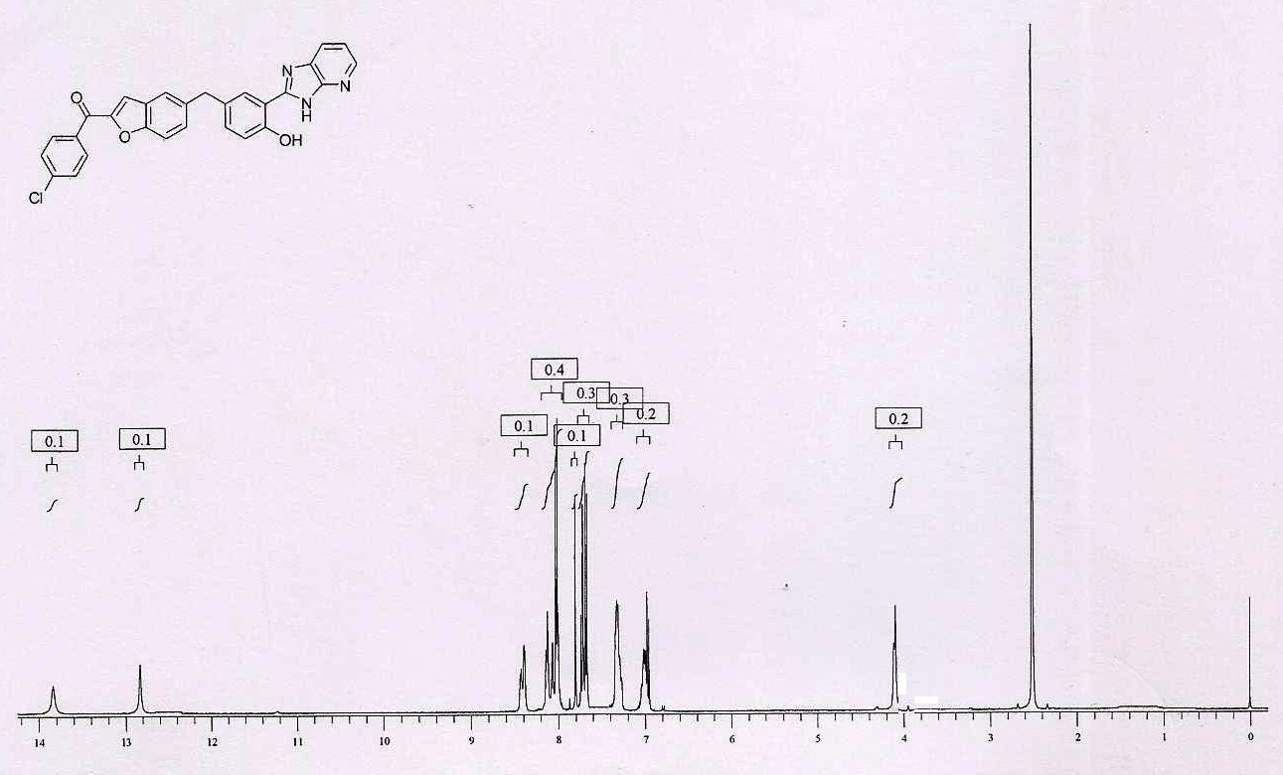
¹³C NMR Spectrum of (4-chlorophenyl)(5-(4-hydroxy-3-(3H-imidazo[4,5-b]pyridin-2-yl) benzyl)benzofuran-2-yl)methanone (4t):
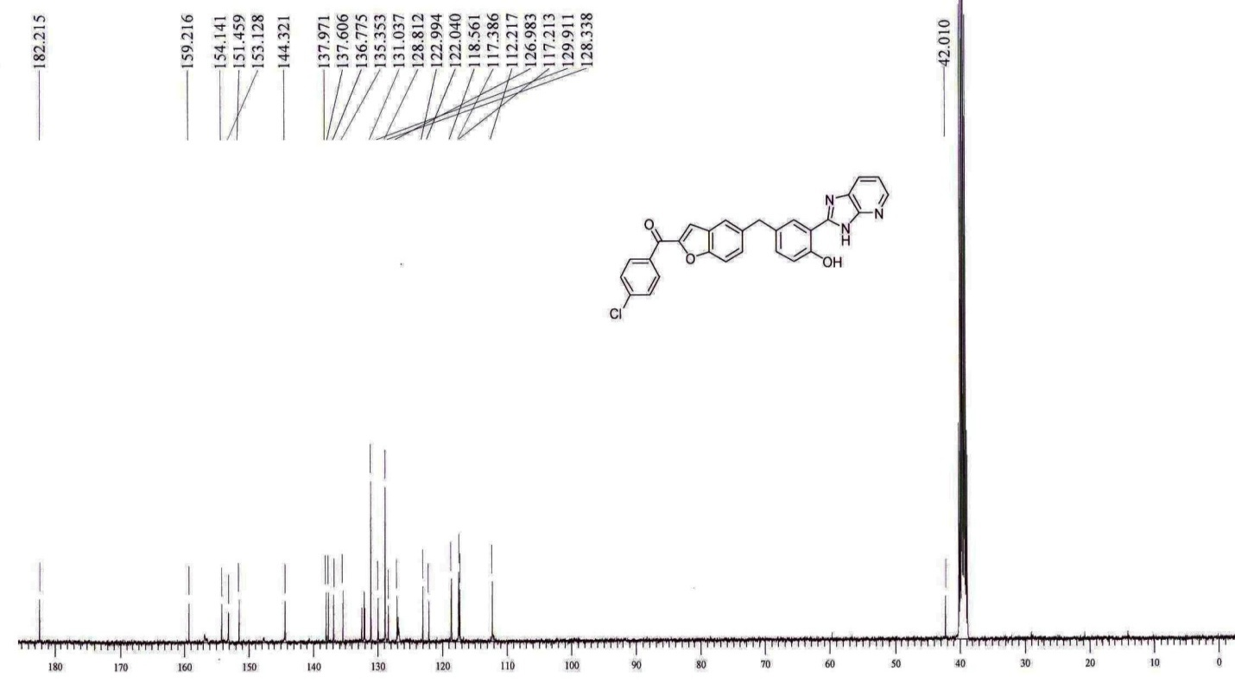
Mass spectrum of (4-chlorophenyl)(5-(4-hydroxy-3-(3H-imidazo[4,5-b] pyridin-2-yl) benzyl) benzofuran-2-yl)methanone (4t):
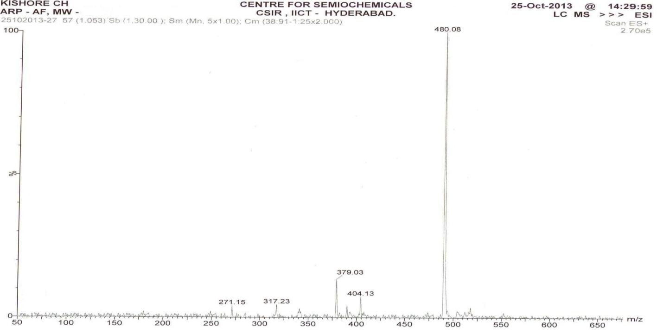
HRMS spectrum of (5-(3-(5,6-dimethyl-1H-benzo[d]imidazol-2-yl)4hydroxybenzyl) benzofuran-2-yl) (phenyl)methanone(4g):

