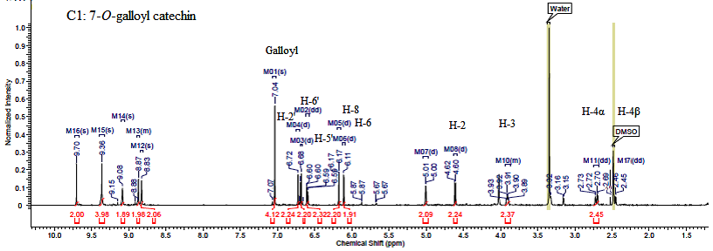
Figure S2: 1H NMR spectrum of GC (C1).Solvent: DMSO-d6, Frequency (MHz):599.67, Nucleus: H, Temperature: 25ºC, Pulse sequence: s2pul, Acquisition time (sec):1.7039, Number of transits: 16, Original point count: 32768, Spectrum offsets (Hz): 3598.0154, Spectrum type: Standard, sweep width (Hz):9615.38.
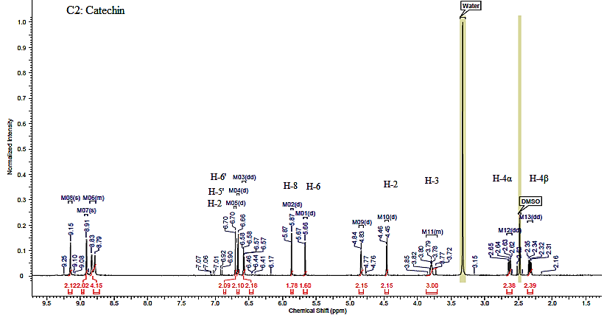
Figure S3: 1H NMR spectrum of C (C2).Solvent: DMSO-d6, Frequency (MHz):599.67, Nucleus: H, Temperature: 25ºC, Pulse sequence: s2pul, Acquisition time (sec):1.7039, Number of transits: 32, Original point count: 16384, Spectrum offsets (Hz): 3598.0154, Spectrum type: Standard, sweep width (Hz):9615.38
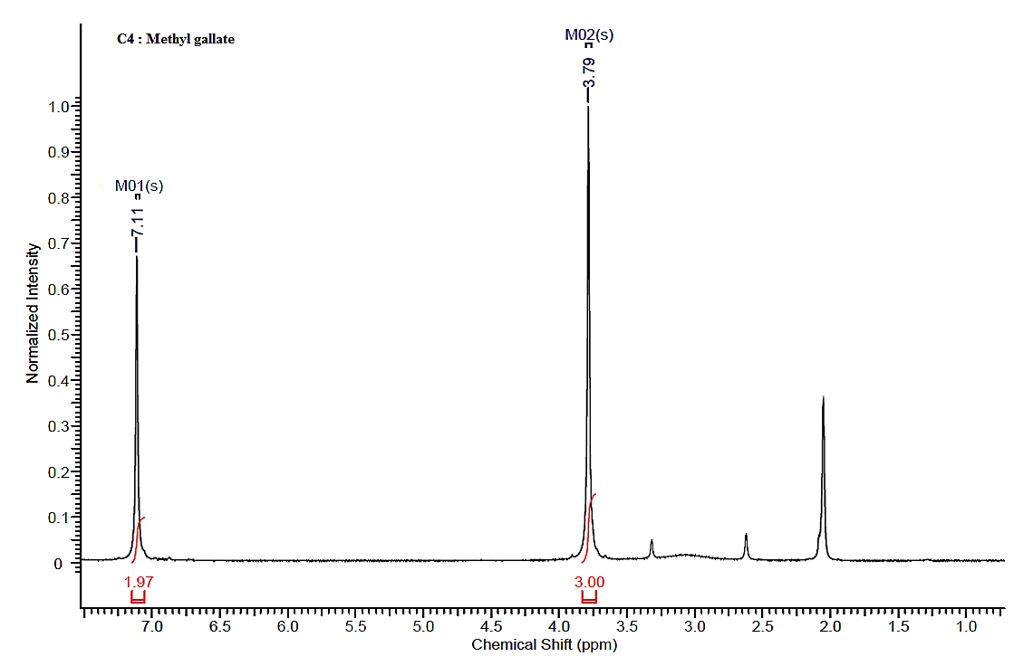
C 3: Methyl gallate
Figure S4: 1H NMR spectrum of MG (C4). Solvent: acetone-d6, Frequency (MHz):599.67, Nucleus: H, Temperature: 25ºC, Pulse sequence: s2pul, Acquisition time (sec):1.704, Number of transits: 16, Original point count: 16384, Spectrum offsets (Hz): 3598.0154, Spectrum type: Standard, sweep width (Hz):9615.4

