Supporting information for
Thermogravimetric Analysis, Kinetic Study, and Pyrolysis-GC/MS Analysis of 1,1ʹ-Azobis-1,2,3-triazole and 4,4ʹ-Azobis-1,2,4-triazole
Chenhui Jia,ª Yuchuan Li,*ª Shujuan Zhang,ª Teng Feiª and Siping Pangª
School of Material Science & Technology, Beijing Institute of Technology, Beijing 100081, P.R. China, Email: liyuchuan@bit.edu.cn

Contents of the supporting information:

The purity of the title compounds S1

S1
The purity of the title compounds
The purity of the title compounds was determined using an Agilent 1260 HPLC equipped with an Eclipse XDB C18 chromatographic column. The temperature was held at 303.15 K during the analytical procedure. The wavelength of the ultraviolet detector was set to 230 nm and the sample injection volume was 5 μL. The mobile phase was methanol/water (90/10), injected at a flow rate of 0.4 mL·min⁻¹. The results were shown in Figure 2 and 3.
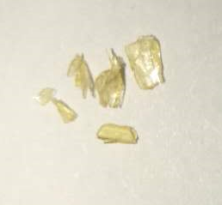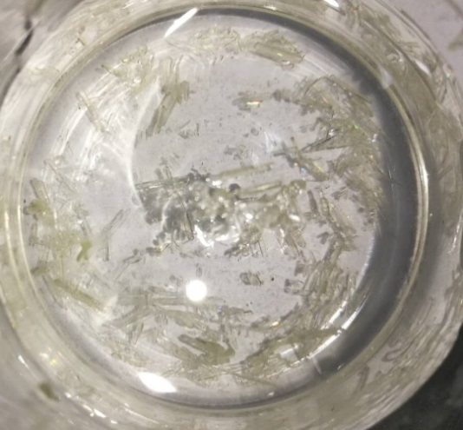
4,4’-azobis-1,2,4-tirazole
1,1’-azobis-1,2,3-tirazole
Fig.1 The crystal of 1,1ʹ-azobis-1,2,3-triazole (1) and 4,4ʹ-azobis-1,2,4-triazole (2)
Fig.2 High-performance liquid chromatograph (HLPC) of 1
Fig.3 High-performance liquid chromatograph (HLPC) of 2

