Structural determinants influencing halogen bonding: a case study on azinesulfonamide analogs of aripiprazole as 5-HT_{1A}, 5-HT₇, and D₂ receptor ligands

Krzysztof Marciniecª*, Rafał Kurczab^{b}, Maria Książek^{c}, Ewa Bębenekª, Elwira Chrobakª, Grzegorz Satała^{b}, Andrzej J. Bojarski^{b}, Joachim Kusz^{c}, Paweł Zajdel^{d}

Additional file
Table S1. Conformation of arylpiperazine derivatives with polymethylene spacer (H-N⁺(CH₂)_{n}N-Y) in the crystal stateª (n=3 and 4).
Category  Structure | N⁺...N-Y [Å] | τ₁ [º] | τ_{1’} [º]^{b} | τ₂ [º] | τ₃ [º] | τ₄ [º] | τ₅ [º]^{c}
n=3
6 | 4.39 | -102.7 | - | -68.3 | 179.7 | -55.1 | -
IWEJAV | 5.04 | -61.8 | 59.6 | 168.43 | 162.2 | -50.9 | -
EZEYUE | 4.98 | -73.3 | 101.9 | 168.8 | 150.5 | 42.2 | -
AJUZUA | 5.09 | -57.0 | 63.5 | -179.2 | 176.6 | 172.7 | -
AJUZUA01 | 5.09 | -56.9 | 63.4 | -179.3 | 176.5 | 171.9 | -
n=4
2 | 5.47 | -113.7 | - | -69.0 | 179.4 | -174.8 | 53.7
3 | 5.48 | -156.3 | - | 74.4 | -170.5 | -176.5 | -49.5
4 | 5.48 | -155.7 | - | 73.9 | -171.4 | -176.2 | -50.5
5 | 5.00 | -119.3 | - | -65.1 | -72.7 | 178.3 | -53.7
MECGIM | 5.50 | 108.3 | - | -69.0 | 178.9 | 175.9 | 162.7
PECHIQ | 4.95 | 78.8 | - | 68.3 | 178.1 | 77.1 | -60.9
KATCIT | 6.25 | 127.9 | - | 164.8 | 173.8 | 177.8 | 58.3
OFAZEA | 6.29 | 108.9 | -80.0 | 172.9 | -176.9 | -178.3 | 55.8
SOBVOW | 6.22 | 104.5 | -79.8 | -166.2 | 173.0 | -164.2 | 58.4
SOBVUC | 6.25 | -113.1 | 84.3 | 179.2 | 171.2 | 175.2 | 51.7
SOBWAJ | 6.22 | -104.8 | 82.9 | 166.5 | -172.7 | 167.5 | -55.9
SOBWEN | 6.29 | -113.0 | 84.8 | 164.4 | 171.5 | 175.6 | 36.8
OFAZOK | 5.79 | -91.6 | 92.9 | -168.7 | -72.4 | 166.2 | 67.7
OFAZIE | 5.90 | -116.6 | 62.8 | -162.7 | -75.7 | 172.8 | 47.6
ª Selected CSD crystals satisfying following conditions: (i) - no substitution in the alkyl chain; (ii) – protonated piperazine nitrogen atom (as it is expected to be while interacting with the receptors),
^{b} due to planarity of terminal group both τ₁ and τ_{1’} are listed.
(τ₅) defined as C11-C12-N⁺-H

Table S2. Conformation of phenyl ring and piperazine moiety in arylpiperazine derivatives with polymethylene spacer [H-N⁺-(CH₂)_{n}-X] in the crystal state (n=2-4).
Category  Structure | τ₆ [º] | Dihedral angle piperazine/aryl ф [º]
2 | -147.5 | 20.6
3 | 159.2 | 47.1
4 | 158.8 | 48.0
5 | -143.8 | 62.8
6 | 154.6 | 51.5
AJUZUA | 162.6 | 35.8
AJUZUA01 | 162.6 | 43.9
AKABAP | 163.3 | 45.4
AKABAP01 | 163.3 | 45.4
AKIMIQ | 17.2 | 19.2
COLDAK | 119.6 | 86.6
CPTAZP | 40.1 | 26.2
DAYQAW | 156.7 | 48.9
EDUWIK | 31.0 | 14.0
EZEYUE | 150.3 | 56.5
EZEZEP | 162.7 | 57.7
EZEZIT | 26.4 | 19.0
FAXLUN | 66.6 | 45.8
FOPYUE | 174.2 | 34.1
HAXQUU | 115.6 | 44.4
HIJCOS | 164.4 | 41.5
IWEJAV | 170.4 | 36.4
KATCIT | 69.1 | 44.9
KIYFUT | 17.8 | 15.3
LERJUP | 74.3 | 48.6
MECGIM | 157.6 | 49.1
MUXZEK | 65.8 | 86.7
OFAZEA | 165.5 | 40.7
OFAZIE | 14.3 | 19.9
OFAZOK | 27.4 | 6.7
OXYPEB10 | 43.0 | 23.0
PECHIQ | 166.2 | 39.0
PEZNEP | 73.0 | 47.3
PEZNIT | 155.4 | 50.6
PEZNOZ | 162.1 | 44.0
PEZNUF | 164.4 | 43.0
SOBVOW | 52.3 | 33.8
SOBVUC | 30.0 | 22.3
SOBWAJ | 167.3 | 39.7
SOBWEN | 43.1 | 22.4
WANCET | 49.4 | 31.3

Figure S1. Histograms of population of different arylpiperazine salts conformations.

Table S3. Strong and weak hydrogen bonds geometry for structures 2-6 [Å and ˚].
Compound | D-H…A | d(D-H) | d(H…A) | d(D…A) | <(DHA)
2 | N(14)-H(14N)…Cl(1) | 1.00 | 2.08 | 3.066(7) | 170.0
2 | C(11)-H(11)…Cl(2)^{i} | 0.95 | 2.75 | 3.644(11) | 156.4
2 | C(110)-H(11A)…O(11)^{ii} | 0.99 | 2.58 | 3.358(13) | 135.2
2 | C(112)-H(11E)…Cl(1)^{ii} | 0.99 | 2.95 | 3.810(9) | 146.3
2 | C(112)-H(11F)…Cl(1)^{iii} | 0.99 | 2.71 | 3.680(10) | 165.9
2 | C(113)-H(11G)…Cl(1)^{ii} | 0.99 | 2.97 | 3.831(9) | 146.3
2 | C(115)-H(11K)…O(12)^{iii} | 0.99 | 2.47 | 3.223(11) | 132.2
2 | C(116)-H(11N)…Cl(1)^{ii} | 0.99 | 2.81 | 3.709(8) | 152.0
2 | C(21)-H(21)…Cl(1) | 0.95 | 2.99 | 3.90(10) | 161.5
2 | C(210)-H(21B)…O(21)^{ii} | 0.99 | 2.64 | 3.441(10) | 137.7
2 | C(214)-H(21I)…O(22)^{iv} | 0.99 | 2.62 | 3.383(13) | 133.5
2 | C(215)-H(21K)…Cl(2) | 0.99 | 2.88 | 3.562(13) | 126.9
2 | C(218)-H(218)…O(22)^{iv} | 0.95 | 2.51 | 3.454(13) | 171.0
3 | N(3)-H(3N)…Cl(3) | 0.81(4) | 2.45(4) | 3.239(3) | 167(4)
3 | N(4)-H(4N)…Cl(3)^{v} | 0.95(4) | 2.11(4) | 3.050(3) | 174(3)
4 | N(3)-H(99)…Cl(1) | 0.94(2) | 2.13(3) | 3.067(2) | 175(2)
4 | N(4)-H(2)…Cl(1)^{vi} | 0.85(3) | 2.43(3) | 3.251(2) | 164(2)
4 | C(13)-H(13B)···Cl(1)^{vii} | 0.99(3) | 2.76(3) | 3.684(3) | 155.3(19)
4 | C(15)-H(15B)···Cl(1)^{viii} | 0.96(3) | 2.94(3) | 3.602(3) | 127.2(19)
4 | C(16)-H(16A)···Cl(1)^{vii} | 0.93(3) | 2.90(3) | 3.738(3) | 150(2)
4 | C(16)-H(16B)···O(2)^{vii} | 0.98(3) | 2.58(3) | 3.532(3) | 166(2)
5 | N(3)-H(3N)…O(1W) | 0.79(4) | 2.00(4) | 2.789(3) | 176(3)
5 | N(4)-H(4N)…Cl(3) | 0.88(3) | 2.15(3) | 3.015(2) | 168(2)
5 | O(1W)-H(1W)…O(2)^{ii} | 0.83(4) | 2.08(4) | 2.903(3) | 170(4)
5 | O(1W)-H(2W)…Cl(3) | 0.91(5) | 2.17(5) | 3.076(2) | 173(4)
6 | N(2)-H(2N)…Cl(3) | 0.84(5) | 2.38(5) | 3.133(2) | 150(4)
6 | N(3)-H(3N)…Cl(3)^{ix} | 0.94(4) | 2.08(4) | 3.17(3) | 174(4)
Symmetry transformations used to generate equivalent atoms: i: -x+1,-y+1,-z+2; ii: x-1,y,z; iii: -x+1,-y+1,-z+1; iv: -x+1,-y,-z+2; v: -x,y-1/2,-z+3/2; vi: -x+1,y+1/2,-z+3/2; vii: x,-y+1/2,z-1/2; viii: -x+1,-y,-z+1; ix: x,y+1,z

Table S4. Optimizedª dihedral angles [º] of the studied compounds.
Compound |  | 2 | 3 | 4 | 5 | 6
τ₁ [º] | X-ray | -113.7 | -156.3 | -155.7 | -119.3 | -102.7
τ₁ [º] | DFT | -85.1 | -109.8 | -110.0 | -64.6 | -75.8
τ₁ [º] | DFT-CPCM | -83.3 | -151.7 | -152.5 | -94.8 | -89.8
τ₁ [º] | Docking 5-HT₇^{b} | -105.6 | -144.6 | -143.6 | -102.4 | -96.1
τ₁ [º] | Docking 5-HT_{1A} | -95.5 | -128.7 | -125.6 |  | -71.5
τ₂ [º] | X-ray | -69.0 | 74.4 | 73.9 | -65.1 | -68.3
τ₂ [º] | DFT | -53.7 | 61.3 | 61.9 | -40.3 | -45.7
τ₂ [º] | DFT-CPCM | -61.9 | 64.7 | 64.9 | -68.3 | -62.0
τ₂ [º] | Docking 5-HT₇ | -62.6 | 70.4 | 69.4 | -67.4 | -65.6
τ₂ [º] | Docking 5-HT_{1A} | -72.9 | 68.4 | 63.7 | -78.6 | -93.6
τ₃ [º] | X-ray | 179.4 | -170.5 | -171.4 | -72.7 | 179.7
τ₃ [º] | DFT | 166.2 | -179.6 | -179.0 | -41.0 | 96.9
τ₃ [º] | DFT-CPCM | -176.9 | 179.1 | 178.8 | 179.9 | 169.4
τ₃ [º] | Docking 5-HT₇ | -170.6 | -169.4 | -161.7 | -42.9 | 167.5
τ₃ [º] | Docking 5-HT_{1A} | -168.4 | -165.8 | -161.5 | -61.1 | 165.1
τ₄ [º] | X-ray | -174.8 | -176.5 | -176.2 | 178.3 | -55.1
τ₄ [º] | DFT | -157.1 | 166.0 | 166.6 | 86.9 | -152.2
τ₄ [º] | DFT-CPCM | -174.3 | 172.2 | 173.0 | 173.2 | -170.2
τ₄ [º] | Docking 5-HT₇ | -175.3 | -173.9 | -177.8 | -170.6 | -59.1
τ₄ [º] | Docking 5-HT_{1A} | -174.5 | -162.6 | -161.1 | -164.9 | -75.7
τ₅ [º] | X-ray | 53.7 | -49.5 | -50.5 | -53.7 | -
τ₅ [º] | DFT | 170.1 | -172.2 | -171.2 | -163.2 | -
τ₅ [º] | DFT-CPCM | 168.6 | -170.2 | -169.5 |  | -
τ₅ [º] | Docking 5-HT₇ | 59.1 | -57.9 | -52.8 | -53.2 | -
τ₅ [º] | Dockin 5-HT_{1A} | -72.2 | -80.9 | -75.8 | -62.5 | -
τ₆ [ º] | X-ray | -147.5 | 159.2 | 158.8 | -143.8 | 154.6
τ₆ [ º] | DFT | -117.6 | 148.9 | 146.9 | -149.2 | 149.3
τ₆ [ º] | DFT-CPCM | -131.5 | 152.5 | 153.0 | -153.0 | 152.6
τ₆ [ º] | Docking 5-HT₇ | -152.7 | 138.1 | 125.9 | 122.7 | 116.5
τ₆ [ º] | Dockin 5-HT_{1A} | -151.8 | 154.2 | 155.5 | -144.8 | 116.1
ª B3LYP/6-311+G(d,p)
^{b} the average dihedral value calculated for the best binding poses found in all considered receptors

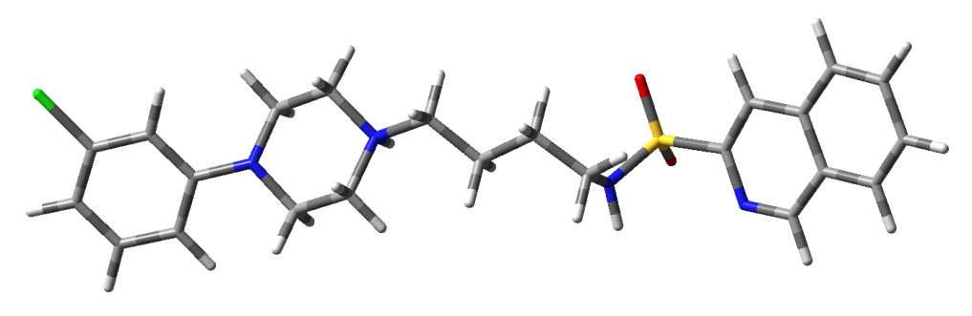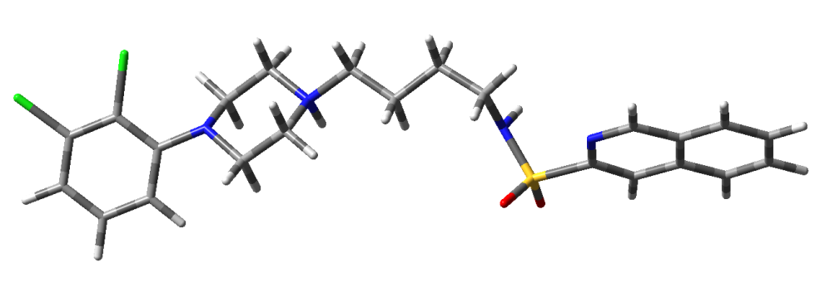
2 3

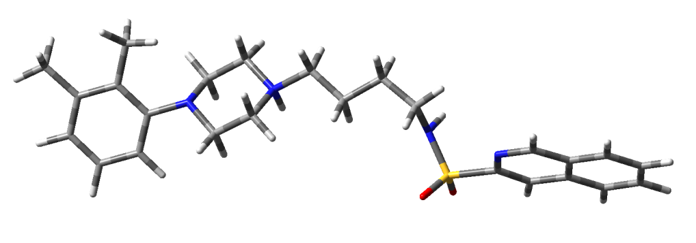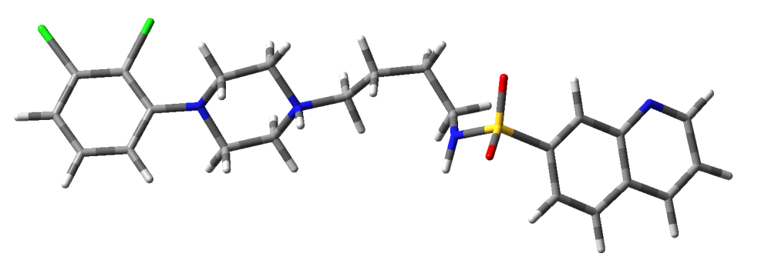
4 5

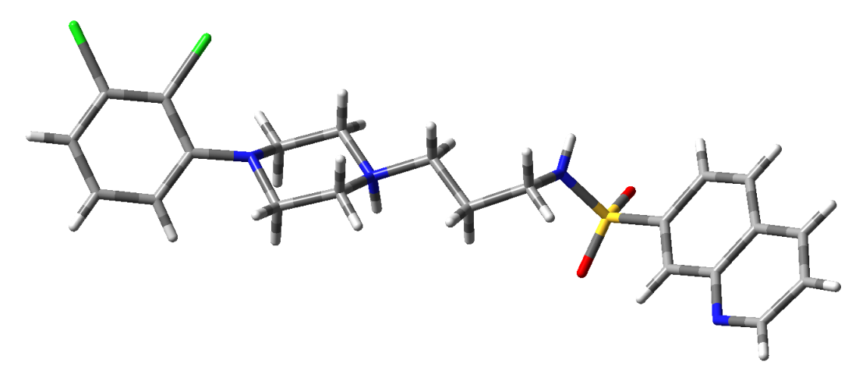
6
Figure S2. Low-energy conformation of the studied compounds in aqueous medium

Table S5. Crystal data and structure refinement
 | 2 | 3 | 4 | 5 | 6
Molecular formula | [C₂₃H₂₈ClN₄O₂S]⁺Cl⁻ | [C₂₃H₂₇Cl₂N₄O₂S]⁺Cl⁻ | [C₂₅H₃₃N₄O₂S]⁺Cl⁻ | [C₂₃H₂₇Cl₂N₄O₂S]⁺Cl⁻ · H₂O | [C₂₂H₂₅Cl₂N₄O₂S]⁺Cl⁻
Formula weight | 495.45 | 529.90 | 489.06 | 547.91 | 515.87
Crystal system | triclinic | monoclinic | monoclinic | monoclinic | monoclinic
Space group | P-1 | P2₁/c | P2₁/c | Pc | P2₁/c
Unit cell dimentions [Å] | a = 7.0093(6)  b = 20.368(3)  c = 20.918(3)  α = 63.049(13)˚  β = 81.543(9)˚  γ = 85.518(8)˚ | a = 15.2389(3)  b = 13.5028(3)  c = 11.8726(2)  α = 90.00˚  β = 94.117(2)˚  γ = 90.00˚ | a = 15.1703(6)  b = 13.7582(5)  c = 11.8775(4)  α = 90.00˚  β = 93.327(3)˚  γ = 90.00˚ | a = 6.9116(2)  b = 29.3055(4)  c = 6.9926(2)  α = 90.00˚  β = 118.088(3)˚  γ = 90.00˚ | a = 25.9210(3)  b = 6.8213(1)  c = 13.3821(2)  α = 90.00˚  β = 94.647(1)˚  γ = 90.00˚
Volume [Å³] | 2632.8(6) | 2436.69(8) | 2474.85(16) | 1249.53(5) | 2358.38(6)
Z | 4 | 4 | 4 | 2 | 4
D_{calc} [g/cm³] | 1.250 | 1.444 | 1.313 | 1.456 | 1.453
Absorption coefficient  [mm⁻¹] | 3.166 | 0.491 | 0.269 | 0.484 | 0.505
F(000) | 1040 | 1104 | 1040 | 572 | 1072
Crystal size [mm³] | 0.12 x 0.02 x 0.02 | 0.10 x 0.10 x 0.01 | 0.08 x 0.06 x 0.02 | 0.13 x 0.10 x 0.02 | 0.25 x 0.17 x 0.02
θ range [˚] | 2.39-58.93 | 2.29-25.06 | 2.27-25.68 | 2.08-25.06 | 2.36-25.06
Diffractometer | SuperNova diffractometer (Agilent Technologies) with Atlas detector
Index ranges | -6 ≤ h ≤ 7  -21 ≤ k ≤ 22  -23 ≤ l ≤ 23 | -18 ≤ h ≤ 17  -16 ≤ k ≤ 14  -14 ≤ l ≤ 14 | -18 ≤ h ≤ 18  -16 ≤ k ≤ 16  -14 ≤ l ≤ 13 | -8 ≤ h ≤ 8  -34 ≤ k ≤ 33  -8 ≤ l ≤ 8 | -30 ≤ h ≤ 30  -6 ≤ k ≤ 8  -15 ≤ l ≤ 15
Reflection collected | 14316 | 32661 | 19598 | 17121 | 31346
Independent reflns | 6966 | 4316 | 4707 | 3358 | 4169
Data/parameters | 6966/577 | 4316/304 | 4707/325 | 3358/321 | 4169/295
Refinement method | Full-matrix least-squares on F²
S (on F²) | 1.244 | 1.283 | 1.063 | 0.996 | 1.304
R indices [I>2σ(I)] | R1 = 0.1205,  wR2 = 0.3321 | R1 = 0.0446,  wR2 = 0.1134 | R1 = 0.0480,  wR2 = 0.1180 | R1 = 0.0193,  wR2 = 0.0530 | R1 = 0.0501,  wR2 = 0.1208
R indices (all data) | R1 = 0.1575,  wR2 = 0.3622 | R1 = 0.0475,  wR2 = 0.1145 | R1 = 0.0720,  wR2 = 0.1361 | R1 = 0.0194,  wR2 = 0.0531 | R1 = 0.0509,  wR2 = 0.1211
Δρ min/max [eÅ³] | -0.758, 0.882 | -0.405, 0.471 | -0.286, 0.339 | -0.156, 0.219 | -0.403, 0.365

