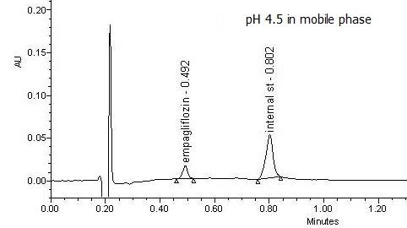
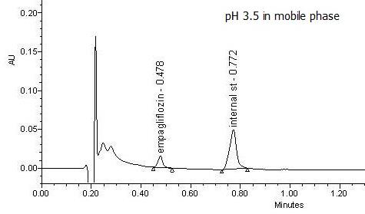
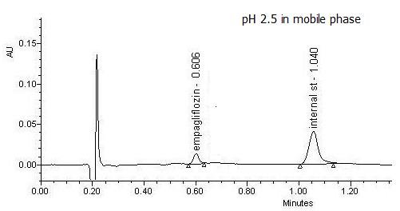
Fig. S1. Chromatograms obtained after using different pH values in mobile phase.
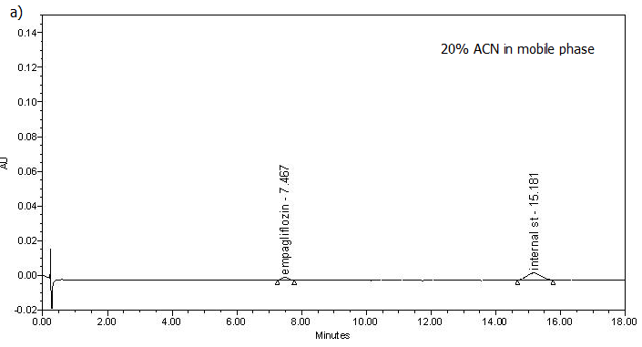
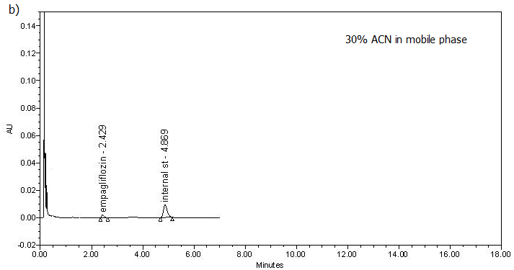
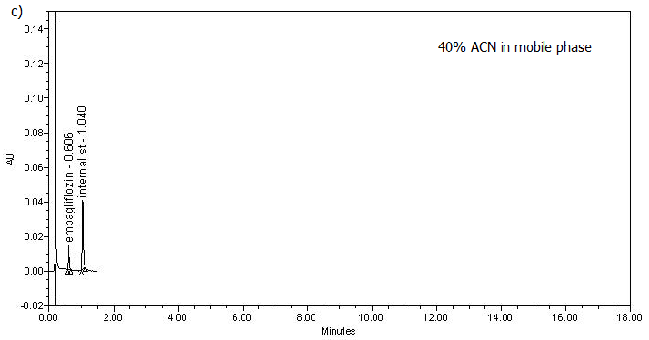
Fig. S2. Chromatograms obtained after elution with mobile phase consists of; (acetonitrile: 0.1% trifluoroacetic acid, 20:80, v/v), b) (acetonitrile: 0.1% trifluoroacetic acid, 30:70, v/v), b) (acetonitrile: 0.1% trifluoroacetic acid, 40:60, v/v).
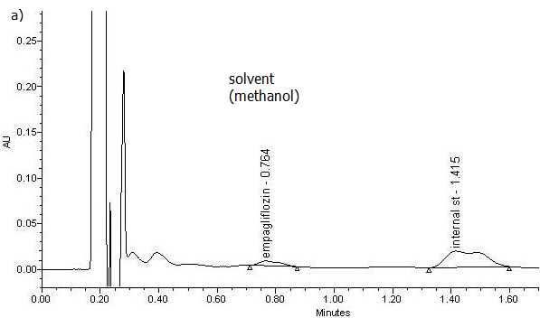
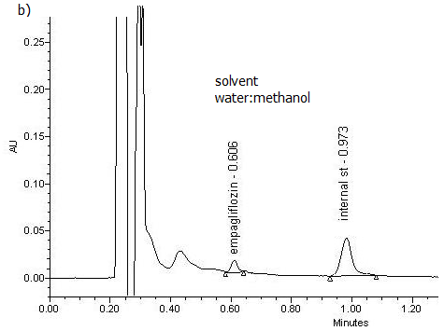

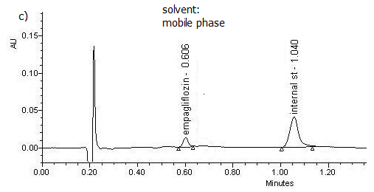
Fig. S3. Chromatograms obtained after using different diluting solvents.
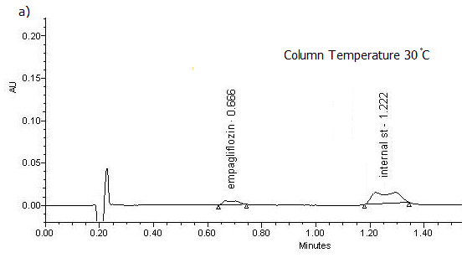
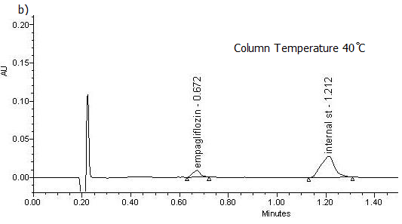
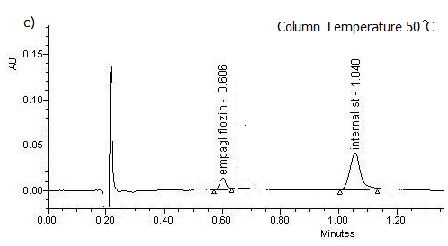
Fig. S4. Chromatograms obtained after using different column temperatures.

