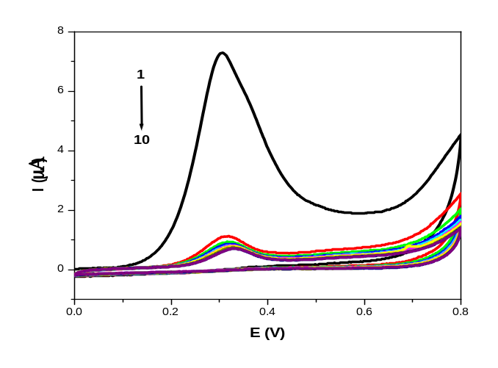
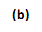
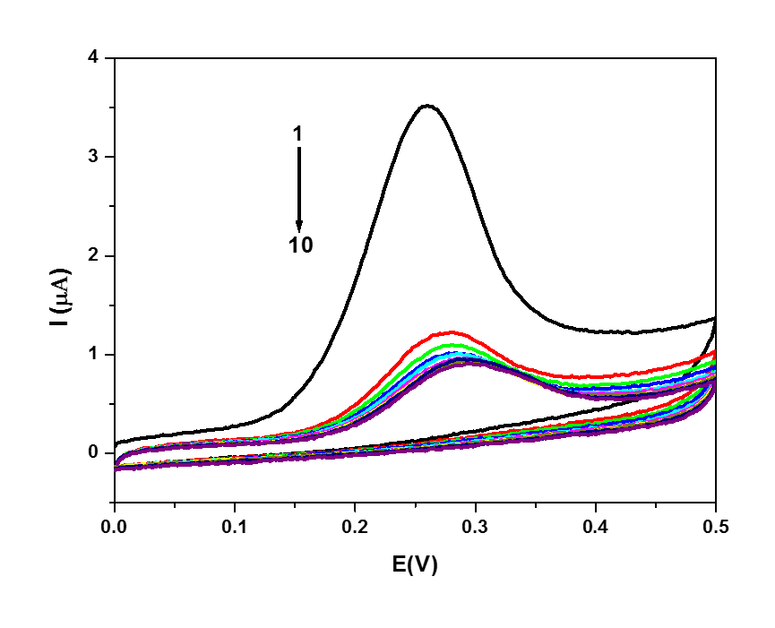

Fig. S1. CVs (scan 1–10) of 3.0x10⁻⁵ M of A5 (a) and A3 (b) in PBS of pH 7.4 obtained at PGE scan rate, 0.10 Vs⁻¹.

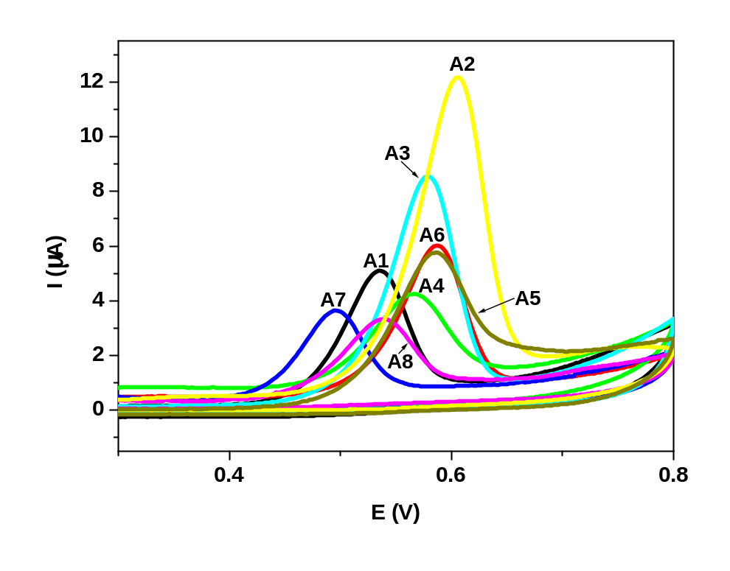

Fig. S2. CVs of 3.0x10⁻⁵ M of A1-A8 in PBS of pH 3.0 obtained at PGE scan rate, 0.10 Vs⁻¹.

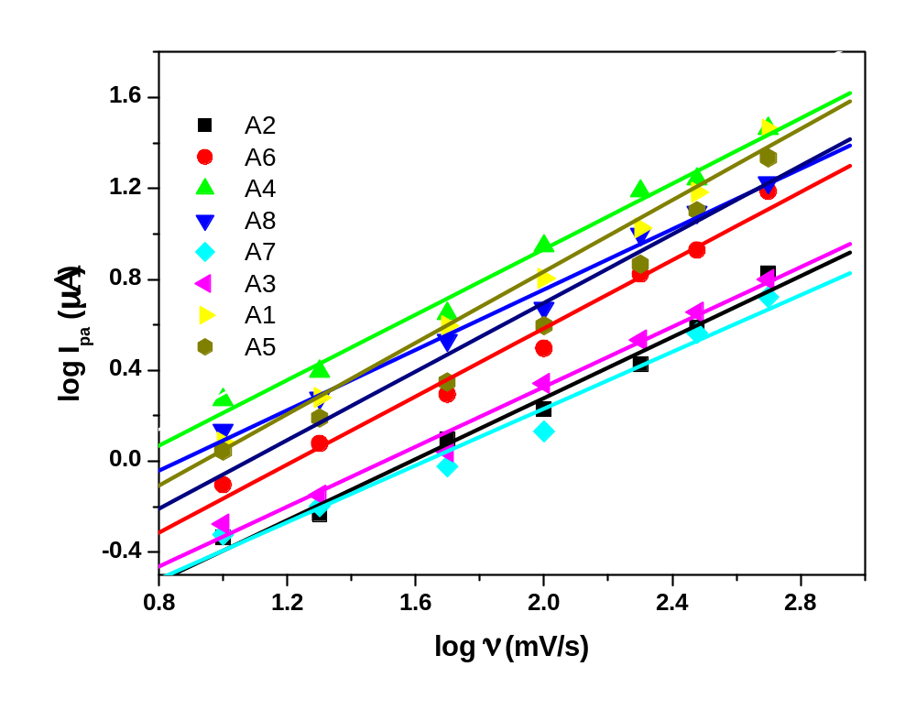
Fig. S3. Plot of log I_{pa} vs. log ν of A1-A8 in PBS of pH 7.4 obtained from CV at PGE.

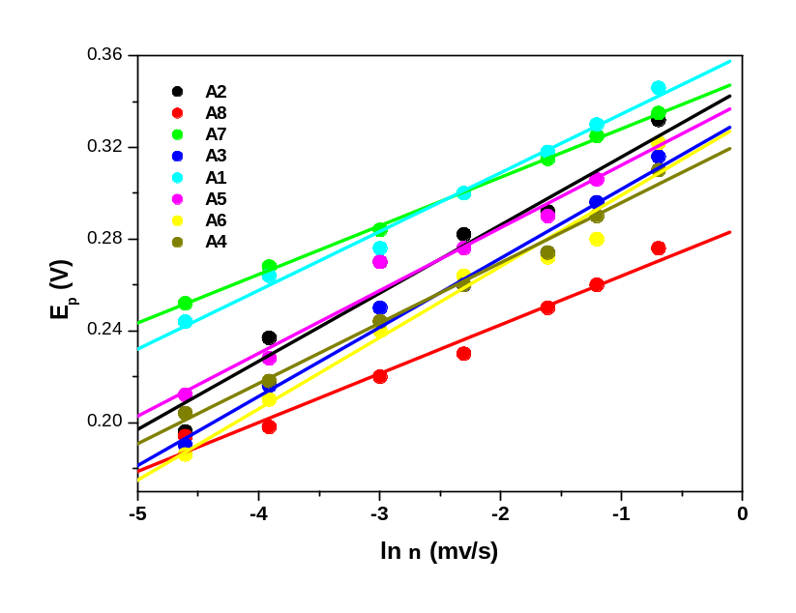
Ln ν (mV/s)

Fig. S4. Plot of E_{p} (V) vs ln ν (mV/s) of A1-A8 in PBS of pH 7.40 obtained from CV at PGE.

