Docking-based virtual screening of TβR1 inhibitors: Evaluation of pose prediction and scoring functions

Shuai Wang#, Jun-Hao Jiang#, Ruo-Yu Li and Ping Deng*

College of Pharmacy, Chongqing Medical University, Chongqing 400016, China.

#These authors contributed equally to this work.
∗Correspondence: 100865@cqmu.edu.cn.

Supporting Information List of Contents

No. | Content | Page
1 | Table S1 Crystal structures of TβR1 with inhibitors reported in PDB | 3-4
2 | Table S2 Physicochemical properties of each crystallographic ligand. MW, molecular weight; HBD, Number of hydrogen bond donors; HBA, Number of hydrogen bond receptors | 5-11
3 | Table S3 Physicochemical properties of compounds in the test set. NC, Number of compounds; MW, molecular weight; nROT, Number of rotatable bonds; nHBA, Number of hydrogen acceptor donors; nHBA, Number of hydrogen bond receptors; nRings, Number of rings | 12
4 | Fig. S1 Overlay of 22 TβR1 proteins in the PDB. Except for the Gly367-Gly374 region (far away from the binding site) of 1RW8 and 1PY5, the rest of the crystal structures were well overlapped | 13

Table S1 Crystal structures of TβR1 with inhibitors reported in PDB
PDB | Organism(s) | Released date | Method | Resolution | Literature
1RW8 | Homo sapiens | 2005-02-01 | X-RAY | 2.4 Å | Bioorg. Med. Chem. Lett.  14: 3581-3584
1PY5 | Homo sapiens | 2004-07-13 | X-RAY | 2.3 Å | Bioorg. Med. Chem. Lett  14: 3581-3584
1VJY | Homo sapiens | 2004-08-31 | X-RAY | 2 Å | J. Med. Chem.  47: 4494-4506
2WOU | Homo sapiens | 2009-09-22 | X-RAY | 2.3 Å | J. Med. Chem.  52: 7901
2WOT | Homo sapiens | 2009-09-22 | X-RAY | 1.85 Å | J. Med. Chem.  52: 7901
2X7O | Homo sapiens | 2010-10-20 | X-RAY | 3.7 Å | J. Med. Chem.  53: 7287
3GXL | Homo sapiens | 2009-04-21 | X-RAY | 1.8 Å | Bioorg. Med. Chem. Lett.  19: 2277-2281
3HMM | Homo sapiens | 2009-06-23 | X-RAY | 1.7 Å | Bioorg. Med. Chem. Lett.  19: 2277-2281
3FAA | Homo sapiens | 2009-01-27 | X-RAY | 3.35 Å | Bioorg. Med. Chem. Lett.  19: 912-916
3KCF | Homo sapiens | 2009-12-22 | X-RAY | 2.8 Å | Bioorg. Med. Chem. Lett.  20: 326-329
3TZM | Homo sapiens | 2012-05-23 | X-RAY | 1.7 Å | Cell Signal  24: 476-483
4X2F | Homo sapiens | 2015-10-28 | X-RAY | 1.49 Å | J. Med. Chem.  58: 457-465
4X2G | Homo sapiens | 2015-08-12 | X-RAY | 1.51 Å | J. Med. Chem.  58: 457-465
4X2J | Homo sapiens | 2014-12-24 | X-RAY | 1.69 Å | J. Med. Chem.  58: 457-465
5E8W | Homo sapiens | 2016-05-11 | X-RAY | 1.86 Å | Acta Crystallogr. D Struct. Biol.  72: 658-674
5E8Z | Homo sapiens | 2016-05-11 | X-RAY | 1.51 Å | Acta Crystallogr. D Struct. Biol.  72: 658-674
5FRI | Homo sapiens | 2016-07-27 | X-RAY | 2 Å | Med. Chem. Commun.  7: 1204-1208
5QIK | Homo sapiens | 2018-10-31 | X-RAY | 1.58 Å | ACS Med. Chem. Lett.  9: 1117-1122
5QIL | Homo sapiens | 2018-10-31 | X-RAY | 1.98 Å | ACS Med. Chem. Lett.  9: 1117-1122
5QIM | Homo sapiens | 2018-10-31 | X-RAY | 1.75 Å | ACS Med. Chem. Lett.  9: 1117-1122
5USQ | Homo sapiens | 2017-04-12 | X-RAY | 2.55 Å | Bioorg. Med. Chem. Lett.  27: 1955-1961
6B8Y | Homo sapiens | 2018-02-07 | X-RAY | 1.65 Å | Bioorg. Med. Chem.  26: 1026-1034

Table S2 Physicochemical properties of each crystallographic ligand. MW, molecular weight; HBD, Number of hydrogen bond donors; HBA, Number of hydrogen bond receptors
PDB | Ligand | Active data | ALogP | MW | HBD | HBA
1RW8 | 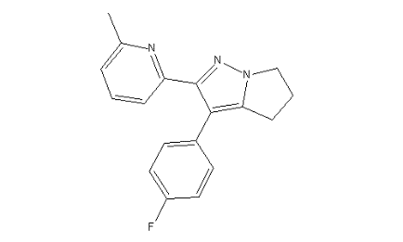  3-(4-fluorophenyl)-2-(6-methylpyridin-2-yl)-5,6-dihydro-4h-pyrrolo[1,2-b]pyrazole | IC₅₀=15 nM | 4.112 | 293.338 | 0 | 2
1PY5 | 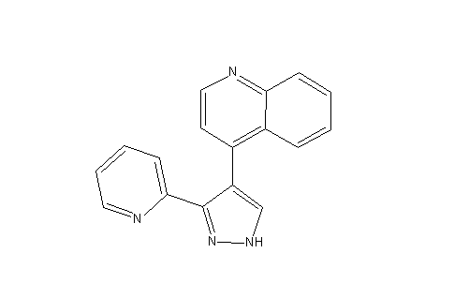  4-(3-pyridin-2-yl-1h-pyrazol-4-yl)quinoline | IC₅₀=59 nM | 3.066 | 272.304 | 1 | 3
1VJY | 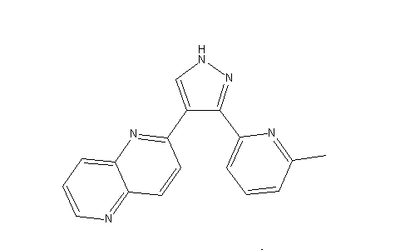  2-[5-(6-methylpyridin-2-yl)-2,3-dihydro-1H-pyrazol-4-yl]-1,5-naphthyridine | IC₅₀=23 nM | 3.055 | 287.319 | 1 | 4
2WOU | 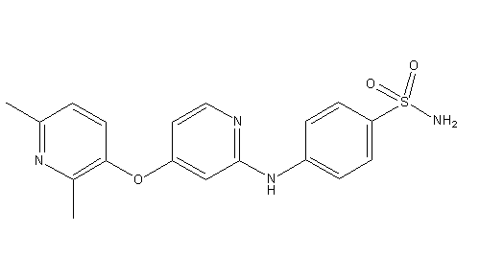  4-({4-[(2,6-dimethylpyridin-3-yl)oxy]pyridin-2-yl}amino)benzenesulfonamide | IC₅₀=72 nM | 1.942 | 369.418 | 2 | 7
2WOT | 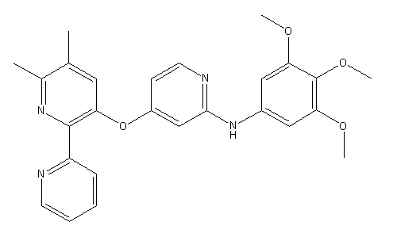  4-({4-[(2,6-dimethylpyridin-3-yl)oxy]pyridin-2-yl}amino)benzenesulfonamide | IC₅₀=44 nM | 5.122 | 458.509 | 1 | 8
2X7O | 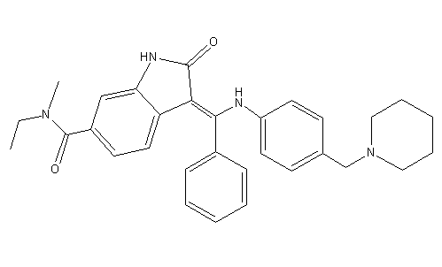  (3Z)-N-ethyl-N-methyl-2-oxo-3-(phenyl{[4-(piperidin-1-ylmethyl)phenyl]amino}methylidene)-2,3-dihydro-1H-indole-6-carboxamide | IC₅₀=34 nM | 4.574 | 494.627 | 2 | 4
3GXL | 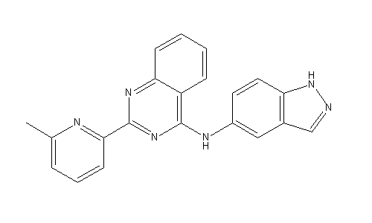  N-1H-indazol-5-yl-2-(6-methylpyridin-2-yl)quinazolin-4-amine (GW857175) | IC₅₀=25 nM | 4.301 | 352.392 | 2 | 5
3HMM | 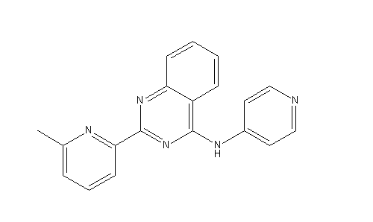  2-(6-methylpyridin-2-yl)-N-pyridin-4-ylquinazolin-4-amine (GW855857) | IC₅₀=25 nM | 3.507 | 313.356 | 1 | 5
3FAA | 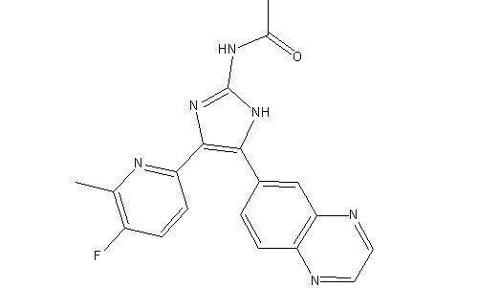  N-[4-(5-fluoro-6-methylpyridin-2-yl)-5-quinoxalin-6-yl-1H-imidazol-2-yl]acetamide | Ki=7.1 nM | 2.366 | 362.36 | 2 | 5
3KCF | 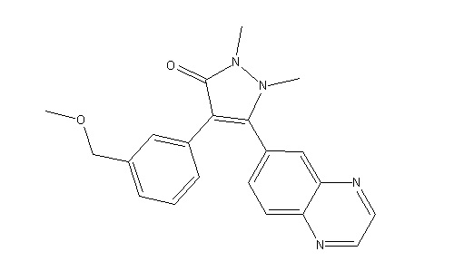  4-[3-(methoxymethyl)phenyl]-1,2-dimethyl-5-quinoxalin-6-yl-1,2-dihydro-3H-pyrazol-3-one | Ki=35 nM | 1.623 | 360.409 | 0 | 5
3TZM | 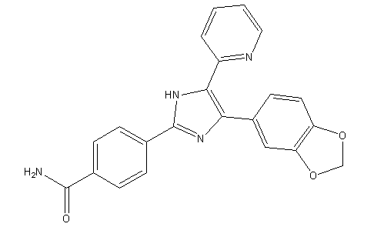  4-[5-(1,3-benzodioxol-5-yl)-4-(pyridin-2-yl)-1H-imidazol-2-yl]benzamide (SB431542) | IC₅₀=94 nM | 2.555 | 390.435 | 2 | 5
4X2F | 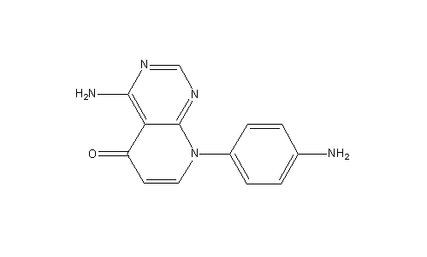  4-amino-8-(4-aminophenyl)pyrido[2,3-d]pyrimidin-5(8H)-one | - | 0.966 | 253.259 | 2 | 6
4X2G | 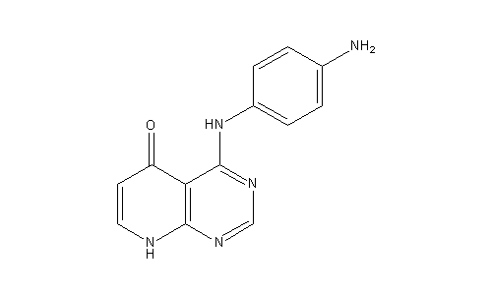  4-[(4-aminophenyl)amino]pyrido[2,3-d]pyrimidin-5(6H)-one | - | 1.316 | 253.259 | 3 | 6
4X2J | 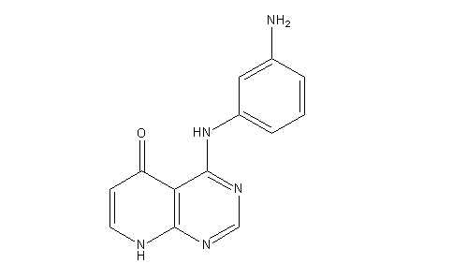  4-[(3-aminophenyl)amino]pyrido[2,3-d]pyrimidin-5(8H)-one | - | 1.316 | 253.259 | 3 | 6
5E8W | 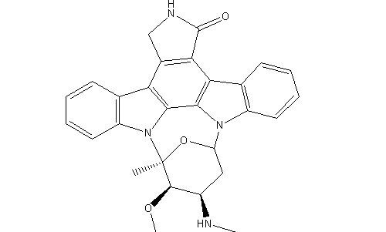  STAUROSPORINE | - | 3.819 | 466.531 | 2 | 4
5E8Z | 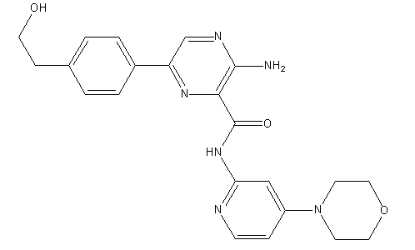  3-amino-6-[4-(2-hydroxyethyl)phenyl]-N-[4-(morpholin-4-yl)pyridin-3-yl]pyrazine-2-carboxamide | - | 0.897 | 420.464 | 3 | 9
5FRI | 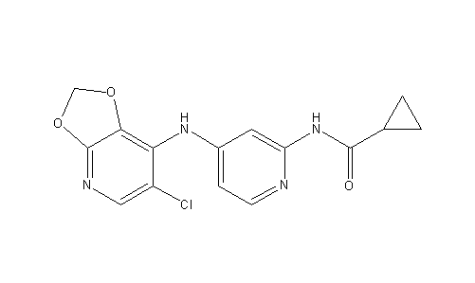  N-[4-[(6-chloro-[1,3]dioxolo[4,5-b]pyridin-7-yl)amino]-2-pyridyl]cyclopropanecarboxamide | IC₅₀=4 nM | 2.467 | 332.742 | 2 | 6
5QIK | 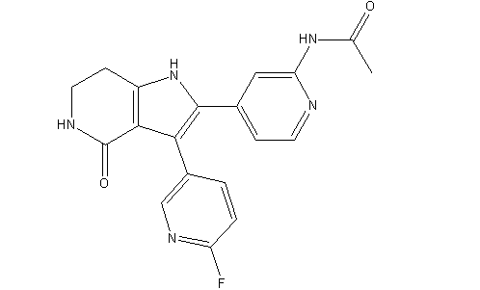  N-{4-[3-(6-fluoropyridin-3-yl)-4-oxo-4,5,6,7-tetrahydro-1H-pyrrolo[3,2-c]pyridin-2-yl]pyridin-2-yl}acetamide | IC₅₀=22 nM | 1.484 | 365.361 | 3 | 4
5QIL | 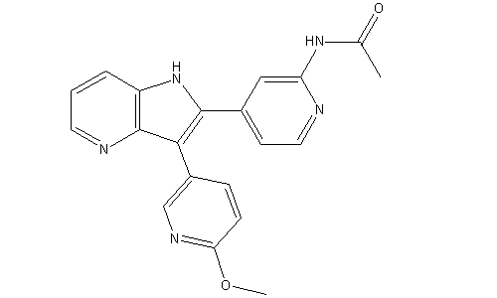  N-{4-[3-(6-methoxypyridin-3-yl)-1H-pyrrolo[3,2-b]pyridin-2-yl]pyridin-2-yl}acetamide | IC₅₀=3 nM | 2.61 | 359.381 | 2 | 5
5QIM | 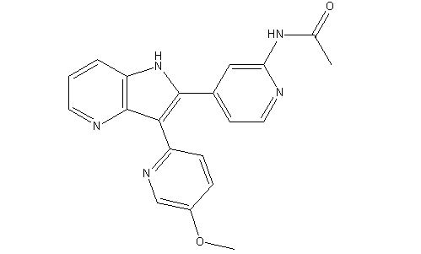  N-{4-[3-(5-methoxypyridin-2-yl)-1H-pyrrolo[3,2-b]pyridin-2-yl]pyridin-2-yl}acetamide | IC₅₀=6 nM | 2.499 | 359.381 | 2 | 5
5USQ | 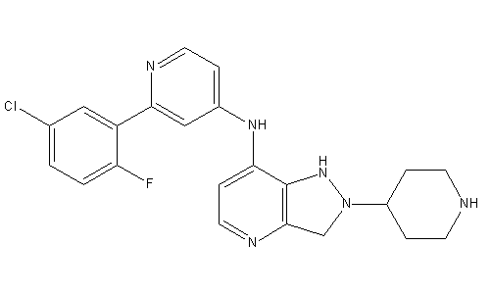  N-[2-(5-chloro-2-fluorophenyl)pyridin-4-yl]-2-[(piperidin-4-yl)methyl]-2H-pyrazolo[4,3-b]pyridin-7-amine | - | 3.704 | 438.928 | 3 | 6
6B8Y | 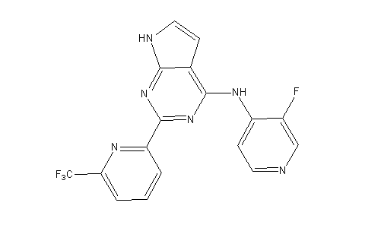  N-(3-fluoropyridin-4-yl)-2-[6-(trifluoromethyl)pyridin-2-yl]-7H-pyrrolo[2,3-d]pyrimidin-4-amine | IC₅₀=0.55 nM | 3.956 | 374.295 | 2 | 5
*The activity (IC50 or Ki) of compounds in 4X2F, 4X2G, 4X2J, 5E8W, 5E8Z and 5USQ was not reported in the original literature.

Table S3 Physicochemical properties of compounds in the test set. NC, Number of compounds; MW, molecular weight; nROT, Number of rotatable bonds; nHBA, Number of hydrogen acceptor donors; nHBA, Number of hydrogen bond receptors; nRings, Number of rings
 | NC | MW | nROT | nHBD | nHBA | nRings
Active | 281 | 251-565 | 2-8 | 0-5 | 2-8 | 3-6
Inactive | 8677 | 231-556 | 0-10 | 0-6 | 1-9 | 1-10

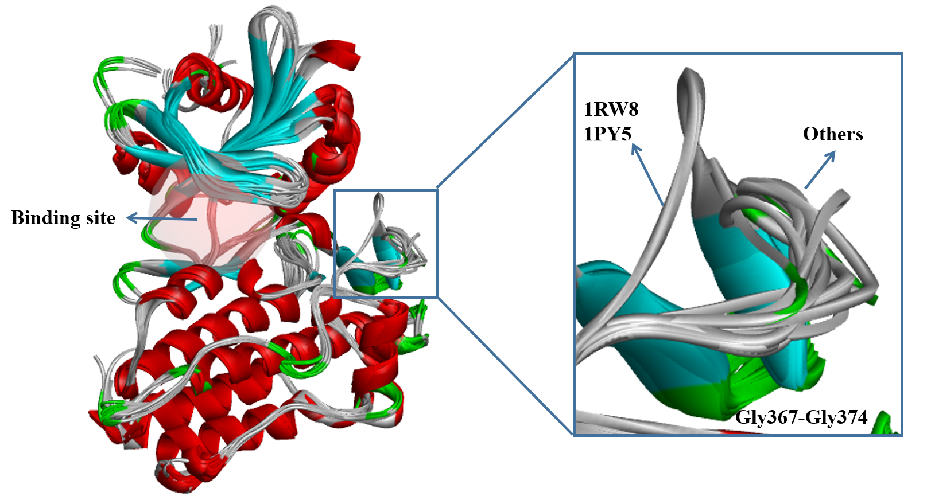

Fig. S1 Overlay of 22 TβR1 proteins in the PDB. Except for the Gly367-Gly374 region (far away from the binding site) of 1RW8 and 1PY5, the rest of the crystal structures were well overlapped

