Additional files
Figure S1. Chromatogram of positive sample from bovine meat - Enrofloxacin

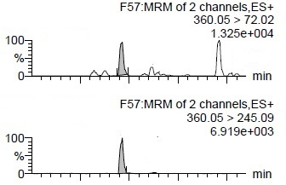

Figure S2. Chromatogram of positive sample from bovine meat – Oxytetracycline

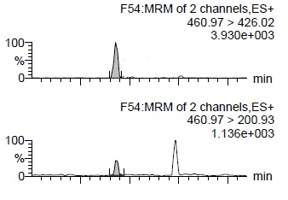

Figure S3. Chromatogram of positive sample from bovine meat – Sulfadiazine
