Synthesis, in vitro biological evaluation and molecular modelling of new 2-chloro-3-hydrazinopyrazine derivatives as potent acetylcholinesterase inhibitors‏ on PC12 cells

Maryam Taheri¹, Samira Aslani¹, Hossein Ghafouri*¹, Asadollah Mohammadi², Vaha Akbary Moghaddam ¹ and Hananeh Naeimi¹
¹ Department of Biology, Faculty of Basic Sciences, University of Guilan, Rasht, Iran
²Department of Chemistry, Faculty of Sciences, University of Guilan, Rasht, Iran

* Corresponding author: E-mail: h.ghafoori@guilan.ac.ir Tel/Fax: +9813333333647

Structure image and ¹H-NMR, ¹³C-NMR, FT-IR spectra of compounds CHP1, CHP2, CHP3, CHP4 and CHP5.

(E)-2-chloro-3-(2-(4-methoxybenzylidene)hydrazinyl)pyrazine(CHP1)

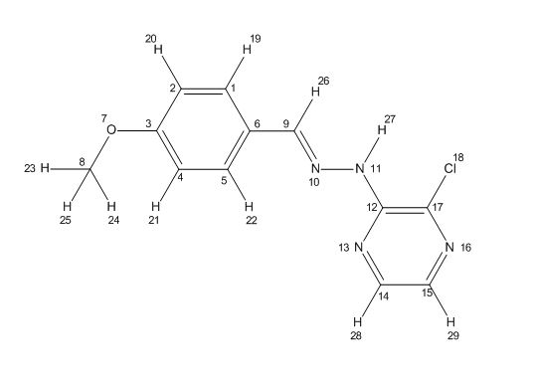
Fig. S1 Structure image of compounds CHP1.

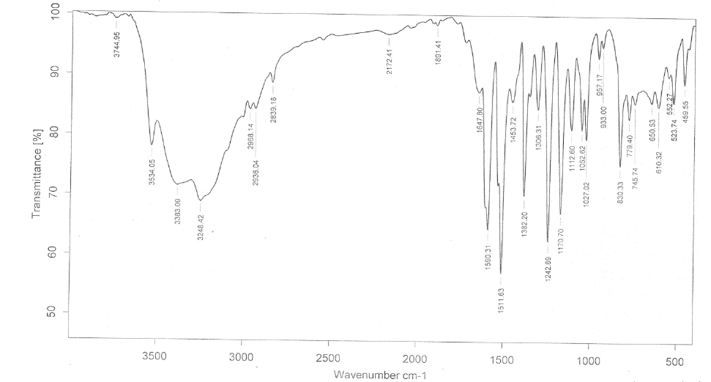Fig. S2 FT-IR spectra of compounds CHP1.

Fig. S3 ¹H-NMR, spectra of compounds CHP1.

Fig. S4 ¹³C-NMR spectra of compounds CHP1.

(E)-3-((2-(3-chloropyrazin-2-yl)hydrazineylidene)methyl)-6-methyl-4H-chromen-4-one (CHP2)

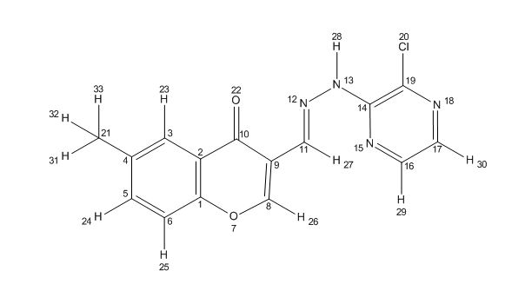
Fig. S5 Structure image of compounds CHP2.

Fig. S6 FT-IR spectra of compounds CHP2.

Fig. S7 ¹H-NMR, spectra of compounds CHP2.

Fig. S8 ¹³C-NMR spectra of compounds CHP2.

(E)-3-((2-(3-chloropyrazin-2-yl)hydrazineylidene)methyl)phenol (CHP3)

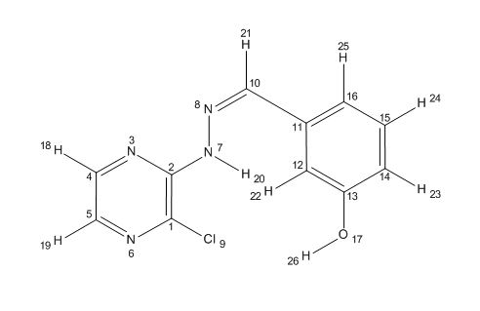
Fig. S9 Structure image of compounds CHP3.

Fig. S10 FT-IR spectra of compounds CHP3.

Fig. S11 ¹H-NMR, spectra of compounds CHP3.

Fig. S12 ¹³C-NMR spectra of compounds CHP3.

(E)-2-((2-(3-chloropyrazin-2-yl)hydrazineylidene)methyl)phenol (CHP4)

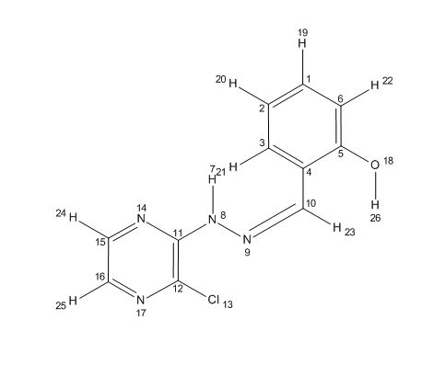
Fig. S13 Structure image of compounds CHP4.

Fig. S14 FT-IR spectra of compounds CHP4.
Fig. S15 ¹H-NMR, spectra of compounds CHP4.

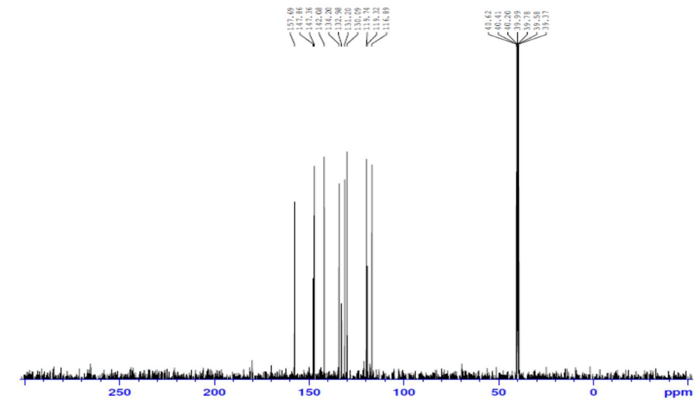
Fig. S16 ¹³C-NMR spectra of compounds CHP4.

(E)-2-chloro-3-(2-(4-chlorobenzylidene)hydrazineyl)pyrazine (CHP5)

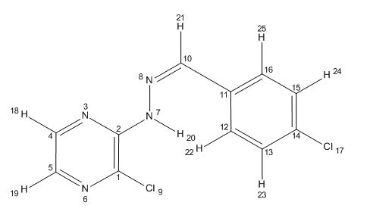
Fig. S17 Structure image of compounds CHP5.

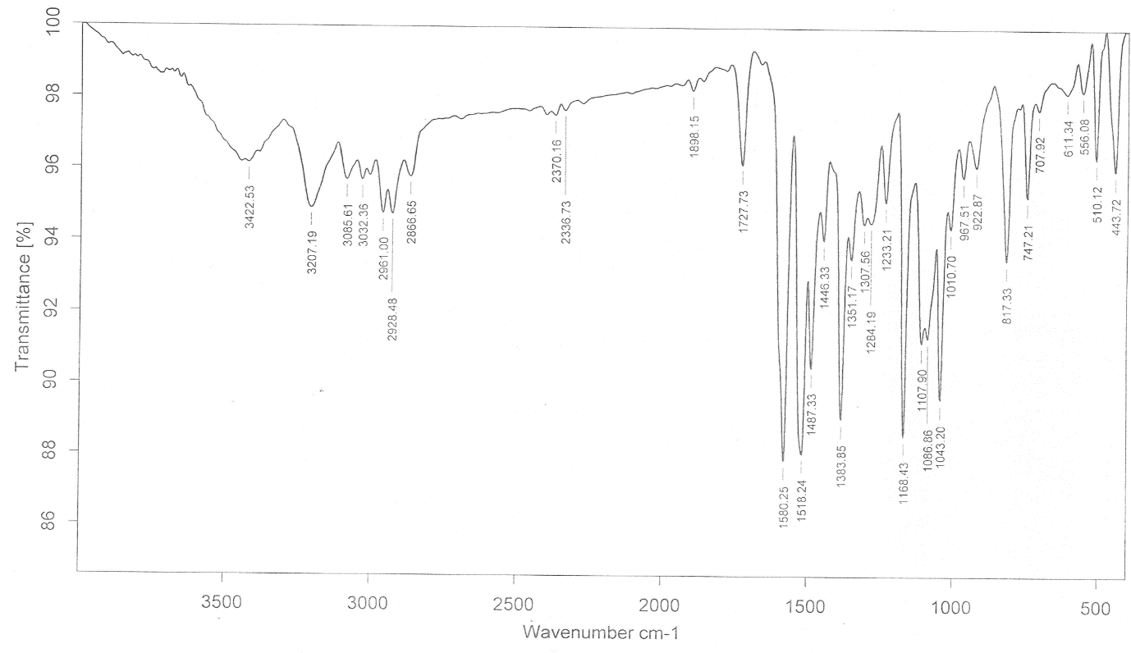
Fig. S18 FT-IR spectra of compounds CHP5.
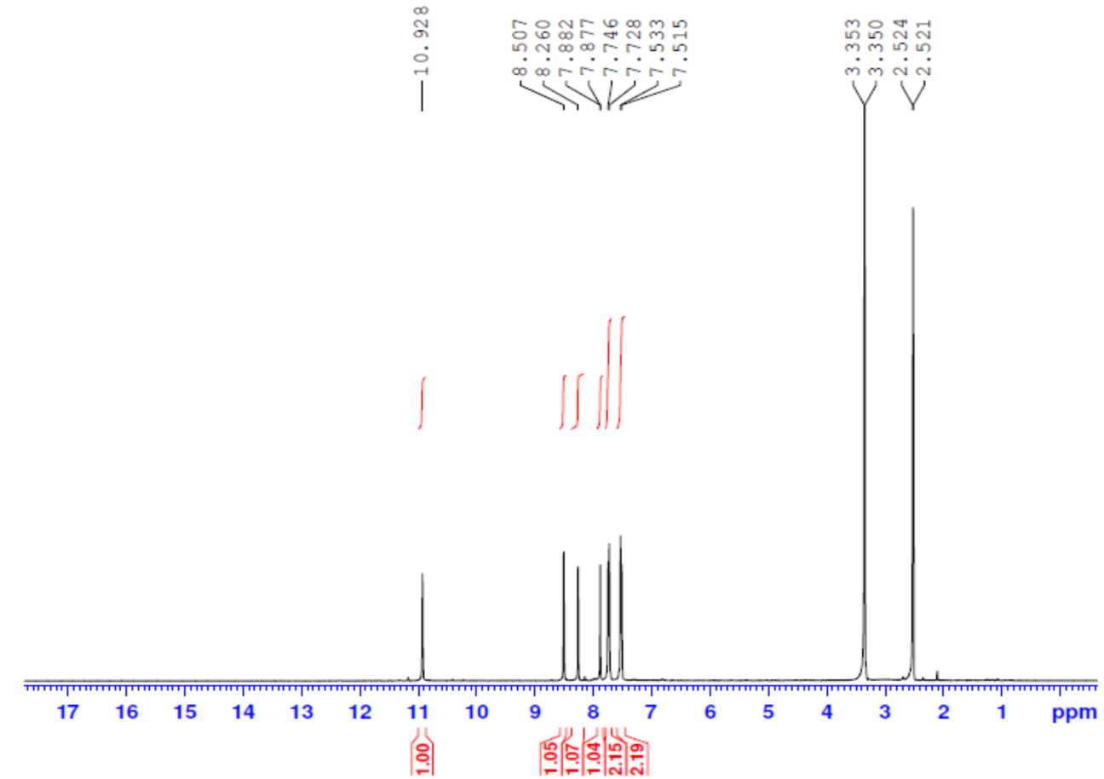
Fig. S19 ¹H-NMR, spectra of compounds CHP5.

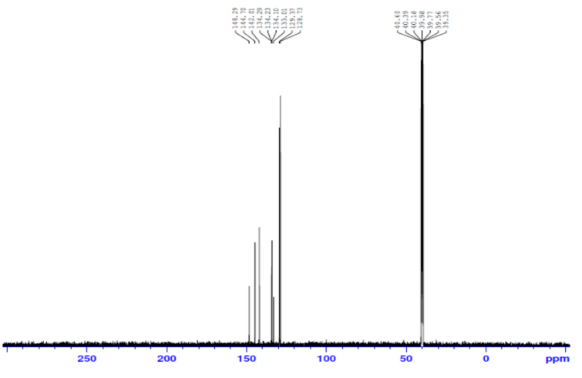
Fig. S20 ¹³C-NMR spectra of compounds CHP5.

ORIGINAL PHOTOS OF WESTERN BLOT GEL
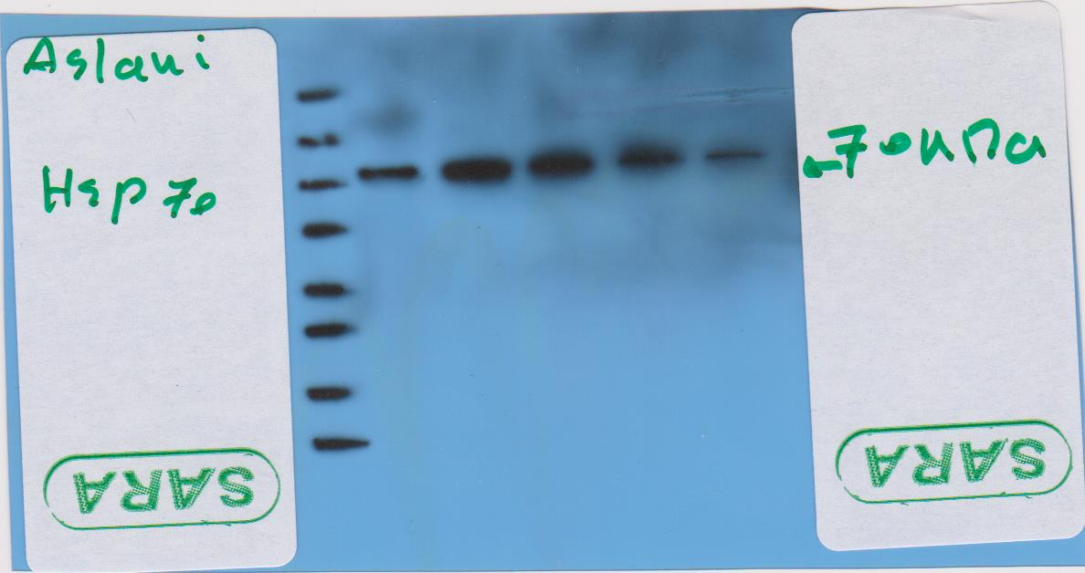
Fig. S21 Original photo of western blot gel (HSP70). Representative Western blot analysis of HSP70 in the PC12 cell homogenate treated with CHP4 and in the presence of Ab1-42.

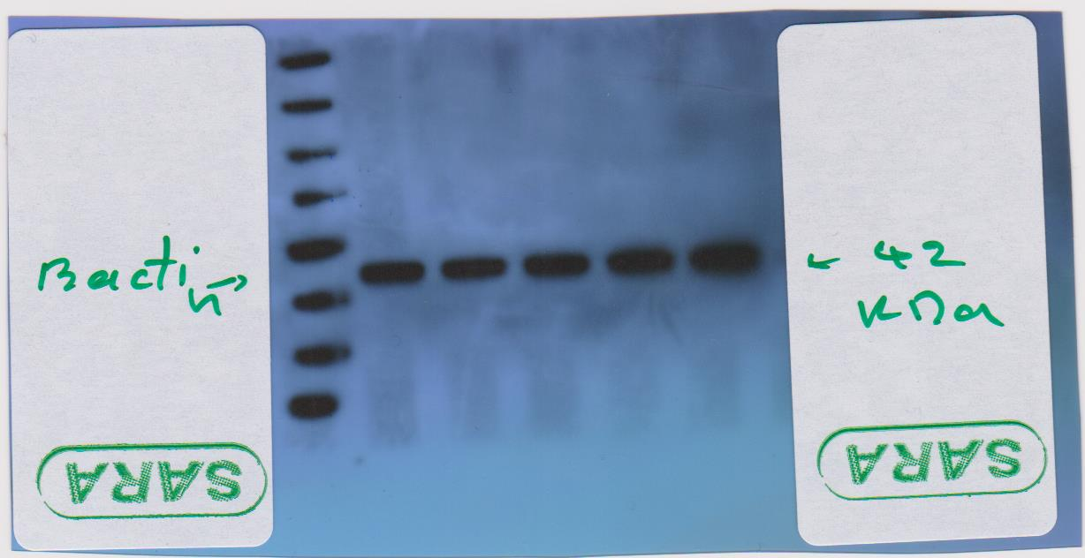
Fig. S22 Original photo of western blot gel (βactin). Representative Western blot analysis of βactin (control) in the PC12 cell homogenate treated with CHP4 and in the presence of Ab1-42.

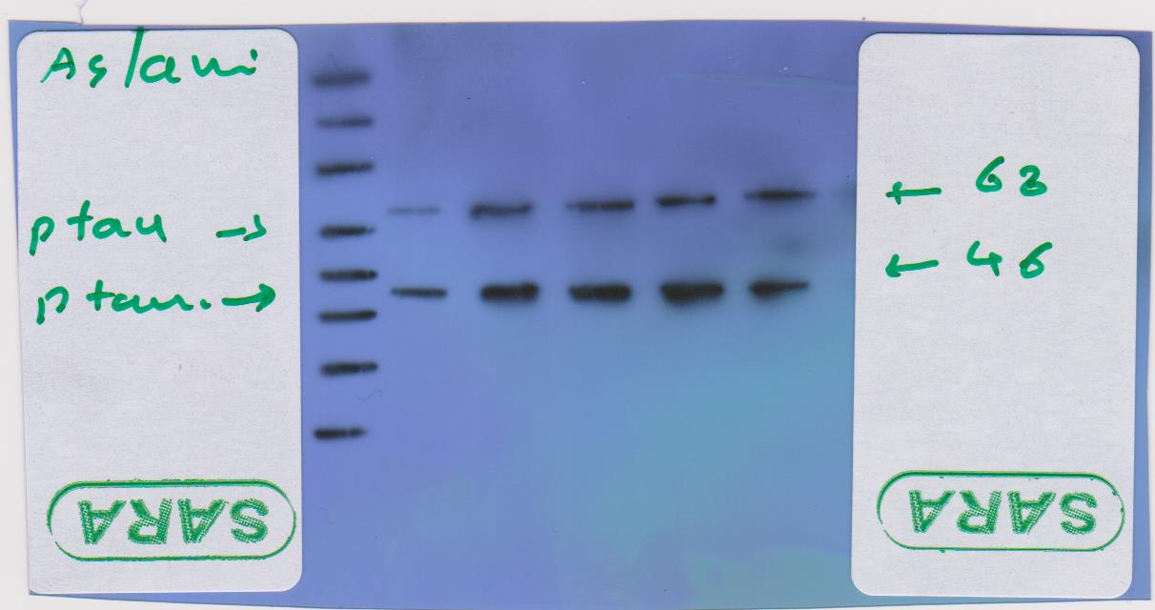
Fig. S23 Original photo of western blot gel (Tau-p). Representative Western blot analysis of Tau-p (68 and 46 kDa) in the PC12 cell homogenate treated with CHP4 and in the presence of Ab1-42.
Optimized geometric properties of CHP1 to CHP5

Table S1 Optimized geometric properties of CHP1
CHP1. Bond length (Å) (DFT)
C1-N6 | 1.317 | C17-O21 | 1.346
C1-Cl9 | 1.744 | C1-C2 | 1.426
C2-N3 | 1.339 | C4-C5 | 1.390
C2-N10 | 1.384 | C13-C15 | 1.459
N3-C4 | 1.336 | C15-C16 | 1.484
C5-N6 | 1.341 | C15-C17 | 1.363
N10-H11 | 1.021 | C16-C18 | 1.486
N10-N12 | 1.351 | C18-C22 | 1.400
N12-C13 | 1.287 | C22-C24 | 1.398
C16-O19 | 1.226 | C23-C26 | 1.388
Bond angle (◦) (DFT)
C2-C1-N6 | 120.983
C2-C1-Cl9 | 122.639
N6-C1-Cl9 | 116.700
C1-C2-N10 | 127.289
N3-C2-N10 | 113.045
C2-N10-N12 | 124.768
N10-N12-C13 | 116.038
N12-C13-C15 | 124.445
C15-C16-O19 | 124.179
C17-O21-C22 | 118.920

Table S2 Optimized geometric properties of CHP2
CHP2. Bond length (Å) (DFT)
C1-N6 | 1.315 | O25-C26 | 1.424
C1-Cl9 | 1.754 | C1-C2 | 1.427
C2-N3 | 1.341 | C4-C5 | 1.391
C2-N10 | 1.379 | C13-C15 | 1.460
N3-C4 | 1.335 | C15-C16 | 1.409
C5-N6 | 1.342 | C15-C17 | 1.405
N10-H11 | 1.020 | C16-C18 | 1.389
N10-N12 | 1.357 | C17-C20 | 1.393
N12-C13 | 1.287 | C18-C22 | 1.403
C22-O25 | 1.364 | C20-C22 | 1.405
Bond angle (◦) (DFT)
C2-C1-N6 | 121.333
C2-C1-Cl9 | 122.918
N6-C1-Cl9 | 115.705
C1-C2-N10 | 127.495
N3-C2-N10 | 113.316
C2-N10-N12 | 124.609
N10-N12-C13 | 116.843
N12-C13-C15 | 122.404
C18-C22-O25 | 115.833
C22-O25-C26 | 118.781

Table S3 Optimized geometric properties of CHP3
CHP3. Bond length (Å) (DFT)
C1-N6 | 1.315 | O25-H26 | 0.966
C1-Cl9 | 1.754 | C1-C2 | 1.429
C2-N3 | 1.343 | C4-C5 | 1.391
C2-N10 | 1.377 | C13-C15 | 1.461
N3-C4 | 1.333 | C15-C16 | 1.411
C5-N6 | 1.341 | C15-C17 | 1.408
N10-H11 | 1.021 | C16-C18 | 1.398
N10-N12 | 1.350 | C17-C20 | 1.393
N12-C13 | 1.289 | C18-C21 | 1.395
C16-O25 | 1.374 | C19-C21 | 1.400
Bond angle (◦) (DFT)
C2-C1-N6 | 121.218
C2-C1-Cl9 | 122.423
N6-C1-Cl9 | 115.359
C1-C2-N10 | 128.455
N3-C2-N10 | 112.519
C2-N10-N12 | 126.332
N10-N12-C13 | 116.672
N12-C13-C15 | 121.264
C15-C16-O25 | 117.494
C16-O25-H26 | 109.834

Table S4 Optimized geometric properties of CHP4
CHP4. Bond length (Å) (DFT)
C1-N6 | 1.316 | O25-H26 | 0.966
C1-Cl9 | 1.751 | C1-C2 | 1.426
C2-N3 | 1.340 | C4-C5 | 1.391
C2-N10 | 1.381 | C13-C15 | 1.464
N3-C4 | 1.335 | C15-C16 | 1.407
C5-N6 | 1.341 | C15-C17 | 1.405
N10-H11 | 1.021 | C16-C18 | 1.395
N10-N12 | 1.352 | C17-C20 | 1.393
N12-C13 | 1.287 | C18-C22 | 1.396
C20-O25 | 1.370 | C20-C22 | 1.403
Bond angle (◦) (DFT)
C2-C1-N6 | 121.201
C2-C1-Cl9 | 122.992
N6-C1-Cl9 | 115.771
C1-C2-N10 | 127.581
N3-C2-N10 | 113.084
C2-N10-N12 | 124.894
N10-N12-C13 | 117.069
N12-C13-C15 | 122.162
C17-C20-O25 | 117.150
C20-O25-H26 | 110.087

Table S5 Optimized geometric properties of CHP5
CHP5. Bond length (Å) (DFT)
C1-N6 | 1.315 | C1-C2 | 1.425
C1-Cl9 | 1.752 | C4-C5 | 1.391
C2-N3 | 1.340 | C13-C15 | 1.462
C2-N10 | 1.382 | C15-C16 | 1.405
N3-C4 | 1.335 | C15-C17 | 1.408
C5-N6 | 1.341 | C16-C18 | 1.395
N10-H11 | 1.021 | C17-C20 | 1.391
N10-N12 | 1.352 | C18-C22 | 1.394
N12-C13 | 1.287 | C20-C22 | 1.394
C22-Cl25 | 1.757
Bond angle (◦) (DFT)
C2-C1-N6 | 121.230
C2-C1-Cl9 | 122.994
N6-C1-Cl9 | 115.734
C1-C2-N10 | 127.515
N3-C2-N10 | 113.136
C2-N10-N12 | 124.664
N10-N12-C13 | 117.231
N12-C13-C15 | 121.875
C18-C22-C25 | 119.527

Vina results

Table S6 Vina Docking results of CHP4

Mode | Affinity (kcal/mol)
------------+-------------------------
1 -8.3
2 -8.3
3 -8.1
4 -8.0
5 -7.9
6 -7.6

Table S7 Vina Docking results of DPZ (donepezil)

Mode | Affinity (kcal/mol
------------+----------------------
1 -12.8
2 -11.3
3 -10.9
4 -10.5
5 -10.4
6 -10.3

Diagram of capability of the synthesized compounds in passing from BBB

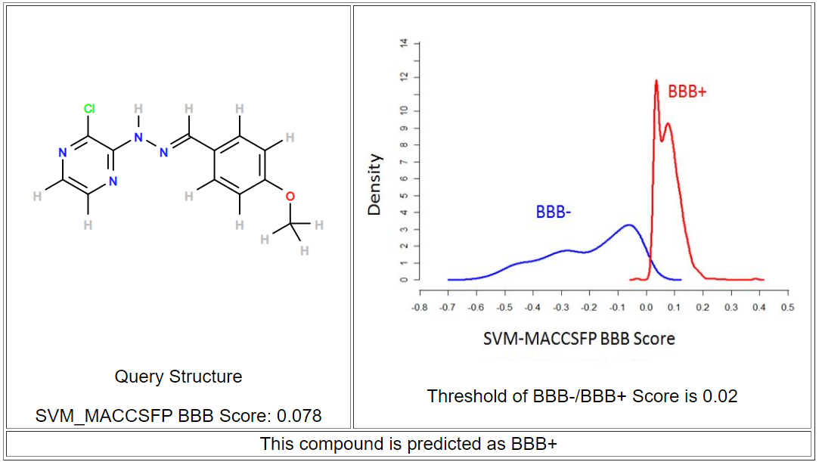
Fig. S24 Diagram of capability of the CHP1 in passing from BBB

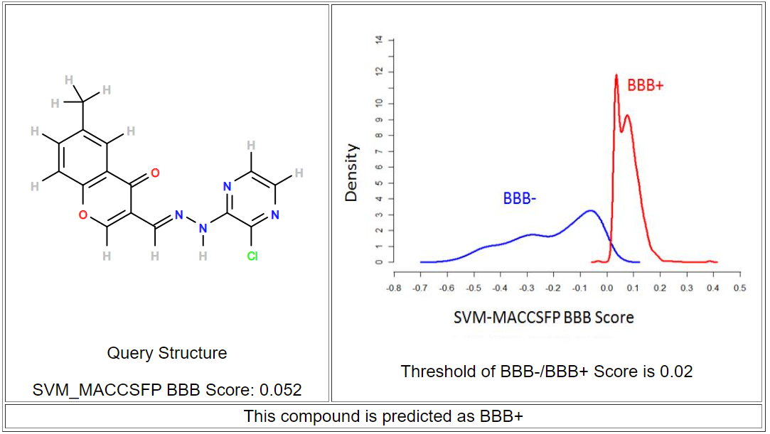
Fig. S25 Diagram of capability of the CHP2 in passing from BBB

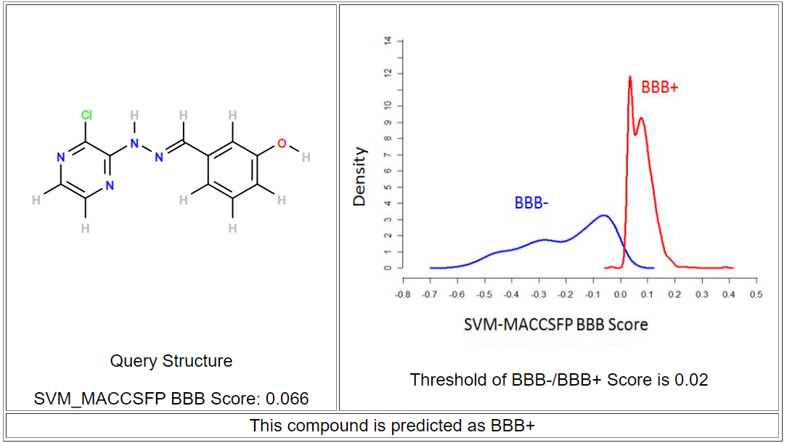
Fig. S26 Diagram of capability of the CHP3 in passing from BBB

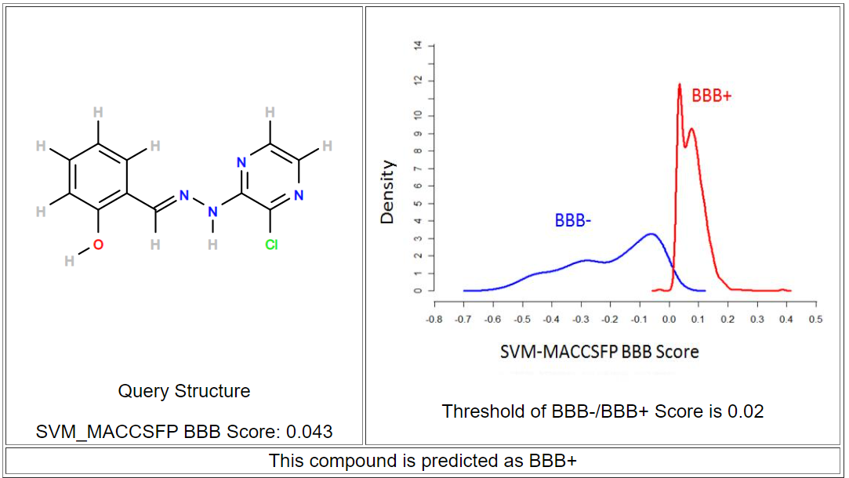
Fig. S27 Diagram of capability of the CHP4 in passing from BBB

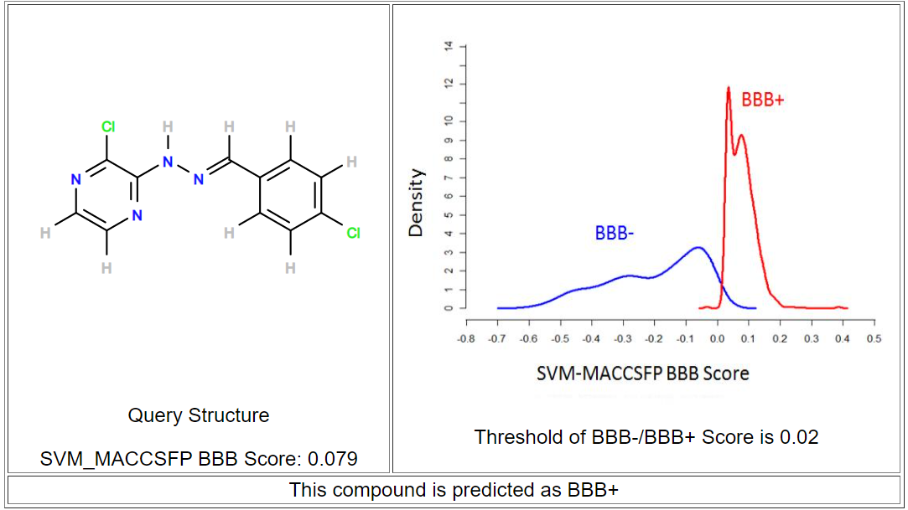
Fig. S28 Diagram of capability of the CHP5 in passing from BBB

Protein and ligand intraction
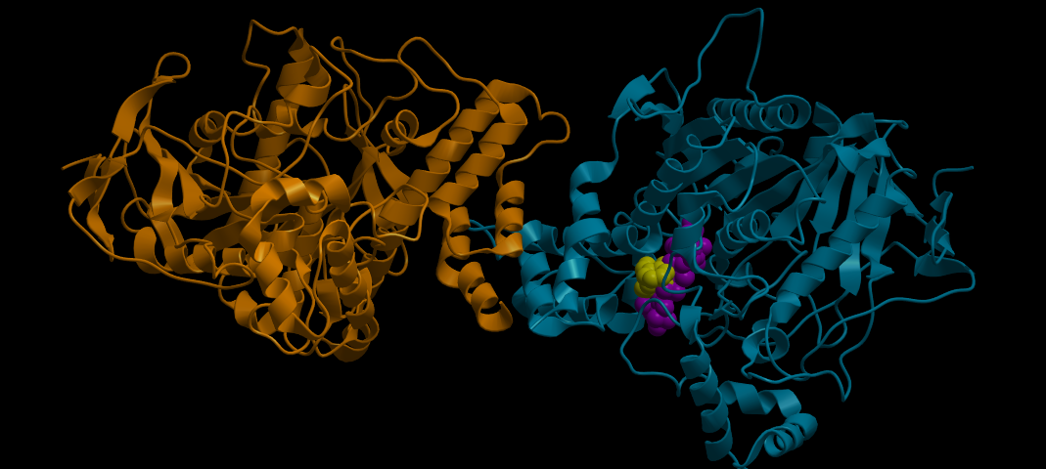
Fig. S29 Ribbon model of the dimeric structure of AChE, chain an AChE (orange); chain b (blue). Docked pose of CHP4 (yellow) occupy the same Cartesian space as DPZ (violet). The CHP4 overlapped with DPZ in the AChE-binding.
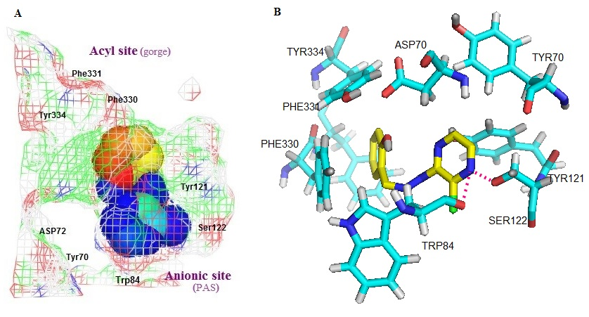
Fig. S30 Representation a binding pocket of AChE. (A) Interaction of aromatic amino acids and ligand in the binding cleft; (B) Magnified the active site of the AChE (cyan) and CPH4 (yellow) complex, exhibiting segment of CHP4 together with AChE in the active site. Several important residues in the binding gorge are demonstrated using PyMOL.

