Ultra-sensitive and selective fluorescence approach for estimation of elagolix in real human plasma and content uniformity using boron-doped carbon quantum dots
Baher I. Salman ª, Ahmed I. Hassan ª, Yasser F. Hassan ª, Roshdy E. Saraya ^{b}
ª Pharmaceutical Analytical Chemistry Department, Faculty of Pharmacy, Al-Azhar University, Assiut branch, Assiut, 71524, Egypt, bahersalman@azhar.edu.eg, bahersalman2013@yahoo.com
Tel: +201099031345
^{b} Pharmaceutical Analytical Chemistry Department, Faculty of Pharmacy, Port Said University, Port Said 42511, Egypt.

* Corresponding author: Baher I. Salman
Email: bahersalman@azhar.edu.eg
bahersalman2013@yahoo.com
Tel. +201099031345

Fig. S1 PXRD for undoped carbon quantum dots

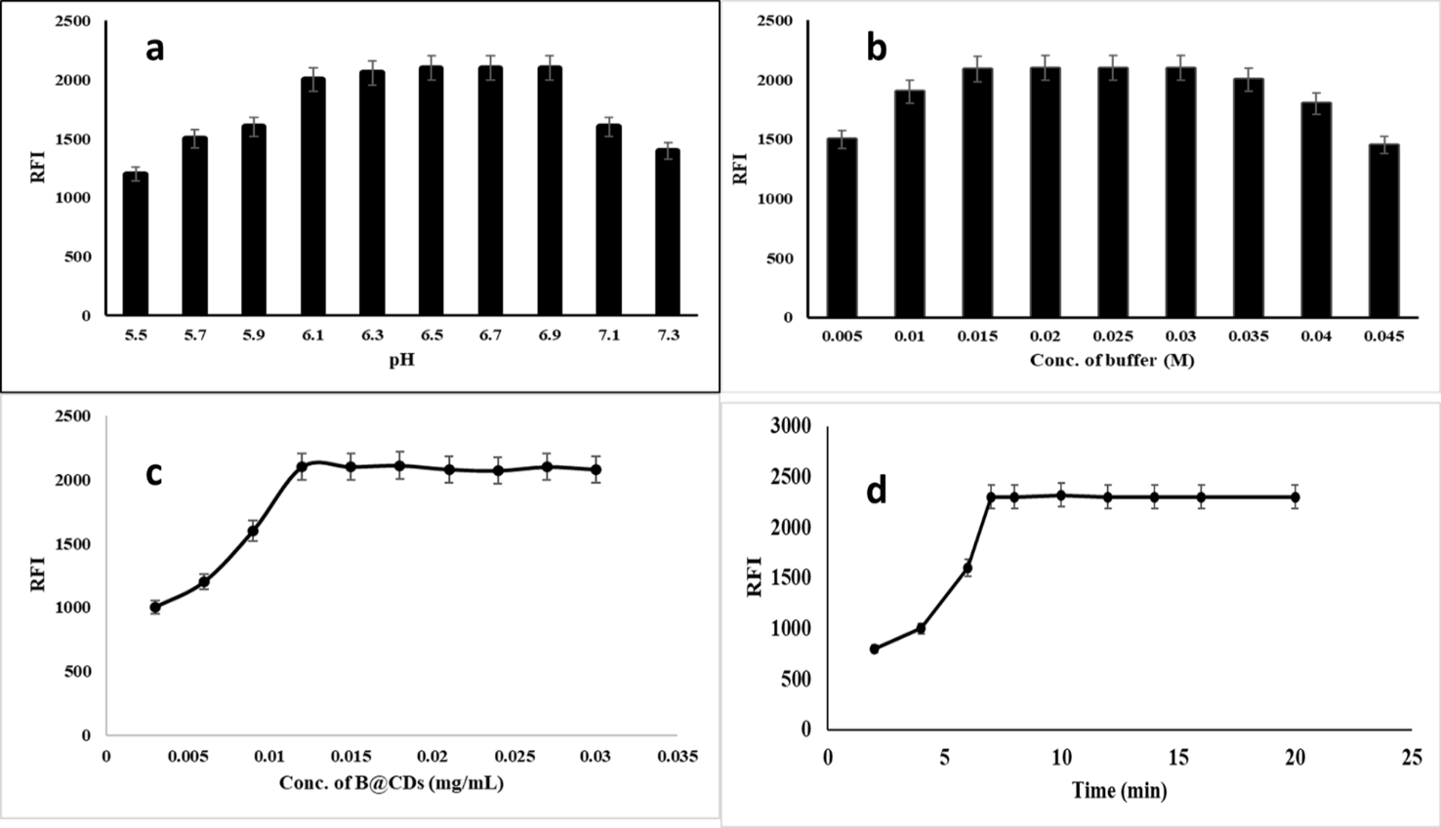

Fig. S2 optimization of B-CDs reaction a) effect of pH, b) effect of volume of buffer, c) volume of B-CDs using ELX (50 ng mL⁻¹), d) reaction time.

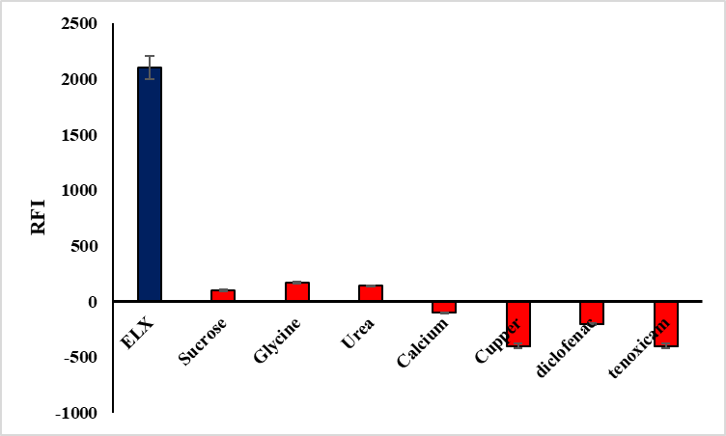
Fig. S3 Selectivity of B@CQDs to ELX

Table S1 Stability and selectivity of ELX in human plasma using different stability conditions.

Conditions | % Recovery ± RSD (n = 5)
Concentrations | LQC  10 ng mL⁻¹ | MQC  50 ng mL⁻¹ | HQC  90 ng mL⁻¹
Three Freeze–thaw cycle stability (-24°C) | 94.39 ± 1.33 | 96.11 ± 1.40 | 94.99 ± 1.14
Long-term stability (1 month at -24°C) | 95.22 ± 1.90 | 95.43 ± 1.30 | 95.30 ± 1.82
Short-term stability (12 hr at -24°C) | 96.90 ± 1.00 | 96.09 ± 1.71 | 96.55 ± 1.67
Post-preparative stability (6 hr at room temperature 25 °C) | 94.05 ± 0.99 | 97.90 ± 1.44 | 96.21 ± 1.72
Post-preparative stability (12 hr at room temperature 25 °C) | 96.50 ± 1.62 | 95.55 ± 1.49 | 96.60 ± 1.05

Table S2 Incurred sample reanalysis data of ELX.

Sample | Initial concentration  % Recovery* ± SD | Incurred concentration % Recovery* ± SD | % Deviation
1 | 97.31 ± 1.60 | 94.00 ± 2.10 | - 3.40
2 | 96.35 ± 2.11 | 95.11 ± 2.07 | - 1.28
3 | 95.02 ± 2.04 | 94.23 ± 1.76 | - 0.83

*: Mean of six determinations.

