SUPPLEMENTARY INFORMATION

Novel diaminoguanidine functionalized cellulose: synthesis, characterization, adsorption characteristics and application for ICP-AES determination of copper(II), mercury(II), lead(II) and cadmium(II) from aqueous solutions
Magda A Akl¹*, Mohammed A Hashem¹, Mohammed A Ismail¹ and Dina A Abdelgalil¹
¹Department of Chemistry, Faculty of Science, Mansoura University, Mansoura 35516, Egypt
*To whom all correspondence should be addressed: Prof Magda Akl
e. mail: magdaakl@yahoo.com

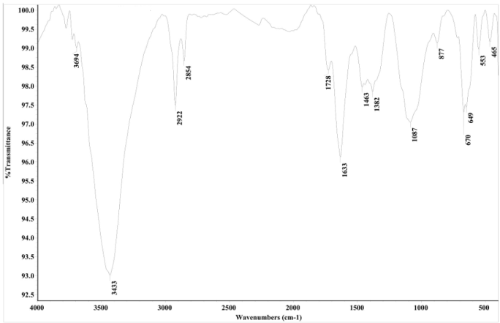
(a)Native cellulose
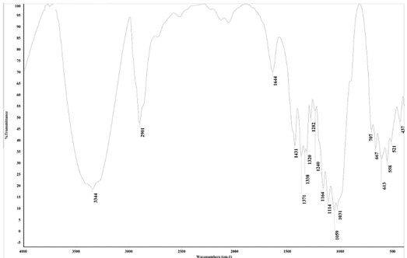
(b)DAC
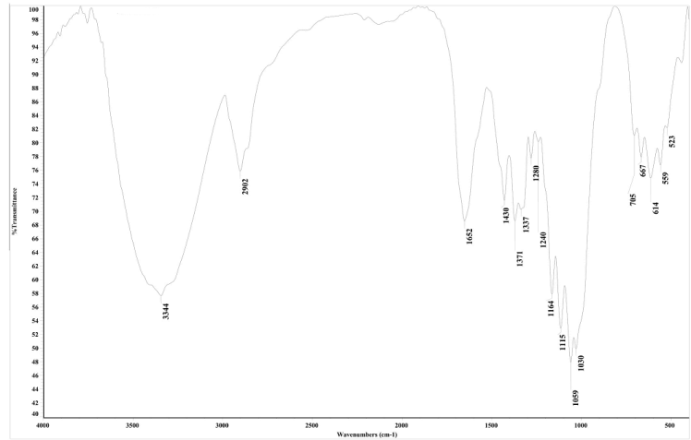
(c) DiGu.MC
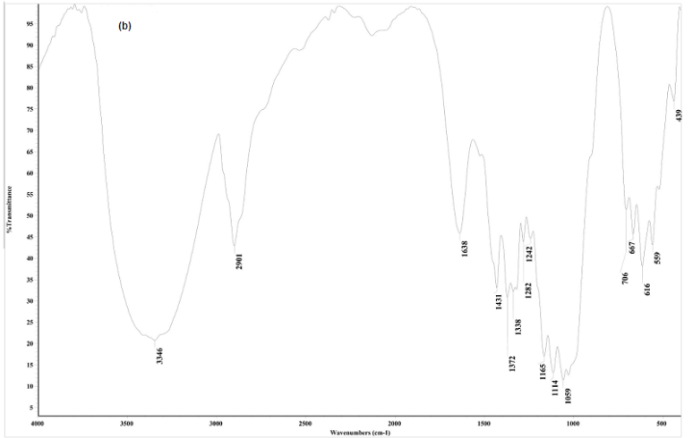
(d) DiGu.MC-Cu(II)
Fig. S1. FTIR of (a)Native cellulose, (b)DAC, (c) DiGu.MC (d) DiGu.MC-Cu(II)

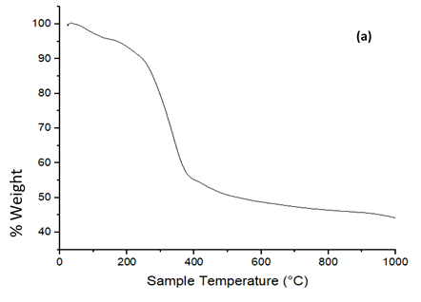
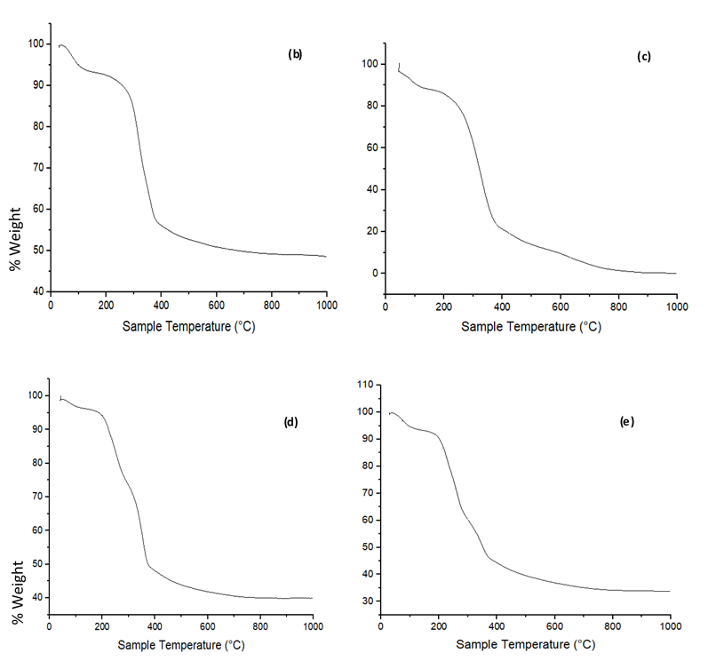
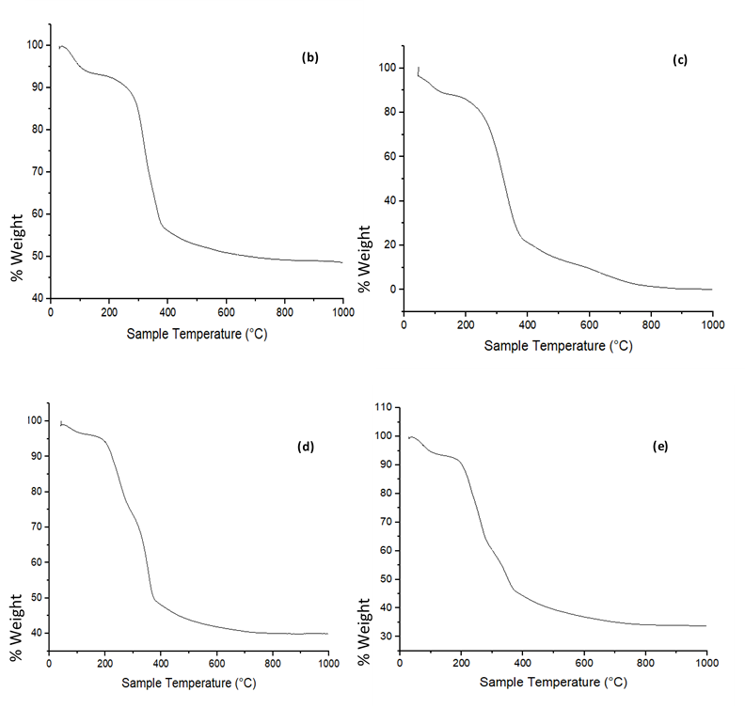

Fig. S2 TGA curves of (a) DiGu-MC, (b) Cu-DiGu-MC, (c) Hg-DiGu-MC, (d) Pb-DiGu-MC
(e) Cd-DiGu-MC.

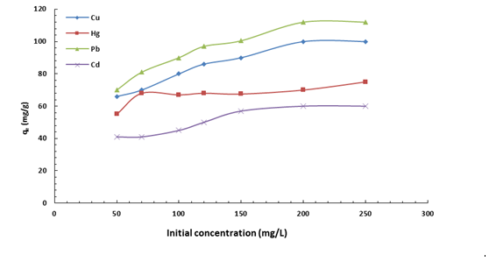
Fig. S3. Effect of initial concentration on adsorption of heavy metals by DiGu-MC

Table S1: Specific Surface areas of native cellulose and DiGu-MC fibers.

Samples | BET surface area (m² g⁻¹)
Native ellulose | 10.400
DiGu.MC | 3.4028

