Synthesis, biological evaluation and molecular docking of new triphenylamine-linked pyridine, thiazole and pyrazole analogues as anticancer agents
Mohamed R. Elmorsy^{1*}, Samar E. Mahmoud¹, Ahmed A. Fadda¹, Ehab Abdel-Latif¹, Miral A. Abdelmoaz²
¹Department of Chemistry, Faculty of Science, Mansoura University, 35516 Mansoura, Egypt.
²Department of Pharmaceutical Chemistry, Faculty of Pharmacy, Sinai University, Kantra, Egypt.
*Correspondence: m.r.elmorsy@gmail.com

1. Spectral analysis:

Figure (S1): IR spectrum of compound 3a

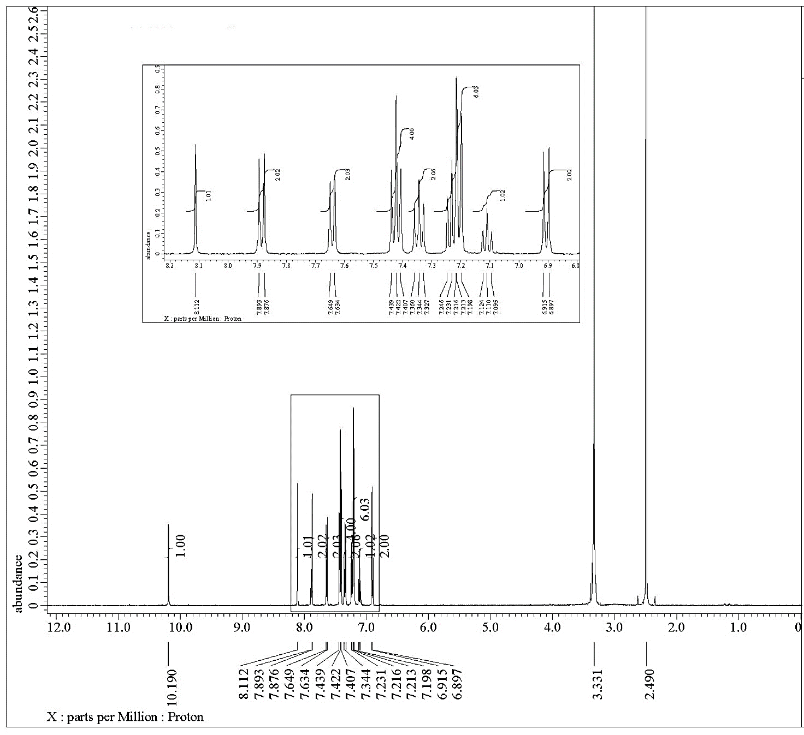
Figure (S2): ¹H NMR spectrum of compound 3a

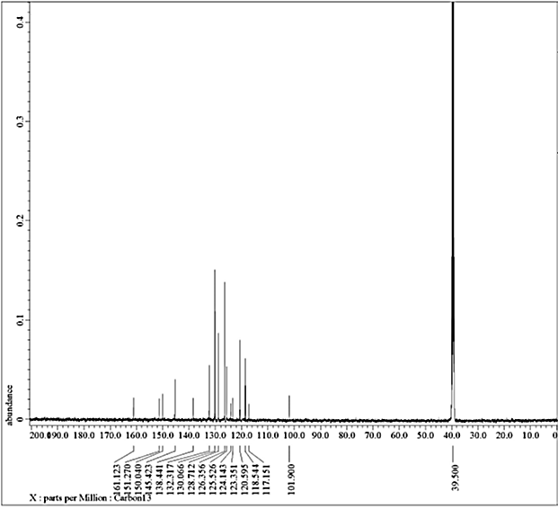
Figure (S3): ¹³C NMR spectrum of compound 3a

Figure (S4): Mass spectrum of compound 3a

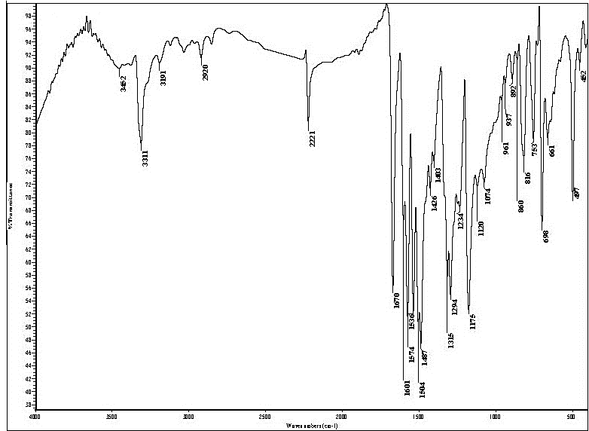
Figure (S5): IR spectrum of compound 3b

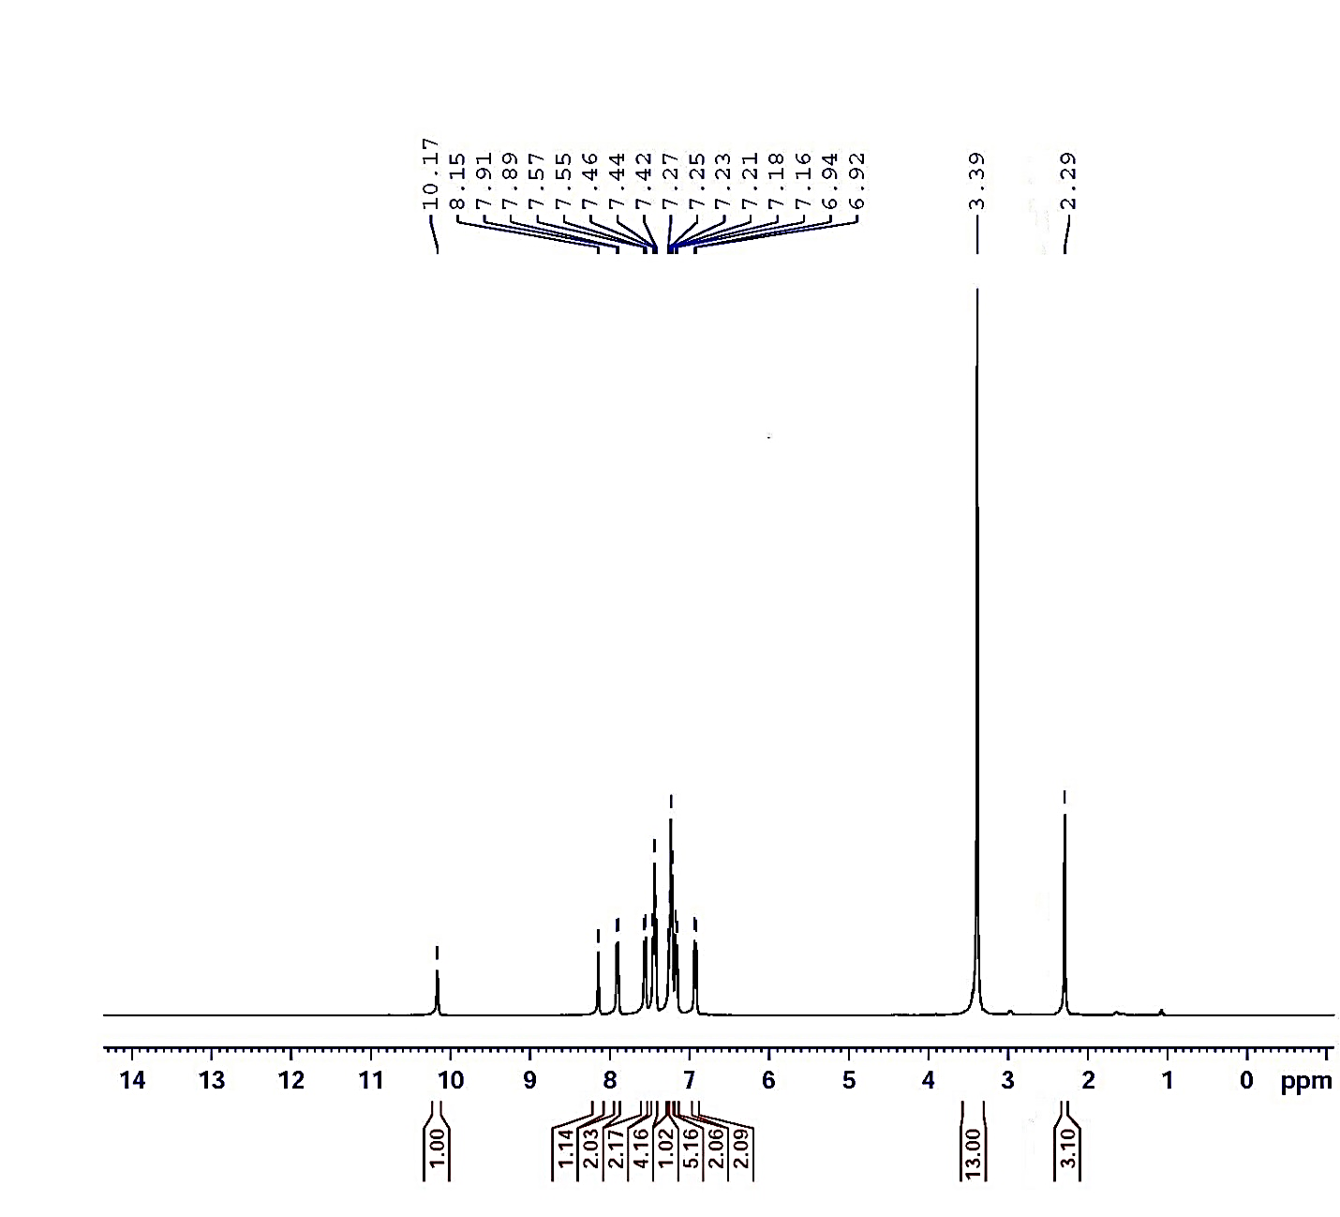
Figure (S6): ¹H NMR spectrum of compound 3b

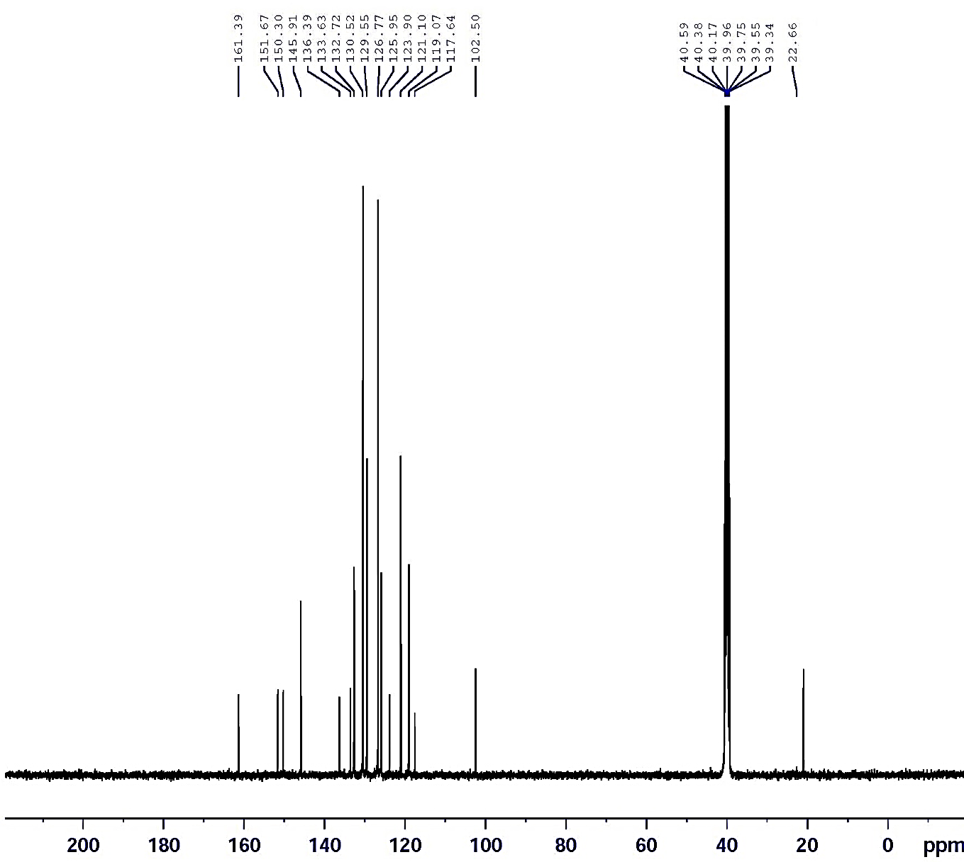
Figure (S7): ¹³C NMR spectrum of compound 3b

Figure (S8): Mass spectrum of compound 3b

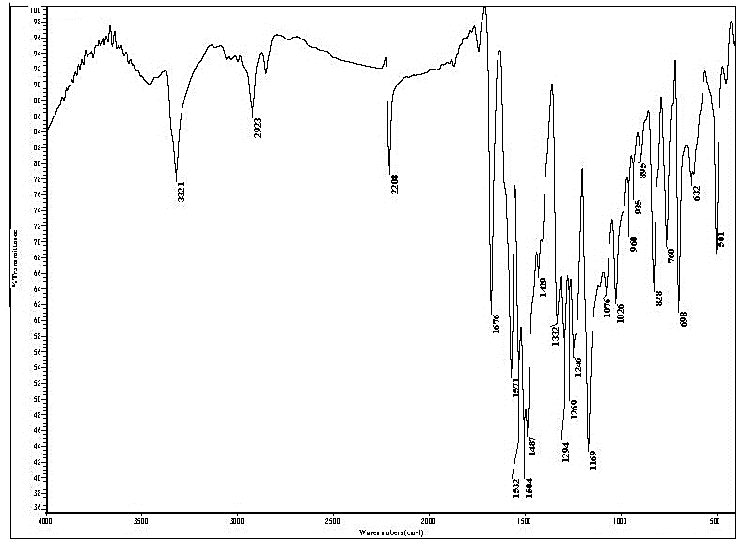
Figure (S9): IR spectrum of compound 3c

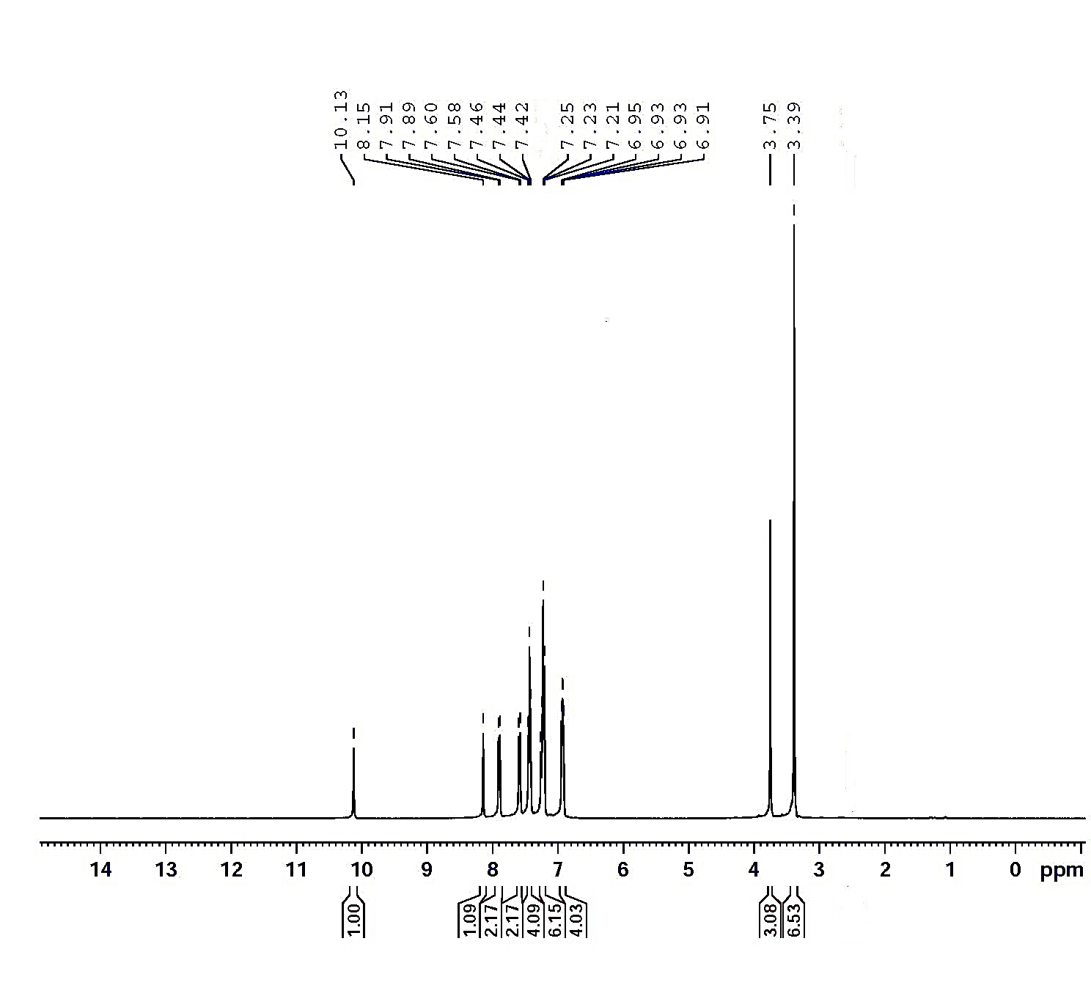
Figure (S10): ¹H NMR spectrum of compound 3c

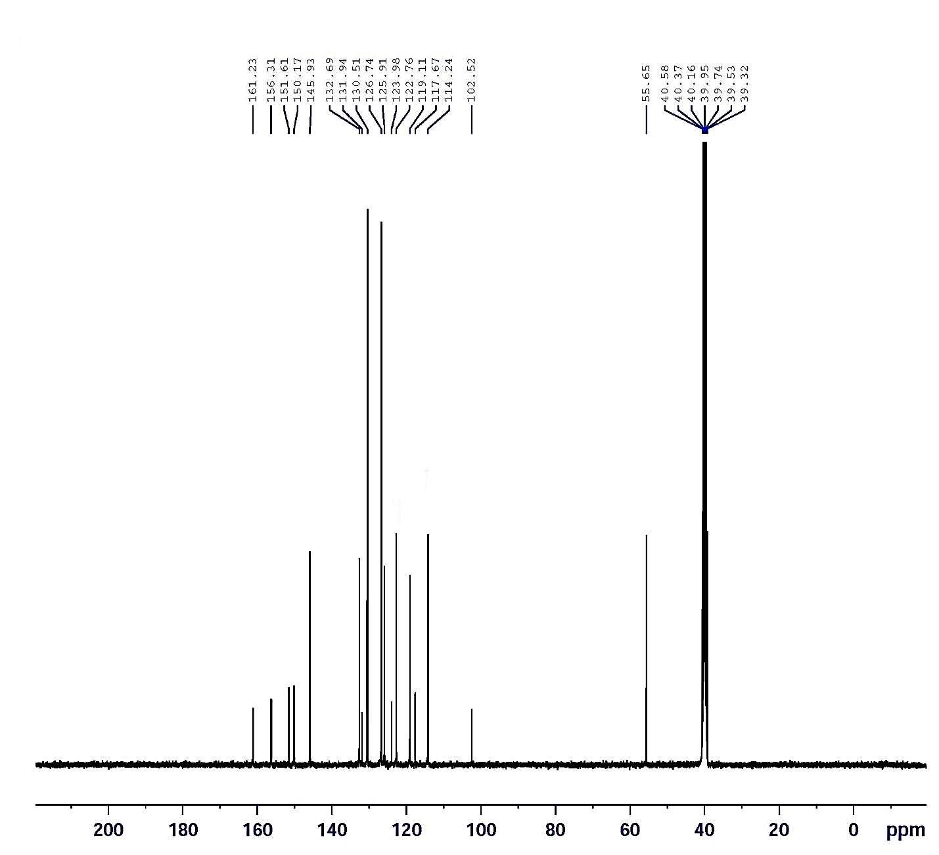
Figure (S11): ¹³C NMR spectrum of compound 3c

Figure (S12): Mass spectrum of compound 3c

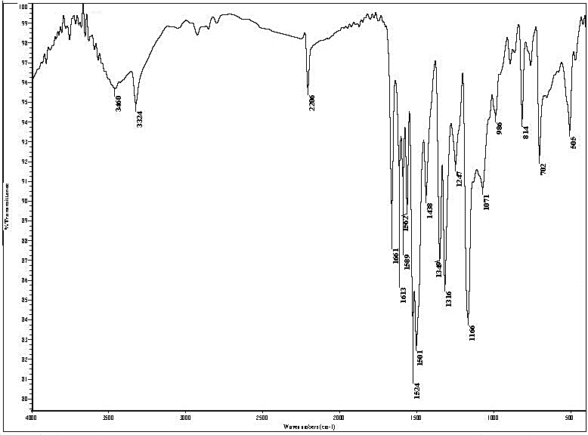
Figure (S13): IR spectrum of compound 3d

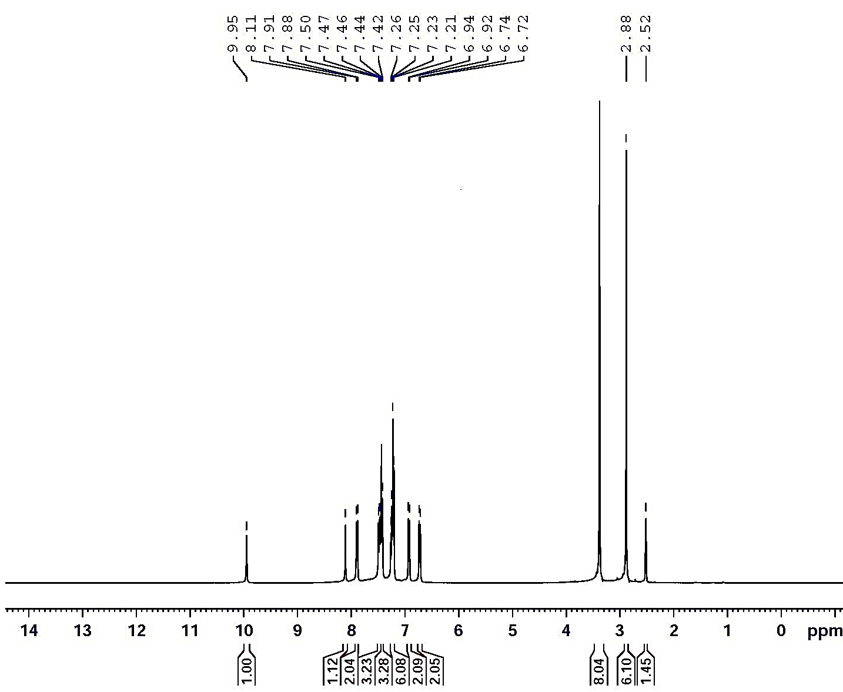
Figure (S14): ¹H NMR spectrum of compound 3d

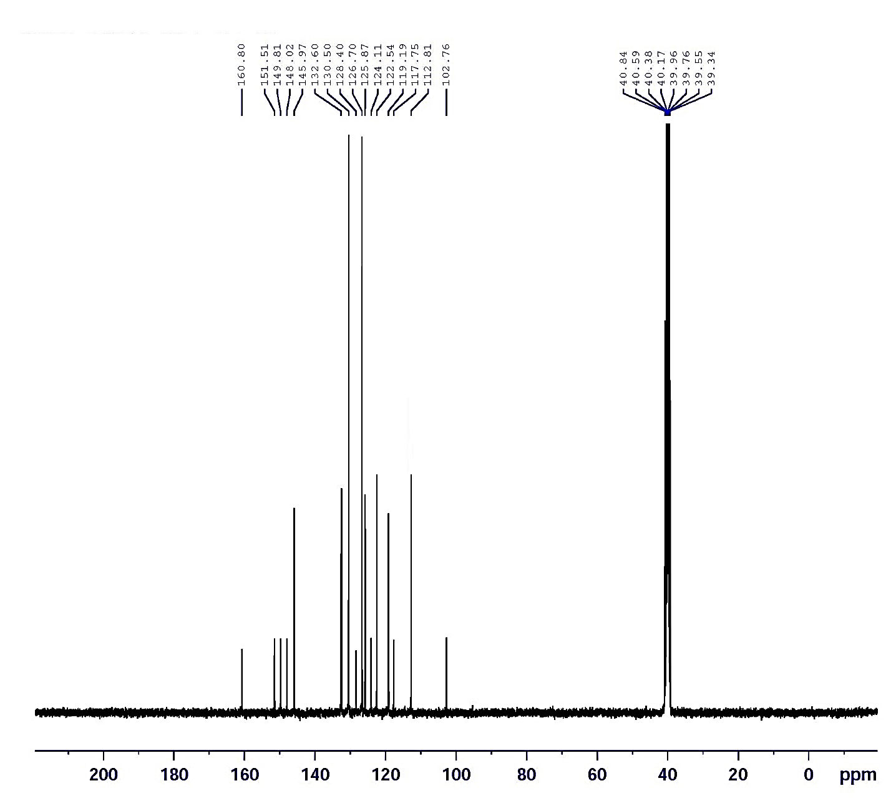
Figure (S15): ¹³C NMR spectrum of compound 3d

Figure (S16): Mass spectrum of compound 3d

Figure (S17): IR spectrum of compound 3e

Figure (S18): ¹H NMR spectrum of compound 3e

Figure (S19): ¹³C NMR spectrum of compound 3e

Figure (S20): Mass spectrum of compound 3e

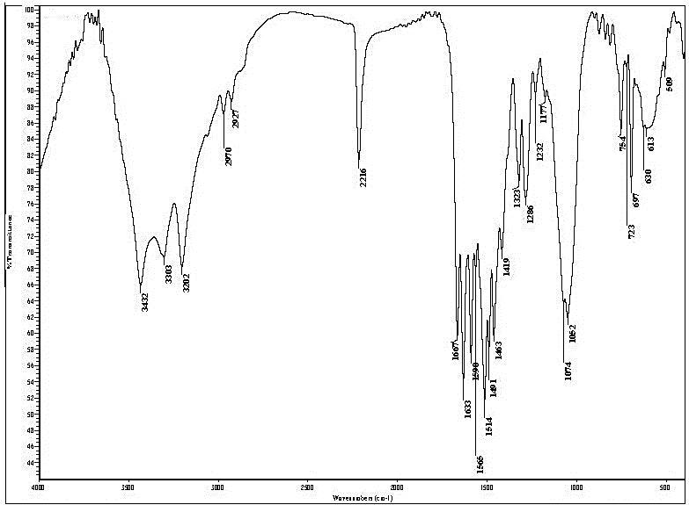
Figure (S21): IR spectrum of compound 4a

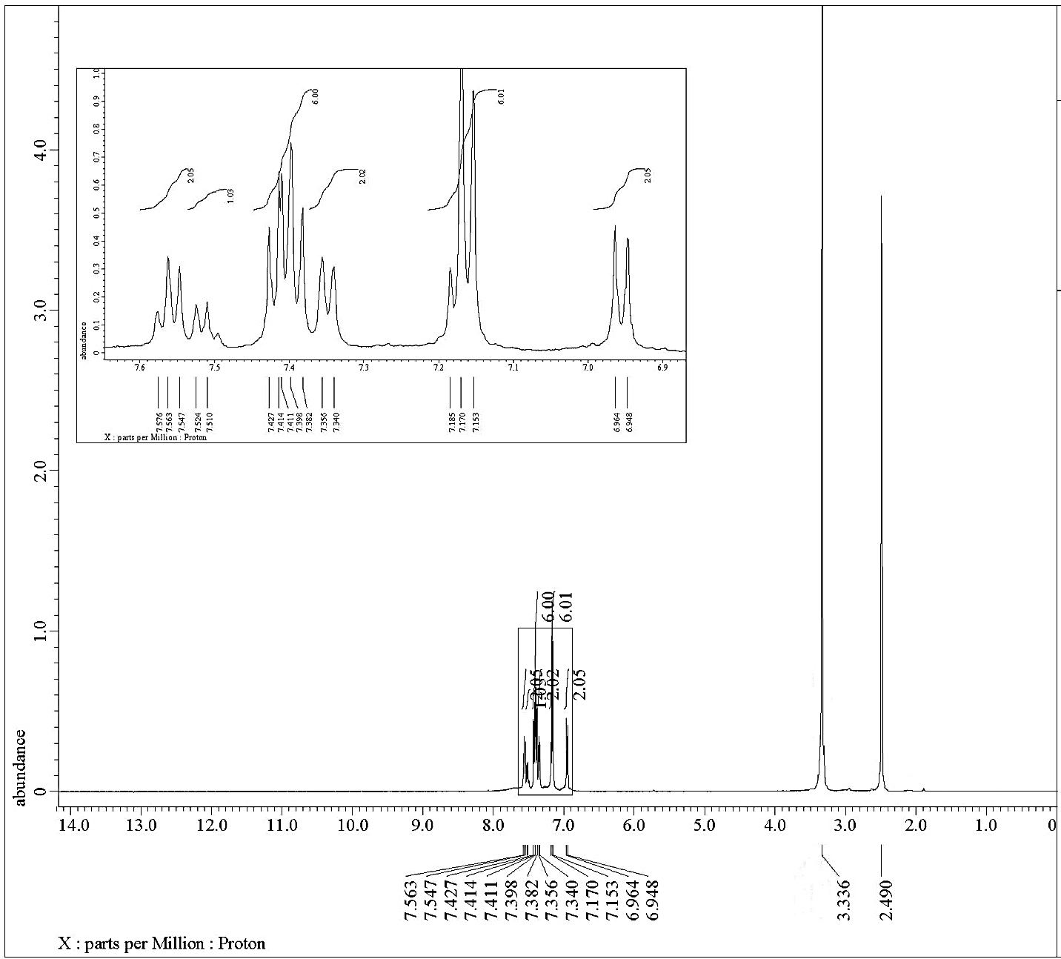
Figure (S22): ¹H NMR spectrum of compound 4a

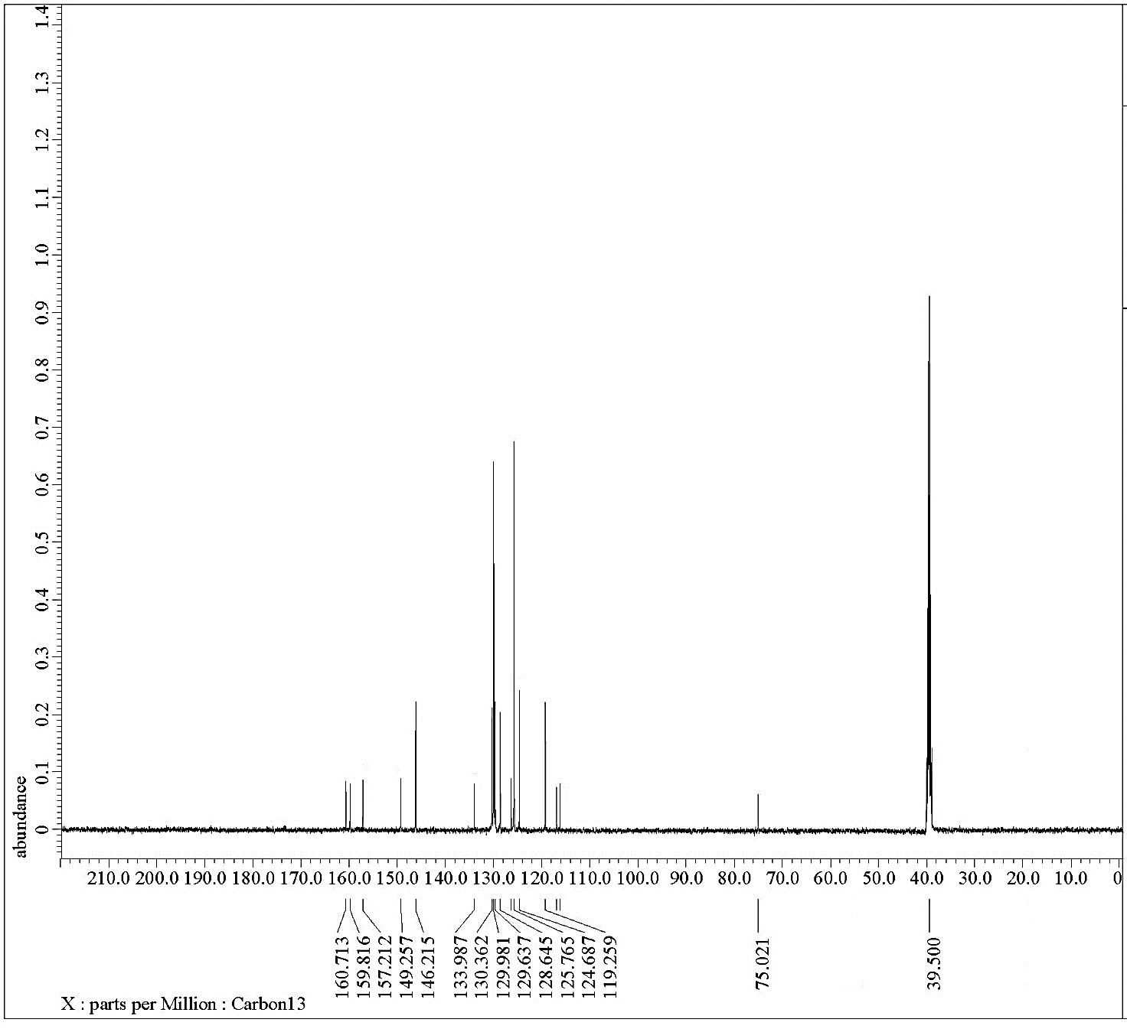

Figure (S23): ¹³C NMR spectrum of compound 4a

Figure (S24): Mass spectrum of compound 4a

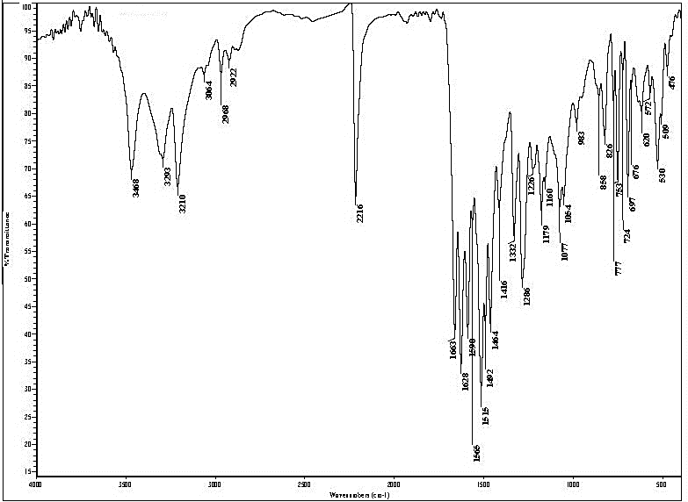
Figure (S25): IR spectrum of compound 4b

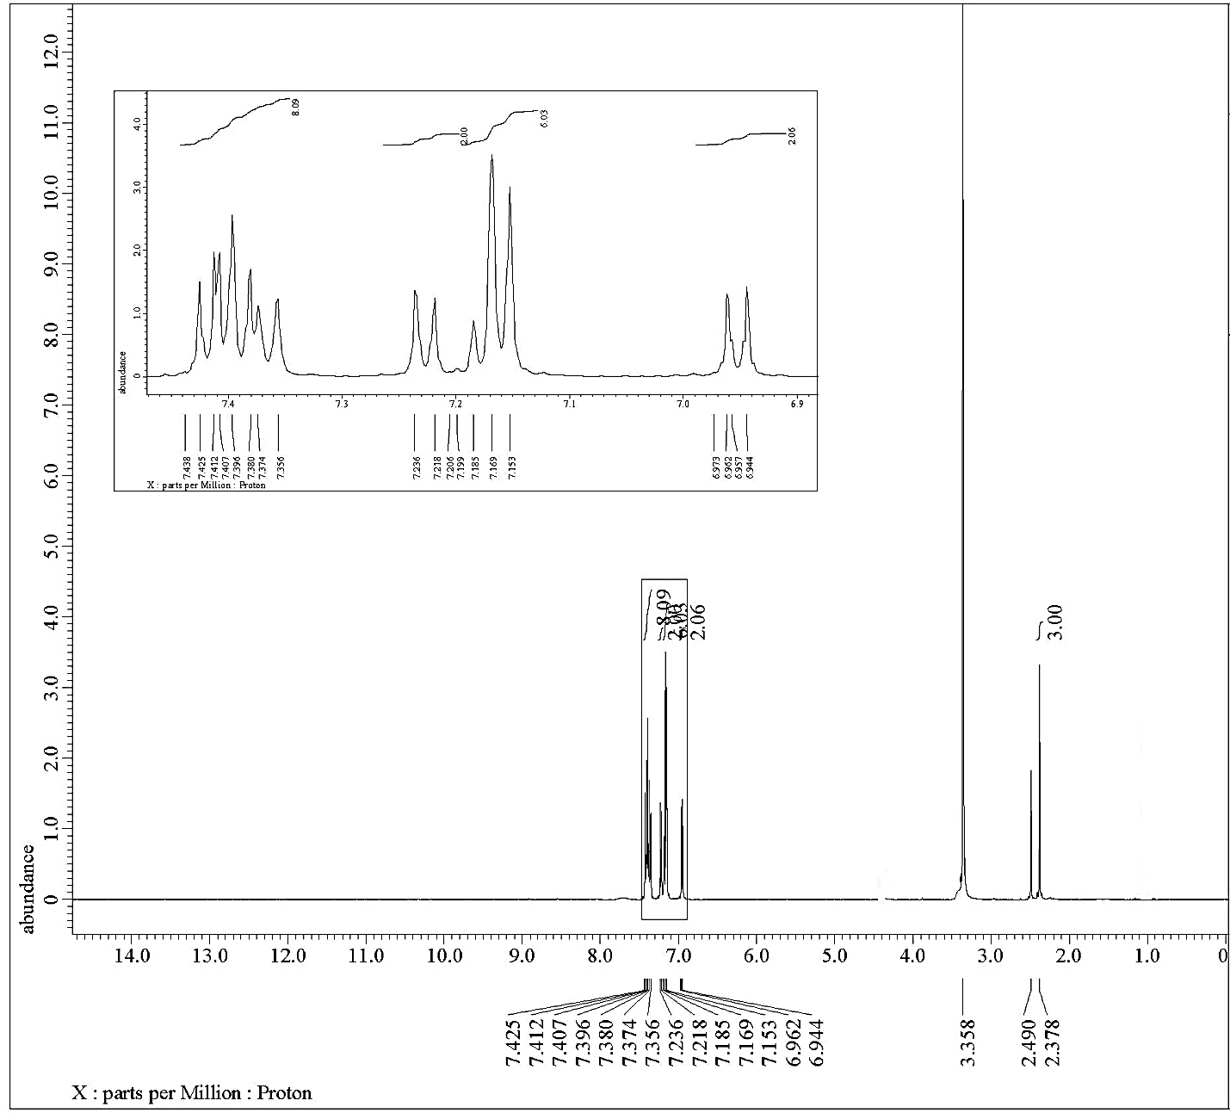
Figure (S26): ¹H NMR spectrum of compound 4b

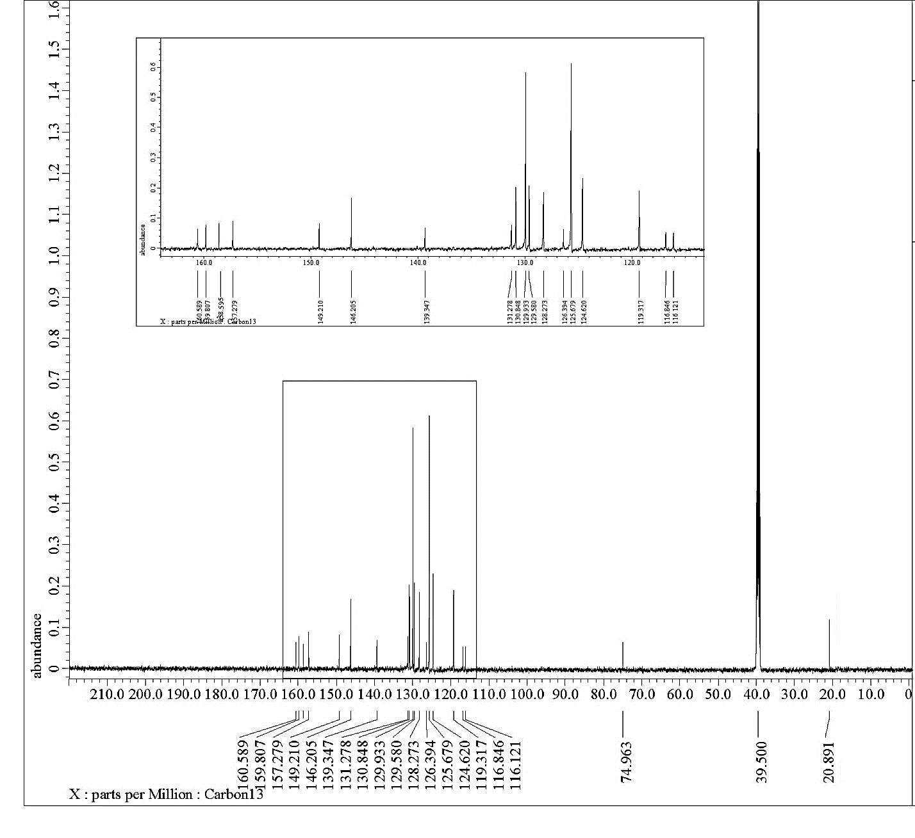
Figure (S27): ¹³C NMR spectrum of compound 4b

Figure (S28): Mass spectrum of compound 4b

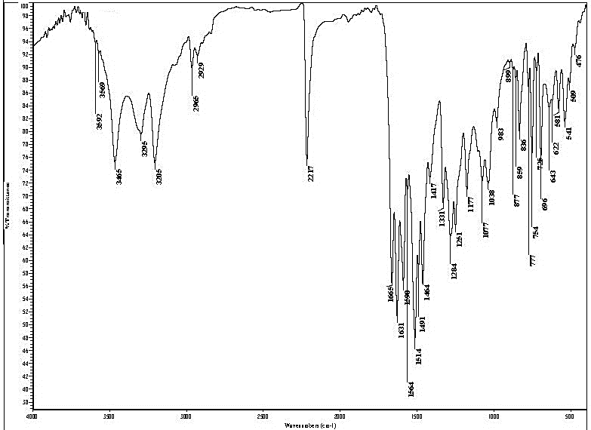
Figure (S29): IR spectrum of compound 4c

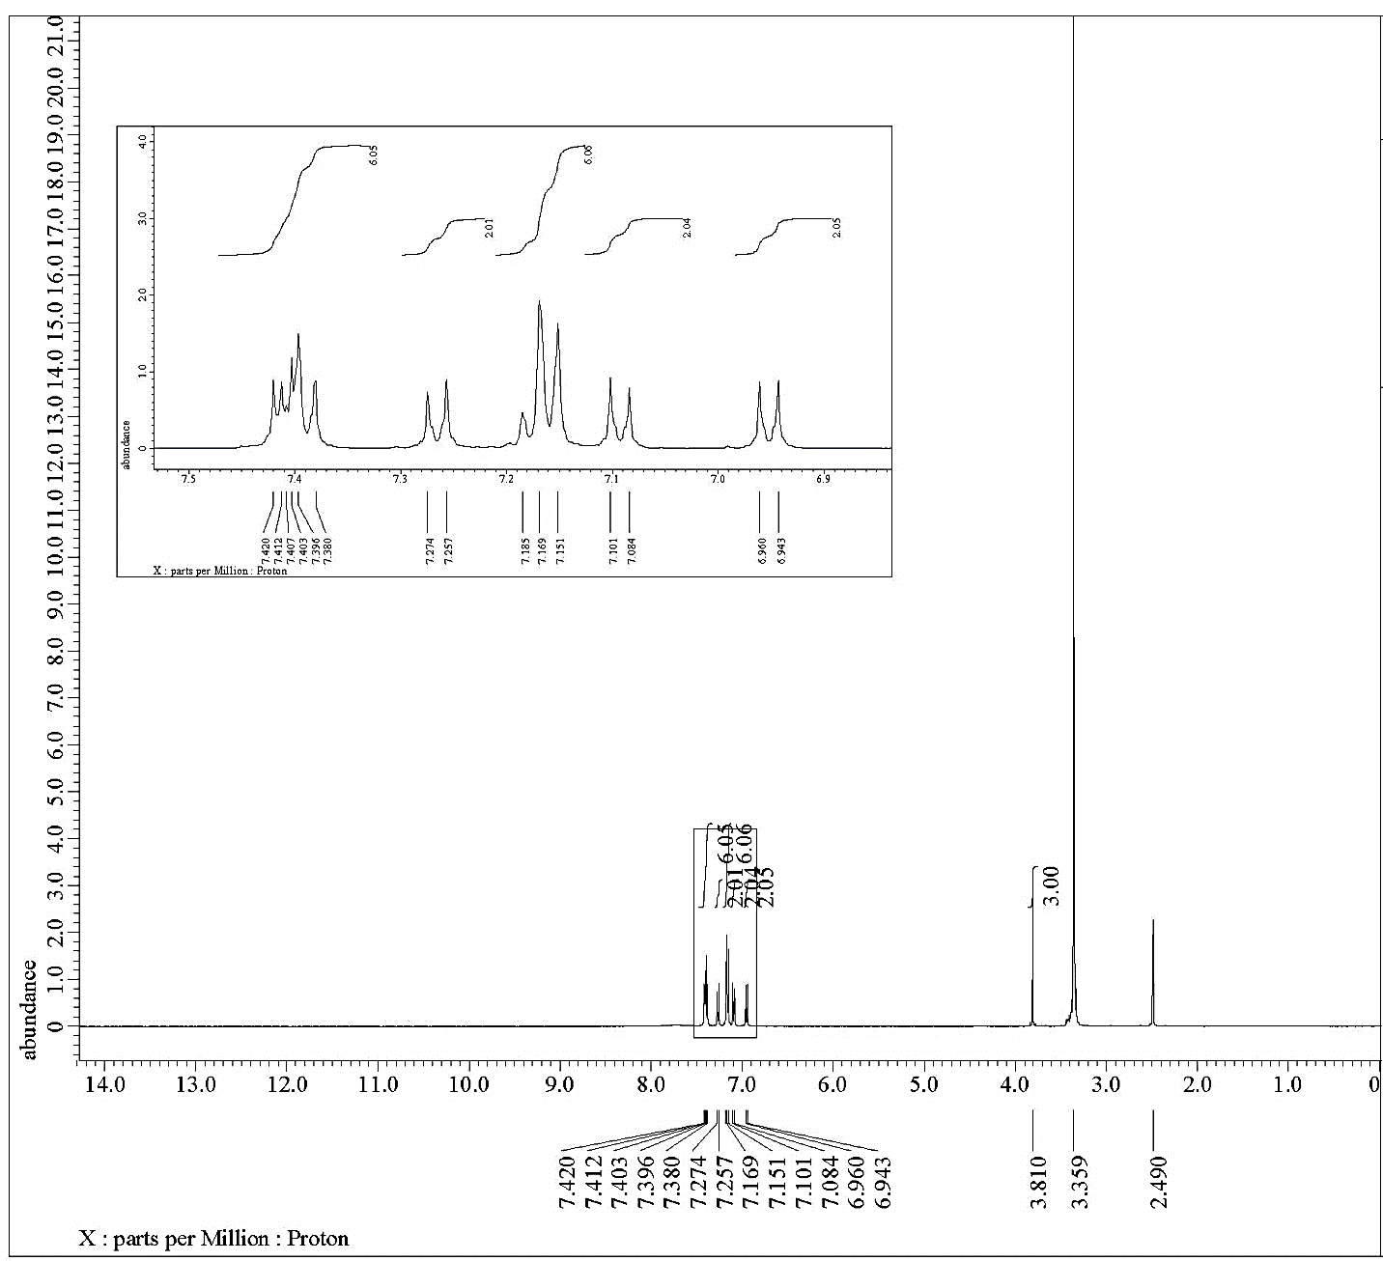
Figure (S30): ¹H NMR spectrum of compound 4c

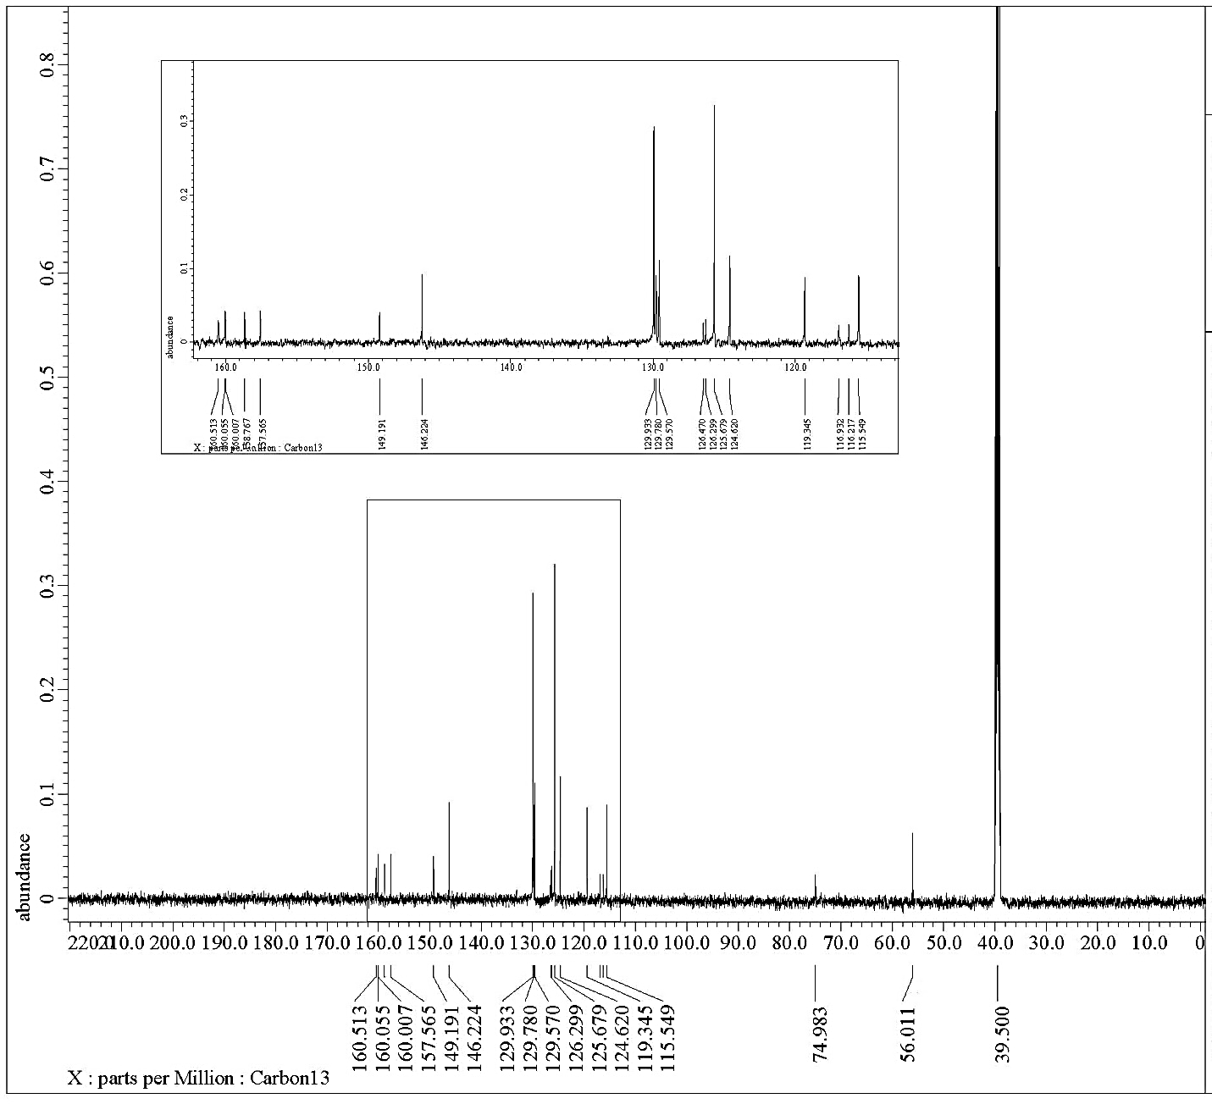
Figure (S31): ¹³C NMR spectrum of compound 4c

Figure (S32): Mass spectrum of compound 4c

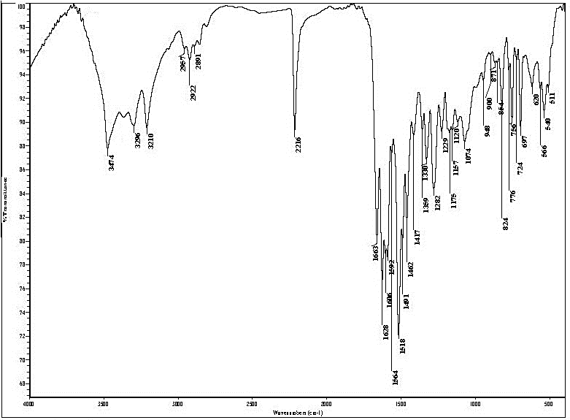
Figure (S33): IR spectrum of compound 4d

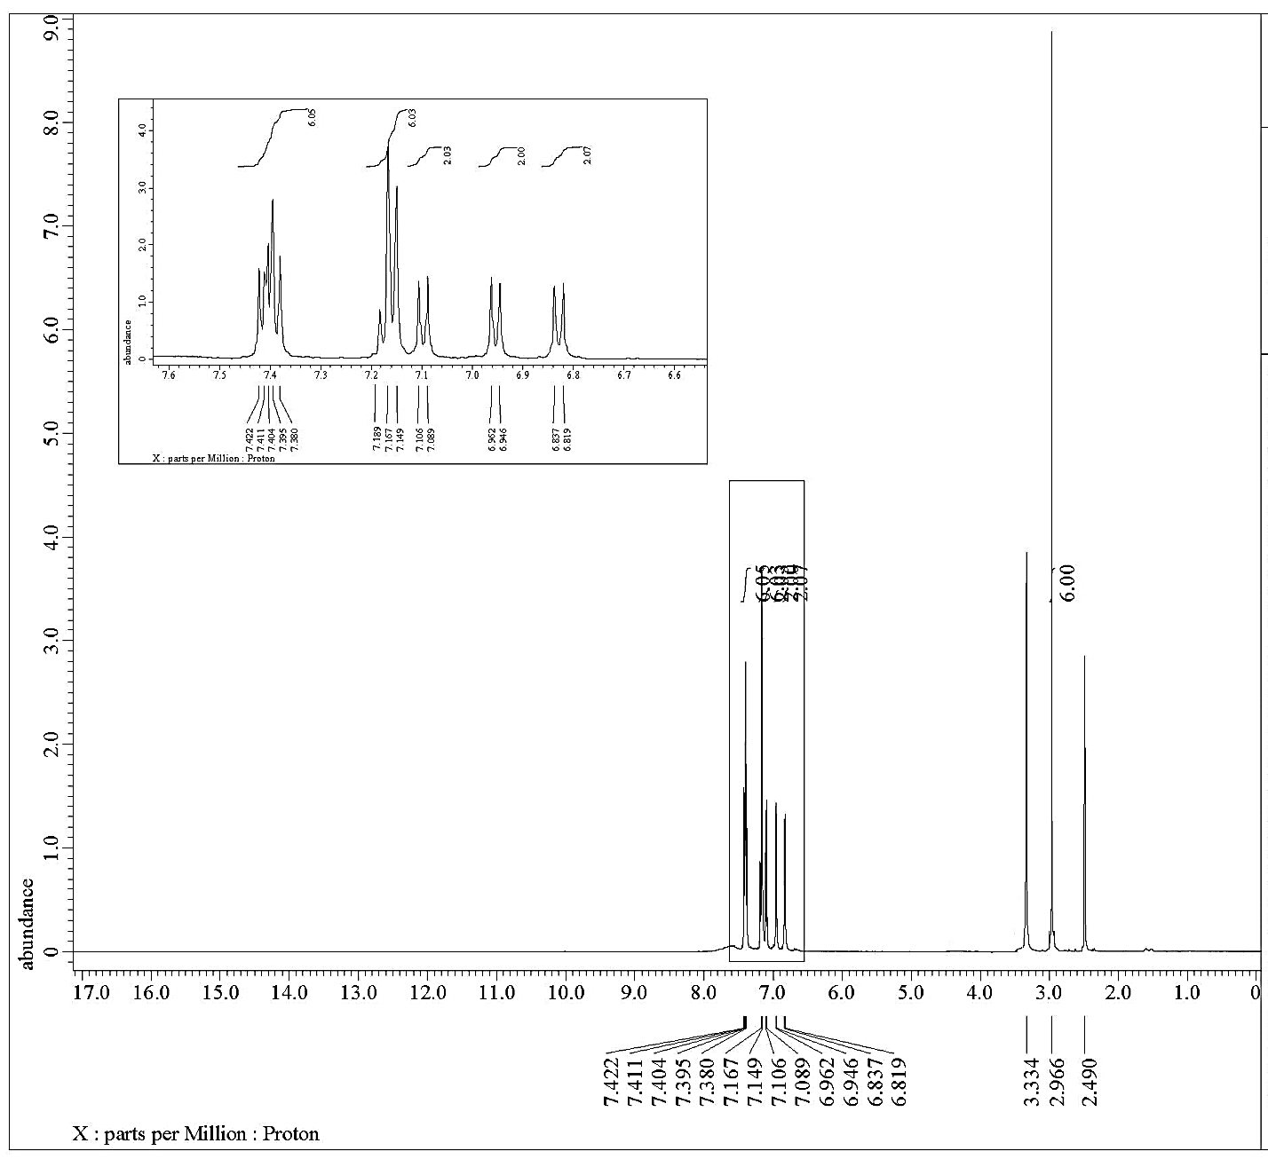
Figure (S34): ¹H NMR spectrum of compound 4d

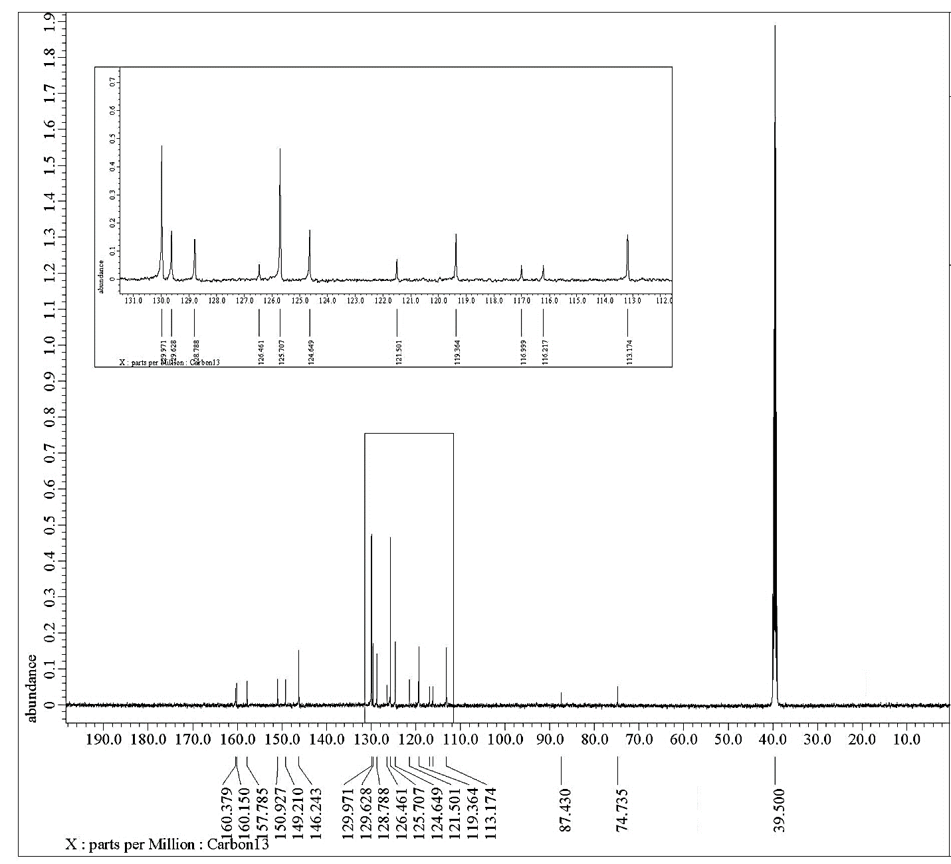
Figure (S35): ¹³C NMR spectrum of compound 4d

Figure (S36): Mass spectrum of compound 4d

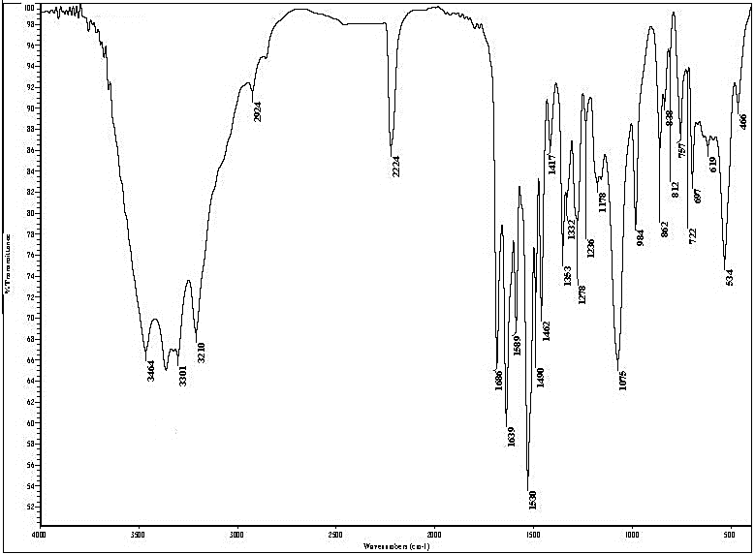
Figure (S37): IR spectrum of compound 4e

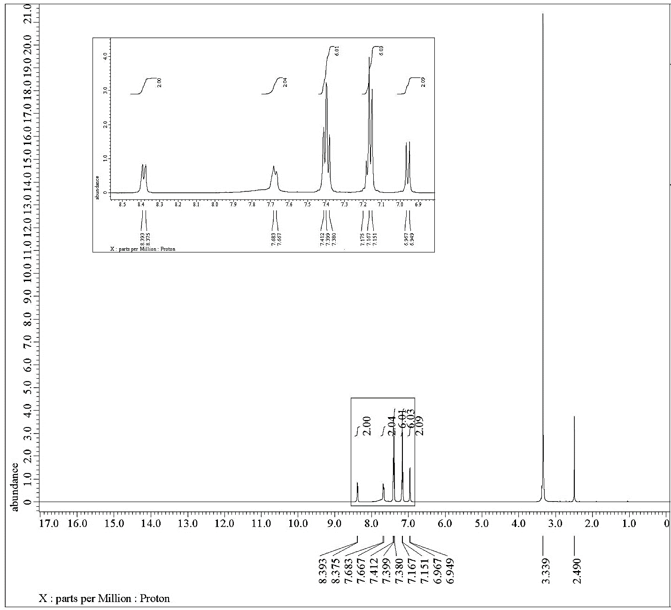
Figure (S38): ¹H NMR spectrum of compound 4e

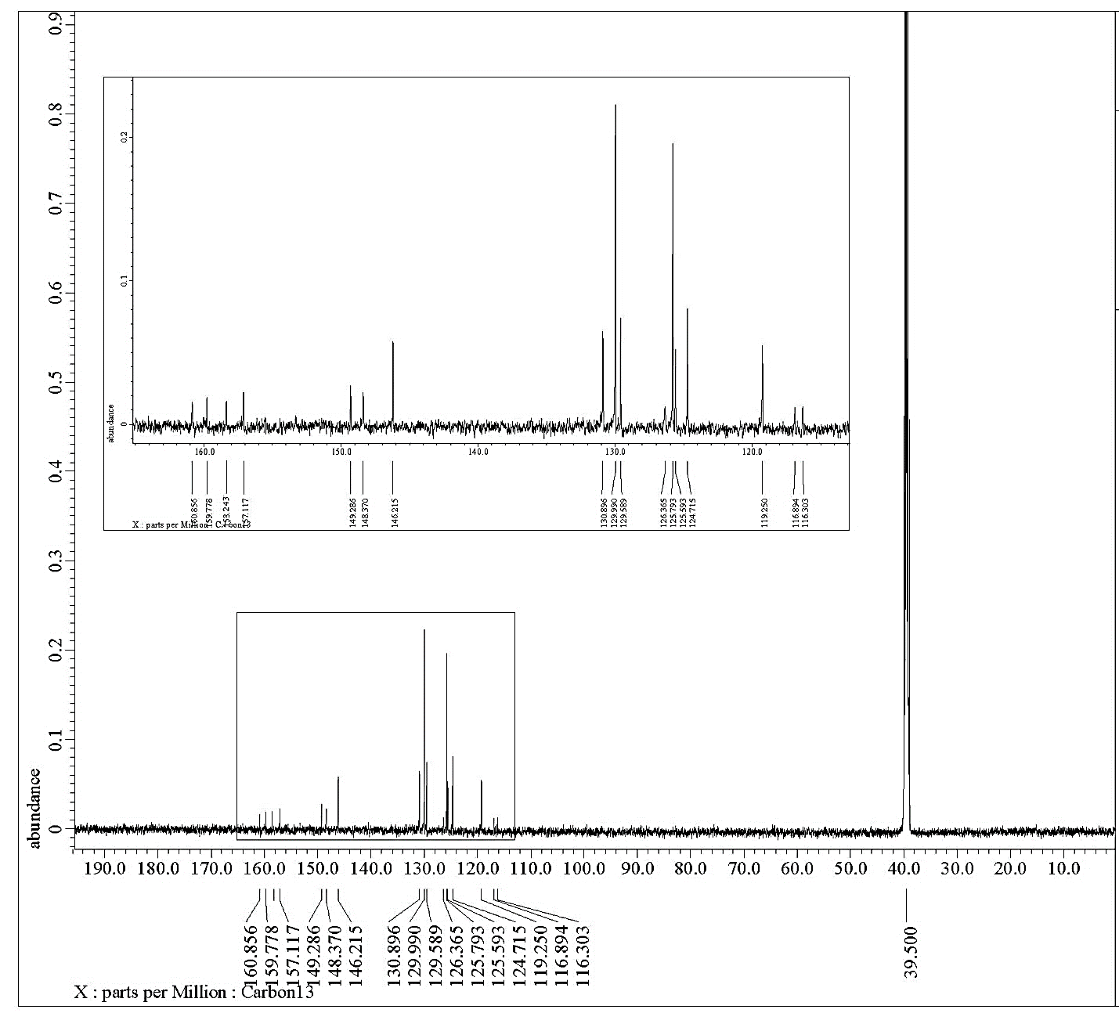
Figure (S39): ¹³C NMR spectrum of compound 4e

Figure (S40): Mass spectrum of compound 4e

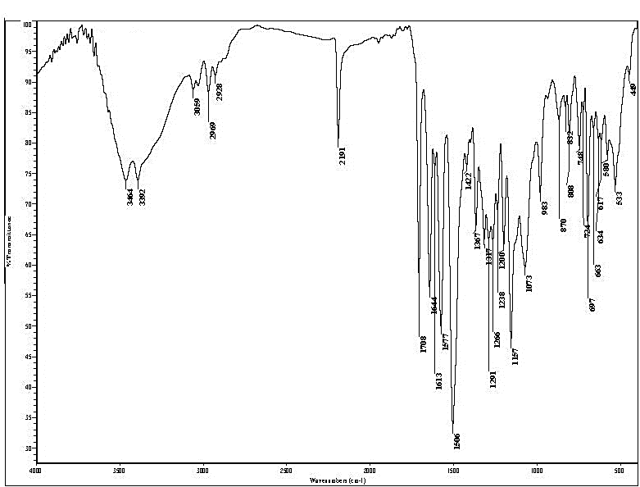
Figure (S41): IR spectrum of compound 9a

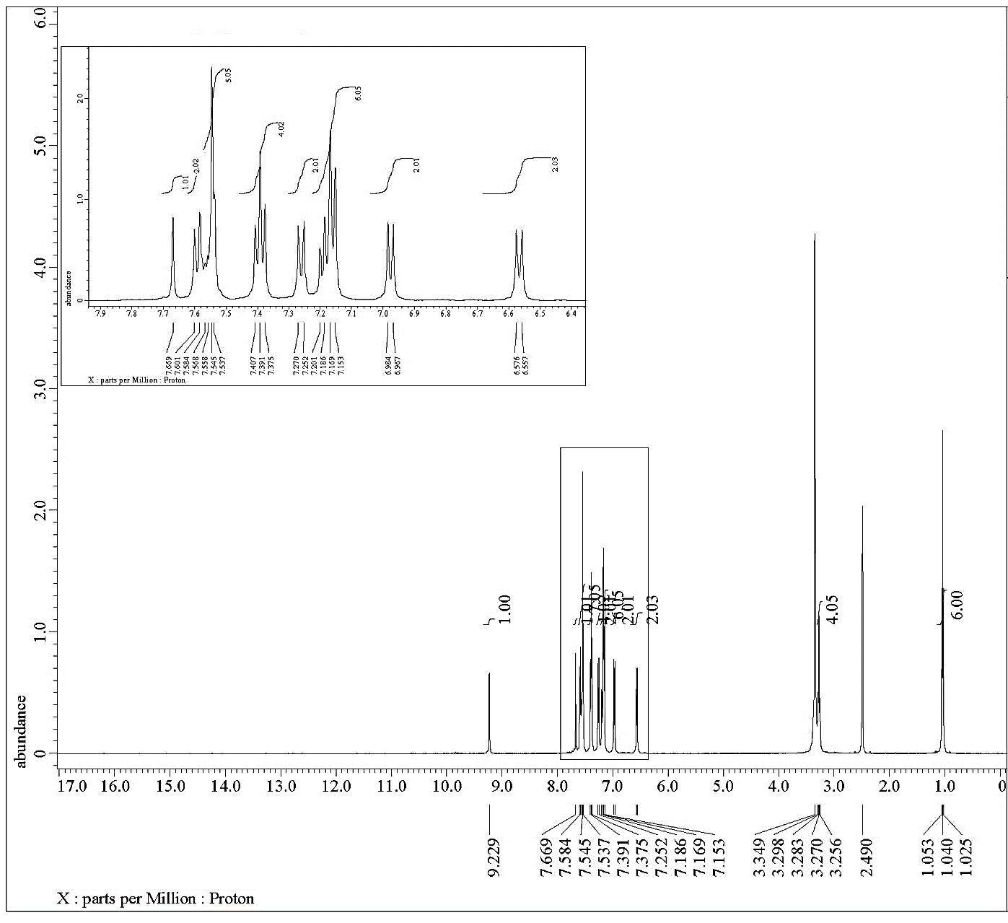
Figure (S42): ¹H NMR spectrum of compound 6a

Figure (S43): Mass spectrum of compound 6a
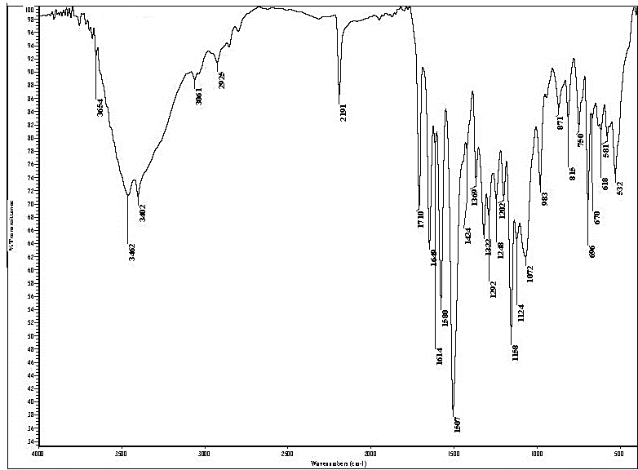
Figure (S44): IR spectrum of compound 6b

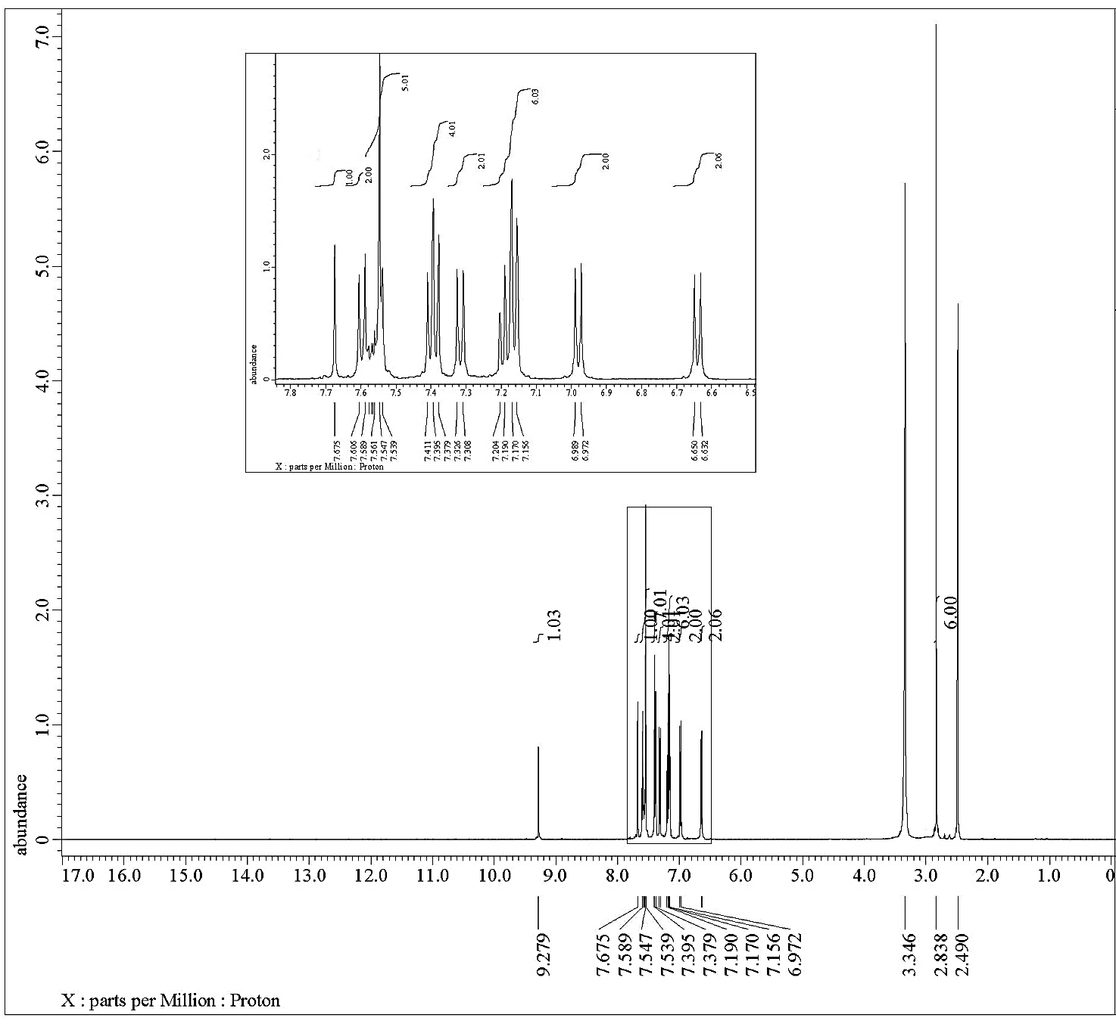
Figure (S45): ¹H NMR spectrum of compound 6b

Figure (S46): Mass spectrum of compound 6b

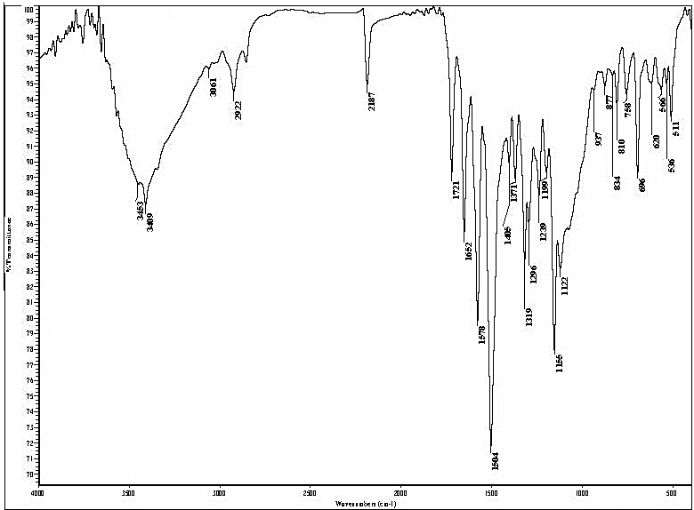
Figure (S47): IR spectrum of compound 6c

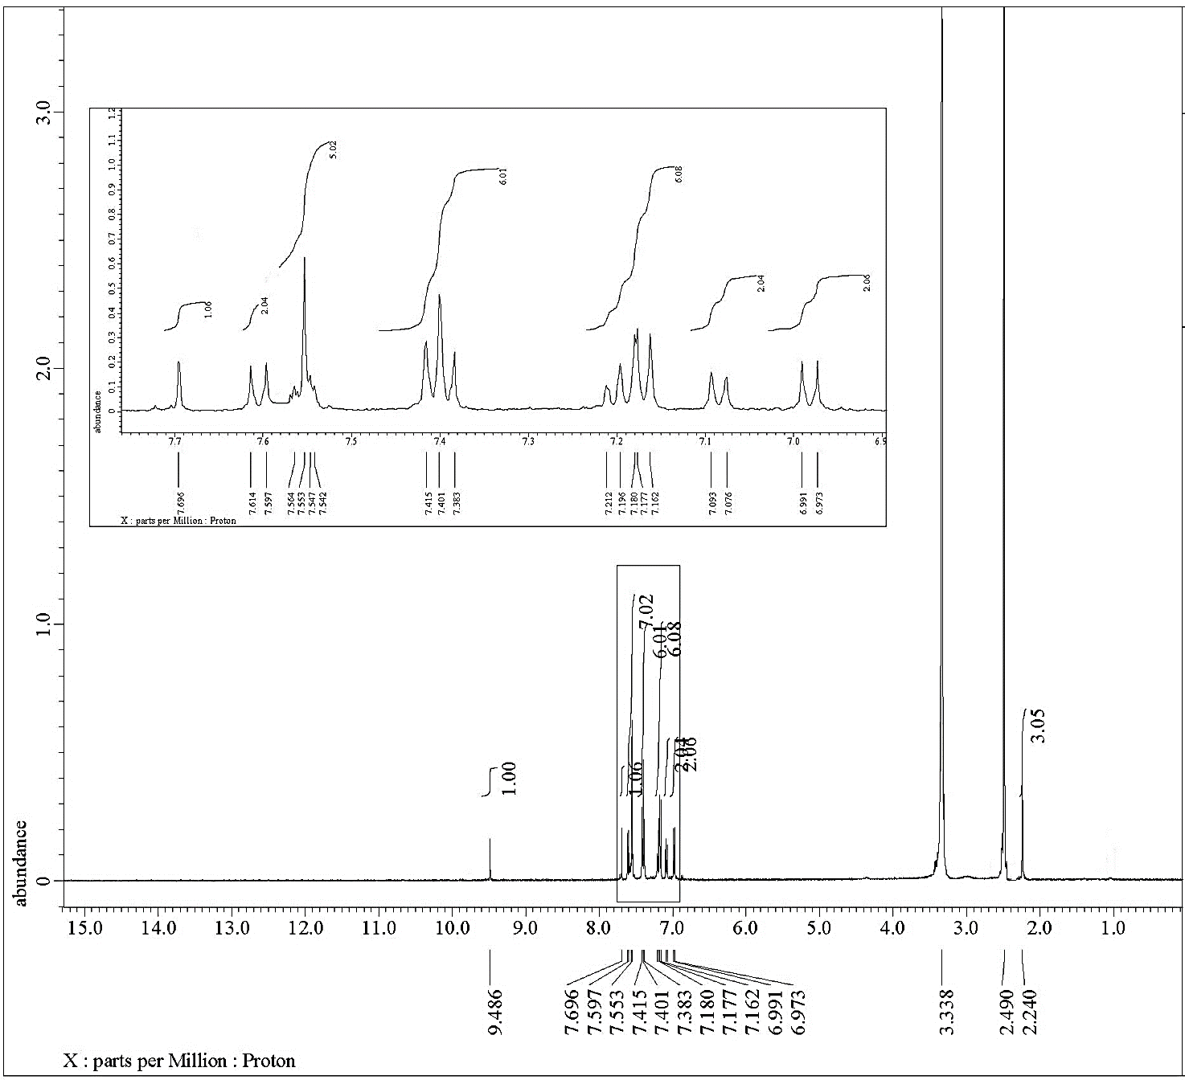
Figure (S48): ¹H NMR spectrum of compound 6c

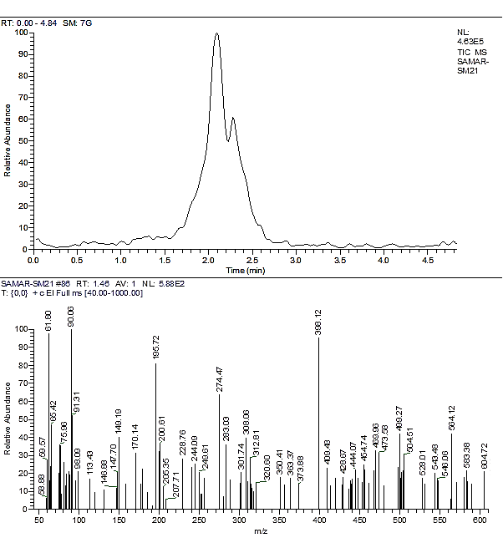
Figure (S49): Mass spectrum of compound 6c

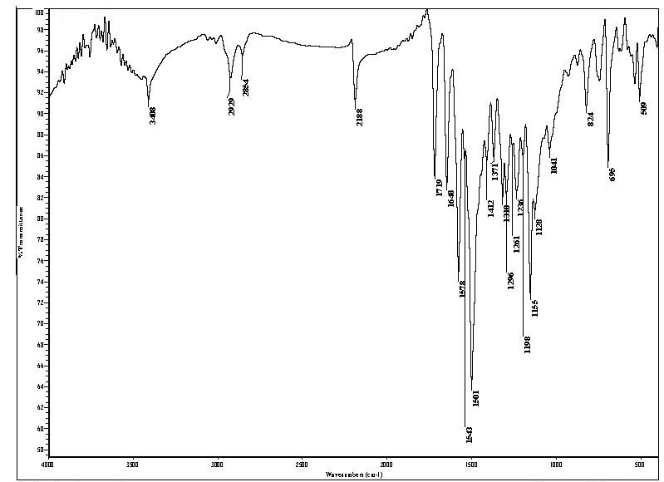
Figure (S50): IR spectrum of compound 6d

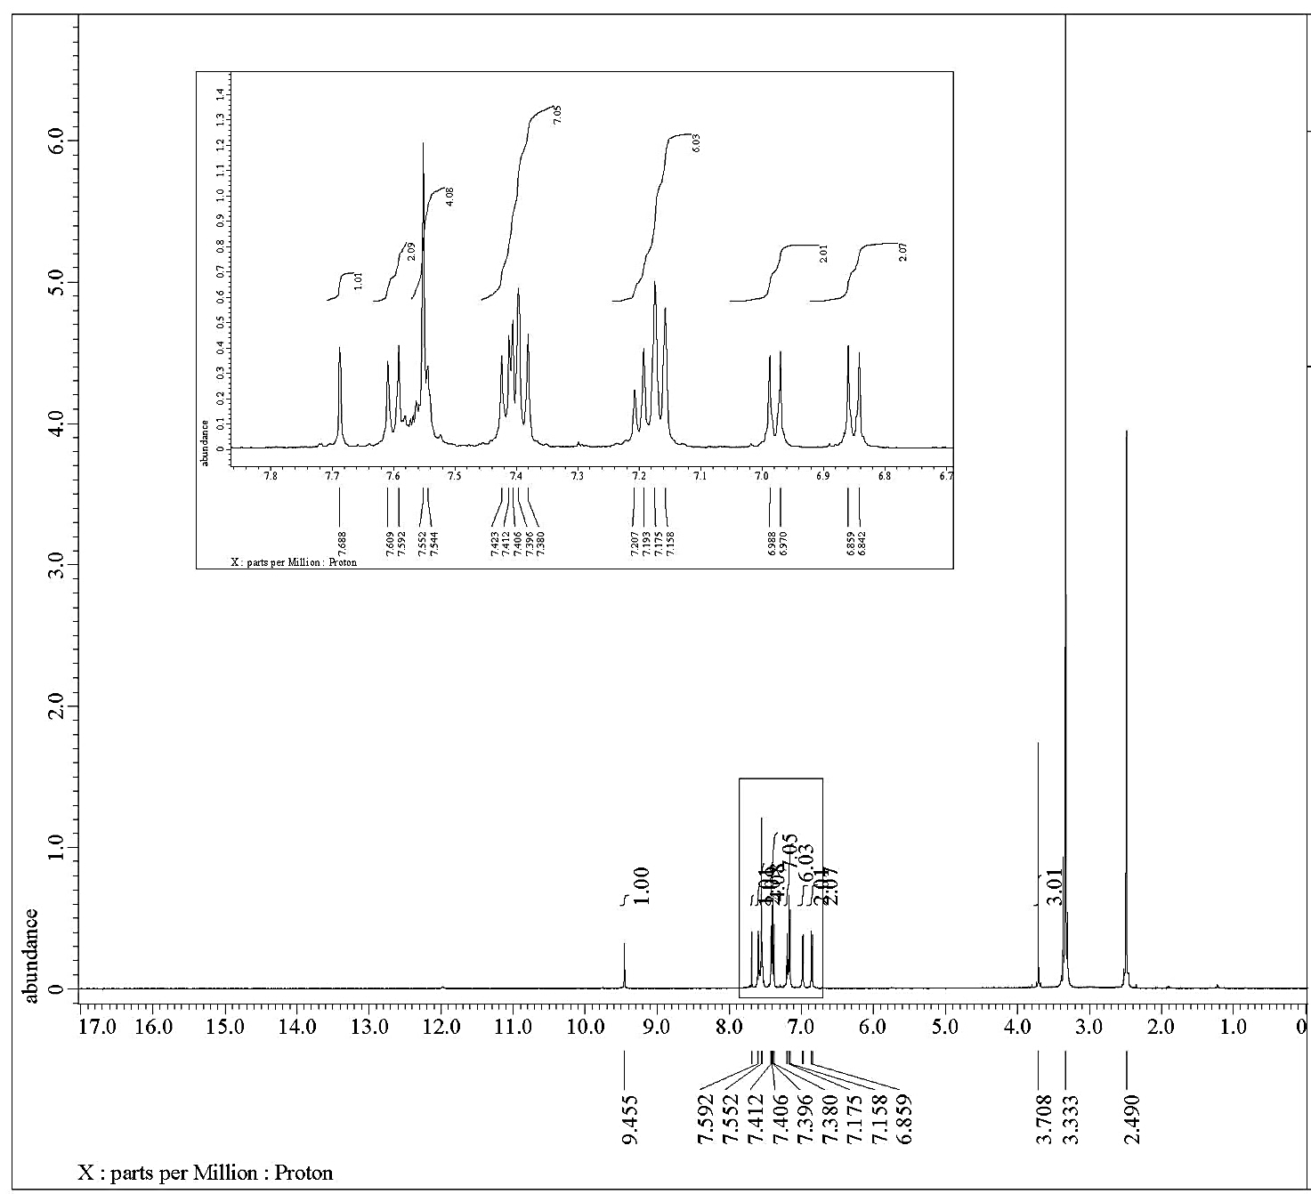
Figure (S51): ¹H NMR spectrum of compound 6d

Figure (S52): Mass spectrum of compound 6d

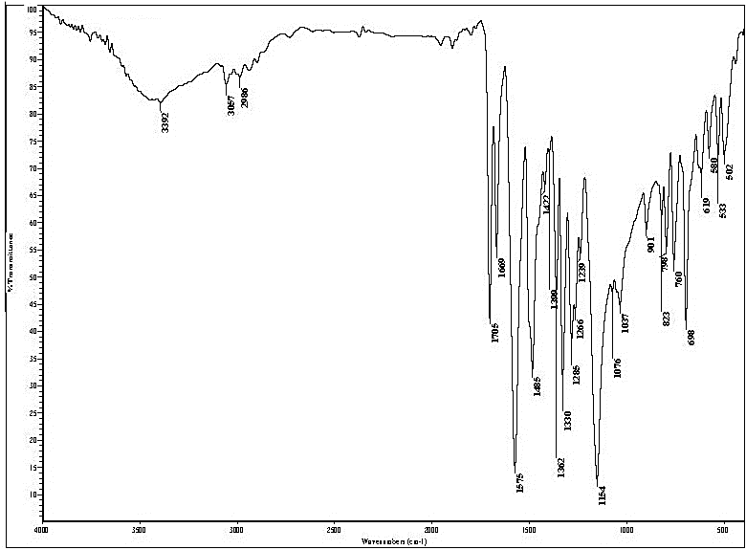
Figure (S53): IR spectrum of compound 8

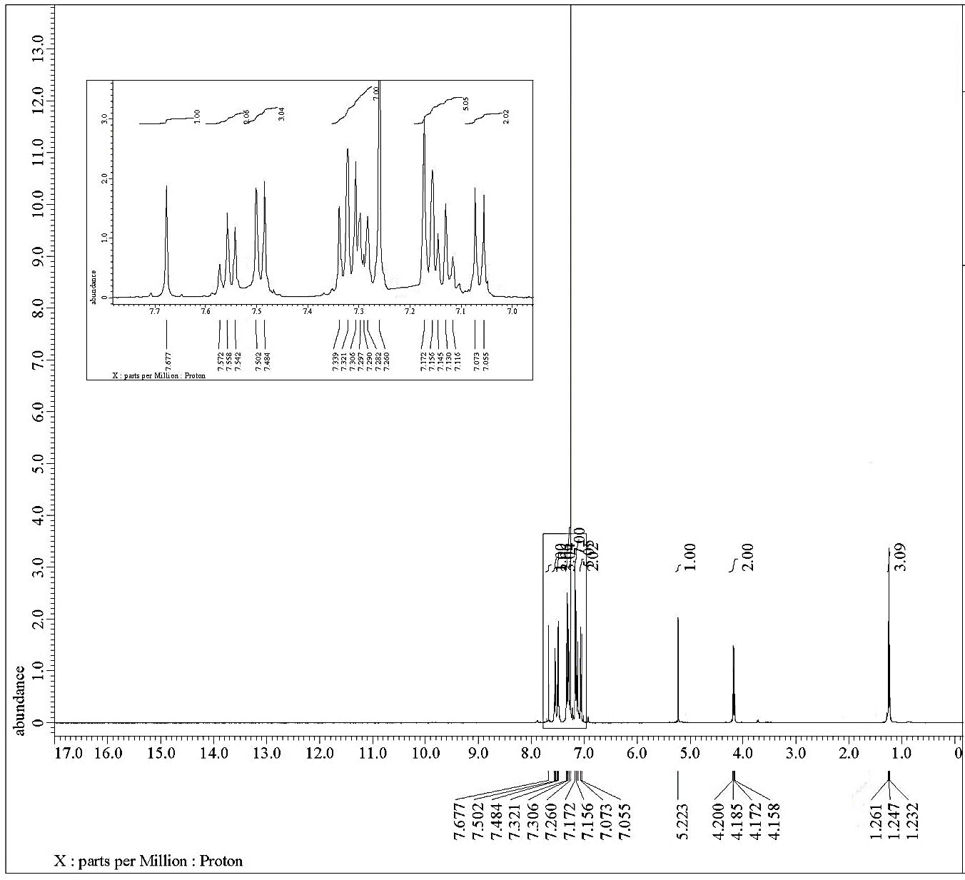
Figure (S54): ¹H NMR spectrum of compound 8

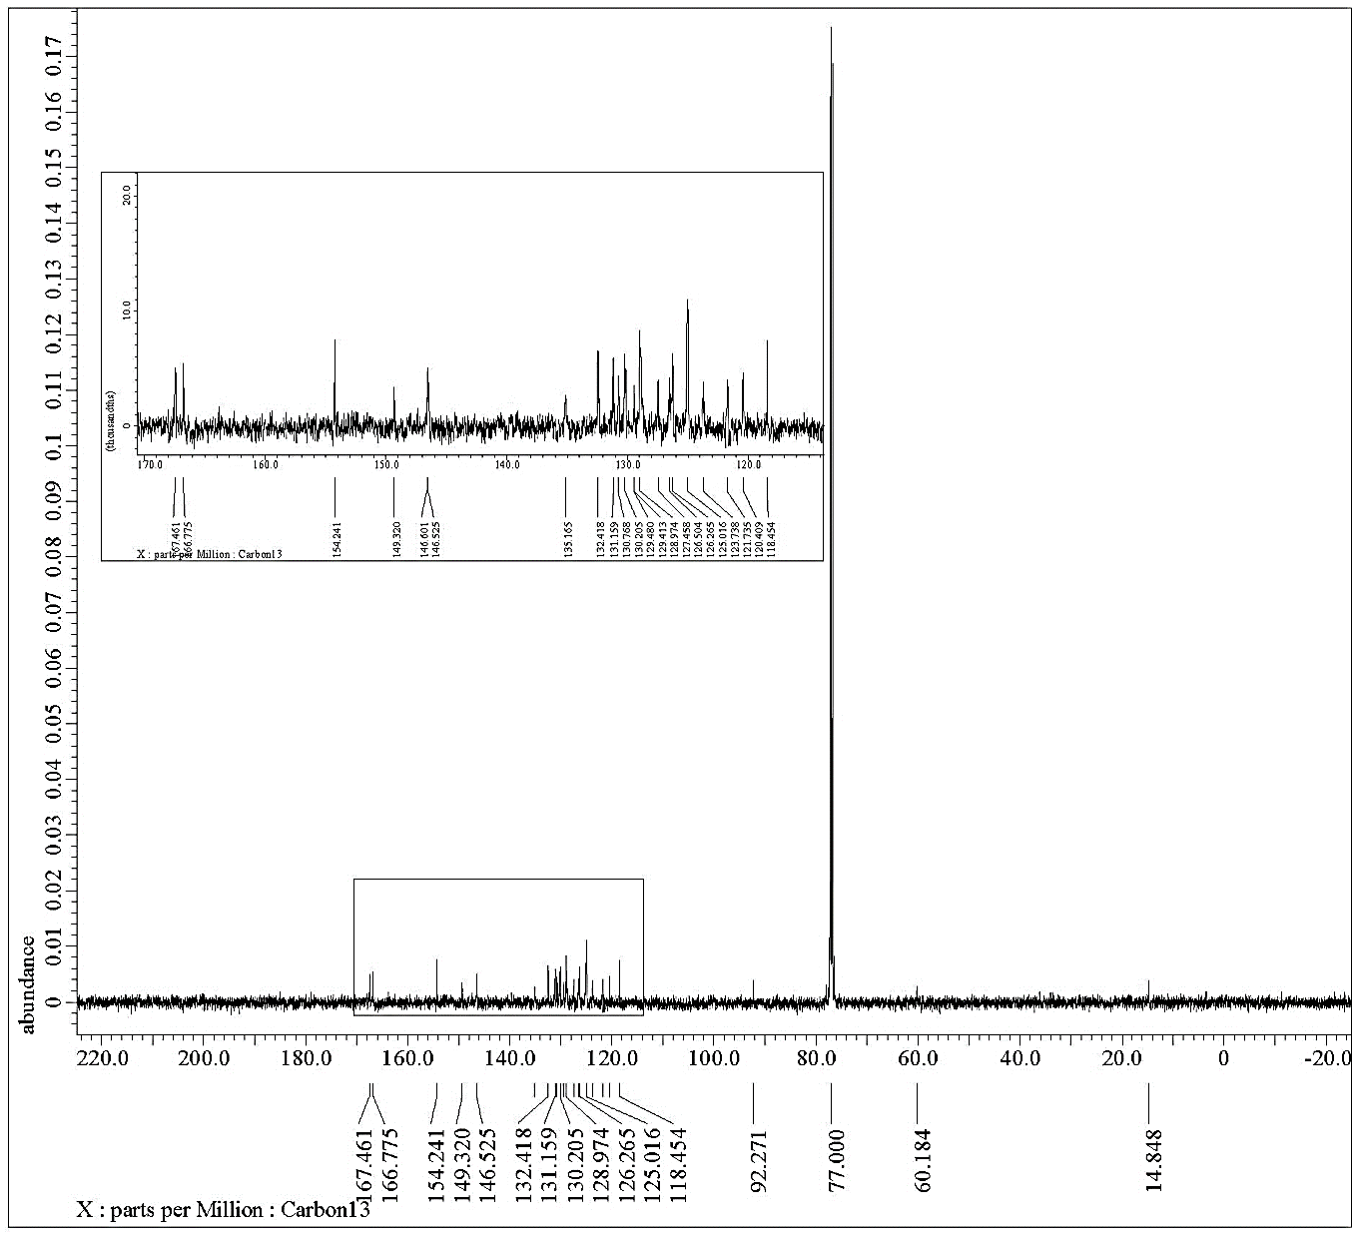
Figure (S55): ¹³C NMR spectrum of compound 8

Figure (S56): Mass spectrum of compound 8

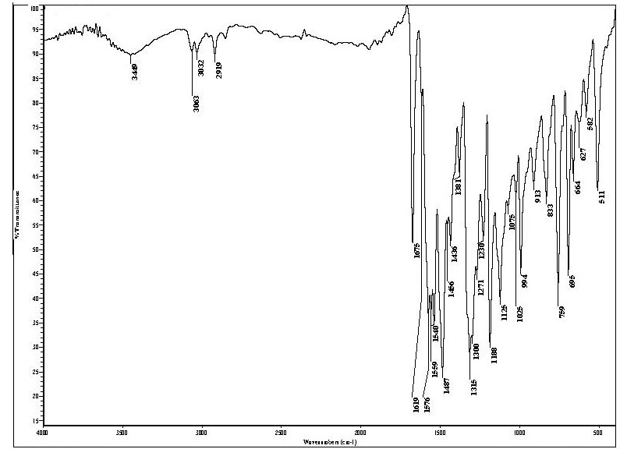
Figure (S57): IR spectrum of compound 9

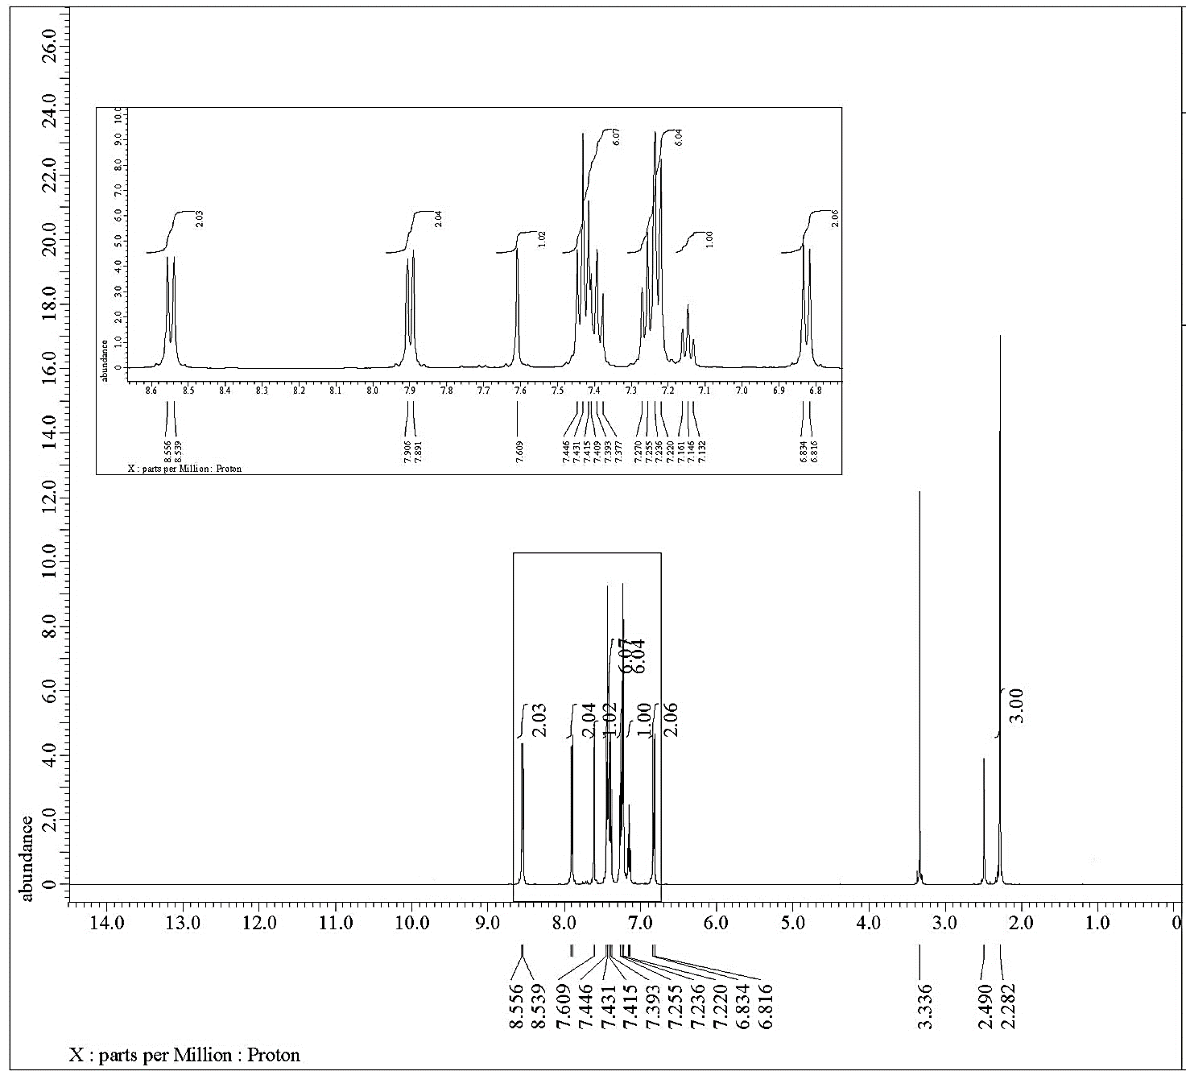
Figure (S58): ¹H NMR spectrum of compound 9

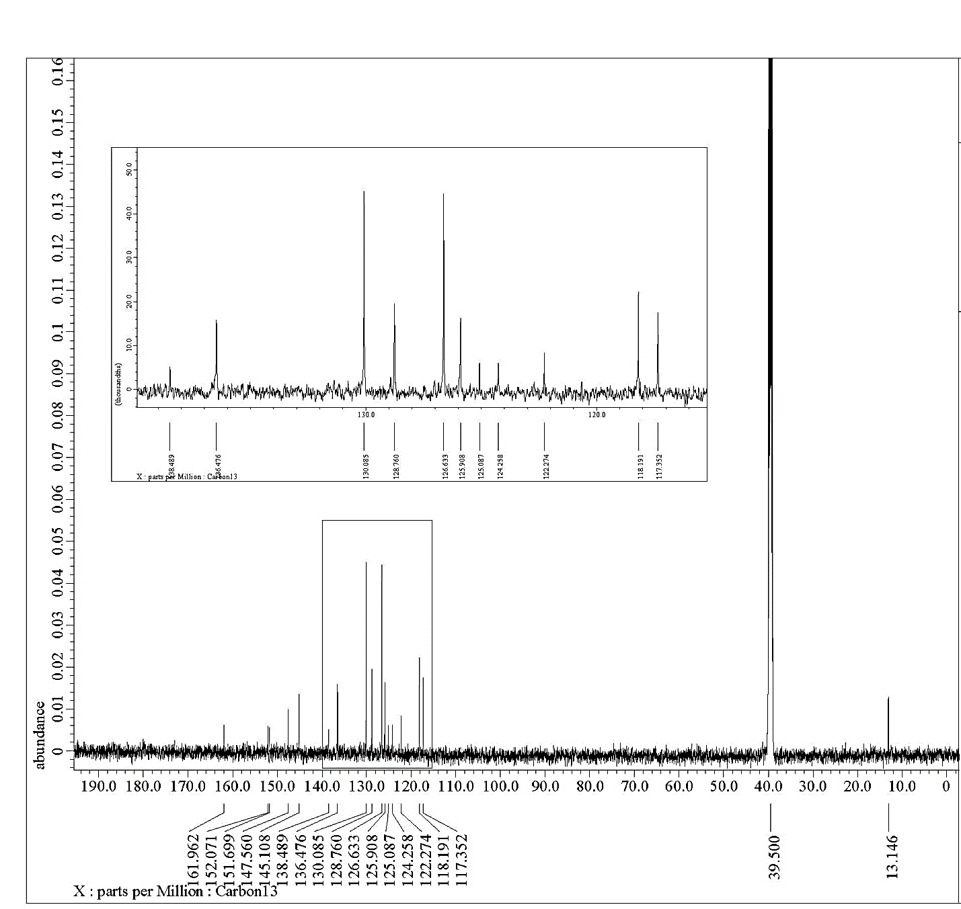
Figure (S59): ¹³C NMR spectrum of compound 9

Figure (S60): Mass spectrum of compound 9
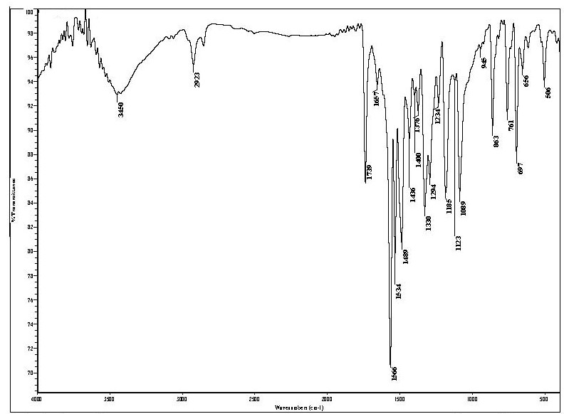
Figure (S61): IR spectrum of compound 10

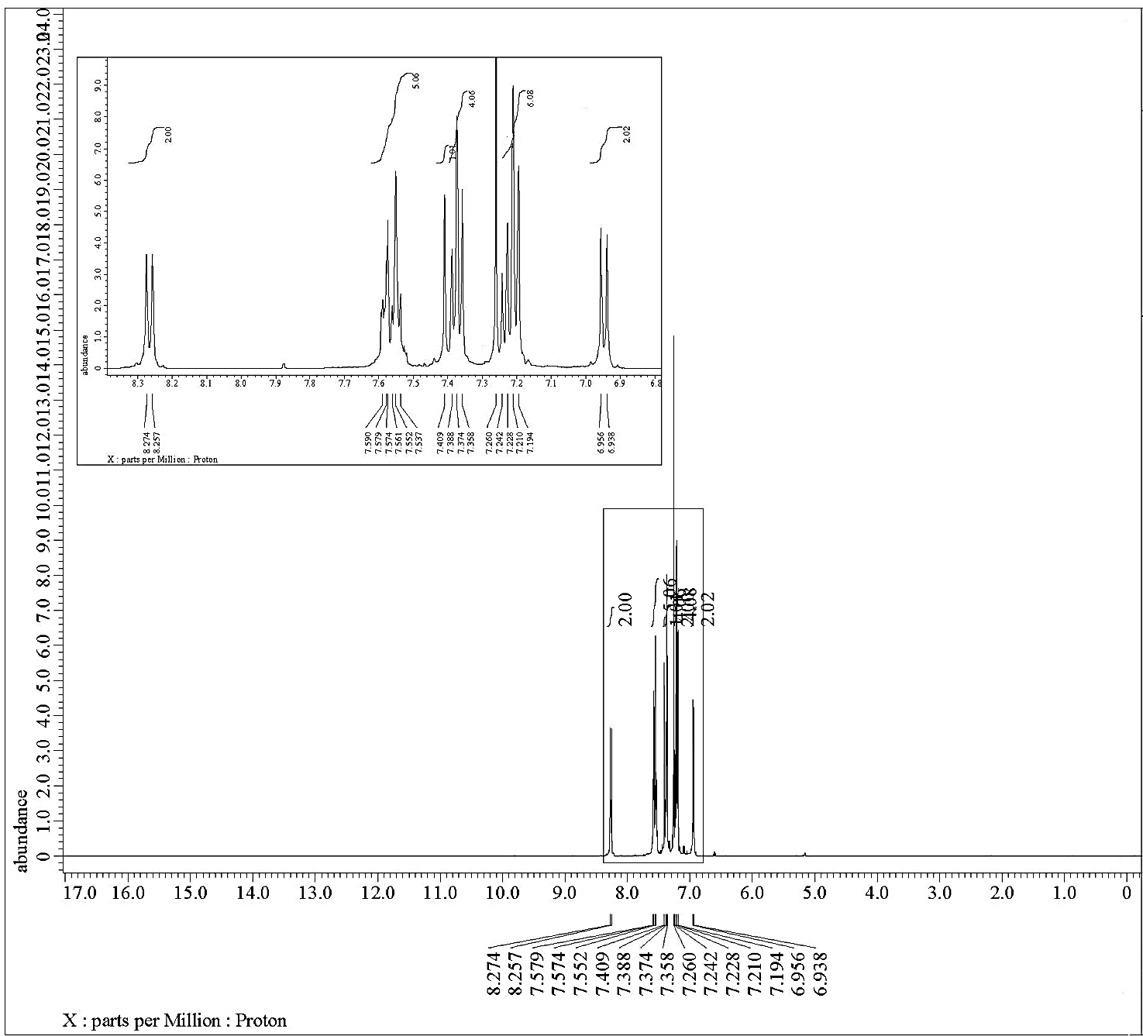
Figure (S62): ¹H NMR spectrum of compound 10

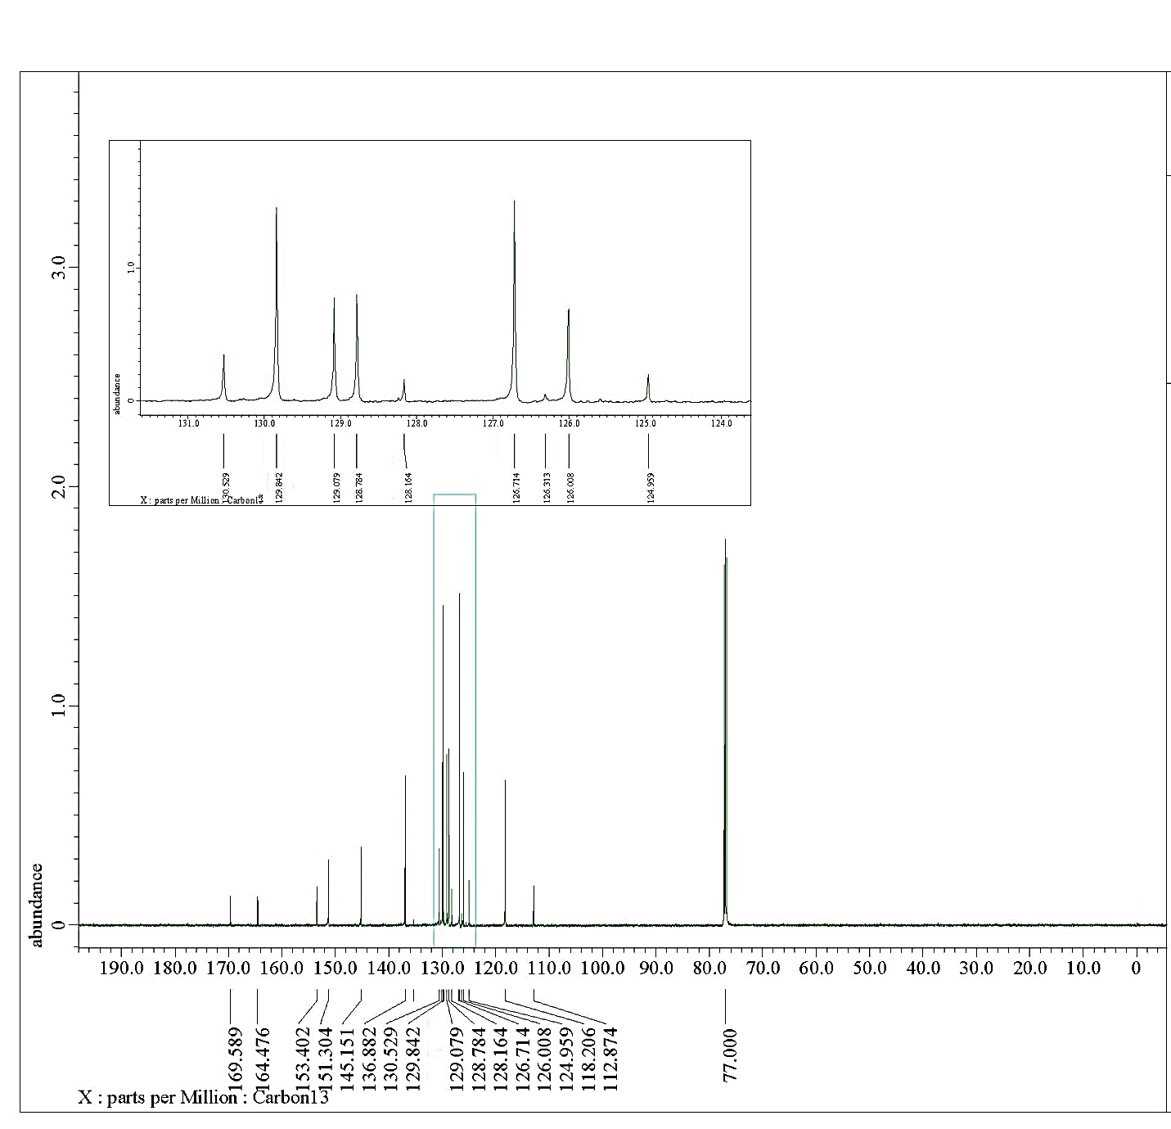
Figure (S63): ¹³C NMR spectrum of compound 10

Figure (S64): Mass spectrum of compound 10

2. Docking analysis:

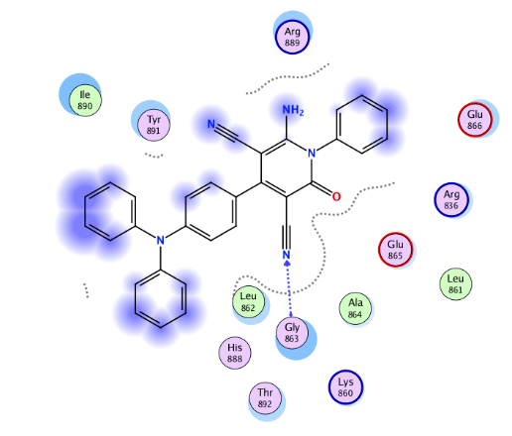 | 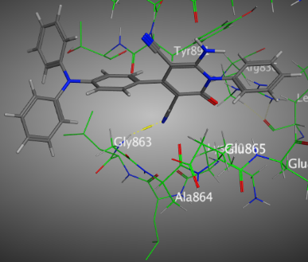
2D | 3D (active sites)
Figure (S65): Interactions of 4a with the residues of (PDB ID: 2ITO) (blue: H-
acceptor bond).

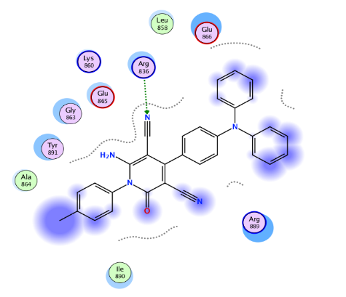 | 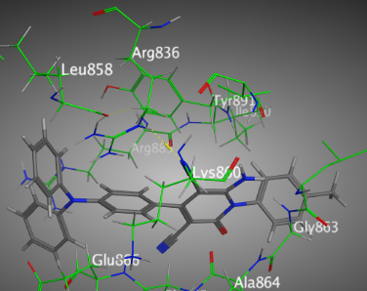
2D | 3D (active sites)
Figure (S66): Interactions of 4b with the residues of (PDB ID: 2ITO) (green: H-acceptor bond).

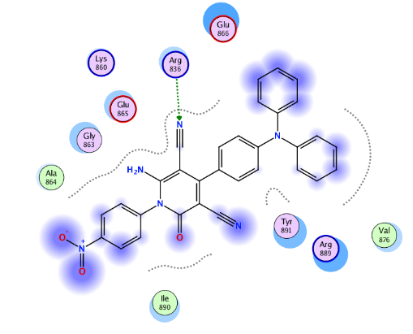 | 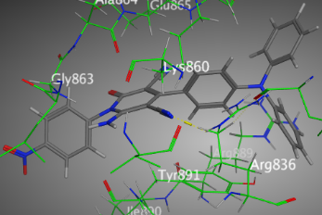
2D | 3D (active sites)
Figure (S67): Interactions of 4e with the residues of (PDB ID: 2ITO) (green: H-acceptor
bond).

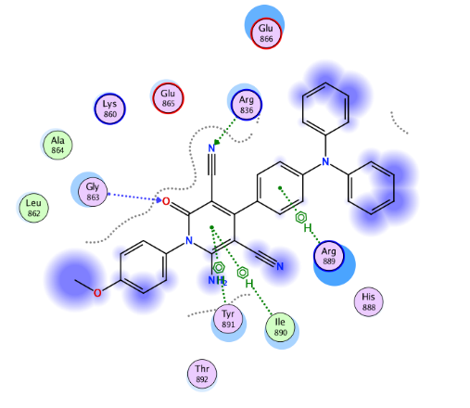 | 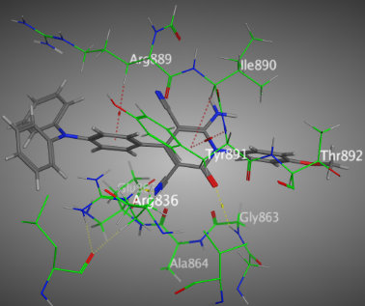
2D | 3D (active sites)
Figure (S68): Interactions of 4c with the residues of (PDB ID: 2ITO) (blue: H-acceptor bond,
green: H-acceptor bond, green ….….: π-H, green ….….: π-π).

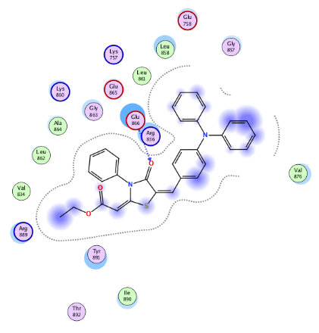 | 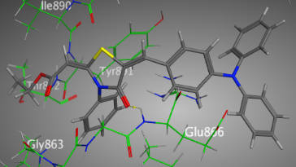
2D | 3D (active sites)
Figure (S69): Interactions of 8 with the residues of (PDB ID: 2ITO) (blue: H-acceptor bond).

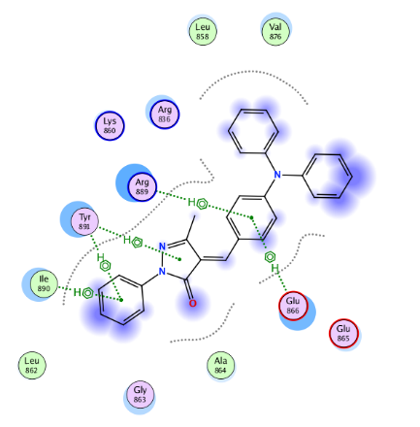 | 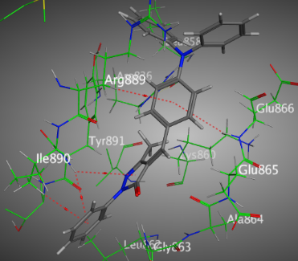
2D | 3D (active sites)
Figure (S70): Interactions of 9 with the residues of (PDB ID: 2ITO) (green ….….: π-H)

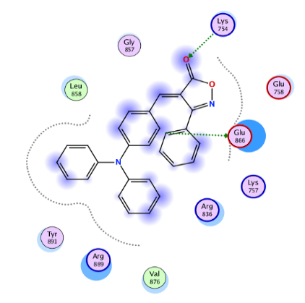 | 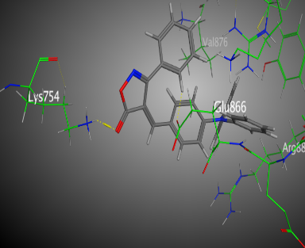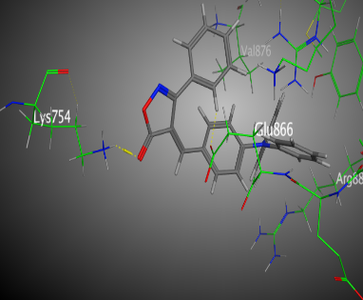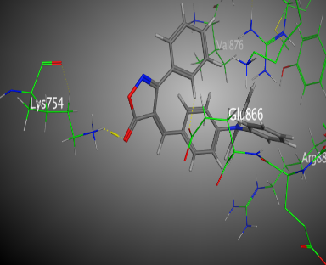
2D | 3D (active sites)
Figure (S71): Interactions of 10 with the residues of (PDB ID: 2ITO) (green: H-donor bond,
green: H-acceptor bond).

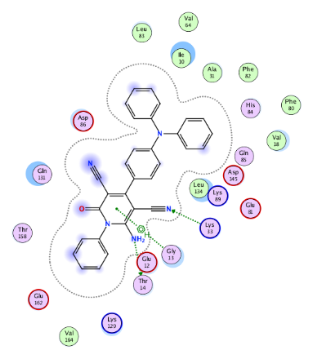 | 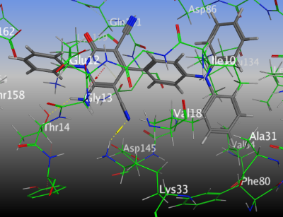
2D | 3D (active sites)
Figure (S72): Interactions of 4a with the residues of (PDB ID: 2A4L) (green: H-donor bond,
green: H-acceptor bond, green …….: π-H).

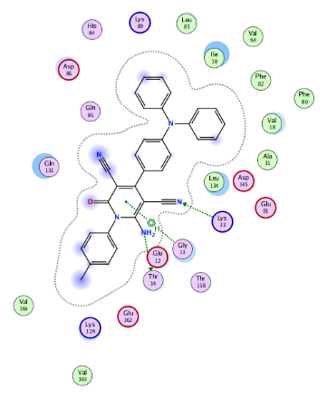 | 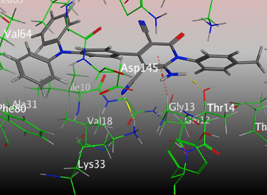
2D | 3D (active sites)
Figure (S73): Interactions of 4b with the residues of (PDB ID: 2A4L) (green: H-donor bond,
green: H-acceptor bond, green ….….: π-H).

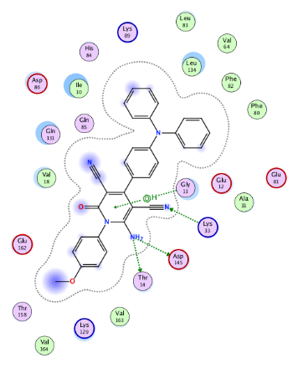 | 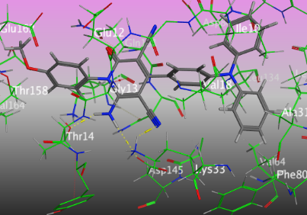
2D | 3D (active sites)
Figure (S74): Interactions of 4c with the residues of (PDB ID: 2A4L) (green: H-donor bond,
green: H-acceptor bond, green ….….: π-H).

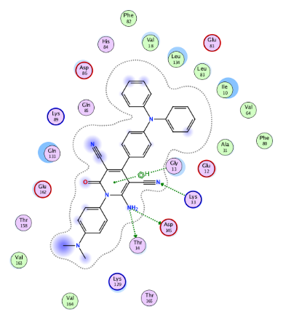 | 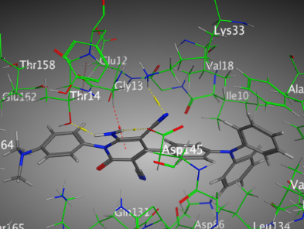
2D | 3D (active sites)
Figure (S75): Interactions of 4d with the residues of (PDB ID: 2A4L) (green: H-donor bond,
green: H-acceptor bond, green ….….: π-H).

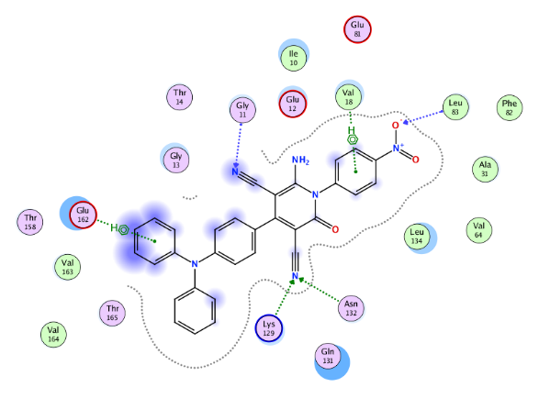 | 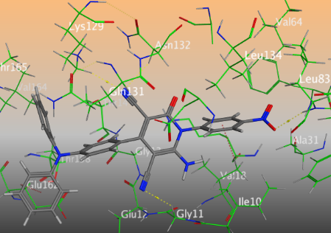
2D | 3D (active sites)
Figure (S76): Interactions of 4e with the residues of (PDB ID: 2A4L) (green: H-acceptor
bond, blue: H-acceptor bond, green ….….: π-H).

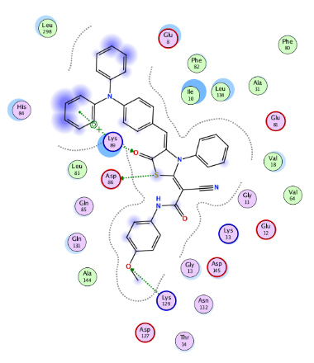 | 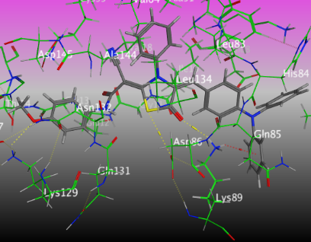
2D | 3D (active sites)
Figure (S77): Interactions of 6d with the residues of (PDB ID: 2A4L) (green: H-donor
bond, green: H-acceptor bond, green ….….: π-H).

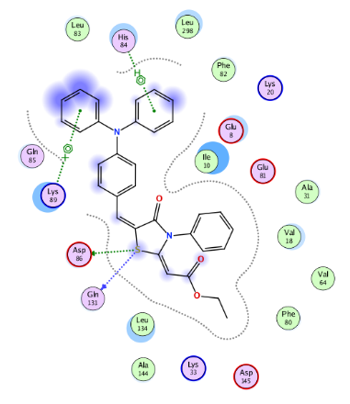 | 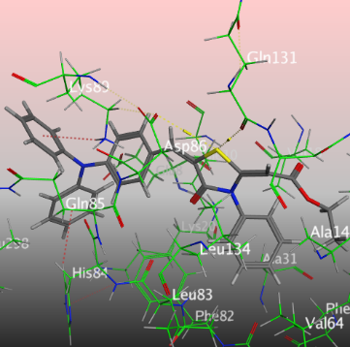
2D | 3D (active sites)
Figure (S78): Interactions of 8 with the residues of (PDB ID: 2A4L) (green: H-donor bond,
blue: H-donor bond, green ….….: π-H, green …..…….. : π-cation).

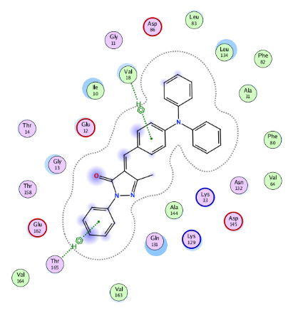 | 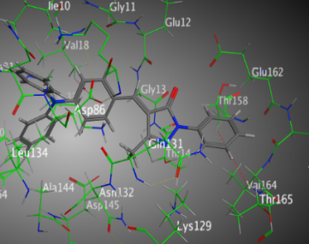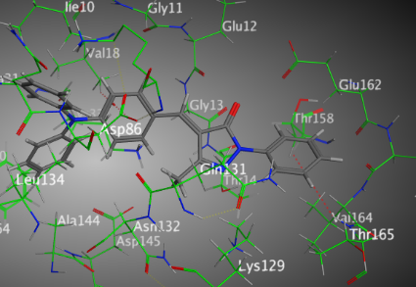
2D | 3D (active sites)
Figure (S79): Interactions of 9 with the residues of (PDB ID: 2A4L) (green ….….: π-H).

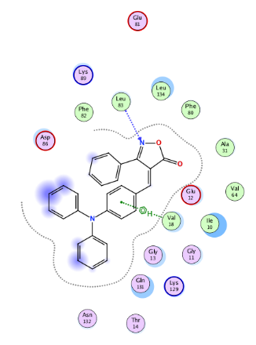 | 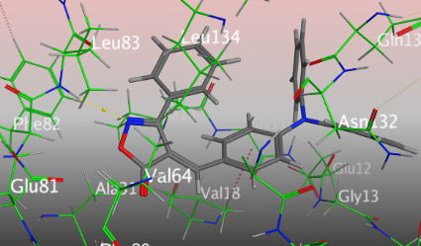
2D | 3D (active sites)
Figure (S80): Interactions of 10 with the residues of (PDB ID: 2A4L) (blue: H-acceptor
bond, green ….….: π-H

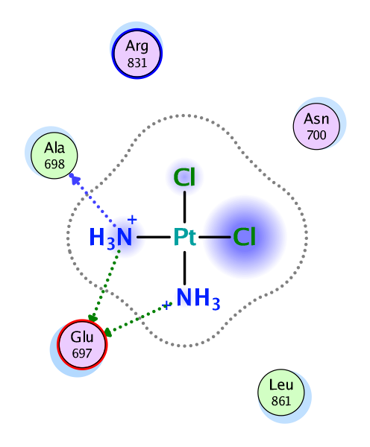 | 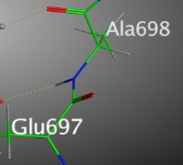  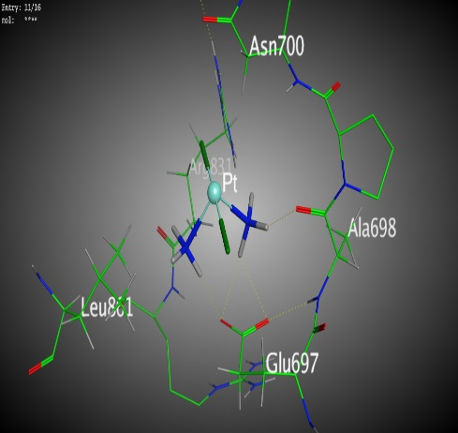
2D | 3D (active sites)
Figure (S81): Interactions of cisplatin with the residues of (PDB ID: 2ITO) (blue: H-donor
bond, green: H-donor bond).

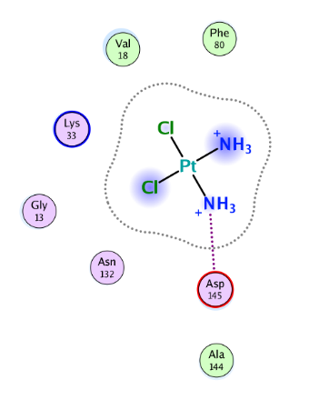 | 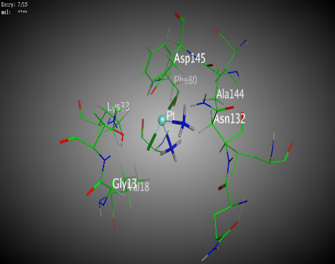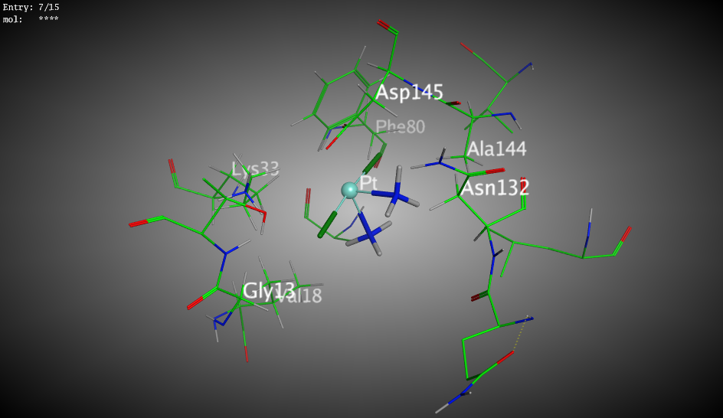
2D | 3D (active sites)
Figure (S82): Interactions of cisplatin with the residues of (PDB ID: 2A4L) (pink: ionic bond)

