Additional file

Compound 1
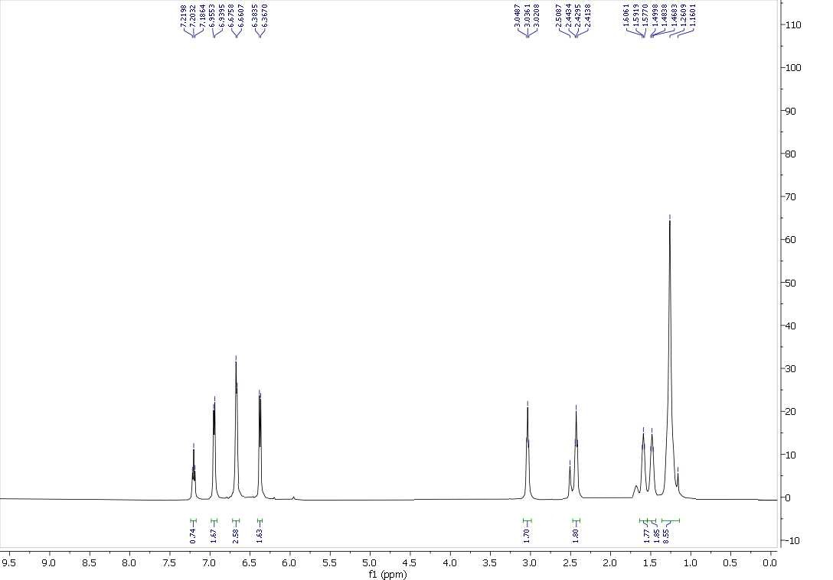
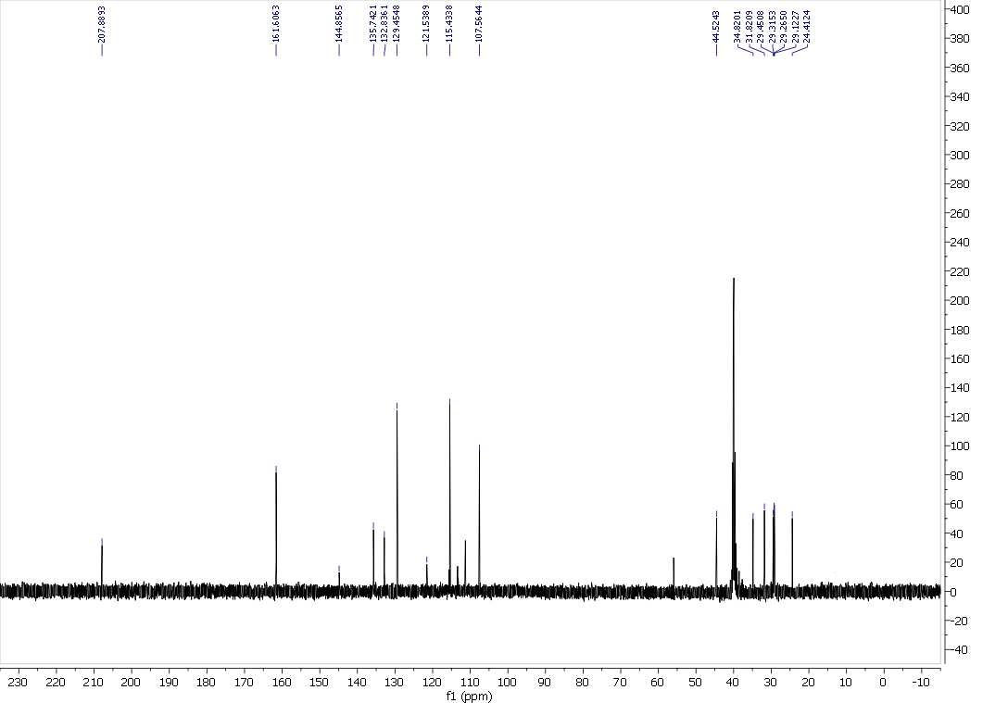

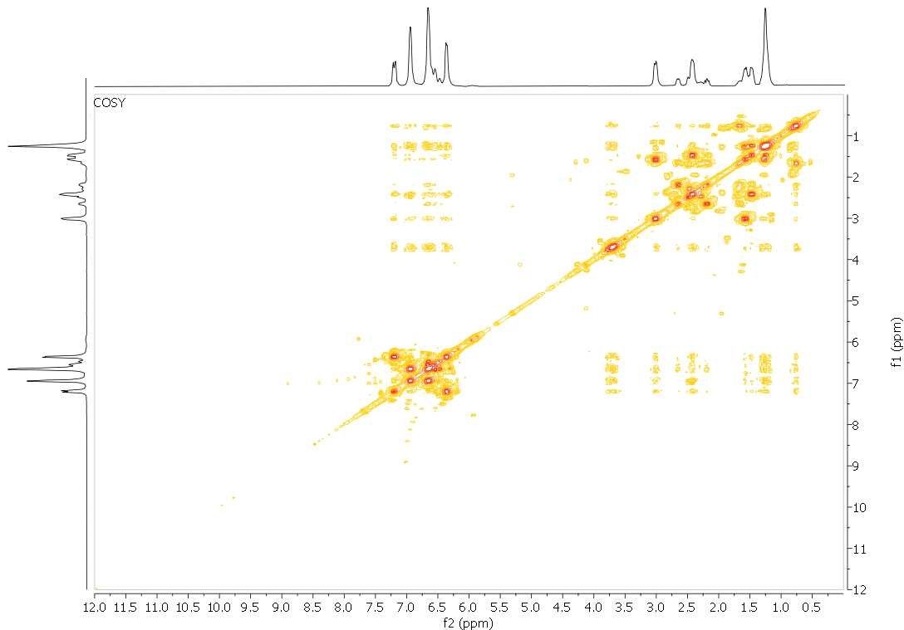

Compound 2
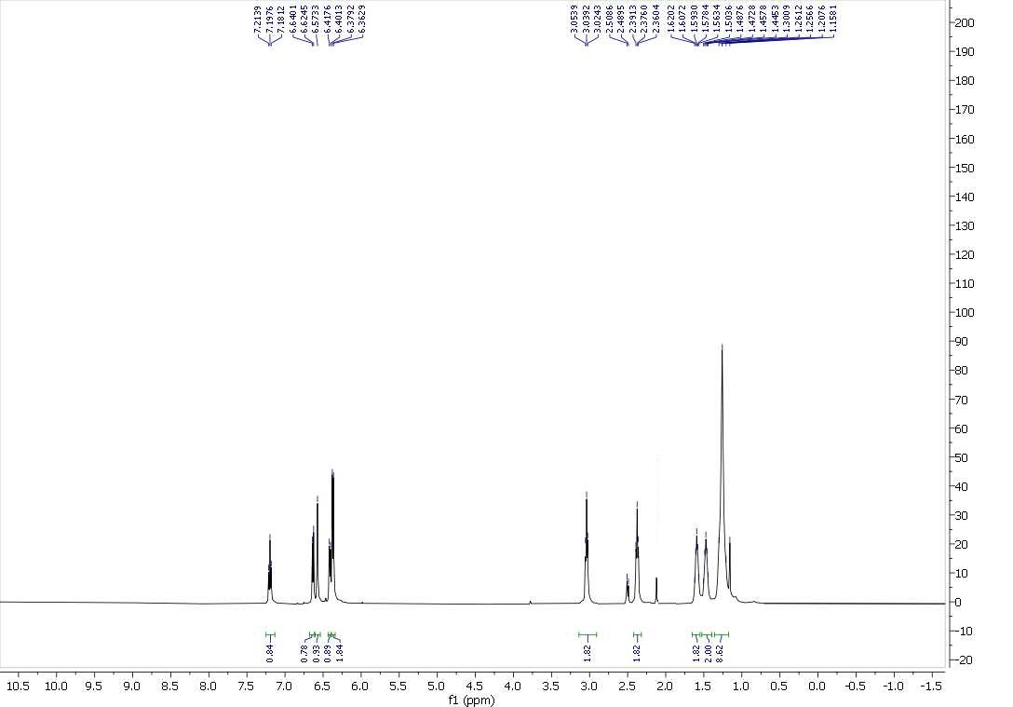
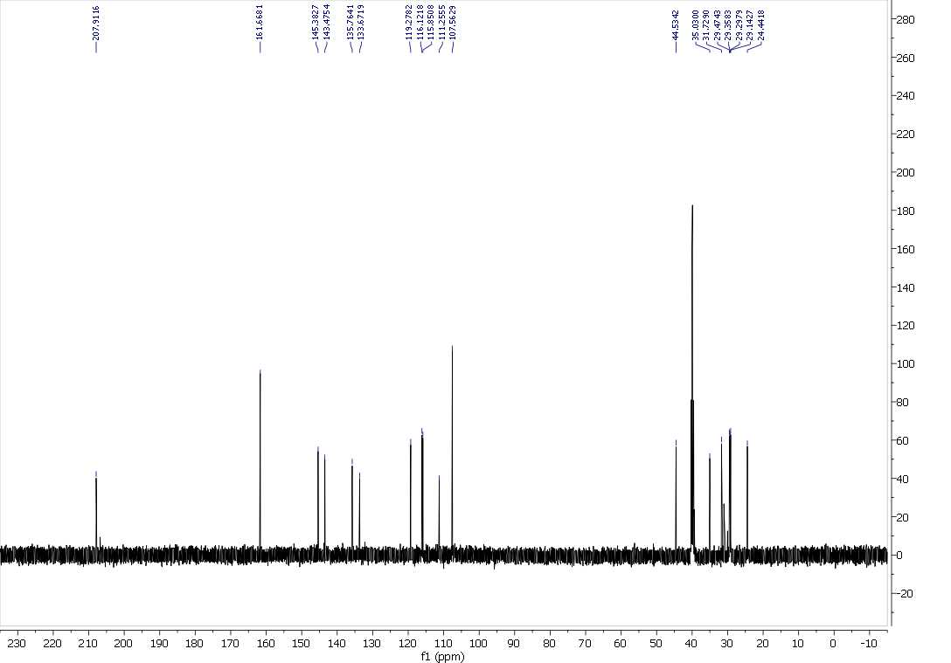

Compound 3
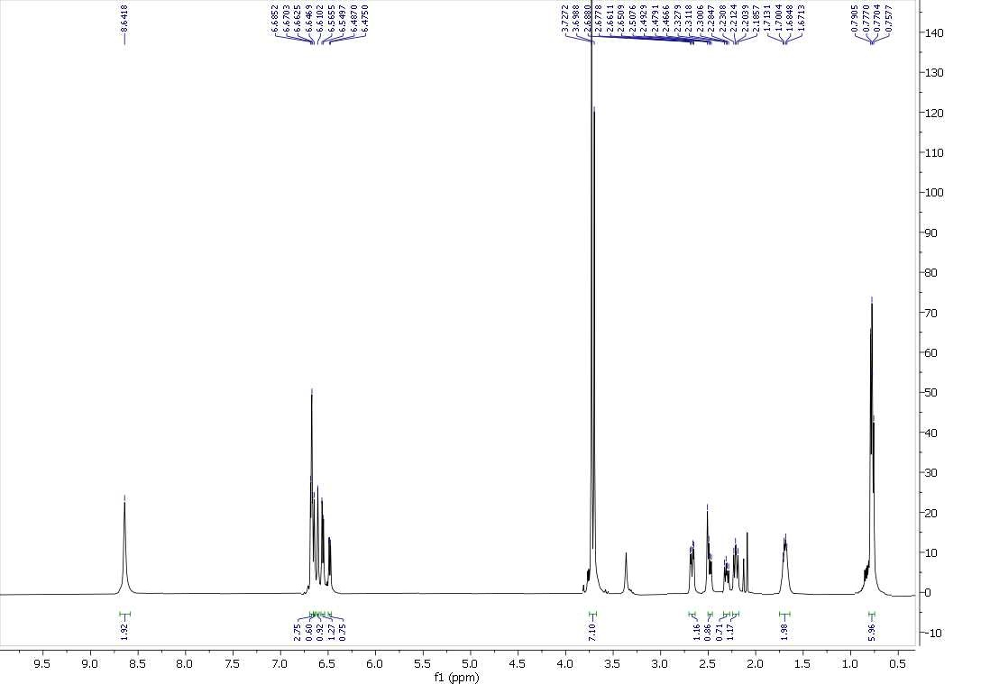
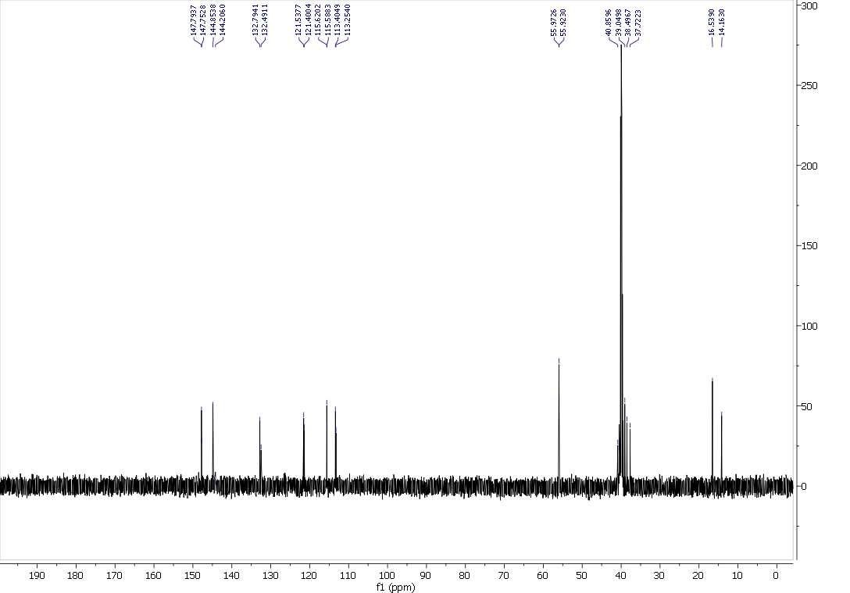
Compound 4
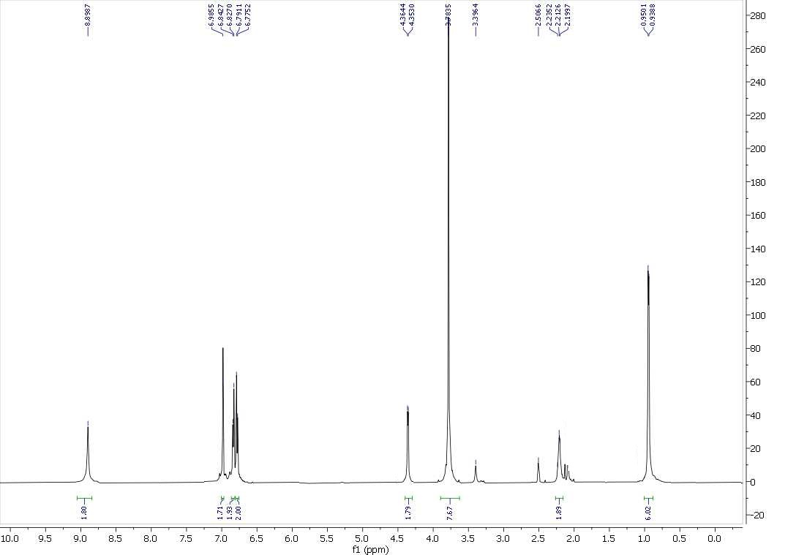

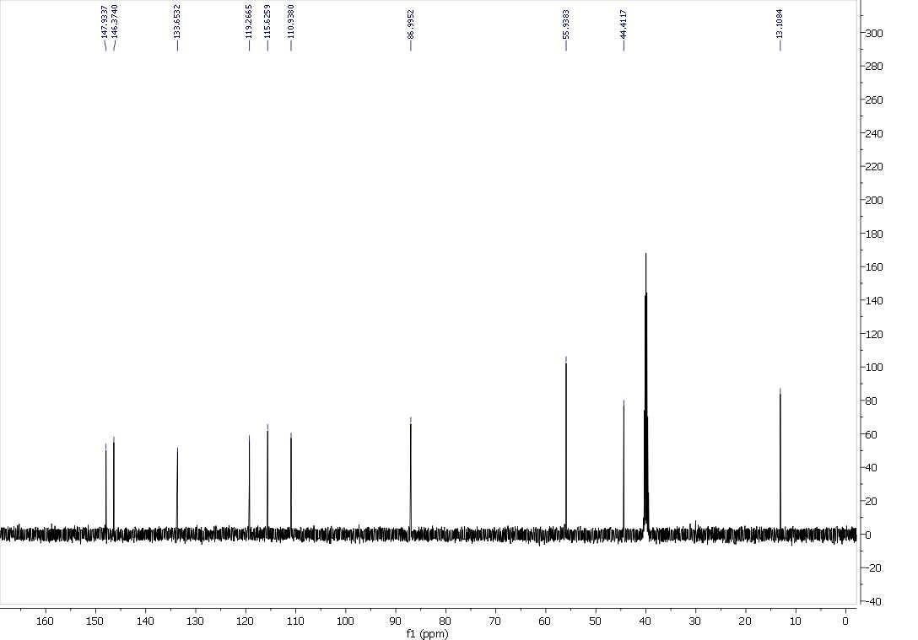
Compound 5
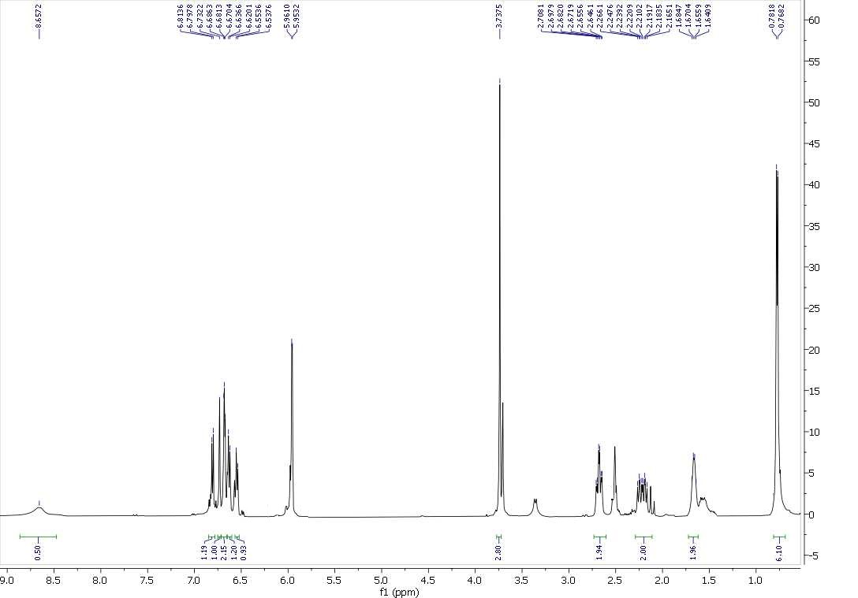
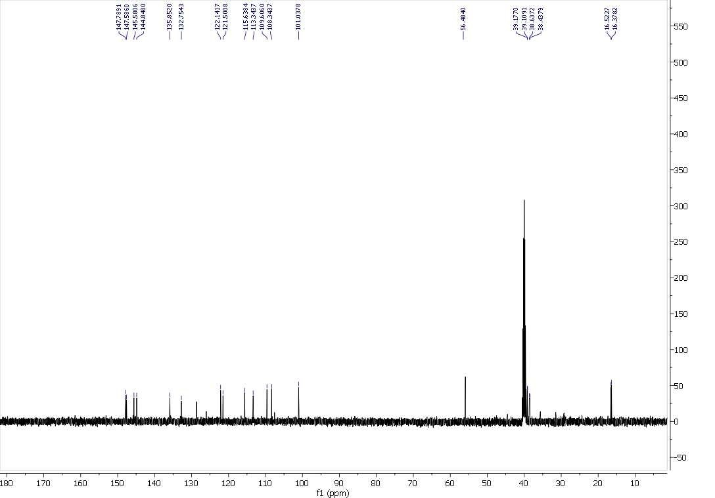

Compound 6
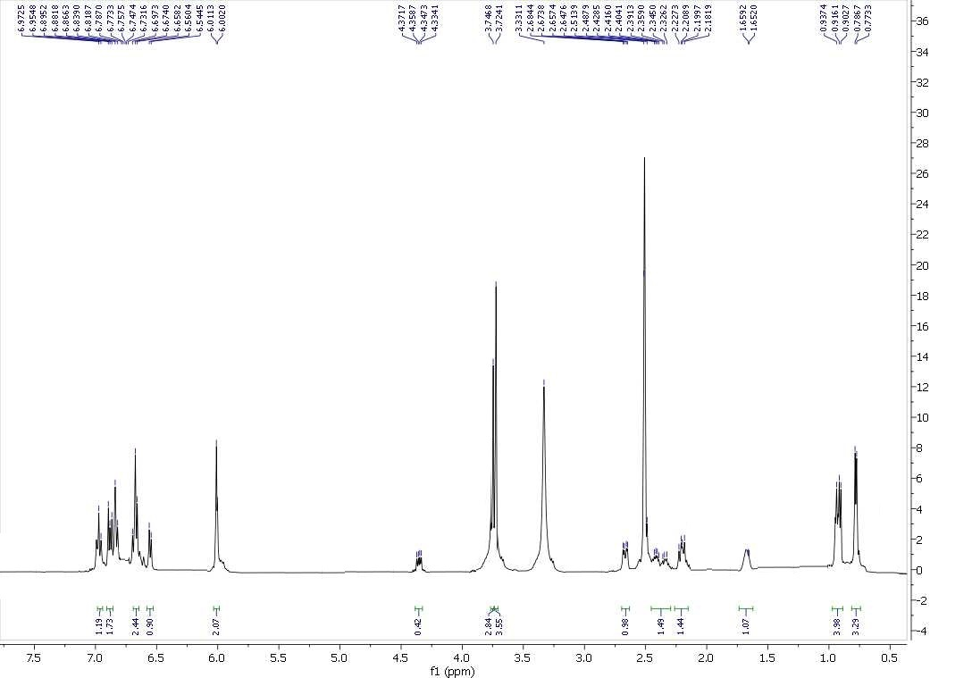
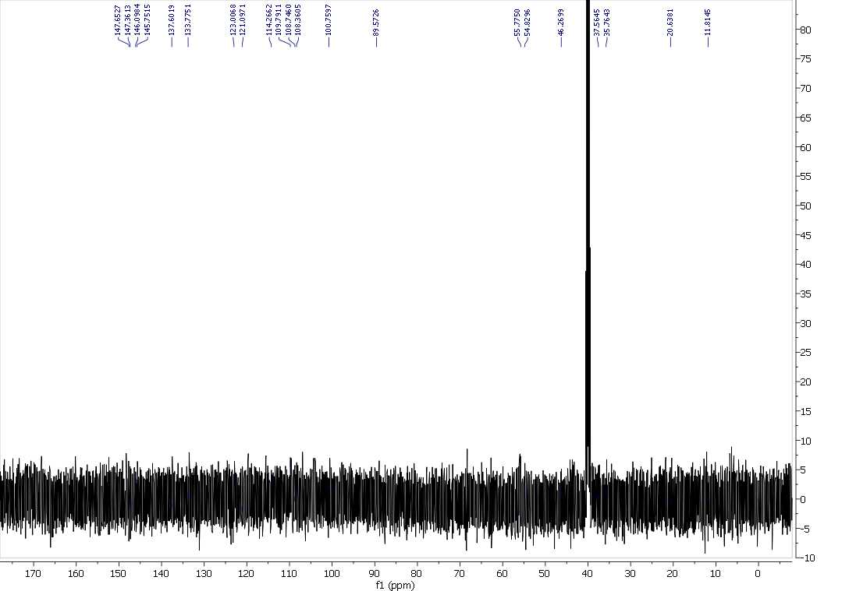

Table S1. Isolated compounds from the aril of M. fragrans
No. | Compound name | No. | Compound name
1 | Macelignan [(2R,3S)-1-(3,4 melhylenedioxyphenyl)-2,3-dimethyl-4-(4- hydroxy-3-methoxyphenyl)-butane] | 44 | (+)-Erythro-(1S,2R)-2-(4-allyl-2,6-dimethoxyphenoxy)-1-(3,4,5-trimethoxyphenyl) propan-1-ol
2 | Meso-dihydroguaiaretic acid | 45 | Erythro-2-(4-allyl-2,6-dimethoxyphenoxy)-1-(4-hydroxy-3-methoxyphenyl) propan-1-ol
3 | 2,3-Dimethyl-1,4-bis-(3,4 methylenedioxyphenyl) butan-1-ol | 46 | (+)-Erythro-(1S,2R)-2-(4-allyl-2,6-dimethoxyphenoxy)-1-(4-hydroxy-3-methoxyphenyl) propan-1-ol
4 | Nectandrin B | 47 | Myrislignan [(−)-erythro-(1R,2S)-2-(4-allyl-2,6-dimethoxyphenoxy)-1-(4-hydroxy-3-methoxyphenyl) propan-1-ol]
5 | Fragransin A₂ | 48 | Threo-2-(4-allyl-2,6-dimethoxyphenoxy)-1-(4-hydroxy-  3-methoxyphenyl) propan-1-ol
6 | Verrucosin [7S,8S,7′R,8′S)-4,4′-dihydroxy-3,3′-dimethoxy-7,7′-epoxylignan] | 49 | (−)-Erythro-(1R,2S)-2-(4-allyl-2,6-dimethoxyphenoxy)-1-(3,4-dimethoxyphenyl) propan-1-ol
7 | Fragransin B₁ | 50 | Erythro-2-(4-allyl-2,6-dimethoxyphenoxy)-1-(3,4-methylenedioxyphenyl) propan-1-ol acetate
8 | Fragransin B₂ | 51 | (−)-Erythro-(1R,2S)-2-(4-allyl-2,6-dimethoxyphenoxy)-1-(3,4-methylenedioxyphenyl) propan-1-ol acetate
9 | Fragransin B₃ | 52 | Erythro-2-(4-allyl-2,6-dimethoxyphenoxy)-1-(3,4-dimethoxyphenyl) propan-1-ol acetate
10 | Fragransin C₁ | 53 | (1S,2R)-2-(4-Allyl-2,6-dimethoxyphenoxy)-1-(3,4-dimethoxyphenyl) propan-1-ol acetate
11 | Fragransin C₂ | 54 | Maceneolignan H [(−)-erythro-(1R,2S)-2-(4-allyl-2,6-dimethoxyphenoxy)-1-(3,4-dimethoxyphenyl) propan-1-ol acetate]
12 | Fragransin C_{3a} | 55 | (1S,2R)-2-(4-Allyl-2,6-dimethoxyphenoxy)-1-(4-hydroxy-3-methoxyphenyl) propan-1-ol acetate
13 | Fragransin C_{3b} | 56 | Erythro-2-(4-allyl-2,6-dimethoxyphenoxy)-1-(5-acetoxy-3,4-dimethoxyphenyl) propan-1-ol acetate
14 | Fragransin D₁ | 57 | 2-(4-Allyl-2,6-dimethoxyphenoxy)-1-(3,4,5-trimethoxyphenyl) propane
15 | Fragransin D₂ | 58 | (−)-(2R)-2-(4-allyl-2,6-dimethoxyphenoxy)-1-(3,4,5-trimethoxyphenyl)propane
16 | Fragransin D₃ | 59 | (−)-(2R)-2-(4-allyl-2,6-dimethoxyphenoxy)-1-(3,4-methylenedioxyphenyl) propane
17 | Fragransin E₁ or machilin F | 60 | Threo-2-(4-allyl-2,6-dimethoxyphenoxy)-1-(4-hydroxy-3-methoxyphenyl) propan-1-ol methyl ether
18 | Austrobailignan-7 | 61 | Erythro-2-(4-allyl-2,6-dimethoxyphenoxy)-1-(4-hydroxy-3-methoxyphenyl) propan-1-ol methyl ether
19 | Licarin A or dehydrodiisoeugenol | 62 | Erythro-2-(4-allyl-2,6-dimethoxyphenoxy)-1-(4-hydroxy-3,5-dimethoxyphenyl) propan-1-ol
20 | (+)-Licarin | 63 | Maceneolignan F [(+)-erythro-(1S,2R)-2-(4-allyl-2,6-dimethoxyphenoxy)-1-(4-hydroxy-3,5-dimethoxyphenyl) propan-1-ol]
21 | (2S,3S)-2,3-Dihydro-2-(4-hydroxy-3,5-dimethoxyphenyl)-7-methoxy-3-methyl-5-(E-propenyl) benzofuran | 64 | 2-(4-Allyl-2,6-dimethoxyphenoxy)-1-(4-hydroxy-3-methoxyphenyl) propane
22 | Isolicarin A | 65 | (−)-(2R)-2-(4-Allyl-2,6-dimethoxyphenoxy)-1-(4-hydroxy-3-methoxyphenyl) propane
23 | Odoratisol A [3′-methoxy-licarin A] | 66 | Erythro-2-(4-allyl-2,6-dimethoxyphenoxy)-1-(3-hydroxy-4,5-dimethoxyphenyl) propan-1-ol
24 | Maceneolignan A [(2R,3R)-2,3-Dihydro-2-(4-hydroxy- 3,5-dimethoxyphenyl)-7-methoxy-3-methyl-5 (E-propenyl)benzofuran] | 67 | Erythro-2-(4-allyl-2,6-dimethoxyphenoxy)-1-(3,4,5-trimethoxyphenyl) propan-1,3-diol
25 | (2S,3S)-2,3-Dihydro-2-(4-hydroy-3,5-dimethoxyphenyl)- 7-methoxy-3-methyl-5-(E-propenyl) benzofuran | 68 | Erythro-2-(4-allyl-2-methoxyphenoxy)-1-(4-hydroxy-3- methoxyphenyl) propan-1-ol
26 | Licarin B | 69 | Threo-2-(4-allyl-2-methoxyphenoxy)-1-(4-hydroxy-3-methoxyphenyl) propan-1-ol
27 | (2S,3S)-2,3-Dihydro-2-(3,4-methylenedioxyphenyl)-7- methoxy-3-methyl-5-(E-propenyl) benzofuran | 70 | Erythro-1-(4-hydroxy-3-methoxyphenyl)-2-(2-methoxy-4-(1(E)-propenyl) phenoxy) propan-1-ol
28 | 3′-Methoxy-licarin B | 71 | Machilin D [threo-1-(4-hydroxy-3-methoxyphenyl)-2-(2-methoxy-4-(1(E)-propenyl) phenoxy) propan-1-ol]
29 | Maceneolignan B [(2R,3R)-3′-methoxy-licarin B] | 72 | Erythro-1-(4-hydroxy-3-methoxyphenyl)-1-methoxy-2-(2-methoxy-4-(1(E)-propenyl) phenoxy) propane
30 | (2S,3S)-2,3-Dihydro-2-(5-methoxy-3,4-methylenedioxyphenyl)-7-methoxy-3-methyl-5-(E-propenyl) benzofuran | 73 | Threo-1-(4-hydroxy-3-methoxyphenyl)-1-methoxy-2-(2-methoxy-4-(1(E)-propenyl) phenoxy) propane
31 | Licarin C | 74 | Threo-1-(4-hydroxy-3,5-dimethoxyphenyl)-2-(2-methoxy- 4-(1(E)-propenyl) phenoxy) propan-1-ol
32 | Maceneolignan C | 75 | Myrifralignan C [(1R,2S)-1-(4-hydroxy-3,5-dimethoxyphenyl)-2-(4-(1(E)-propenyl)-2-methoxy phenoxy) propan-1-ol]
33 | Maceneolignan D | 76 | Maceneolignan G [(+)-erythro-(1S,2R)-2-(4-acroloyl-2,6-dimethoxyphenoxy)-1-(4-hydroxy-3-methoxyphenyl) propan-1-ol]
34 | Maceneolignan E | 77 | Myristicanol A [erythro-2-(4-(3-hydroxy-1-(E)-propenyl)-2,6-dimethoxyphenoxy)-1-(3,4,5-trimethoxyphenyl) propan-1-ol]
35 | (2S,3S)-2-(4-Hydroxy-3-methoxyphenyl)-5-formyl-7-methoxy-3-methyldihydrobenzofuran | 78 | Myristicanol B [erythro-2-(4-(3-hydroxy-1-(E)-propenyl)-2,6-dimethoxyphenoxy)-1-(3,4-dimethoxyphenyl) propan-1-ol]
36 | Fragransol A | 79 | Myrislignanometin E [(1R,2S)-2-(4-(3-hydroxy-1-(E)-propenyl)-2,6-dimethoxyphenoxy)-1-(4-hydroxy-3-methoxyphenyl) propan-1-ol]
37 | Fragransol B | 80 | Maceneolignan I
38 | Fragransol C | 81 | (−)-Miliusfragranol B
39 | Fragransol D | 82 | Maceneolignan J
40 | Isodihydrocarinatidin | 83 | Maceneolignan K
41 | Dihydrocarinatidin | 84 | 1-Deoxycarinatone [2-[(1S)-2-(4-hydroxy-3-methoxyphenyl)-1-methylethyl]-6-methoxy-4-(prop-2-enyl)phenol]
42 | (+)-Erythro-(1S,2R)-2-(4-allyl-2,6-dimethoxyphenoxy)-1-(3,4-methylenedioxyphenyl) propan-1-ol | 85 | (S)-1-(3,4,5-Trimethoxyphenyl)-2-(3-methoxy-5-(prop-1-yl) phenyl)-propan-1-ol
43 | Erythro-2-(4-allyl-2,6-dimethoxyphenoxy)-1-(3,4,5-trimethoxyphenyl) propan-1-ol

