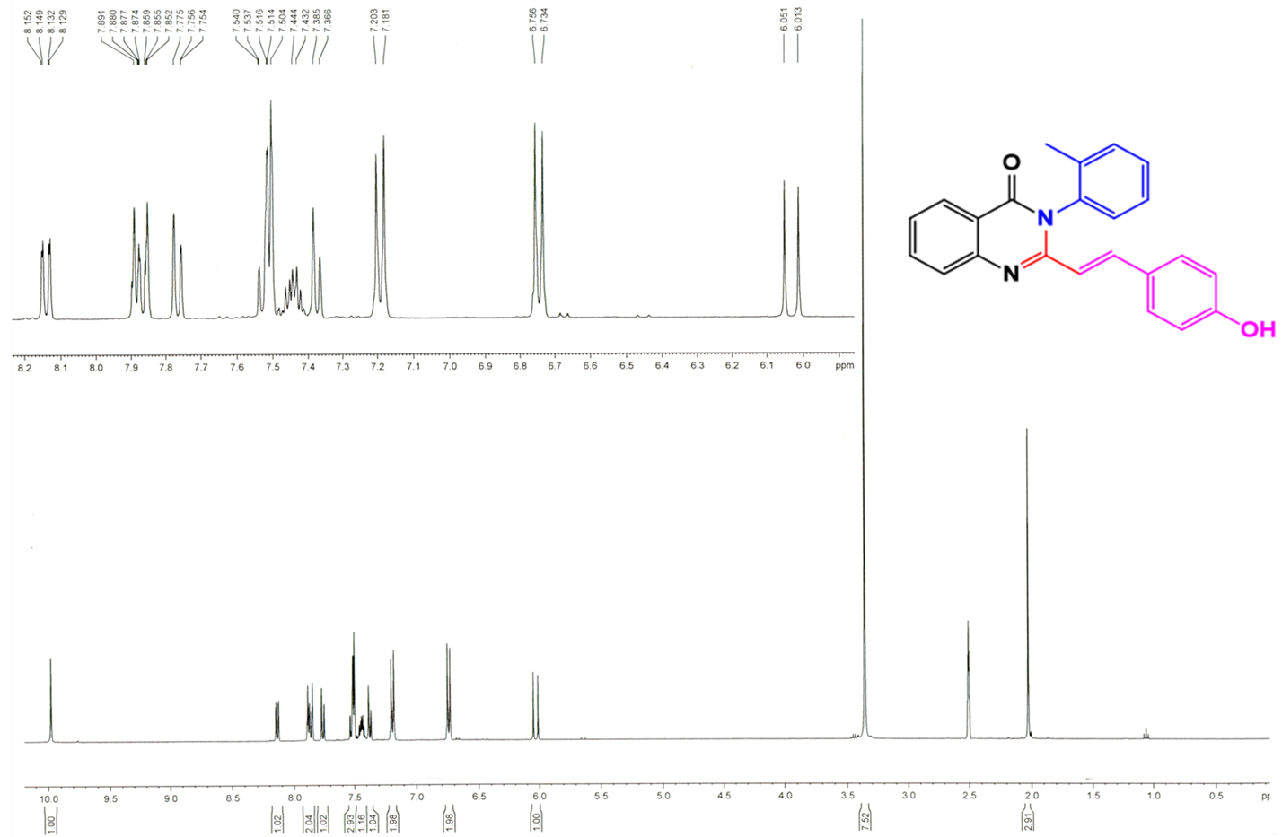
Figure S6: ₁H NMR spectrum of compound 11 in DMSO-d₆

