Additional file 1
Ultra-High Resolution X-ray Structure of Orthorhombic Bovine Pancreatic Ribonuclease A at 100K

David. R. Lisgartenª, Rex A. Palmer^{b*}, Jon B. Cooper^{c} , Claire E. Naylor^{d}, Rosemary. C. Talbertª, Brendan J. Howlin^{e}, John N. Lisgarten^{f} , Janez Konc^{g}, Shabir Najmudin^{h} and Carina M. C. Lobley^{i}

(a)Biomolecular Research Group, School of Psychology and Life Sciences, Canterbury Christ Church University, North Holmes Road, Canterbury, Kent CT1 1QU, UK david.lisgarten@canterbury.ac.uk +44(0)1227783903, rosemary.talbert@canterbury.ac.uk +44(0)1227783924

(b) Department of Crystallography, Biochemical Sciences, Birkbeck College, Malet St, London WC1E7HX, UK rex.palmer@btinternet.com +44( 0)2084491049

(c) Division of Medicine, UCL, Gower Street, London, WC1E 6BT and Department of Biological Sciences, Birkbeck, University of London, Malet Street, Bloomsbury, London, WC1E 7HX. jon.cooper@ucl.ac.uk
(d)
Kisaco Research, 41a Maltby Street, London, SE1 3PA. censtares@googlemail.com

(e) Chemical Sciences Division, Faculty of Health and Medical Sciences, University of Surrey, Guildford, Surrey GU2 7HX, UK b.howlin@surrey.ac.uk+44(0)1483300800.
(f) School of Science, University of Greenwich (Medway Campus), Chatham Maritime,
Kent ME4 4TB, UK J.Lisgarten@greenwich.ac.uk
(g) National Institute of Chemistry, Hajdrihova 19 SI-1000, Ljubljana, Slovenia. konc@cmm.ki.si
(h) Randall Centre for Cell and Molecular Biophysics, 3rd floor New Hunt's House, Faculty of Life Sciences and Medicine, King's College, London SE1 1UL, UK shabir.najmudin@kcl.ac.uk.
(i) European Spallation Source ERIC Lund, Kalmar County, Sweden carina.lobley@diamond.ac.uk

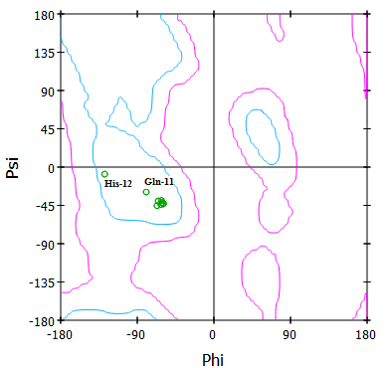
Figure S1: Orthorhombic RNase A. Ramachandran Plot for alpha helix I. With the exception of His-12 and Gln-11 the (φ, ψ) values are well placed in the alpha helix region. The distortion associated with these deviations is evident in Figure 8.
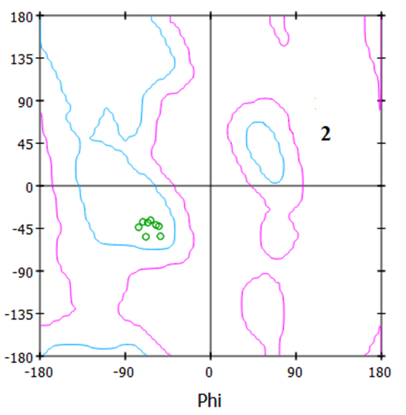
Figure S2: Orthorhombic RNase A. Ramachandran Plot for alpha helix II. All the (φ, ψ) values are well placed in the alpha helix region.
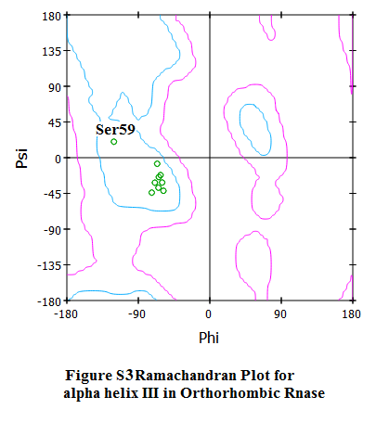
Figure S3: Ramachandran Plot for alpha helix III in Orthorhombic RNase A. The main chain conformation deviates slightly from the ideal at residue Ser-59.

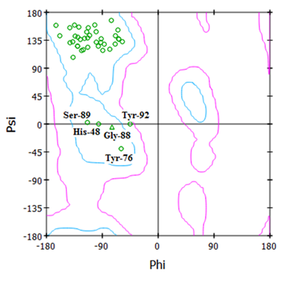

Figure S4: Ramachandran Plot for Beta Sheets in Orthorhombic RNase A. The main chain conformation is well within the accepted Beta Sheet region.

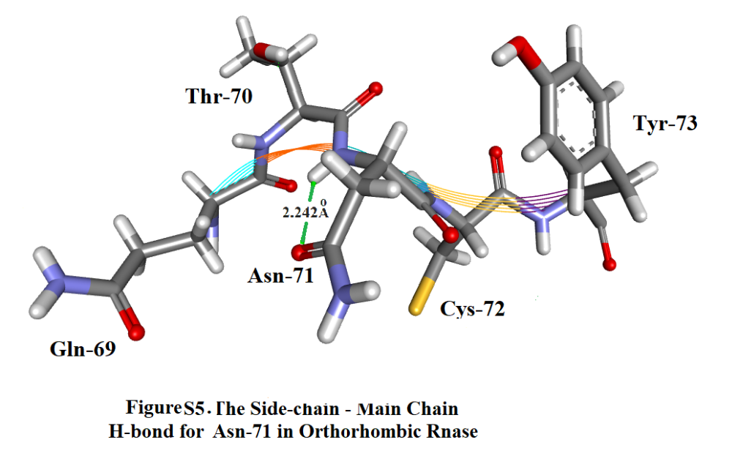

Figure S5. The Side-Chain – Main – Chain H-bond for Asn-71 in Orthorhombic RNase A.
Table S1: Numbers of Protein-Protein and Protein Solvent Hydrogen Bonds
Residue Protein-Protein Protein-Water Solvent

K1 Lys-1 2 [Glu-2 Thr-3] 4
E2 Glu-2 2 [Lys-1 Arg-10] 3
T3 Thr-3 4 [Lys-1Ala-5Ala-6 Lys-7] 0
A4 Ala-4 1 [Phe-8] 1
A5 Ala-5 4 [Thr-3, Phe-8] 2
[Glu-9, Pro-117]
A6 Ala-6 3 [Thr-3, Glu-9, Arg-10] 1
K7 Lys-7 3 [Thr-3, Arg-10, Gln-11] 0
F8 Phe-8 3 [Ala-4, Ala-5, His-12] 0
E9 Glu-9 4 [Ala-5, His-12] 5
[Arg-33, Ala-6]
R10 Arg-10 5 [Lys-7, Glu-2] 0
Fig 9 [Arg-33, Asn-34, Ala-6] 0
Q11 Gln-11 3 [Lys-7, Lys-41, Asn-44] 2 SO41152 H2O2174
H12 His-12 5 [Phe-8, Glu-9, Thr-45] 0
[Phe-46, Val-47]
X13 Met-13 2 [Glu-9, Arg-33] 0
D14 Asp-14 5 [Arg-33, Val-47, Thr-17] 0
[Tyr-25, His-48]
S15 Ser-15 1 [Glu-49] 0 SOE1168
S16 Ser-16 0 2 HOH2040 HOH2028
T17 Thr-17 2 [Asp-14], [His-48] 0
S18 Ser-18 1 [Ser-80] 2
A19 Ala-19 1 [Gln-101] 0
A20 Ala-20 1 [Gln-101] 1 ETOH1162/11163 H202163
S21 Ser-21 0* 0
S22 Ser-22 2 [Asn-24, Tyr-25] 0 SO41153
S23 Ser-23 0 1 SO41153 EOH1165
N24 Asn-24 3 [Ser-22, Asn-27, Gln-28] 2 ETOH1165
Y25 Tyr-25 4 [Ser-22, Asp-14, Gln-28] 0
[Met-29]
C26 Cys-26 2 [Thr-99, Met-30] 0
N27 Asn-27 3 [Asn-24, Tyr-97, Lys-31] 2
Q28 Gln-28 4 [Asn-24, Tyr-25, Lys-31] 2
[Ser-32]
M29 Met-29 2 [Tyr-25, Arg-33] 1
M30 Met-30 2 [Cys-26, Leu-35] 0
K31 Lys-31 3 [Asn-27, Gln-28, Asn-34] 1
S32 Ser-32 1 [Gln-28] 1
R33 Arg-33 4 [Asp-14, Arg-10, Met-29] 0 [Glu-9]
N34 Asn-34 3 [Arg-10, Lys-31, Lys-37] 1
L35 Leu-35 2 [Met-30, Lys-41] 1
T36 Thr-36 1 [Arg-39] 1
K37 Lys-37 2 [Arg-39, Asn-34] 1
D38 Asp-38 1 [Tyr-92] 2
R39 Arg-39 1 [Lys-37, Thr-36] 1

Residue Protein-Protein Protein-Water Solvent

C40 Cys-40 1 [Pro-42] 1
K41 Lys-41 4 [Leu-35, Gln-11] 2 SO41152
[Tyr-97, Val-43]
P42 Pro-42 3 [Glu-86, Cys-40, Arg-85] 0
V43 Val-43 2 [Lys-41, Cys-84] 0
N44 Asn-44 2 [Cys-84, Gln-11] 2
T45 Thr-45 3 [His-12, Asp-83, Thr-82] 2
F46 Phe-46 3 [Thr-82, His-12, Ile-81] 0
V47 Val-47 4 [Asp-14, His-12] 0
[Glu-49, Ser-80]
H48 His-48 3 [Ser-80, Asp-14, Thr-17] 0
E49 Glu-49 4 [Ser-15, Val-47] 0
[Ser-80, Met-79]
S50 Ser-50 2 [Asp-53, Val-54] 0 SOE1168
L51 Leu-51 2 [Val-54, Gln-55] 0 SOE1168
A52 Ala-52 2 [Ala-56, Gln-55] 1 SOE1168
D53 Asp-53 1 [Ser-50] 1
V54 Val-54 3 [Ser-50, Leu-51, Val-57] 0
Q55 Gln-55 5 [Leu-51, Cys-58, Ala-52] 2
[Val-116, Prp-117]
A56 Ala-56 3 [Ala-52, Ser-59, Gln-60] 0
V57 Val-57 2 [Val-54, Gln-60] 0
C58 Cys-58 1 [Gln-55] 0
S59 Ser-59 1 [Ala-56] 3
Q60 Gln-60 5 [Val-57, Ala-56, Asn-62] 2
[Tyr-76, Ser-75]
K61 Lys-61 2 [Gln-74, Tyr-73] 0
N62 Asn-62 3 [Gln-60, Thr-70, Cys-72] 0 EOH 1161 [H-bond needs work]
V63 Val-63 1 [Cys-72] 0
A64 Ala-64 1 [Gln-69] 1
C65 Cys-65 3 [Gln-69, Gly-68, Asp-121] 1
K66 Lys-66 1 [Asp-121] 1
N67 Asn-67 1 [Gln-69] 2
G68 Gly-68 1 [Cys-65] 1
Q69 Gln-69 3 [Cys-65, Asn-67, Ala-64] 2
T70 Thr-70 1 [Asn-62] 0
N71 Asn-71 3 [Asn-71*, Cys-110] 1
[Ala-109]
C72 Cys-72 3 [Asn-62, Val-63] 0
Y73 Tyr-73 3 [Val-108, Lys-61, Ile-107] 0
Q74 Gln-74 3 [Lys-61, Tyr-76, Ile-106] 2
S75 Ser-75 3 [Ile-106, His-105, Gln60] 1
Y76 Tyr-76 3 [His-105, Gln-60, Gln-74] 5
S77 Ser-77 1 [Thr-78] 2

Residue Protein-Protein Protein-Water Solvent

T78 Thr-78 2 [Asn-103, Ser-77] 4
M79 Met-79 3 [Lys-104, Glu-49, Asn-103]0
S80 Ser-80 6 [His-48, Glu-49, Ser-18] 0
[Gln-101, Val-47, Asn-103]
I81 Ile-81 3 [Ala-102, Phe-46, Gln-101] 0
T82 Thr-82 4 [Phe-46, Gln-101, Thr-45] 0
[Thr-100]
D83 Asp-83 5 [Arg-85, Thr-45, Thr-100] 6
[Cys-84, Thr-99]
C84 Cys-84 4 [Asn-44, Asp-83] 0
[Val-43, Lys-98]
R85 Arg-85 4 [Asp-83, Lys-98] 1
[Pro-42, Tyr-97]
E86 Glu-86 3 [Pro-42, Ala-96, Ser-90] 3
T87 Thr-87 2 [Ala-96, Ser-90] 1
G88 Gly-88 0* 1
S89 Ser-89 0* 3 SOE1169
S90 Ser90 3 [Thr-87, Ala-96, Glu-86] 0
K91 Lys-91 2 [Tyr-92, Asn-44] 2
Y92 Tyr-92 2 [Asp-38, Lys-91] 1
P93 Pro-93 1 [Cys-95] 1
N94 Asn-94 1 [Lys-91] 0
C95 Cys-95 1 [Pr0-93] 2
A96 Ala-96 3 [Ser-90, Thr-87, Glu-86] 0
Y97 Tyr-97 3 [Asn-27, Lys-41, Arg-85] 4
K98 Lys-98 2 [Arg-85, Cys-84] 1
T99 Thr-99 2 [Cys-26, Asp-83] 4
T100 Thr-100 2 [Asp-83, Thr-82] 0
Q101 Gln-101 5 [Ala-20, Thr-82, Ser-80] 3
[Ala-19, Ile-81]
A102 Ala-102 1 [Ile-81] 0
N103 Asn-103 3 [Thr-78, Ser-80, Met-79] 2
K104 Lys-104 2 [Met-79, Val-124] 1
H105 His-105 4 [Ser-75, Val-124] 0
[Tyr-76, Ser-123]
I106 Ile-106 3 [Ser-75, Gln-74, Ala-122] 0
I107 Ile-107 3 [Tyr-73, Ala-122, Asp-121] 0
V108 Val-108 3 [Tyr-73, Cys-72, His-119] 0
A109 Ala-109 4 [His-119, Val-118] 0
[Asn-71, Pro-117]
C110 Cys-110 2 [Asn-71, Val-116] 0
E111 Glu-111 2 [Val-116, Tyr-115] 3
G112 Gly-112 1 [Tyr-115] 0 SO41151

Residue Protein-Protein Protein-Water Solvent

N113 Asn-113 1 [Pro-114] 1 SO41151
P114 Pro-114 2 [Val-116, Asn-113] 1
Y115 Tyr-115 2 [Glu-111, Gly-112] 2
V116 Val-116 4 [Glu-111, Pro-114] 0
[Cys-110, Gln-55]
P117 Pro-117 3 [Ala-5, Ala-109, Gln55] 3
V118 Val-118 1 [Ala-109] 1
H119 His-119 2 [Ala-109, Val-108] 1 SO41152
F120 Phe-120 0 3 SO41152
D121 Asp-121 3 [Lys-66, Ile-107, Cys-65] 3
A122 Ala-122 2 [Ile-107, Ile-106] 1
S123 Ser-123 1 [His-105] 3
V125 Val-124 1 [His-105, Lys-104] 1

Notes: The residues in Orthorhombic RNase A are listed in order from 1 to 124.
Explanation: For example, starting at the top of the list Lys-1 forms 2 H-bonds with Glu-2 and Thr-3 respectively and 4 H-bonds with water molecules. Ser-21 forms no H-bonds with other residues or with water molecules. *Unusually Asn-71 forms probably the only inter-chain H-bond (see Figure 12). No other H-bonds were detected for Asn-71.

Table S2: Numbers of Residues with m Protein-Protein and n Protein-Water Hydrogen Bonds Per Residue:

Protein-Protein Protein-Water Number of Residues Special Remarks
m n
0 0 1 Ser-21 1 0 6
2 0 12
3 0 13
4 0 10
5 0 2
6 0 1 Ser-80
0 1 2
1 1 10
2 1 4
3 1 2
4 1 1 Arg-85
0 2 2
1 2 5
2 2 3
3 2 7
0 3 1 Phe-120
1 3 2
2 3 2
3 3 3
4 3 0
5 3 1 Gln-101
0 4 0
1 4 0
2 4 2
0 5 0
1 5 0
2 5 0
3 5 1 Tyr-76
4 5 1 Glu-9
5 6 1 Asp-83

Explanation: This table summarises the number of residues with m Protein-Protein and n Protein-Water H-bonds. Thus Ser-21 has neither and there are 10 residues with 1 Protein-Protein and 1 Protein-Water H-bond.

Table S3. Comparison of observed electron densities between the Orthorhombic and Monoclinic structures using Coot [14].

3
- Using Coot [14] a complete survey of the electron density of individual amino acid residues in bovine pancreatic ribonuclease X-ray structures has been carried out: (a) the present 0.85Å resolution orthorhombic structure at 100K (18 problem areas) and (b) the 1.45Å resolution monoclinic structure at RT of Howlin 1989 [ ] 24 problem areas. Those residues where problems have been detected are highlighted.
- Regions where the same or similar defects have been observed are: Lys-1, Gln-28, Lys-31, Lys-41, Lys-66, Asp-83, Lys-91. This list includes 5 Lysines.
- Lys-1 and Thr-3 are close to the N-terminus.
- His-119 is close to the C-terminus and Val-124 is at the C-terminus.
- In the active site for Orthorhombic RNase only Lys-41 is bifurcated.
For 3RN3[1] Lys-7 has missing density; Lys-41 has poor density; His-119 is bifurcated.

(a) 0.85Å 100K (orthorhombic) (b) 1.45Å (monoclinic)

K1 Weak and missing after Cβ No density after Cδ
E2 Clear and complete density Clear and complete density
T3 Clear and complete density Clear except for CH₃
A4 Clear and complete density Clear and complete density
A5 Clear and complete density Clear and complete density
A6 Clear and complete density Clear and complete density
K7 Clear and complete density Clear but missing end density
F8 Clear and complete density Clear and complete density
E9 Clear and complete density Clear and complete density
Except for one oxygen missing
R10 Clear and complete density Clear and complete density
Q11 Clear and complete density Clear and complete density
H12 Clear and complete density Clear and complete density
M13 Clear and complete density Clear and complete density
D14 Clear and complete density Clear and complete density
S15 Modelled with double end OH Clear and complete density
S16 Clear and complete density Missing OH at end
T17 Clear and complete density Clear and complete density
S18 OH disordered Clear and complete density
Density otherwise good
A19 Clear and complete density Clear and complete density
A20 Clear and complete density Clear and complete density
S21 Clear and complete density Clear and complete density
S22 Clear and complete density Clear and complete density
S23 Clear and complete density Clear and complete density
N24 Clear and complete density Problems and missing density
at end of chain
Y25 Clear and complete density Clear and complete density
C26 Slight disorder at end of chain Clear and complete density N27 Clear and complete density Clear and complete density
Q28 Clear but weak Missing density at end of chain M29 Clear and complete density Clear and complete density M30 Clear and complete density Clear and complete density
K31 Side chain bifurcated but Clear but density missing after Cδ
density good
S32 Disorder at end of side chain Clear and complete density
R33 Clear and complete density Clear and complete density
N34 Clear and complete density Clean but middle density missing
L35 Side chain is bifurcated. Clear and complete density
Good density.
T36 Clear and complete density Clear and complete density
K37 Clear and complete density Poor density badly modelled D38 Clear and complete density Clear and complete density
R39 Clear and complete density Poor density after Cβ
C40 Clear and complete density Clear and complete density
K41 Clear but weak density End parts missing and badly modelled
P42 Clear and complete density Clear and complete density
V43 Clear and complete density Good but one CH₃ missing
N44 Clear and complete density Clear and complete density
T45 Clear and complete density Clear and complete density
F46 Clear and complete density Clear and complete density
V47 Clear and complete density Clear and complete density
H48 Clear and complete density Clear and complete density
E49 Clear and complete density Clear and complete density
S50 Clear and complete density Clear and complete density
L51 Good density but centrally Clear and complete density
bifurcated
A52 Clear and complete density Clear and complete density
D53 Clear and complete density Clear and complete density
V54 Clear and complete density Clear and complete density
Q55 Totally bifurcated Clear and complete density
Density good
A56 Clear and complete density Clear and complete density
V57 Clear and complete density Clear and complete density
C58 Clear and complete density Clear and complete density
S59 Clear and complete density Clear and complete density
Q60 Clear and complete density Clear and complete density
K61 Clear and complete density End density missing
N62 Clear and complete density Clear and complete density
V63 Clear and complete density Clear and complete density
A64 Clear and complete density Clear and complete density
C65 Clear and complete density Clear and complete density
K66 Double conformation at end Very poor density mostly missing
N67 Clear and complete density Clear and complete density
G68 Clear and complete density Clear and complete density
Q69 Clear and complete density Clear and complete density
T70 Clear and complete density Clear and complete density
N71 Clear and complete density Clear and complete density
C72 Clear and complete density Clear and complete density
Y73 Clear and complete density Clear and complete density
Q74 Clear and complete density Clear and complete density
S75 Clear and complete density Clear and complete density
Y76 Density good Clear and complete density but double conformation
S77 Clear and complete density Poor density and missing at end
T78 Clear and complete density Clear and complete density
M79 Clear and complete density Clear and complete density
S80 Clear and complete density Clear and complete density
I81 Clear and complete density Clear and complete density
T82 Clear and complete density Clear and complete density
D83 Goo density one O missing at end of chain but double conformation
C84 Clear and complete density one O missing at end of chain
R85 Clear and complete density Side chain mostly missing
E86 Clear and complete density one O missing at end of chain
T87 Clear and complete density Poor density some atoms missing
G88 Clear and complete density Cβ missing
S89 Clear and complete density Clear and complete density
S90 Clear and complete density Clear and complete density
K91 Weak density modelled as Very poor density, middle missing
two conformations
Y92 Clear and complete density Clear and complete density
P93 Clear and complete density Clear and complete density
N94 Clear and complete density Clear and complete density
C95 Clear and complete density Clear and complete density
A96 Clear and complete density Clear and complete density
Y97 Clear and complete density Clear and complete density
K98 Clear and complete density Density good but end two atoms missing T99 Clear and complete density Clear and complete density
T100 Double end of chain conformation Clear and complete density
Q101 Clear and complete density Clear and complete density
A102 Clear and complete density Clear and complete density
N103 Double conformation at end Clear and complete density
poor density
K104 Clear and complete density Good density but end atom missing H105 Clear and complete density Clear and complete density
I106 Clear and complete density Clear and complete density
I107 Clear and complete density Clear and complete density
V108 Clear and complete density Clear and complete density
A109 Clear and complete density Clear and complete density
C110 Clear and complete density Clear and complete density
E111 Clear and complete density Clear and complete density
G112 Clear and complete density Clear and complete density
N113 Clear and complete density V poor density even in the main chain missing atoms in side chain
P114 Clear and complete density Clear and complete density
Y115 Clear and complete density Clear and complete density
V116 Clear and complete density Clear and complete density
P117 Clear and complete density Clear and complete density
V118 Clear and complete density Clear and complete density
H119 Clear and complete density Modelled as major and minor. Minor vv weak
F120 Clear and complete density Clear and complete density
D121 Clear and complete density Clear and complete density

A122 Clear and complete density Clear and complete density S123 Clear and complete density Clear and complete density V124 Good density Clear and complete density but double conformation at end

Notes: 1. Lysine frequently has problems. 2.The side –chains of Gln-11, His-12, Lys-41, Thr-45 and His-119 are generally recognised as being closely involved in the enzyme activity. It has also been suggested that Lys-7, Asp-44, Lys-66, Phe-120, Asp-121 and Ser-123 may also have a possible role in this mechanism. In the present orthorhombic structure the only problems with any of these residues occur for Lys-41 and Lys-66 both of which have clear density. In the monoclinic structure of Howlin et al [1 ] both Lys-41 and Lys-66 are again problematic as is also Lys-7.
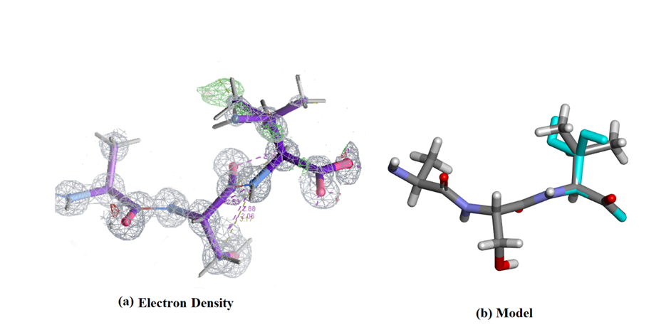

Figure S6. The last three residues of Orthorhombic RNase A. (a) Electron density (Coot [14]) and (b) model (Biovia [17]). The electron density is complete but Val-124 is disordered. Compare this diagram with Figure S7 corresponding to 3RN3.
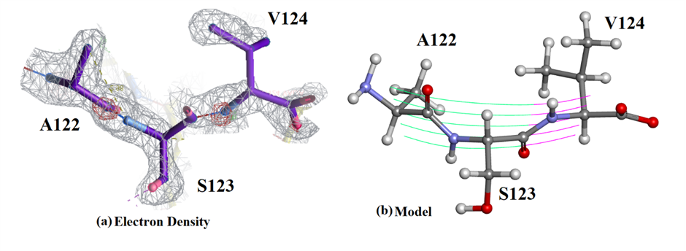
Figure S7. The last three residues of 3RN3. (a) Electron density (Coot [14]) and (b) model (Biovia [17]). Part of the electron density is missing from the Val-124 side-chain. This is contrasted by the corresponding views of Orthorhombic RNase in Figure S6. The effect of a much higher resolution, 0.85Å compared to 1.5Å, is easy to see. The density for the orthorhombic structure is also complete for this excerpt of the structure. In (b) the coloured wavy lines indicate the course of the main chain.

Table S4. Comparison of PISA interfaces between Ribonuclease 3rn3 and 7p4r

Interfaces in PDB 3rn3 crystal.
Space symmetry group: P 1 21 1. Resolution: 1.45 Å
## |  | Structure 1 |  |  |  | × | Structure 2 |  |  |  |  |  | interface  area, Å² | Δ^{i}G  kcal/mol | Δ^{i}G  P-value | N_{HB} | N_{SB} | N_{DS} | CSS
NN | «» | Range | ^{i}N_{at} | ^{i}N_{res} | Surface Å² | × | Range | Symmetry op-n | Sym.ID | ^{i}N_{at} | ^{i}N_{res} | Surface Å²
1 |  | A | 24 | 7 | 6790 | x | A | -x+2,y-1/2,-z | 2_745 | 34 | 7 | 6790 | 229.0 | 0.3 | 0.695 | 4 | 3 | 0 | 0.000
2 |  | A | 25 | 7 | 6790 | x | A | x-1,y,z | 1_455 | 19 | 8 | 6790 | 190.2 | -2.8 | 0.269 | 0 | 0 | 0 | 0.000
3 |  | A | 14 | 4 | 6790 | x | A | -x+2,y-1/2,-z+1 | 2_746 | 23 | 9 | 6790 | 169.1 | -1.3 | 0.455 | 3 | 0 | 0 | 0.000
4 |  | A | 22 | 7 | 6790 | x | A | x,y-1,z | 1_545 | 17 | 7 | 6790 | 153.0 | -1.1 | 0.470 | 2 | 0 | 0 | 0.000
5 |  | [SO4]A:155 | 5 | 1 | 187 | f | A | x,y,z | 1_555 | 18 | 8 | 6790 | 103.8 | -14.9 | 0.792 | 4 | 0 | 0 | 0.100
6 |  | A | 12 | 4 | 6790 | x | A | -x+1,y-1/2,-z | 2_645 | 8 | 2 | 6790 | 80.8 | 0.5 | 0.597 | 1 | 0 | 0 | 0.000

interface #1/6

 | Structure 1 |  | Structure 2
Selection range | A |  | A
class | Protein |  | Protein
symmetry operation | x,y,z |  | -x+2,y-1/2,-z
symmetry ID | 1_555 |  | 2_745
Number of atoms
interface | 24 | 2.5% | 34 | 3.6%
surface | 552 | 58.0% | 552 | 58.0%
total | 951 | 100.0% | 951 | 100.0%
Number of residues
interface | 7 | 5.6% | 7 | 5.6%
surface | 114 | 91.9% | 114 | 91.9%
total | 124 | 100.0% | 124 | 100.0%
Solvent-accessible area, Å
interface | 234.9 | 3.5% | 223.1 | 3.3%
total | 6790.4 | 100.0% | 6790.4 | 100.0%
Solvation energy, kcal/mol
isolated structure | -92.8 | 100.0% | -92.8 | 100.0%
gain on complex formation | 0.5 | -0.5% | -0.2 | 0.2%
average gain | -0.5 | 0.6% | -0.8 | 0.8%
P-value | 0.754 |  | 0.640

Hydrogen bonds
## | Structure 1 | Dist. [Å] | Structure 2
1 | A:LYS 91[ NZ ] | 2.84 | A:ASN 67[ O ]
2 | A:ARG 39[ NE ] | 3.18 | A:GLU 111[ OE2]
3 | A:ASP 38[ O ] | 3.01 | A:THR 70[ N ]
4 | A:ASP 38[ OD1] | 2.37 | A:THR 70[ OG1]

Salt bridges
## | Structure 1 | Dist. [Å] | Structure 2
1 | A:ARG 39[ NH2] | 3.44 | A:GLU 111[ OE1]
2 | A:ARG 39[ NE ] | 3.18 | A:GLU 111[ OE2]
3 | A:ARG 39[ NH2] | 3.65 | A:GLU 111[ OE2]
interface #2/6

Structure 1 | Structure 2
Selection range |  | A |  | A
class |  | Protein |  | Protein
symmetry operation |  | x,y,z |  | x-1,y,z
symmetry ID |  | 1_555 |  | 1_455
Number of atoms
interface |  | 25 | 2.6% | 19 | 2.0%
surface |  | 552 | 58.0% | 552 | 58.0%
total |  | 951 | 100.0% | 951 | 100.0%
Number of residues
interface |  | 7 | 5.6% | 8 | 6.5%
surface |  | 114 | 91.9% | 114 | 91.9%
total |  | 124 | 100.0% | 124 | 100.0%
Solvent-accessible area, Å
interface |  | 183.0 | 2.7% | 197.3 | 2.9%
total |  | 6790.4 | 100.0% | 6790.4 | 100.0%
Solvation energy, kcal/mol
isolated structure |  | -92.8 | 100.0% | -92.8 | 100.0%
gain on complex formation |  | -1.1 | 1.2% | -1.7 | 1.8%
average gain |  | -0.6 | 0.6% | -0.4 | 0.5%
P-value |  | 0.390 |  | 0.185

No disulfide bonds found, No covalent bonds found, No hydrogen bonds found, No salt bridges found

interface #3/6

 | Structure 1 |  | Structure 2
Selection range | A |  | A
class | Protein |  | Protein
symmetry operation | x,y,z |  | -x+2,y-1/2,-z+1
symmetry ID | 1_555 |  | 2_746
Number of atoms
interface | 14 | 1.5% | 23 | 2.4%
surface | 552 | 58.0% | 552 | 58.0%
total | 951 | 100.0% | 951 | 100.0%
Number of residues
interface | 4 | 3.2% | 9 | 7.3%
surface | 114 | 91.9% | 114 | 91.9%
total | 124 | 100.0% | 124 | 100.0%
Solvent-accessible area, Å
interface | 180.4 | 2.7% | 157.7 | 2.3%
total | 6790.4 | 100.0% | 6790.4 | 100.0%
Solvation energy, kcal/mol
isolated structure | -92.8 | 100.0% | -92.8 | 100.0%
gain on complex formation | -0.6 | 0.6% | -0.8 | 0.8%
average gain | -0.3 | 0.3% | -0.5 | 0.6%
P-value | 0.447 |  | 0.462

Hydrogen bonds
## | Structure 1 | Dist. [Å] | Structure 2
1 | A:SER 23[ N ] | 2.86 | A:SER 15[ O ]
2 | A:ASN 24[ ND2] | 2.57 | A:SER 18[ OG ]
3 | A:SER 23[ OG ] | 3.27 | A:SER 18[ N ]

interface #4/6
 | Structure 1 |  | Structure 2
Selection range | A |  | A
class | Protein |  | Protein
symmetry operation | x,y,z |  | x,y-1,z
symmetry ID | 1_555 |  | 1_545
Number of atoms
interface | 22 | 2.3% | 17 | 1.8%
surface | 552 | 58.0% | 552 | 58.0%
total | 951 | 100.0% | 951 | 100.0%
Number of residues
interface | 7 | 5.6% | 7 | 5.6%
surface | 114 | 91.9% | 114 | 91.9%
total | 124 | 100.0% | 124 | 100.0%
Solvent-accessible area, Å
interface | 153.9 | 2.3% | 152.1 | 2.2%
total | 6790.4 | 100.0% | 6790.4 | 100.0%
Solvation energy, kcal/mol
isolated structure | -92.8 | 100.0% | -92.8 | 100.0%
gain on complex formation | -0.3 | 0.3% | -0.9 | 0.9%
average gain | -0.5 | 0.5% | -0.4 | 0.4%
P-value | 0.585 |  | 0.378

Hydrogen bonds
## | Structure 1 | Dist. [Å] | Structure 2
1 | A:SER 89[ OG ] | 3.80 | A:GLN 55[ OE1]
2 | A:SER 89[ OG ] | 3.63 | A:GLN 55[ NE2]

interface #5/6
 | Structure 1 |  | Structure 2
Selection range | [SO4]A:155 |  | A
class | Ligand |  | Protein
symmetry operation | x,y,z |  | x,y,z
symmetry ID | 1_555 |  | 1_555
Number of atoms
interface | 5 | 100.0% | 18 | 1.9%
surface | 5 | 100.0% | 552 | 58.0%
total | 5 | 100.0% | 951 | 100.0%
Number of residues
interface | 1 | 100.0% | 8 | 6.5%
surface | 1 | 100.0% | 114 | 91.9%
total | 1 | 100.0% | 124 | 100.0%
Solvent-accessible area, Å
interface | 133.2 | 71.4% | 74.5 | 1.1%
total | 186.5 | 100.0% | 6790.4 | 100.0%
Solvation energy, kcal/mol
isolated structure | 21.0 | 100.0% | -92.8 | 100.0%
gain on complex formation | -15.0 | -71.1% | 0.1 | -0.1%
average gain | -21.0 | -100.0% | -0.4 | 0.4%
P-value | 0.942 |  | 0.665

Hydrogen bonds
## | Structure 1 | Dist. [Å] | Structure 2
1 | A:SO4 155[ O1 ] | 2.99 | A:HIS 12[ NE2]
2 | A:SO4 155[ O2 ] | 2.82 | A:HIS 12[ NE2]
3 | A:SO4 155[ O2 ] | 2.70 | A:PHE 120[ N ]
4 | A:SO4 155[ O4 ] | 2.53 | A:HIS 119[ ND1]

interface #6/6

 | Structure 1 |  | Structure 2
Selection range | A |  | A
class | Protein |  | Protein
symmetry operation | x,y,z |  | -x+1,y-1/2,-z
symmetry ID | 1_555 |  | 2_645
Number of atoms
interface | 12 | 1.3% | 8 | 0.8%
surface | 552 | 58.0% | 552 | 58.0%
total | 951 | 100.0% | 951 | 100.0%
Number of residues
interface | 4 | 3.2% | 2 | 1.6%
surface | 114 | 91.9% | 114 | 91.9%
total | 124 | 100.0% | 124 | 100.0%
Solvent-accessible area, Å
interface | 77.1 | 1.1% | 84.5 | 1.2%
total | 6790.4 | 100.0% | 6790.4 | 100.0%
Solvation energy, kcal/mol
isolated structure | -92.8 | 100.0% | -92.8 | 100.0%
gain on complex formation | 0.9 | -1.0% | -0.4 | 0.5%
average gain | -0.3 | 0.3% | -0.2 | 0.2%
P-value | 0.858 |  | 0.416

Hydrogen bonds
## | Structure 1 | Dist. [Å] | Structure 2
1 | A:LYS 37[ O ] | 3.23 | A:LYS 1[ N ]

Interfaces in 7p4r crystal.
Space symmetry group: P 21 21 21. Resolution: 0.85 Å

Ultra-High Resolution X-ray Structure of Orthorhombic Bovine Pancreatic Ribonuclease at 100K

Interfaces
## |  | Structure 1 |  |  |  | × | Structure 2 |  |  |  |  |  | interface  area, Å² | Δ^{i}G  kcal/mol | Δ^{i}G  P-value | N_{HB} | N_{SB} | N_{DS} | CSS
NN | «» | Range | ^{i}N_{at} | ^{i}N_{res} | Surface Å² | × | Range | Symmetry op-n | Sym.ID | ^{i}N_{at} | ^{i}N_{res} | Surface Å²
1 |  | A | 65 | 16 | 6957 | x | A | x-1/2,-y+1/2,-z | 3_455 | 58 | 19 | 6957 | 492.7 | -1.1 | 0.541 | 0 | 0 | 0 | 0.000
2 |  | A | 42 | 13 | 6957 | x | A | -x+1/2,-y,z-1/2 | 2_554 | 35 | 14 | 6957 | 335.0 | -1.2 | 0.507 | 0 | 0 | 0 | 0.000
3 |  | A | 30 | 8 | 6957 | x | A | -x,y-1/2,-z+1/2 | 4_545 | 36 | 14 | 6957 | 296.0 | 1.9 | 0.650 | 0 | 0 | 0 | 0.000
4 |  | A | 15 | 6 | 6957 | x | A | -x+1,y-1/2,-z+1/2 | 4_645 | 20 | 7 | 6957 | 148.4 | -0.7 | 0.512 | 0 | 0 | 0 | 0.000

Plus 66 other intermolecular links involving the ligands ie SO4 or Ethanol

interface #1/70
 | Structure 1 |  | Structure 2
Selection range | AA |  | AA
class | Protein |  | Protein
symmetry operation | x,y,z |  | x-1/2,-y+1/2,-z
symmetry ID | 1_555 |  | 2_455
Number of atoms
interface | 65 | 6.8% | 58 | 6.1%
surface | 564 | 59.3% | 564 | 59.3%
total | 951 | 100.0% | 951 | 100.0%
Number of residues
interface | 16 | 12.9% | 19 | 15.3%
surface | 115 | 92.7% | 115 | 92.7%
total | 124 | 100.0% | 124 | 100.0%
Solvent-accessible area, Å
interface | 461.1 | 6.6% | 524.4 | 7.5%
total | 6957.1 | 100.0% | 6957.1 | 100.0%
Solvation energy, kcal/mol
isolated structure | -94.2 | 100.0% | -94.2 | 100.0%
gain on complex formation | 0.9 | -1.0% | -2.0 | 2.1%
average gain | -1.2 | 1.3% | -1.1 | 1.1%
P-value | 0.804 |  | 0.363

Hydrogen bonds
## | Structure 1 | Dist. [Å] | Structure 2
1 | AA:SER 15[ H ] | 2.45 | AA:TYR 76[ OH ]
2 | AA:ARG 33[HH21] | 1.92 | AA:SER 59[ O ]
3 | AA:ARG 33[HH22] | 2.43 | AA:TYR 76[ OH ]
4 | AA:ASN 34[HD22] | 2.21 | AA:ASP 53[ OD1]
5 | AA:MET 13[ O ] | 2.94 | AA:TYR 76[ OH ]

Salt bridges
## | Structure 1 | Dist. [Å] | Structure 2
1 | AA:ARG 10[ NE ] | 3.35 | AA:ASP 53[ OD1]

interface #2/70
 | Structure 1 |  | Structure 2
Selection range | AA |  | AA
class | Protein |  | Protein
symmetry operation | x,y,z |  | -x+1/2,-y,z-1/2
symmetry ID | 1_555 |  | 1_554
Number of atoms
interface | 42 | 4.4% | 35 | 3.7%
surface | 564 | 59.3% | 564 | 59.3%
total | 951 | 100.0% | 951 | 100.0%
Number of residues
interface | 13 | 10.5% | 14 | 11.3%
surface | 115 | 92.7% | 115 | 92.7%
total | 124 | 100.0% | 124 | 100.0%
Solvent-accessible area, Å
interface | 331.8 | 4.8% | 338.1 | 4.9%
total | 6957.1 | 100.0% | 6957.1 | 100.0%
Solvation energy, kcal/mol
isolated structure | -94.2 | 100.0% | -94.2 | 100.0%
gain on complex formation | -1.5 | 1.5% | 0.2 | -0.3%
average gain | -0.8 | 0.8% | -0.6 | 0.7%
P-value | 0.381 |  | 0.674

Hydrogen bonds
## | Structure 1 | Dist. [Å] | Structure 2
1 | AA:ASN 113[HD22] | 2.15 | AA:VAL 43[ O ]
2 | AA:THR 70[ OG1] | 3.31 | AA:GLY 88[ O ]
3 | AA:THR 70[ H ] | 2.12 | AA:GLY 88[ O ]

interface #3/70
 | Structure 1 |  | Structure 2
Selection range | AA |  | AA
class | Protein |  | Protein
symmetry operation | x,y,z |  | -x,y-1/2,-z+1/2
symmetry ID | 1_555 |  | 3_545
Number of atoms
interface | 30 | 3.2% | 36 | 3.8%
surface | 564 | 59.3% | 564 | 59.3%
total | 951 | 100.0% | 951 | 100.0%
Number of residues
interface | 8 | 6.5% | 14 | 11.3%
surface | 115 | 92.7% | 115 | 92.7%
total | 124 | 100.0% | 124 | 100.0%
Solvent-accessible area, Å
interface | 329.7 | 4.7% | 262.3 | 3.8%
total | 6957.1 | 100.0% | 6957.1 | 100.0%
Solvation energy, kcal/mol
isolated structure | -94.2 | 100.0% | -94.2 | 100.0%
gain on complex formation | 3.2 | -3.4% | -1.2 | 1.3%
average gain | -0.5 | 0.6% | -0.7 | 0.7%
P-value | 0.965 |  | 0.438

Hydrogen bonds
## | Structure 1 | Dist. [Å] | Structure 2
1 | AA:LYS 37[ HZ3] | 2.37 | AA:SER 21[ O ]
2 | AA:ARG 39[HH22] | 2.01 | AA:ASP 14[ OD1]
3 | AA:ASP 38[ OD1] | 2.68 | AA:SER 21[ OG]

Salt bridges
## | Structure 1 | Dist. [Å] | Structure 2
1 | AA:ARG 39[ NH1] | 3.47 | AA:ASP 14[ OD2]
2 | AA:ARG 39[ NH2] | 3.53 | AA:ASP 14[ OD2]
3 | AA:ARG 39[ NH2] | 2.77 | AA:ASP 14[ OD1]

interface #4/70
Structure 1 | Structure 2
Selection range |  | AA |  | AA
class |  | Protein |  | Protein
symmetry operation |  | x,y,z |  | -x+1,y-1/2,-z+1/2
symmetry ID |  | 1_555 |  | 3_645
Number of atoms
interface |  | 15 | 1.6% | 20 | 2.1%
surface |  | 564 | 59.3% | 564 | 59.3%
total |  | 951 | 100.0% | 951 | 100.0%
Number of residues
interface |  | 6 | 4.8% | 7 | 5.6%
surface |  | 115 | 92.7% | 115 | 92.7%
total |  | 124 | 100.0% | 124 | 100.0%
Solvent-accessible area, Å
interface |  | 157.3 | 2.3% | 139.5 | 2.0%
total |  | 6957.1 | 100.0% | 6957.1 | 100.0%
Solvation energy, kcal/mol
isolated structure |  | -94.2 | 100.0% | -94.2 | 100.0%
gain on complex formation |  | -0.2 | 0.2% | -0.5 | 0.6%
average gain |  | -0.3 | 0.3% | -0.4 | 0.4%
P-value |  | 0.538 |  | 0.487

For both forms: Analysis of the protein interfaces has not revealed any specific interactions that could result in the formation of stable quaternary structures.
Most probably, the structures do not form a complex in solution.

All the above stats were generated by using PDBe PISA v1.52 [20/10/2014] on the EBI Web server.

Table S5 MD For Lys-41

C-CA-CB-CG |  | CA-CB-CG-CD | CB-CG-CD-CE | CG-CD-CE-NZ |  | A | B | A | B |  | B | A | B |  | RN3
54.58169 |  | 175.6994 | 175.0251 | -93.9457 |  | 60.76 | 132.64 | 175.01 | -143.13 | -177.97 | -43.5 | 170.61 | -175.04 |  | 132.64 | -143.13 | -43.5 | -175.04
65.55544 |  | 177.82 | -163.159 | -83.2331 |  | 60.76 | 132.64 | 175.01 | -143.13 | -177.97 | -43.5 | 170.61 | -175.04
68.06978 |  | 173.4704 | -171.853 | -97.1893 |  | 60.76 | 132.64 | 175.01 | -143.13 | -177.97 | -43.5 | 170.61 | -175.04
83.62248 |  | 176.9016 | 175.5179 | -91.2196 |  | 60.76 | 132.64 | 175.01 | -143.13 | -177.97 | -43.5 | 170.61 | -175.04
66.01351 |  | 169.9173 | -161.789 | -68.7005 |  | 60.76 | 132.64 | 175.01 | -143.13 | -177.97 | -43.5 | 170.61 | -175.04
75.59292 |  | 173.1697 | -171.78 | -97.8377 |  | 60.76 | 132.64 | 175.01 | -143.13 | -177.97 | -43.5 | 170.61 | -175.04
56.26902 |  | 170.4412 | -179.067 | -78.8421 |  | 60.76 | 132.64 | 175.01 | -143.13 | -177.97 | -43.5 | 170.61 | -175.04
64.36303 |  | 171.8756 | 179.919 | -84.5376 |  | 60.76 | 132.64 | 175.01 | -143.13 | -177.97 | -43.5 | 170.61 | -175.04
76.3103 |  | 168.6847 | 177.2181 | -68.3003 |  | 60.76 | 132.64 | 175.01 | -143.13 | -177.97 | -43.5 | 170.61 | -175.04
68.82958 |  | 165.221 | 179.637 | -76.1323 |  | 60.76 | 132.64 | 175.01 | -143.13 | -177.97 | -43.5 | 170.61 | -175.04
63.40079 |  | 174.346 | -167.866 | -95.2621 |  | 60.76 | 132.64 | 175.01 | -143.13 | -177.97 | -43.5 | 170.61 | -175.04
68.94984 |  | 167.4895 | -179.593 | -76.488 |  | 60.76 | 132.64 | 175.01 | -143.13 | -177.97 | -43.5 | 170.61 | -175.04
64.37743 |  | 172.8463 | -171.999 | -72.8285 |  | 60.76 | 132.64 | 175.01 | -143.13 | -177.97 | -43.5 | 170.61 | -175.04
62.20957 |  | -171.928 | 179.315 | -98.1099 |  | 60.76 | 132.64 | 175.01 | -143.13 | -177.97 | -43.5 | 170.61 | -175.04
66.6338 |  | -177.835 | -179.211 | -85.251 |  | 60.76 | 132.64 | 175.01 | -143.13 | -177.97 | -43.5 | 170.61 | -175.04
76.29916 |  | 167.2723 | 175.9471 | -84.4015 |  | 60.76 | 132.64 | 175.01 | -143.13 | -177.97 | -43.5 | 170.61 | -175.04
60.45237 |  | 166.1179 | -175.545 | -57.2791 |  | 60.76 | 132.64 | 175.01 | -143.13 | -177.97 | -43.5 | 170.61 | -175.04
63.74891 |  | 164.7692 | -171.683 | -89.4129 |  | 60.76 | 132.64 | 175.01 | -143.13 | -177.97 | -43.5 | 170.61 | -175.04
70.91924 |  | 154.6507 | -174.651 | -77.0713 |  | 60.76 | 132.64 | 175.01 | -143.13 | -177.97 | -43.5 | 170.61 | -175.04
53.89794 |  | 169.5462 | 178.9759 | -70.0819 |  | 60.76 | 132.64 | 175.01 | -143.13 | -177.97 | -43.5 | 170.61 | -175.04
79.94112 |  | 179.0931 | 177.7789 | -88.8721 |  | 60.76 | 132.64 | 175.01 | -143.13 | -177.97 | -43.5 | 170.61 | -175.04
64.5267 |  | 166.1826 | -174.37 | -72.7625 |  | 60.76 | 132.64 | 175.01 | -143.13 | -177.97 | -43.5 | 170.61 | -175.04
72.19032 |  | 173.3999 | -164.48 | -82.3553 |  | 60.76 | 132.64 | 175.01 | -143.13 | -177.97 | -43.5 | 170.61 | -175.04
70.18359 |  | 179.8584 | 175.2831 | -91.0744 |  | 60.76 | 132.64 | 175.01 | -143.13 | -177.97 | -43.5 | 170.61 | -175.04
65.60604 |  | 170.3221 | 168.231 | -67.521 |  | 60.76 | 132.64 | 175.01 | -143.13 | -177.97 | -43.5 | 170.61 | -175.04
73.92185 |  | 161.1304 | 171.8425 | -84.7503 |  | 60.76 | 132.64 | 175.01 | -143.13 | -177.97 | -43.5 | 170.61 | -175.04
71.19894 |  | 165.6356 | -175.001 | -65.1958 |  | 60.76 | 132.64 | 175.01 | -143.13 | -177.97 | -43.5 | 170.61 | -175.04
65.39854 |  | 163.476 | 174.3391 | -81.1036 |  | 60.76 | 132.64 | 175.01 | -143.13 | -177.97 | -43.5 | 170.61 | -175.04
60.51816 |  | -174.545 | -172.274 | -83.4251 |  | 60.76 | 132.64 | 175.01 | -143.13 | -177.97 | -43.5 | 170.61 | -175.04
76.5303 |  | 170.6277 | -176.239 | -84.6599 |  | 60.76 | 132.64 | 175.01 | -143.13 | -177.97 | -43.5 | 170.61 | -175.04
78.56857 |  | -174.458 | -172.008 | -105.723 |  | 60.76 | 132.64 | 175.01 | -143.13 | -177.97 | -43.5 | 170.61 | -175.04
67.10004 |  | 159.7704 | 166.8606 | -100.987 |  | 60.76 | 132.64 | 175.01 | -143.13 | -177.97 | -43.5 | 170.61 | -175.04
67.52151 |  | 172.6974 | 175.2203 | -111.684 |  | 60.76 | 132.64 | 175.01 | -143.13 | -177.97 | -43.5 | 170.61 | -175.04
82.62222 |  | 166.8644 | 167.2631 | -86.6312 |  | 60.76 | 132.64 | 175.01 | -143.13 | -177.97 | -43.5 | 170.61 | -175.04
82.69967 |  | 178.3232 | 177.6274 | -99.1173 |  | 60.76 | 132.64 | 175.01 | -143.13 | -177.97 | -43.5 | 170.61 | -175.04
73.62487 |  | 167.4484 | 175.4008 | -90.5004 |  | 60.76 | 132.64 | 175.01 | -143.13 | -177.97 | -43.5 | 170.61 | -175.04
65.98914 |  | -168.859 | -159.393 | -110.014 |  | 60.76 | 132.64 | 175.01 | -143.13 | -177.97 | -43.5 | 170.61 | -175.04
77.21452 |  | 177.6354 | 172.4325 | -103.213 |  | 60.76 | 132.64 | 175.01 | -143.13 | -177.97 | -43.5 | 170.61 | -175.04
33.45079 |  | -175.509 | -174.43 | -90.0829 |  | 60.76 | 132.64 | 175.01 | -143.13 | -177.97 | -43.5 | 170.61 | -175.04
64.99759 |  | 176.0298 | -171.407 | -95.1574 |  | 60.76 | 132.64 | 175.01 | -143.13 | -177.97 | -43.5 | 170.61 | -175.04
69.2588 |  | 166.4173 | 179.1099 | -83.5333 |  | 60.76 | 132.64 | 175.01 | -143.13 | -177.97 | -43.5 | 170.61 | -175.04
66.91754 |  | 177.1807 | 171.3219 | -95.1008 |  | 60.76 | 132.64 | 175.01 | -143.13 | -177.97 | -43.5 | 170.61 | -175.04
60.82489 |  | 171.6677 | 178.8515 | -82.1115 |  | 60.76 | 132.64 | 175.01 | -143.13 | -177.97 | -43.5 | 170.61 | -175.04
71.05885 |  | 148.012 | -175.481 | -78.3673 |  | 60.76 | 132.64 | 175.01 | -143.13 | -177.97 | -43.5 | 170.61 | -175.04
70.75826 |  | 169.4226 | 162.9723 | -95.6852 |  | 60.76 | 132.64 | 175.01 | -143.13 | -177.97 | -43.5 | 170.61 | -175.04
72.0741 |  | -179.528 | -175.548 | -104.512 |  | 60.76 | 132.64 | 175.01 | -143.13 | -177.97 | -43.5 | 170.61 | -175.04
44.41869 |  | 169.8338 | -152.43 | -95.0363 |  | 60.76 | 132.64 | 175.01 | -143.13 | -177.97 | -43.5 | 170.61 | -175.04
71.32714 |  | 174.1175 | -174.52 | -85.3897 |  | 60.76 | 132.64 | 175.01 | -143.13 | -177.97 | -43.5 | 170.61 | -175.04
71.06393 |  | 176.533 | -176.115 | -166.441 |  | 60.76 | 132.64 | 175.01 | -143.13 | -177.97 | -43.5 | 170.61 | -175.04
59.77693 |  | 178.6117 | -177.415 | -179.55 |  | 60.76 | 132.64 | 175.01 | -143.13 | -177.97 | -43.5 | 170.61 | -175.04
55.32205 |  | -177.125 | -175.89 | -173.476 |  | 60.76 | 132.64 | 175.01 | -143.13 | -177.97 | -43.5 | 170.61 | -175.04
76.40952 |  | 176.7609 | 169.5163 | -159.911 |  | 60.76 | 132.64 | 175.01 | -143.13 | -177.97 | -43.5 | 170.61 | -175.04
72.37405 |  | 172.025 | 177.6476 | -173.78 |  | 60.76 | 132.64 | 175.01 | -143.13 | -177.97 | -43.5 | 170.61 | -175.04
66.49053 |  | 167.0757 | -175.665 | -80.9558 |  | 60.76 | 132.64 | 175.01 | -143.13 | -177.97 | -43.5 | 170.61 | -175.04
54.53233 |  | 176.9167 | -152.843 | -92.1841 |  | 60.76 | 132.64 | 175.01 | -143.13 | -177.97 | -43.5 | 170.61 | -175.04
81.04482 |  | 168.7291 | 176.397 | -79.9651 |  | 60.76 | 132.64 | 175.01 | -143.13 | -177.97 | -43.5 | 170.61 | -175.04
63.40587 |  | 179.8063 | -166.595 | -75.6034 |  | 60.76 | 132.64 | 175.01 | -143.13 | -177.97 | -43.5 | 170.61 | -175.04
76.25713 |  | 164.3684 | -175.469 | -97.8912 |  | 60.76 | 132.64 | 175.01 | -143.13 | -177.97 | -43.5 | 170.61 | -175.04
76.79762 |  | -171.583 | 160.512 | -170.14 |  | 60.76 | 132.64 | 175.01 | -143.13 | -177.97 | -43.5 | 170.61 | -175.04
61.72213 |  | 173.6765 | -175.832 | -92.2099 |  | 60.76 | 132.64 | 175.01 | -143.13 | -177.97 | -43.5 | 170.61 | -175.04
72.31192 |  | 174.5703 | 177.7999 | -103.887 |  | 60.76 | 132.64 | 175.01 | -143.13 | -177.97 | -43.5 | 170.61 | -175.04
60.22483 |  | -175.928 | -172.893 | -86.8204 |  | 60.76 | 132.64 | 175.01 | -143.13 | -177.97 | -43.5 | 170.61 | -175.04
62.40728 |  | 169.8381 | -167.866 | -86.72 |  | 60.76 | 132.64 | 175.01 | -143.13 | -177.97 | -43.5 | 170.61 | -175.04
66.12922 |  | 171.1947 | -175.794 | -87.7225 |  | 60.76 | 132.64 | 175.01 | -143.13 | -177.97 | -43.5 | 170.61 | -175.04
68.34998 |  | 175.0003 | -173.106 | -102.132 |  | 60.76 | 132.64 | 175.01 | -143.13 | -177.97 | -43.5 | 170.61 | -175.04
60.95637 |  | 175.7762 | -177.16 | -78.4347 |  | 60.76 | 132.64 | 175.01 | -143.13 | -177.97 | -43.5 | 170.61 | -175.04
67.94522 |  | 165.7481 | -173.506 | -90.571 |  | 60.76 | 132.64 | 175.01 | -143.13 | -177.97 | -43.5 | 170.61 | -175.04
57.1723 |  | 176.5898 | -173.452 | -70.0332 |  | 60.76 | 132.64 | 175.01 | -143.13 | -177.97 | -43.5 | 170.61 | -175.04
70.111 |  | 172.114 | 166.1799 | -77.7115 |  | 60.76 | 132.64 | 175.01 | -143.13 | -177.97 | -43.5 | 170.61 | -175.04
48.40363 |  | -176.222 | -169.824 | -82.1711 |  | 60.76 | 132.64 | 175.01 | -143.13 | -177.97 | -43.5 | 170.61 | -175.04
69.72627 |  | 167.9584 | -172.992 | -72.2145 |  | 60.76 | 132.64 | 175.01 | -143.13 | -177.97 | -43.5 | 170.61 | -175.04
62.35901 |  | 176.8571 | -176.939 | -90.0976 |  | 60.76 | 132.64 | 175.01 | -143.13 | -177.97 | -43.5 | 170.61 | -175.04
68.232 |  | 174.1586 | -177.67 | -86.6799 |  | 60.76 | 132.64 | 175.01 | -143.13 | -177.97 | -43.5 | 170.61 | -175.04
66.50056 |  | 164.7873 | 173.0329 | -78.0127 |  | 60.76 | 132.64 | 175.01 | -143.13 | -177.97 | -43.5 | 170.61 | -175.04
71.19101 |  | 157.66 | -178.782 | -72.2984 |  | 60.76 | 132.64 | 175.01 | -143.13 | -177.97 | -43.5 | 170.61 | -175.04
70.77644 |  | -178.82 | -179.138 | -83.0819 |  | 60.76 | 132.64 | 175.01 | -143.13 | -177.97 | -43.5 | 170.61 | -175.04
60.91307 |  | 171.672 | -176.648 | -84.2188 |  | 60.76 | 132.64 | 175.01 | -143.13 | -177.97 | -43.5 | 170.61 | -175.04
65.27776 |  | 158.176 | 177.322 | -69.4548 |  | 60.76 | 132.64 | 175.01 | -143.13 | -177.97 | -43.5 | 170.61 | -175.04
62.96227 |  | 171.7693 | -172.353 | -63.2066 |  | 60.76 | 132.64 | 175.01 | -143.13 | -177.97 | -43.5 | 170.61 | -175.04
66.56477 |  | 172.5469 | 176.2744 | -85.2267 |  | 60.76 | 132.64 | 175.01 | -143.13 | -177.97 | -43.5 | 170.61 | -175.04
62.86177 |  | 160.4363 | -176.713 | -74.8353 |  | 60.76 | 132.64 | 175.01 | -143.13 | -177.97 | -43.5 | 170.61 | -175.04
56.59439 |  | -176.03 | -169.219 | -97.3984 |  | 60.76 | 132.64 | 175.01 | -143.13 | -177.97 | -43.5 | 170.61 | -175.04
73.97842 |  | 179.9518 | 175.8516 | -99.9641 |  | 60.76 | 132.64 | 175.01 | -143.13 | -177.97 | -43.5 | 170.61 | -175.04
78.95255 |  | 165.6451 | 176.7983 | -91.3072 |  | 60.76 | 132.64 | 175.01 | -143.13 | -177.97 | -43.5 | 170.61 | -175.04
69.20857 |  | 160.3372 | 169.7574 | -76.6803 |  | 60.76 | 132.64 | 175.01 | -143.13 | -177.97 | -43.5 | 170.61 | -175.04
56.44745 |  | 175.1069 | -174.844 | -105.237 |  | 60.76 | 132.64 | 175.01 | -143.13 | -177.97 | -43.5 | 170.61 | -175.04
78.56549 |  | -176.92 | 163.8216 | 177.2621 |  | 60.76 | 132.64 | 175.01 | -143.13 | -177.97 | -43.5 | 170.61 | -175.04
66.73845 |  | -177.713 | 167.0028 | -165.823 |  | 60.76 | 132.64 | 175.01 | -143.13 | -177.97 | -43.5 | 170.61 | -175.04
79.86969 |  | -179.903 | 166.7963 | -178.221 |  | 60.76 | 132.64 | 175.01 | -143.13 | -177.97 | -43.5 | 170.61 | -175.04
64.60264 |  | 169.9279 | 178.5578 | -167.99 |  | 60.76 | 132.64 | 175.01 | -143.13 | -177.97 | -43.5 | 170.61 | -175.04
69.91919 |  | 173.9784 | 179.3383 | -170.23 |  | 60.76 | 132.64 | 175.01 | -143.13 | -177.97 | -43.5 | 170.61 | -175.04
78.43949 |  | -177.878 | 163.0904 | 179.9971 |  | 60.76 | 132.64 | 175.01 | -143.13 | -177.97 | -43.5 | 170.61 | -175.04
66.16373 |  | -177.075 | 164.8829 | 179.2485 |  | 60.76 | 132.64 | 175.01 | -143.13 | -177.97 | -43.5 | 170.61 | -175.04
56.91754 |  | 178.2994 | -170.538 | -176.673 |  | 60.76 | 132.64 | 175.01 | -143.13 | -177.97 | -43.5 | 170.61 | -175.04
50.93956 |  | 170.4615 | 167.6037 | -166.622 |  | 60.76 | 132.64 | 175.01 | -143.13 | -177.97 | -43.5 | 170.61 | -175.04
66.87915 |  | 176.1749 | 164.3637 | -175.579 |  | 60.76 | 132.64 | 175.01 | -143.13 | -177.97 | -43.5 | 170.61 | -175.04
75.74519 |  | -177.151 | 163.6213 | 178.9253 |  | 60.76 | 132.64 | 175.01 | -143.13 | -177.97 | -43.5 | 170.61 | -175.04
62.29317 |  | 151.9507 | 174.5443 | -171.443 |  | 60.76 | 132.64 | 175.01 | -143.13 | -177.97 | -43.5 | 170.61 | -175.04
80.17129 |  | 163.745 | 158.8427 | -166.356 |  | 60.76 | 132.64 | 175.01 | -143.13 | -177.97 | -43.5 | 170.61 | -175.04
63.72564 |  | 158.6213 | 168.194 | -174.838 |  | 60.76 | 132.64 | 175.01 | -143.13 | -177.97 | -43.5 | 170.61 | -175.04
59.16823 |  | 171.468 | -173.25 | -173.902 |  | 60.76 | 132.64 | 175.01 | -143.13 | -177.97 | -43.5 | 170.61 | -175.04

Figure S8. Torsions C-CA-CB-CG for Lysine 41 generated from 300ps of molecular dynamics.

Figure S9. Torsions CA-CB-CG-CD for Lysine 41 generated from 300ps of molecular dynamics.

Figure S10. Torsions CB-CG-CD-CE for Lysine 41 generated from 300ps of molecular dynamics.

Figure S11. Torsions CG-CD-CE-NZ for Lysine 41 generated from 300ps of molecular dynamics.

